EXP No: 1
Date: 09-08-05

FAMILIARISATION OF EQUIPMENTS

PROBLEM DEFINITION:

To familiarize with different instruments used in electronic laboratories and to study how to operate them.

COMPONENTS REQUIRED AND EQUIPMENTS:

1. Resistor
2. Capacitors
3. Inductor
4. Diode
5. Transistor
- DC power supply
- Multimeter.
- Function generator.
- Cathode ray oscilloscope.
- Bread board

THEORY:

Resistors:

From the topic of current we know that certain materials such as copper have many free electrons. Other materials have fewer free electrons and substances such as glass, rubber, mica have practically no free electron movement therefore making good insulators. Between the extremes of good conductors such as silver, copper and good insulators such as glass and rubber lay other conductors of reduced conducting ability, they "resist" the flow of electrons hence the term resistance.

Fixed value resistors:

Carbon Film Resistors
During manufacture, a thin film of carbon is deposited onto a small ceramic rod. The resistive coating is spiraled the resistance between the two ends of the rod is as close as possible to the correct value. Metal leads and end caps are added; the resistor is covered with an insulating coating and finally painted with coloured bands to indicate the resistor value.
Carbon film resistors are cheap and easily available, with values within ±10% or ±5% of their marked, or 'nominal' value. Metal film and metal oxide resistors are made in a similar way, but can be made more accurately to within ±2% or ±1% of their nominal value. There are some differences in performance between these resistor types, but none which affect their use in simple circuits.
Wirewound resistors are made by winding thin wire onto a ceramic rod. They can be made extremely accurately for use in multimeters, oscilloscopes and other measuring equipment. Some types of wirewound resistors can pass large currents wihtout overheating and are used in power supplies and other high current circuits.
The resistance value from color bands:
Hold the resistor as shown below:
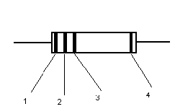

Three bands that are close together are to the left.

Then colors of:
Band no.1 signifies the 1st digit
Band no.2 signifies the 2nd digit
Band no.3 the multiplier.
Band no.4 the tolerance.

Band Color | Band 1 and 2 | Multiplier | Tolerance
Black | 0 | 1 | -
Brown | 1 | 10 | 1%
Red | 2 | 100 | 2%
Orange | 3 | 1000 | -
Yellow | 4 | 10,000 | -
Green | 5 | 100,000 | -
Blue | 6 | 10⁶ | -
Violet | 7 | 10⁷ | -
Grey | 8 | 10⁸ | -
White | 9 | 10⁹ | -
Gold | - | 0.1 | 5%
Silver | - | 0.01 | 10%
No Color | - | - | 20%

For example:
Band 1 =Red
Band 2= Violet
Band 3= Orange
Band 4= gold
Resistance = 27 X 1000 = 27000ohm = 27 kΩ ± 5%
Band 1= Brown
Band 2= Black
Band 3 = Red
Band 4 = Silver
Resistance = 10 X 100 = 1000 ohm = 1kΩ ± 10%

Variable resistor:

Rheostat
This is the simplest way of using a variable resistor. Two terminals are used: one connected to an end of the track, the other to the moveable wiper. Turning the spindle changes the resistance between the two terminals from zero up to the maximum resistance.
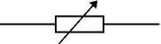
Rheostat Symbol
Rheostats are often used to vary current, for example to control the brightness of a lamp or the rate at which a capacitor charges.
If the rheostat is mounted on a printed circuit board you may find that all three terminals are connected! However, one of them will be linked to the wiper terminal. This improves the mechanical strength of the mounting but it serves no function electrically.

Potentiometer
Variable resistors used as potentiometers have all three terminals connected.
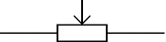
Potentiometer Symbol
This arrangement is normally used to vary voltage, for example to set the switching point of a circuit with a sensor, or control the volume (loudness) in an amplifier circuit. If the terminals at the ends of the track are connected across the power supply then the wiper terminal will provide a voltage which can be varied from zero up to the maximum of the supply.

Presets
These are miniature versions of the standard variable resistor. They are designed to be mounted directly onto the circuit board and adjusted only when the circuit is built. For example to set the frequency of an alarm tone or the sensitivity of a light-sensitive circuit. A small screwdriver or similar tool is required to adjust presets.
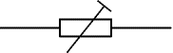
Preset Symbol
Presets are much cheaper than standard variable resistors so they are sometimes used in projects where a standard variable resistor would normally be used.

Capacitors:

The capacitor's function is to store electricity, or electrical energy. The capacitor also functions as a filter, passing alternating current (AC), and blocking direct current (DC).
This symbol is used to indicate a capacitor in a circuit diagram.
The capacitor is constructed with two electrode plates facing each other, but separated by an insulator.
When DC voltage is applied to the capacitor, an electric charge is stored on each electrode. While the capacitor is charging up, current flows. The current will stop flowing when the capacitor has fully charged.
When a circuit tester, such as an analog meter set to measure resistance, is connected to a electrolytic capacitor, a current will flow, but only for a moment. You can confirm that the meter's needle moves off of zero, but returns to zero right away.
When you connect the meter's probes to the capacitor in reverse, you will note that current once again flows for a moment. Once again, when the capacitor has fully charged, the current stops flowing. So the capacitor can be used as a filter that blocks DC current. (A "DC cut" filter.)
However, in the case of alternating current, the current will be allowed to pass. Alternating current is similar to repeatedly switching the test meter's probes back and forth on the capacitor. Current flows every time the probes are switched.
The value of a capacitor (the capacitance), is designated in units called the Farad ( F ).
Recently, a new capacitor with very high capacitance has been developed. The Electric Double Layer capacitor has capacitance designated in Farad units. These are known as "Super Capacitors."

Breakdown voltage
When using a capacitor, you must pay attention to the maximum voltage which can be used. This is the "breakdown voltage." The breakdown voltage depends on the kind of capacitor being used. You must be especially careful with electrolytic capacitors because the breakdown voltage is comparatively low. The breakdown voltage of electrolytic capacitors is displayed as Working Voltage.
The breakdown voltage is the voltage that when exceeded will cause the dielectric (insulator) inside the capacitor to break down and conduct. When this happens, the failure can be catastrophic.

Electrolytic Capacitors (Electrochemical type capacitors)
Aluminum is used for the electrodes by using a thin oxidization membrane.
Large values of capacitance can be obtained in comparison with the size of the capacitor, because the dielectric used is very thin.
The most important characteristic of electrolytic capacitors is that they have polarity. They have a positive and a negative electrode.[Polarised] This means that it is very important which way round they are connected. If the capacitor is subjected to voltage exceeding its working voltage, or if it is connected with incorrect polarity, it may burst. It is extremely dangerous, because it can quite literally explode. Make absolutely no mistakes.

Ceramic Capacitors
Ceramic capacitors are constructed with materials such as titanium acid barium used as the dielectric. Internally, these capacitors are not constructed as a coil, so they can be used in high frequency applications. Typically, they are used in circuits which bypass high frequency signals to ground.
These capacitors have the shape of a disk. Their capacitance is comparatively small.
Multilayer Ceramic Capacitors
The multilayer ceramic capacitor has a many-layered dielectric. These capacitors are small in size, and have good temperature and frequency characteristics.
Square wave signals used in digital circuits can have a comparatively high frequency component included.
This capacitor is used to bypass the high frequency to ground.
Polystyrene Film Capacitors
In these devices, polystyrene film is used as the dielectric. This type of capacitor is not for use in high frequency circuits, because they are constructed like a coil inside. They are used well in filter circuits or timing circuits which run at several hundred KHz or less.
The component shown on the left has a red color due to the copper leaf used for the electrode. The silver color is due to the use of aluminum foil as the electrode.

Electric Double Layer Capacitors (Super Capacitors)
This is a "Super Capacitor," which is quite a wonder.
The capacitance is 0.47 F (470,000 µF).
I have not used this capacitor in an actual circuit.

Care must be taken when using a capacitor with such a large capacitance in power supply circuits, etc. The rectifier in the circuit can be destroyed by a huge rush of current when the capacitor is empty. For a brief moment, the capacitor is more like a short circuit. A protection circuit needs to be set up.
The size is small in spite of capacitance. Physically, the diameter is 21 mm, the height is 11 mm.
Care is necessary, because these devices do have polarity.
Polyester Film Capacitors
This capacitor uses thin polyester film as the dielectric.
They are not high tolerance, but they are cheap and handy. Their tolerance is about ±5% to ±10%.
Polypropylene Capacitors
This capacitor is used when a higher tolerance is necessary than polyester capacitors offer. Polypropylene film is used for the dielectric. It is said that there is almost no change of capacitance in these devices if they are used with frequencies of 100KHz or less.
The pictured capacitors have a tolerance of ±1%.
Mica Capacitors
These capacitors use Mica for the dielectric. Mica capacitors have good stability because their temperature coefficient is small. Because their frequency characteristic is excellent, they are used for resonance circuits, and high frequency filters. Also, they have good insulation, and so can be utilized in high voltage circuits. It was often used for vacuum tube style radio transmitters, etc.
Mica capacitors do not have high values of capacitance, and they can be relatively expensive.
Metallized Polyester Film Capacitors
These capacitors are a kind of a polyester film capacitor. Because their electrodes are thin, they can be miniaturized.
Variable Capacitors
Variable capacitors are used for adjustment etc. of frequency mainly.
When adjusting the value of a variable capacitor, it is advisable to be careful.
One of the component's leads is connected to the adjustment screw of the capacitor. This means that the value of the capacitor can be affected by the capacitance of the screwdriver in your hand.

Diode:

In this discussion the term diode and rectifier will be used interchangeably; however, the term diode usually implies a small signal device with current typically in the milliamp range; and a rectifier, a power device, conducting from1 to 1000 amps or even higher. Many diodes or rectifiers are identified as 1NXXXX . A semiconductor diode consists of a PN junction and has two(2) terminals, an anode(+) and a cathode(-). Current flows from anode to cathode within the diode
An ideal diode is like a light switch in your home. When the switch is closed, the circuit is completed; and the light turns on.When the switch is open, there is no current and the light is off.
However, the diode has an additional property; it is unidirectional, i.e.current flows in only one direction(anode to cathode internally).When a forward voltage is applied, the diode conducts; and when a reverse voltage is applied, there is no conduction. A mechanical analogy is a ratchat, which allows motion in one direction only. An ideal diode characteristic would be

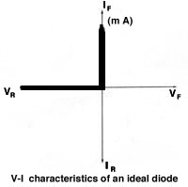

However, a typical diode characteristic is more like the following:
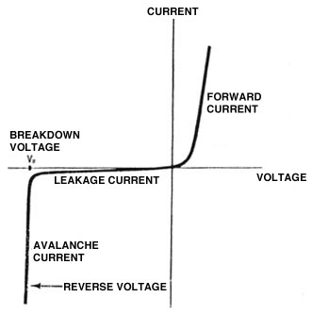
Leakage current

In the reverse direction there is a small leakage current up until the reverse breakdown voltage is reached. This leakage is undesireable, obviously the lower the better, and is specified at a voltage less the than breakdown; diodes are intended to operate below their breakdown voltage.
Current Rating

The current rating of a diode is determined primarily by the size of the diode chip, and both the material and configuration of the package, Average Current is used, not RMS current. A larger chip and package of high thermal conductivity are both conducive to a higher current rating.
Switching

The switching speed of a diode depends upon its construction and fabrication. In general the smaller the chip the faster it switches, other things being equal. The chip geometry, doping levels, and the temperature at nativity determine switching speeds . The reverse recovery time, trr, is usually the limiting parameter; trr is the time it takes a diode to switch from on to off.

Conclusion
The very minimal diode specifications are:
(a)Maximum reverse voltage
(b)Rated forward current
(c)Maximum forward voltage drop
(d)Maximum leakage current
(e)Package style
(f)Maximum reverse recovery time

Transistor:

Transistors, having 2 junctions, are 3 terminal semiconductor devices. The three terminals are emitter, collector, and base. A transistor can be either NPN or PNP. See the schematic representations below:

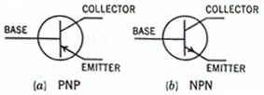

Note that the direction of the emitter arrow defines the type transistor. Biasing and power supply polarity are positive for NPN and negative for PNP transistors. The transistor is primarily used as an current amplifier. When a small current signal is applied to the base terminal, it is amplified in the collector circuit. This current amplification is referred to as H_{FE} or beta and equals Ic/Ib.
As with all semiconductors, breakdown voltage is a design limitation. There are breakdown voltages that must be taken into account for each combination of terminals. i.e. Vce, Vbe,and Vcb. However, Vce(collector-emitter voltage) with open base, designated as Vceo, is usually of most concern and defines the maximum circuit voltage.
Also as with all semiconductors there are undesireable leakage currents, notably Icbo ,collector junction leakage; and Iebo, emitter junction leakage.

The negative collector-emitter voltage tells you that the transistor is PNP. Also that the output current increases with input or base current and varies very little with collector-emitter voltage.

Primary considerations when selecting a transistor are:
(a) Voltage ratings of all three junctions
(b) Power rating and thermal resistance
(c) Current handling capability and the transistor case size
(d) Leakage currents, mainly Icbo and Iebo
(e) Frequency response and /or switching times.
(f) Current gain (HFE and hfe)
(g) Temperature parameter variation.
(h) Saturation resistance
(I) h-parameters for linear applications

INDUCTOR:

"Inductance is the ability of a coil to establish (or induce) a voltage within itself to oppose changes in current through its windings".
That means when varying current flows through a coil, a voltage is induced within the coil in a direction so as to oppose the change of current through it.

The circuit symbol of an inductor is:
and like a resistor, it can be connected either way in a circuit, with the exception of mutually coupled coils that have to be connected in a particular way.

The unit of inductance:
The unit of inductance is 'henry' denoted by H. Usually, in electronics smaller values of H are used like mH (millihenry).
Applications of inductors:
One of the major applications come in from "mutually coupled" coils where the magnetic field established in one coil, 'cuts' through the other coil and hence induces a voltage in the other coil. This is called 'mutual inductance'. Such coils are widely used in transformers.

DC POWER SUPPLY:

Almost all electronic circuits need a DC bias voltage. DC sources are available market in various ranges. These are mainly categorized into fixed and variable. Fixed DC supplies provide fixed DC supply and voltage. Some units provide only positive voltages while some other provide both positive and negative. DC supplies which provide both

positive and negative voltages are called duel power supplies. Certain integrated circuits and discrete circuits need dual power supplies. +15V dual supplies are very popular. Variable power supplies provide the flexibility to vary the range of voltage. Operator can turn the knob and fix the required voltage. Most of the variable power sources have a range from 0-30V. Usually, coarse and fine adjustments are provide in these units.

MULTIMETER:

Multimeter is a very popular electronic measuring device and it is a essential equipments to repair or trouble shoot an electronic circuit. Multimeter as its name suggest is used to measure variable electrical quantities such as voltage, current and resistor. Multimeter works in different modes namely ammeter, voltmeter and ohmmeter. The modes can be set using a selector switch provided in the multimeter. Some multimeters incorporate the additional facility to the measure inductance, capacitance h_{FE} of transistor.

Both AC and DC voltages and current can be measured using the multimeter. These are available in two types called analog and digital. Analog multimeter has a needle moving over a calibrated scale while the digital multimeter gives the digital display measured quantities.
A digital multimeter (DMM) is made from the basic digital voltmeter. For the measurement of current, the voltage drop across a precision resistance is measured. DMM can be connected to an ohmmeter by using an accurate current source. It measures the voltage drop across the resistance being measured.

FUNCTION GENERATOR:

Many of the experiment need sinusoidal and square waves. Function generator provides various signal with a provision to vary the frequency and amplitude. In almost all of the function generators the type of wave forms are available sine, square and triangular. The frequency range of the function generator is generally 0-20 MHz. A known name ‘offset’ is provided to add positive or negative DC voltage to the generated signal. If the operator does not need any DC shift, by turning off. This knob offset can be multiplied and thus the signal can be made to swing exactly with respect to the zero reference.

Function Generator

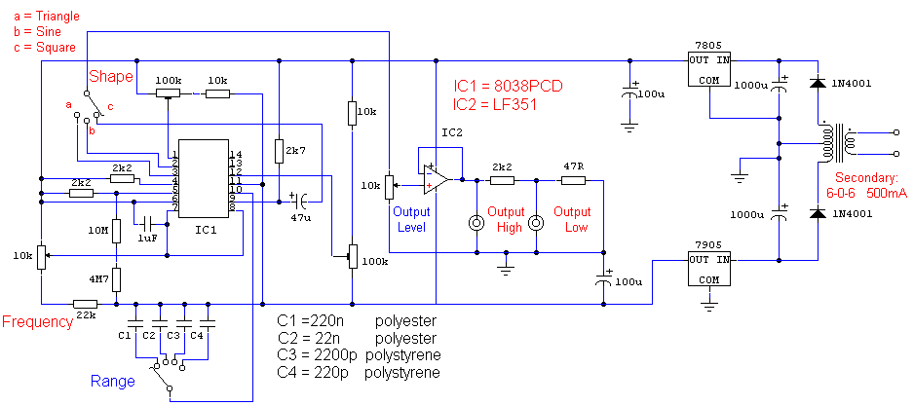

CATHODE RAY OSCILLOSCOPE:

Cathode Ray Oscilloscope is an instrument which gives the usual representation of electric signals. It is one among the most versatile tool used for the research and study of electronic circuits and systems. It displays the signal on the screen in X and Y axis used in the conventional graph construction. The X axis represent the time and Y axis the amplitude of the signal. Oscilloscope of this type are capable of displaying a voltage variations which takes place over a period of microseconds and nanoseconds. Cathode Ray Oscilloscope (CRO) is the heart of CRO. It is vacuum tube which generate a narrow electron beam and made to fall on a fluorescent screen situated at one side of the tube. The electron beam is deflected both horizontal and vertical. The wave to be obtained is fed across the vertical deflection plate which the horizontal plates elongates the wave form in the time axis.

Block Diagram Of CRO

***************** Block Diagram Of CRO *****************

The heart of CRO is CRT is shown below.

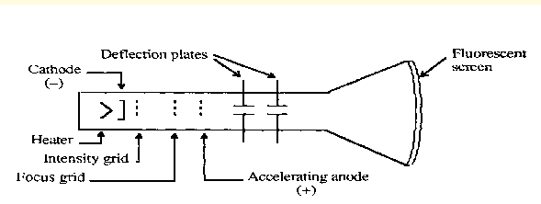

The controls and sockets in the front panel of a typical Cathode Ray Oscilloscope are explained below in this category.

Power control:

OFF/INTENS: Turns power on. A pilot LED indicates the starters whether it is on or off. The intensity of the displayed electron becomes can be varied using this knob.

FOCUS: Using this, the beam can be made sharply defined. This helps to take the readings more accurately.

VERTICAL DEFLECTIONS:

Y-POSITION: Controls the vertical shift of the trace.

AC/DC: In AC position the DC component of the signal is blocked by a blocking capacitor. In DC position, signal is directly coupled.

TIME-BASE AND HORIZONTAL DEFLECTIONS:

X-POSITION: Controls the horizontal shifting of the trace.

LEVEL: Help the signal to remain still.

µs/ms: In combination with Time/Div switch, selects the time coefficients.

MAGNIN: Allows the magnification of the horizontal deflection by a factor of n.

TIME/DEV: Enlarges the signal in X-direction. In combination with µs/ms selects the time coefficients.

BREAD BOARD:

A solder less bread board is a multipurpose board with 128 groups of 5 connected terminals (micro sockets) in each we can insert the pin of the components is caught in between two plates with spring action. The 128 groups of terminals are arranged on the upper side and lower side of the bread board in two sets of 64 each. Each group on both sides is marked with 1 to 62 except the first two groups. It means the numbering starts from the third group and the first two groups are not numbered.

RESULT:

Familiarized with DC power supply, multimeter, function generator, CRO and bread board.

