Chapter 1: Fundamentals of Data Communication

1.0 Introduction
1.1 Data Communication Model
1.2 Data Communications System Tasks
1.3 Communication Network and Services
1.4 Data Communications Networking
1.4.1 Wide-Area Networks
1.4.2 Local Area Networks
1.5 Protocols and Protocol Architecture
1.5.1 The OSI model
1.5.2 The TCP/IP model

This chapter provides the big picture of the data communication networks. The tasks involved in the communication networks, different communication services required, the kind of networks available, protocol architectures and OSI, TCP/IP protocol models are discussed in brief. In essence fundamental concepts of the data communication networks are discussed briefly, providing the basis for detailed discussion in later chapters. At the end of the chapter the student will have a context in which to place various topics as they progress through the later chapters.

1.0 Introduction

Basic Communication Model
Communication is the conveyance of a message from one entity, called the source or transmitter, to another, called the destination or receiver, via a channel of some sort.
To give a very basic example of such a communication system is conversation; people commonly exchange verbal messages, with the channel consisting of waves of compressed air molecules at frequencies, which are audible to the human ear. This is depicted in Figure 1.1.
The conveyance of a message could be followed by a reciprocal response message from the original destination (now a source) to the original source (now a destination) to complete one cycle in a dialogue between corresponding entities. Depending on the application or need for the information exchange, either atomic one-way transactions or a two-way dialogue could be appropriate.
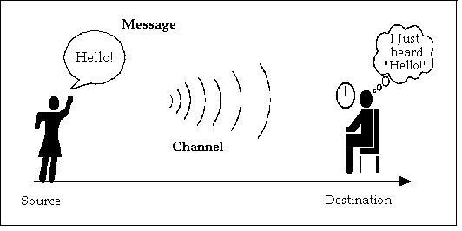
Figure 1.1: Basic Communication Model
The only way that a message source can be certain that the destination properly received the message is by some kind of acknowledgment response from the destination. Conversing people might say "I understand" or nod their head in response to a statement made by their peer. This acknowledged form of dialogue is the basis of reliable communications - somehow the source must get feedback that the destination correctly received the message.
The basic model explained above wherein originator and destination are human beings can be generalized as in Figure 1.2. to suite the data communication between two systems exchanging information between them.
Source: Device that generates the data to be passed on to the Destination device. It could be a user computer trying to make a query to a server computer.
Transmitter: If the data generated by the Source device has to be transmitted through Transmission Channel or Transmission System then it has to be presented in a form that is acceptable to the Transmission system. This job is done by the Transmitter. For example, a modem takes a digital bit stream from the attached computer and transforms that stream of bits into an analog signals which can be handled by the telephone network.
Transmission System: This can be a single transmission line connecting the two systems communicating or a complex network to which numerous communicating systems are connected.
Receiver: This receives the signal from the transmission system and converts it into a form that is suitable to the destination device. For example, a modem accepts analog signal from a transmission channel and transforms it into digital bit stream.
Destination: Device to which the source device sends data.

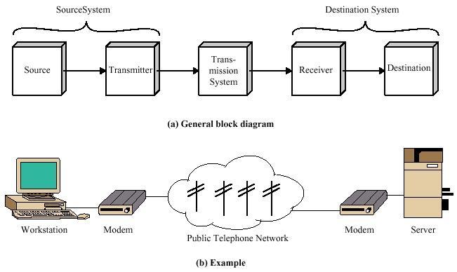
Figure 1.2 Simple Data Communication model

  - Data Communication Model
Figure 1.3 provides a new perspective on the data communication model of Figure1.2. Let us trace through the details of this figure using electronic mail as an example.
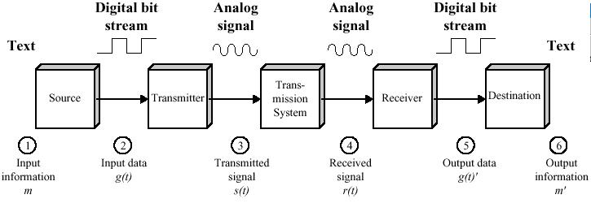
Figure 1.3 Data Communication model
Consider that the source input device and transmitter are components of a personal computer. The user of the PC wishes to send a message to another user—for example, "Good luck for your exams" (m). The user activates the electronic mail package on the PC and enters the message via the keyboard (input device). The character string is briefly buffered in main memory. We can view it as a sequence of bits (g) in memory. The personal computer is connected to some transmission medium, such as a local network or a telephone line by an I/O device (transmitter), such as a local network transceiver or a modem. The input data are transferred to the transmitter as a sequence of voltage shifts g(t) representing bits on some communications bus or cable. The transmitter is connected directly to the medium and converts the incoming stream [g(t)] into a signal [s(t)] suitable for transmission. The transmitted signal s(t) presented to the medium is subject to a number of impairments, before it reaches the receiver. Thus, the received signal r(t) may differ to some degree from s(t). The receiver will attempt to estimate the original s(t), based on r(t) and its knowledge of the medium, producing a sequence of bits g'(t). These bits are sent to the output personal computer, where they are briefly buffered in memory as a block of bits (g’). In many cases, the destination system will attempt to determine if an error has occurred and, if so, will cooperate with the source system to eventually obtain a complete, error-free block of data. These data are then presented to the user via an output device, such as a printer or a screen. The message (m'), as viewed by the user, will usually be an exact copy of the original message (m).
Now consider a telephone conversation. In this case, the input to the telephone is a message (m) in the form of sound waves. The sound waves are converted by the telephone into electrical signals of the same frequency. These signals are transmitted without modification over the telephone line. Hence, the input signal g(t) and the transmitted signal s(t) are identical. The signal s(t) will suffer some distortion over the medium, so that r(t) will not be identical to s(t). Nevertheless, the signal r(t) is converted back into a sound wave with no attempt at correction or improvement of signal quality. Thus m’ is not an exact replica of m. However, the received sound message is generally comprehensible to the listener.

1.2 Data Communications System Tasks
Some of the Key tasks to be performed by a Data Communications System are listed below.
- Signal Generation
- Interfacing
- Synchronisation
- Exchange Management
- Transmission System Utilisation
- Error Detection and Correction
- Flow Control
- Addressing
- Routing
- Message Formatting
All the data that are transmitted over the transmitting system propagate as Electromagnetic signals. Hence the communicating device must be able to generate and receive these signals. Signal generation should be such that the resultant signal is capable of being propagated through the transmission medium and interpretable as data at the receiver.
A device must interface with the transmission system in order to communicate.
Unless the receiver and transmitter are in Synchronisation the receiver will not be able to make sense out of received signals. Receiver should know when the transmission of data starts, when it ends.
For meaningful data transaction there should be some kind management of data being exchanged. Both the transmitter and receiver should adhere to some common convention about the format of data, amount of data that can be sent at a time and so on. This requires a prior definition of message formatting.
Transmission System Utilisation refers to the need to make efficient use of Transmission Channel, which are generally shared by many communicating devices. Various techniques (Multiplexing) are available to allocate the total capacity of a transmission channel among connected devices. Care should be taken to avoid probable Congestion in some kind of multiplexing.
In any communication system transmitted data is prone to error. Either it is because of transmitted signal getting distorted in the transmission medium leading to misinterpretation of signal or errors introduced by the intermediate devices. Error detection and Correction is required in cases where there is no scope for error in the data transaction. We can think of file transfer between two computers where there is a need for this. But in some cases it may not be very important as in the case of telephonic conversation.
There is a possibility of transmitter generating data faster than the receiver device capable of handling. To handle this there should be some kind of flow control mechanism agreed upon between the two communicating devices.
When more than two devices share a transmitting facility, a source system must somehow indicate the identity (or address) of the destination. The transmission system must ensure that the data being sent are routed only to the destination system.
The list of tasks explained above is not exhaustive one. But sure it indicates the complexities involved in a communication system. The data communication system must be designed to handle the above tasks as required so that meaningful communication can take place between two devices efficiently.

1.3 Communication Network and Services
A communication network, in its simplest form, is a set of equipment and facilities that provides a communication service: the transfer of information between users located at various geographical points. Here we focus on networks that use electronic or optical technologies. Examples of such networks include telephone networks, computer networks, television broadcast networks, cellular telephone networks, and the Internet.
The ability of communication network to transfer information at extremely high speeds allows users to gather information in large volumes, nearly instantaneously and, with the aid of computers, to almost immediately exercise action at a distance. These two unique capabilities form the basis for many existing services and an unlimited number of future network-based services. We will now discuss several services that are supported by current networks. The services are examined from the point of view of user requirements, that is, quality of service, features, and capabilities. The viewpoint here is that networks should ultimately be designed to meet the requirements of the user applications.
Radio and television broadcasting are probably the most common communication services. Various stations transmit an ensemble of signals simultaneously over radio or cable distribution networks. Aside from selecting the station of interest, the role of the user in these services is passive. Relatively high audio and video quality is expected, but a significant amount of delay (in the order of seconds or more) can be tolerated even in live broadcasts.
Telephone service is the most common real-time service provided by a network. Two persons are able to communicate by transmitting their voices across the network. The service is connection-oriented in the sense that the users must first interact with the network to set up a connection.
The telephone service has the real-time requirement in that users cannot interact as in face-to-face conversation if the delays are greater than a fraction of second (approximately 250 milliseconds). The service must also be reliable in the sense that once the connection is established it must not be interrupted because of failures in the network. At the minimum the delivered voice signal must be intelligible, but in most situations the users expect a much higher quality that enables the listener not only to recognize what the speaker says but also to discern subtleties in intonation, mood, and so on. A high degree of availability is another requirement: Telephone users expect the network to be capable of completing the desired connection almost all the time. Security and privacy of the conversation are consideration in some situations.
The telephone service can be enhanced in a number of ways. For example, the toll-free service is provided wherein the caller will not be billed but costs of the call are automatically billed to the subscriber of the service. Similarly, in credit-card or calling-card services, the cost of a call is automatically billed to the holder of the card. Clearly, security and fraud are issues here.
Telephone networks provide a broad class of call management services that use the originating number or the destination number to determine the handling of a call. Caller ID allows the originating number, and sometimes name, of the originating call to be displayed to the destination user when the receiving device is display capable. Voice mail allows a destination user to have calls forwarded to a message-receiving device when the destination user is not available.
Cellular telephone service extends the normal telephone service to mobile users who are free to move within a regional area covered by an interconnected array of smaller geographical areas called cells. Each cell has a radio transmission system that allows it to communicate with users in its area. The use of radio transmission implies design compromises that may result in lower voice quality, lower availability, and greater exposure to eavesdropping. In addition, the cellular system must handle the handing off of users as they move from one cell to another so that an ongoing conversation is not terminated abruptly. Some cellular providers also support a roaming service where a subscriber is able to place calls while visiting regional areas other than the subscriber's home base. Note that the mobility aspect to the roaming service is not limited to cellular (or wireless) communications. Indeed, the need for mobility arises whenever a subscriber wishes to access a service from anywhere in the world.
Electronic mail (e-mail) is another common network service. The user typically provides a text message and a name and/or address to a mail application. The application interacts with a local mail server, which in turn transmits the message to a destination server across a computer network. The destination user retrieves the message by using a mail application, such as Outlook Express software package of Microsoft. E-mail is not a real-time service in that fairly large delays can be tolerated. It is also not necessarily connection-oriented in that a network connection does not need to be set up expressly for each individual message. The service requires reliability in terms of the likelihood of delivering the message without errors and to the correct destination. In some instances the user may be able to request delivery confirmation. Again security and privacy may be a concern.
Many applications that involve an interaction between processes running in two computers may be characterized by client/server interaction. For example, a user likes to view a document file of a particular company and he initiates a process - client - to access a given file on the server which hosts that particular document. The World Wide Web (WWW) application typifies this interaction. The WWW consists of a framework for accessing documents that are located in computers connected to the Internet. These documents consist of text, graphics, and other media and are interconnected by links that appear within the documents. The WWW is accessed through a browser program that displays the documents and allows the user to access other documents by clicking on one of these links. Each link provides the browser with a Uniform resource locator (URL) that specifies the name of the system where the document is located as well as the name of the file that contains the requested document. For example the URL
http://www.ksouonline.org/prog.html
specifies the document in the Internet, which provides the details about IT programmes offered by KSOU.
The first term, http, specifies the retrieval mechanism to be used, in this case, the Hyper Text Transfer Protocol (HTTP). Next the URL specifies the name of the host machine, namely, www.ksouonline.org. The remaining data gives the path to the document within the host machine, that is, the URL identifies the document file on the server hosting the desired document. By entering the above URL in the address field of a browser such as Internet Explorer or Netscape Navigator, user can view the document.
In addition to text the files the WWW may contain audio and images that involve large amounts of information. While the user does not require real-time response, excessive delay in retrieving files reduces the degree of interactivity of the overall application where the user seeks information, reads it, and again seeks additional information by clicking on other items or on links to other Web sites. The overall delay is determined by the delays in accessing the servers as well as the time required to transmit the files through the network.
There are many other network services like Video on demand, Streamed Audiovisual Services, Audio Conferencing, Audio-Visual Conferencing. The basic information in these services is of audio and visual in nature and they require huge data to convey the information. Apart from having huge data to be transported between communicating systems, since these services are of real-time in nature the bandwidth of the underlying communication network required for these services is also huge. Looking at the technological development happening in the data communication field, days are not for off when these services are provided to common user over the Internet at affordable cost.

1.4 Data Communications Networking
In its simplest form, data communication takes place between two devices that are directly connected by some form of point-to-point transmission medium. Often, however, it is impractical for two devices to be directly, point-to-point connected. This is so for one (or both) of the following contingencies:
- The devices are very far apart. It would be inordinately expensive, for example, to string a dedicated link between two devices thousands of miles apart.
- There is a set of devices, each of which may require a link to many of the others at various times. Examples are all of the telephones in the world and all of the terminals and computers owned by a single organization. Except for the case of a very few devices, it is impractical to provide a dedicated wire between each pair of devices.
The solution to this problem is to attach each device to a communications network. Figure 1.4 relates this area to the communications model of Figure l.2a and also suggests the two major categories into which communications networks are traditionally classified: Wide-Area Networks (WANs) and Local-Area Networks (LANs). The distinction betweens the two, both in terms of technology and application, has become somewhat blurred in recent years, but it remains a useful way of organizing the discussion.
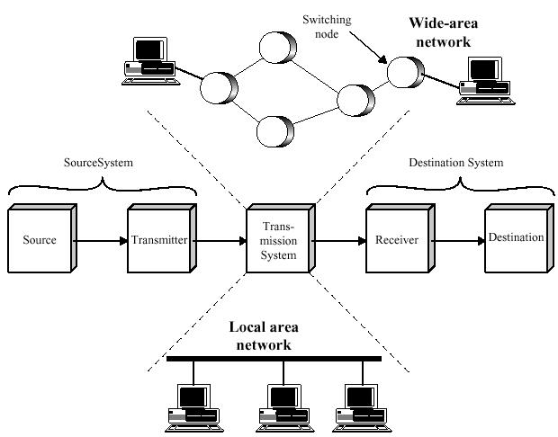
Figure 1.4 Simplified Network models

1.4.1 Wide-Area Networks
Wide-area networks have traditionally been considered to be those that cover a large geographical area, require the crossing of public right-of-ways, and rely at least in part on circuits provided by a common telephone carrier. Typically, a WAN consists of a number of interconnected switching nodes. Transmission from any one device is routed through these internal nodes to the specified destination device. These nodes (including the boundary nodes to which the devices are connected) are not concerned with the content of the data; rather, their purpose is to provide a switching facility that will move the data from node to node until they reach their destination. Traditionally, WANs have been implemented using one of two technologies: circuit switching and packet switching. More recently, frame relay and ATM networks have assumed major roles.

Circuit Switching
In a circuit-switched network, a dedicated communication path is established between two stations through the nodes of the network. That path is a connected sequence of physical links between nodes. On each link, a logical channel is dedicated to the connection. Data generated by the source station are transmitted along the dedicated path as rapidly as possible. At each node, incoming data are routed or switched to the appropriate outgoing channel without delay. The most common example of circuit switching is the telephone network.

Packet Switching
A quite different approach is used in a packet-switched network. In this case, it is not necessary to dedicate transmission capacity along a path through the network. Rather, data are sent out in a sequence of small chunks, called packets. Each packet is passed through the network from node to node along some path leading from source to destination. At each node, the entire packet is received, stored briefly, and then transmitted to the next node. Packet-switched networks are commonly used for terminal-to-computer and computer-to-computer communications.

Frame Relay
Packet switching was developed at a time when digital long-distance transmission facilities exhibited a relatively high error rate compared to today's facilities. As a result, there is a considerable amount of overhead built into packet-switched schemes to compensate for errors. The overhead includes additional bits added to each packet to introduce redundancy and additional processing at the end stations and the intermediate switching nodes to detect and recover from errors.
With modern high-speed telecommunication systems, this overhead is unnecessary and counterproductive. It is unnecessary because the rate of errors has been dramatically lowered and any remaining errors can easily be caught in the end systems by logic that operates above the level of the packet-switching logic; it is counterproductive because the overhead involved soaks up a significant fraction of the high capacity provided by the network.
Frame relay was developed to take advantage of these high data rates and low error rates. Whereas the original packet-switching networks were designed with a data rate to the end user of about 64 kbps(kilo bits per second, 1 kilo=10³), frame relay networks are designed to operate efficiently at user data rates of up to 2 Mbps (Mega bits per second, 1 Mega=10⁶). The key to achieving these high data rates is to strip out most of the overhead involved with error control.

ATM
Asynchronous Transfer Mode (ATM), sometimes referred to as cell relay, is a culmination of all of the developments in circuit switching and packet switching over the past 25 years.
ATM can be viewed as an evolution from frame relay. The most obvious difference between frame relay and ATM is that frame relay uses variable-length packets, called frames, and ATM uses fixed-length packets, called cells. As with frame relay, ATM provides little overhead for error control, depending on the inherent reliability of the transmission system and on higher layers of logic in the end systems to catch and correct errors. By using a fixed-packet length, the processing overhead is reduced even further for ATM compared to frame relay. The result is that ATM is designed to work in the range of 10s and 100s of Mbps, compared to the 2-Mbps target of frame relay.
ATM can also be viewed as an evolution from circuit switching. With circuit switching, only fixed-data-rate circuits are available to the end system. ATM allows the definition of multiple virtual channels with data rates that are dynamically defined at the time the virtual channel is created. By using full, fixed-size cells, ATM is so efficient that it can offer a constant-data-rate channel even though it is using a packet-switching technique. Thus, ATM extends circuit switching to allow multiple channels with the data rate on each channel dynamically set on demand.

ISDN and Broadband ISDN
Merging and evolving communications and computing technologies, coupled with increasing demands for efficient and timely collection, processing, and dissemination of information are leading to the development of integrated systems that transmit and process all types of data – plain text data, audio, video. A significant outgrowth of these trends is the Integrated Services Digital Network (ISDN). Through this user with a single access point to ISDN network can avail of different kinds of communication – his computer can access the Internet, he can use the network for his telephone usage and also probably video communication.
The ISDN is intended to be a worldwide public telecommunications network to replace existing public telecommunications networks and deliver a wide variety of services. The ISDN is defined by the standardization of user interfaces and implemented as a set of digital switches and paths supporting a broad range of traffic types and providing value-added processing services. In practice, there are multiple networks, implemented within national boundaries, but, from the user's point of view, there is intended to be a single, uniformly accessible, worldwide network.
Despite the fact that ISDN has yet to achieve the universal deployment hoped for, it is already in its second generation. The first generation, sometimes referred to as narrowband ISDN, is based on the use of a 64-kbps channel as the basic unit of switching and has a circuit-switching orientation. The major technical contribution of the narrowband ISDN effort has been frame relay. The second generation, referred to as broadband ISDN, supports very high data rates (100s of Mbps) and has a packet-switching orientation. The major technical contribution of the broadband ISDN effort has been asynchronous transfer mode (ATM), also known as cell relay.

1.4.2 Local Area Networks (LAN)
As with Wide-Area Networks, a Local-Area Network or LAN is a communications network that interconnects a variety of devices and provides a means for information exchange among those devices. There are several key distinctions between LANs and WANs;
- The scope of the LAN is small, typically a single building or a cluster of buildings. This difference in geographic scope leads to different technical solutions.
- It is usually the case that the LAN is owned by the same organization that owns the attached devices. For WANs, this is less often the case, or at least a significant fraction of the network assets are not owned. This has two implications. First, care must be taken in the choice of LAN, as there may be a substantial capital investment (compared to dial-up or leased charges for wide area networks) for both purchase and maintenance. Second, the network management responsibility for a local network falls solely on the user.
- The internal data transfer rates of LANs are typically much greater than those of wide-area networks.
Traditionally, LANs make use of a broadcast network approach rather than a switching approach. With a broadcast communication network, there are no intermediate switching nodes. At each station, there is a transmitter / receiver that communicates over a medium shared by other stations. A transmission from any one station is broadcast to and received by all other stations. We will be concerned with networks used to link computers, workstations, and other digital devices. Also in the case of LANs, data are usually transmitted in packets. Because the medium is shared, only one station at a time can transmit a packet.
More recently, examples of switched LANs have appeared, the two most prominent examples are ATM LANs, which simply use an ATM network in a local area, and Fiber Channel.
Various topologies are possible for broadcast LANs. Figure 1.5 shows two of them.
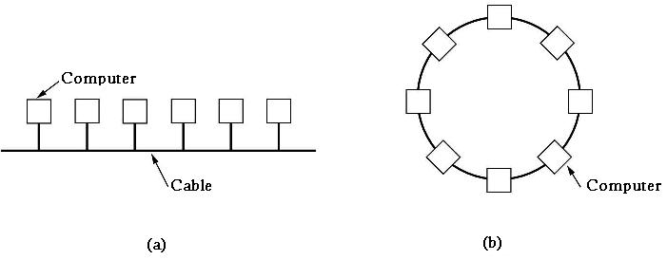

Figure 1.5 Two broadcast networks. (a) Bus, (b) Ring

Ethernet
In a bus (i.e. a linear cable) network, at any instant one machine is the master and is allowed to transmit. An arbitration mechanism is needed to resolve conflicts when two or more machines want to transmit simultaneously. The arbitration mechanism may be centralized or distributed. IEEE 802.3 CSMA/CD popularly known as Ethernet, for example, is a bus based broadcast network with decentralized control operating at 10 or 100 Mbps. Computers on an Ethernet can transmit whenever they want to; if two or more packets collide, each computer just waits a random time and tries again later.
Token Ring
A second type of broadcast system is the token ring network. A ring really consists of a collection of ring interfaces connected by point-to-point lines. Each bit arriving at an interface is copied back onto the ring at the other interface. In a token ring, a special pattern of bits called token, circulates around the ring whenever all stations are idle. When a station wants to transmit a frame, it is required to seize the token and remove it from the ring before transmitting. Because there is only one token, only one station can transmit at a given instant, thus solving the channel access problem.

1.5 Protocols and Protocol Architecture
When computers, terminals, and/or other data processing devices exchange data, the scope of concern is much broader than the concerns we have discussed so far. Consider, for example, the transfer of a file between two computers. There must be a data path between the two computers, either directly or via a communication network. But more is needed. Typical tasks to be performed are
- The source system must either activate the direct data communication path or inform the communication network of the identity of the desired destination system.
- The source system must ascertain that the destination system is prepared to receive data.
- The file transfer application on the source system must ascertain that the file management program on the destination system is prepared to accept and store the file for this particular user.
- If the file formats used on the two systems are incompatible, one or the other system must perform a format translation function.
It is clear that there must be a high degree of cooperation between the two computer systems. The exchange of information between computers for the purpose of cooperative action is generally referred to as computer communications. Similarly, when two or more computers are interconnected via a communication network, the set of computer stations is referred to as a computer network.
In discussing computer communications and computer networks, two concepts are paramount:
- Protocols
- Protocol architecture or Computer Communications architecture
A network protocol is a set of rules for communicating between computers. Protocols govern format, timing, sequencing, and error control. Without these rules, the computer cannot make sense of the stream of incoming bits.
A protocol is used for communication between entities in different systems. For two entities to communicate successfully, they must speak the same language. What is communicated, how it is communicated, and when it is communicated must conform to some mutually acceptable convention or protocol between the entities involved. The key elements of a protocol are
- Syntax Includes such things as data format and signal levels.
- Semantics Includes control information for coordination and error handling.
- Timing Includes speed matching and sequencing.
What is a protocol, really? It is software that resides either in a computer's memory or in the memory of a transmission device, like a network interface card. When data is ready for transmission, this software is executed. The software prepares data for transmission and sets the transmission in motion. At the receiving end, the software takes the data off the wire and prepares it for the computer by taking off all the information added by the transmitting end.
Having introduced the concept of a protocol, we can now introduce the concept of protocol architecture.
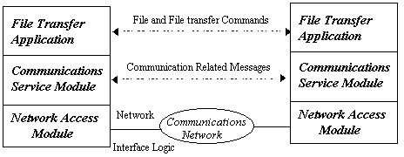
Figure 1.6 A simplified architecture for file transfer
It is clear that there must be a high degree of cooperation between the two computers. Instead of implementing the logic for this as a single module, the task is broken up into subtasks, each of which is implemented separately. As an example, Figure 1.6 suggests the way in which a file transfer facility could be implemented. Three modules are used. Tasks 3 and 4 in the preceding list could be performed by a file transfer module. The two modules on the two systems exchange files and commands. However, rather than requiring the file transfer module to handle the details of actually transferring data and commands, the file transfer modules each rely on a communications service module. This module is responsible for making sure that the file transfer commands and data are reliably exchanged between systems. Among other things, this module would perform task 2. Now, the nature of the exchange between systems should be independent of the nature of the network that interconnects them. Therefore, rather than building details of the network interface into the communications service module, it makes sense to have a third module, a network access module that performs task 1 by interacting with the network.
The file transfer module contains all of the logic that is unique to the file transfer application, such as transmitting passwords, file commands, and file records. There is a need to transmit these files and commands reliably. However, the same sorts of reliability requirements are relevant to a variety of applications (e.g., electronic mail, document transfer). Therefore, these requirements are met by a separate communications service module that can be used by a variety of applications. The communications service module is concerned with assuring that the two computer systems are active and ready for data transfer and for keeping track of the data that are being exchanged to assure delivery. However, these tasks are independent of the type of network that is being used. Therefore, the logic for actually dealing with the network is separated out into a separate network access module. That way, if the network to be used is changed, only the network access module is affected.
Thus, instead of a single module for performing communications, there is a structured set of modules that implements the communications function. That structure is referred to as protocol architecture. Each module in a layer is defined by a protocol and a set of protocols which work together are termed as protocol stack. The terms protocol architecture and protocol stack are used interchangeably.
Two protocol architectures have served as the basis for the development of interoperable communications standards: the TCP/IP protocol suite and the OSI reference model. TCP/IP is the most widely used interoperable architecture, and OSI has become the standard model for classifying communication functions. Hence a brief introduction to both of them is given below.

1.5.1 The OSI Protocol Architecture
The Open System Interconnection (OSI) model includes a set of protocols that attempt to define and standardize the data communications process. The OSI protocols were defined by the International Organization for Standardization (ISO).
The OSI model is not a single definition of how data communications actually takes place in the real world. Numerous protocols may exist at each layer. The OSI model states how the process should be divided and what protocols should be used at each layer. If a network vendor implements one of the protocols at each layer, its network components should work with other vendors' offerings. The OSI model has seven layers.
Application
Presentation
Session
Transport
Network
Data Link
Physical
- The Physical layer provides the electrical and mechanical interface to the network medium (the cable). This layer gives the data-link layer (layer 2) its ability to transport a stream of serial data bits between two communicating systems; it conveys the bits that move along the cable. It is responsible for making sure that the raw bits get from one place to another, no matter what shape they are in, and deals with the mechanical and electrical characteristics of the cable.
- The Data-Link layer handles the physical transfer, framing (the assembly of data into a single unit or block), flow control and error-control functions over a single transmission link; it is responsible for getting the data packaged for the Physical layer. The data link layer provides the network layer (layer 3) reliable information-transfer capabilities. The data-link layer is often subdivided into two parts-Logical Link Control (LLC) and Medium Access Control (MAC)-depending on the implementation.
- The Network layer provides for the transfer of data in the form of packets across the communication networks. It establishes, maintains, and terminates logical and physical connections across multiple interconnected networks. A key aspect of this transfer is the routing of packets from the source to the destination machine typically traversing a number of transmission links and network nodes where routing is carried out. Routing is the process by which a path is selected out of many available paths to the destination so that data packet reaches the destination fast, efficiently, reliably as required. This function makes the network most complex layer in the reference model. Also network layer is responsible for translating logical addresses, or names, into physical (or data-link) addresses. It provides flow-control functions across the computer-network interface.
- The Transport layer ensures data is successfully sent and received between two end nodes. If data is sent incorrectly, this layer has the responsibility to ask for retransmission of the data. Also it ensures data are passed onto the upper layers in the same order in which they were sent. Specifically, it provides a reliable, network-independent message-interchange service to the top three application-oriented layers. This layer acts as an interface between the bottom and top three layers. By providing the session layer (layer 5) with a reliable message transfer service, it hides the detailed operation of the underlying network from the session layer.
- The Session layer decides when to turn communication on and off between two computers. It provides the mechanisms that control the data-exchange process and coordinates the interaction between them. It sets up and clears communication channels between two communicating components. Unlike the network layer (layer 3), it deals with the programs running in each machine to establish conversations between them. Some of the most commonly encountered protocol stacks, including TCP/IP, don't implement a session layer.
- The Presentation layer performs code conversion and data reformatting (syntax translation). It is the translator of the network, making sure the data is in the correct form for the receiving application. Of course, both the sending and receiving applications must be able to use data subscribing to one of the available abstract data syntax forms. Most commonly, applications handle these sorts of data translations themselves rather than handing them off to a Presentation layer.
- The Application layer provides the interface between the software running in a computer and the network. It provides functions to the user's software, including file transfer access and management (FTAM) and electronic mail service.
Unfortunately, protocols in the real world do not conform precisely to these neat definitions. Some network products and architectures combine layers. Others leave layers out. Still others break the layers apart. But no matter how they do it, all working network products achieve the same result - getting data from here to there.

1.5.2 The TCP/IP Protocol Architecture
TCP/IP is a result of protocol research and development conducted on the experimental packet-switched network, ARPANET, funded by the Defense Advanced Research Projects Agency (DARPA) in the U.S, and is generally referred to as the TC/IP protocol suite. This protocol suite consists of a large collection of protocols that have been issued as Internet standards by the Internet Activities Board (IAB).
There is no official TCP/IP protocol model as there is in the case of OSI. However, based on the protocol standards that have been developed, we can organize the communication task for TCP/IP into five relatively independent layers;
- Application layer
- Transport layer (TCP)
- Internet layer (IP)
- Network access layer
- Physical layer
The physical layer covers the physical interface between a data transmission device (e.g., workstation, computer) and a transmission medium or network. This layer is concerned with specifying the characteristics of the transmission medium, the nature of the signals, the data rate, and related matters.
The network access layer is concerned with the exchange of data between an end system and the network to which it is attached. The sending computer must provide the network with the address of the destination computer, so that the network may route the data to the appropriate destination. The specific software used at this layer depends on the type of network to be used; different standards have been developed for circuit-switching, packet-switching (e.g., X.25), local area networks (e.g., Ethernet), and others. Thus, it makes sense to separate those functions having to do with network access into a separate layer. By doing this, the remainder of the communications software, above the network access layer, need not be concerned about the specifics of the network to be used. The same higher-layer software should function properly regardless of the particular network to which the computer is attached.
The network access layer is concerned with access to and routing data across a network for two end systems attached to the same network. In those cases where two devices are attached to different networks, procedures are needed to allow data to traverse multiple interconnected networks. This is the function of the Internet layer. The Internet Protocol (IP) is used at this layer to provide the routing function across multiple networks. This protocol is implemented not only in the end systems but also in routers. A router is a processor that connects two or more networks and whose primary function is to relay data from one network to the other on its route from the source to the destination end system.
Regardless of the nature of the applications that are exchanging data, there is usually a requirement that data be exchanged reliably. That is, we would like to be assured that all of the data arrive at the destination application and that the data arrive in the same order in which they were sent. As we shall see, the mechanisms for providing reliability are essentially independent of the nature of the applications. Thus, it makes sense to collect those mechanisms in a common layer shared by all applications; this is referred to as the transport layer. The Transmission Control Protocol (TCP) is the most commonly used protocol to provide this functionality. This protocol model TCP/IP derived its name from the above two protocols.
Finally, the application layer contains the logic needed to support the various user applications. For each different type of application, such as file transfer, separate module is needed that is peculiar to that application.
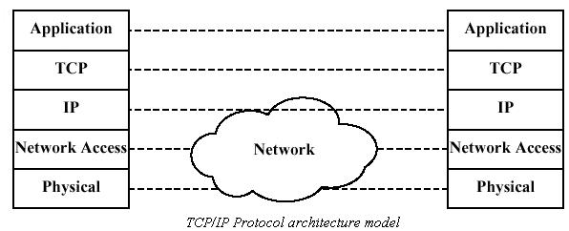
Figure 1.7 TCP/IP Protocol Architecture Model
Figure1.7 shows how the TCP/IP protocols are implemented in end systems. Note that the physical and network access layers provide interaction between the end system and the network, whereas the transport and application layers are what is known as end-to-end protocols; they support interaction between two end systems. The internet layer has the flavor of both. At this layer, the end system communicates routing information to the network but also must provide some common functions between the two end systems.

Exercise
- Discuss the different entities involved in a simple communication network model.
- List the various tasks involved in data communication system and briefly explain them.
- List the categories into which communication networks are classified. List different kind of networks under each category and briefly discuss one network each under a category.
- What is protocol? What are the elements of a protocol?
- Explain the concept of protocol architecture using File transfer application as an example.
- Briefly discuss the OSI and TCP/IP protocol models.

