EXP No: 2
Date: 09-08-05

DIODE CHARACTERISTICS

INTRODUCTION:

The diode is a PN junction diode which is the one of the semiconductor device with two semiconductor materials in physical contact, one with excess of holes (P-type) and other with excess of electrons (N-type).
The most important characteristics of a PN junction is its ability to allow the flow of current in only one direction. In the opposite direction, if offers very high resistance. The diode conducts a small current in the forward direction up to a threshold voltage, 0.3 for germanium and 0.7 for silicon; after that it conducts. In the reverse direction there is a small leakage current up until the reverse breakdown voltage is reached. This leakage is undesirable, obviously the lower the better, and is specified at a voltage less the than breakdown; diodes are intended to operate below their breakdown voltage.
The N-type material acquires an excess of positive charge near the junction and the P-type material acquires an excess of negative charge. Eventually diffuse charges build up and an electric field is created which drives the minority charges and eventually equilibrium is reached. A region develops at the junction called the depletion region. This region is essentially un-doped or just intrinsic silicon

PROBLEM DEFINITION:

- To plot the forward biased characteristic of Si and Ge.
- To plot the reverse biased characteristic of Zener diode and Ge.
- To find the cut in voltage of Ge and Si from forward bias characteristics.
- To find the breakdown voltage of Zener diode from the reverse bias
characteristics.
- To find the dynamic and static resistance of Si, Ge diodes.

THEORETICAL BACKGROUND:

A P type semiconductor and a N type semiconductor are electrically neutral when they are kept apart. When joined together it leads to the formation of a junction diode, which leads to the flow of current only in one direction. This current is due to the flow of majority carriers (holes or electrons) from P region to N region & vice versa. The neutrality thus ended, leads to the formation of a potential barrier across the junction (barrier potential). This barrier potential is approximately 0.65V for silicon and 0.35V for germanium. A region devoid of majority carriers is created which is called the depletion region. Its depth is about 1picom.
The lead connected to the P type semiconductor is the anode & to the N type is the cathode.

Forward bias:
A set up in which the anode of the diode is connected to the positive terminal of the battery and cathode to the negative terminal of the battery is said to be forward biased. Current passes through the diode only when the battery potential exceeds the barrier potential. Once this is achieved high current flows in the order of mA due to the drift of holes and electrons.

Reverse bias:
If the positive terminal of the battery is connected to the N type semiconductor and negative terminal to the P type semiconductor, the diode is said to be reverse biased. In this connection the majority carriers are attracted to the battery leading to a widening of the depletion region. The minority carriers move to the junction as result of this and cause a minute current to flow through it. In silicon it is of the order of nA, germanium in microA, zener it is mA.

Static and Dynamic resistance of the diode:
In a forward biased diode the circuit offers a definite resistance. The static resistance is the ratio of DC voltage across the diode to the Dc current flow through it. Dynamic resistance of the diode at any point is the reciprocal of the slope of the tangent of the characteristic curve at that point.
i.e.; Dynamic resistance= change in voltage =dV
Resulting change in current dI

PROCEDURE:

- Identify the anode and cathode terminal of the Si diode using multimeter. Setup the circuit on the board as shown in the circuit diagram.
- Switch on the power supply and vary the voltage from 0 to 0.7V in step of 0.1V. Note the corresponding readings of the voltmeter and ammeter in the tabular column for forward bias characteristics.
- Now plot the forward bias characteristics.
- Repeat the steps 2 and 3 for Ge diode.
- Using Zener diode setup the circuit on the bread board as shown in the circuit diagram.
- Vary the voltage from 0 to 10V and note the corresponding voltmeter and ammeter reading and plot its reverse characteristics graph.
- To measure forward static resistance, consider the point and the forward characteristics and note the corresponding voltage to current is the static resistance. Repeat the same for reverse characteristics.
- To measure dynamic forward resistance, for a particular DC current, find out the reciprocal of the slope at the point corresponding to that current.

COMPONENTS REQUIRED:

Components  Required | Specification | Quantity
Diodes  Resistor  Ammeters  Voltmeters  DC power supply  Bread board | Si- 1N4007  Ge- 0A79  Zener- Sz 5.6  1000ohm  0-100mA  0-0.1mA  0-1V  0-30V  0-30V,3A,variable  --- | 1  1  1  1  1  1  1  1  1  1

CIRCUITS:

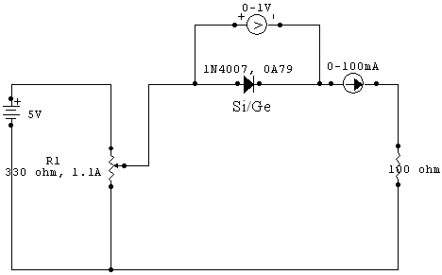

FORWARD BIAS CIRCUIT

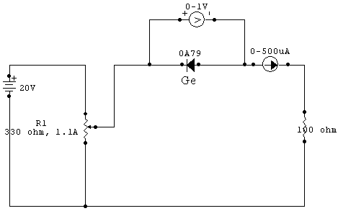

REVERSE BIAS CIRCUIT

ZENER REVERSE BIAS CIRCUIT

OBSERVATION TABLE:
Forward characteristics:
Silicon Germanium

V(v) | I(mA) | V(v) | I(mA)
0.00 | 0.0 | 0.1 | 0
0.20 | 0.0 | 0.2 | 0
0.40 | 0.0 | 0.3 | 0
0.50 | 0.0 | 0.4 | 2
0.60 | 2.5 | 0.5 | 5
0.62 | 4.0 | 0.6 | 10
0.64 | 6.0 | 0.7 | 15
0.66 | 8.0 | 0.8 | 23
0.68 | 14.0 | 0.9 | 31
0.70 | 20.0 | 1.0 | 45
0.72 | 32.0 | 1.2 | 90

Reverse characteristics:

Germanium Zener diode

V(v) | I(microA) | V(v) | I(mA)
0 | 0 | 0 | 0
0.1 | 20 | 2 | 0
0.2 | 40 | 4 | 0
0.3 | 60 | 6 | 0
0.4 | 90 | 6.3 | 3
0.53 | 100 | 6.6 | 10
0.64 | 120 | 6.8 | 30
 |  | 6.8 | 40

GRAPHS:

FORWARD BIAS CHARACTERISTICS OF Si DIODE

FORWARD BIAS CHARACTERISTICS Ge DIODE

REVERSE BIAS CHARACTERISTICS OF Ge DIODE

REVERSE BIAS CHARACTERICTS OF ZENER DIODE

CALCULATIONS:

Forward static resistance of Si = . 0.6 . = 240 ohm
2.5*10⁻³
Forward static resistance of Ge = . 0.5 . = 100 ohm
5*10⁻³
Reverse static resistance of Ge = . 0.1 . = 5000 ohm
20*10⁻⁶
Forward dynamic resistance of Si = 0.64-0.62 = 10 ohm
(6-4)*10⁻³
Forward dynamic resistance of Ge = . 0.7-0.6 . = 20 ohm
(15-10)*10⁻³

RESULT:

Forward static resistance of Si = 240 ohm
Forward static resistance of Ge = 100 ohm
Cut in voltage of Si = 5.8V
Cut in voltage of Ge = 3.5V
Break down voltage of Ze = 6.8V
Forward dynamic resistance of Si = 10 ohm
Forward dynamic resistance of Ge = 20 ohm

CONCLUTION:

An ideal PN junction diode is a two terminal polarity sensitive device that has zero resistance (diode conducts) when it is forward biased and infinite resistance when reverse biased. Due to these characteristics the diode finds number of application as given below
1) Rectifiers in d.c power supplies
2) Switch in digital logic circuits used in computers
3) Clamping network used as d.c restorer in TV receivers and voltage multipliers
4) Clipping circuits used as wave shaping circuits used in computers, radars, radio and
TV receivers
5) Demodulation (detector) circuits.
Another application of diode is to pass the higher of two voltages without affecting the lower. A good example is battery backup, a method of keeping s device running (for instance a precision electronic clock) in case of power failure.

Expt.No: 3
Date: 16/08/05

HALF WAVE RECTIFIER

INTRODUCTION:

The rectifier is a circuit which converts the sinusoidal ac voltage into a pulsating dc voltage. The rectifier is basically a diode circuit having 1,2,4 diodes depending on whether it is a half wave rectifier , full wave rectifier(center tapped) or a full wave rectifier(bridge). The basic principle used is that a PN diode conducts electricity when it is forward biased and practically does not conduct electricity when reverse biased. The output voltage from the rectifier is pulsating i.e. it contains an unwanted ac component and a dc component. In order to remove we required a filter circuit. Filters are typically constructed from elements such as capacitor and/or inductor and resistor. Here we setup a half wave rectifier using diode and to plot the input and output waveforms.

PROBLEM DEFINITION:

To design a half wave rectifier using diode 1N4007.

THEORETICAL BACKGROUND:

The half wave rectifier is a circuit, which converts an ac voltage to dc voltage. In the half wave rectifier circuit serves two purposes, it can be used to obtain the desired level of ac voltage or step up or step down the voltage.

The primary of the transformer is connected to the supply. During the positive half cycle of the input voltage the polarity of the voltage across the secondary forward biases the diode. As a result a current flows through the load resistor. The forward biased diode offers a very low resistance to the flow of current through it. The voltage appearing across the load is the same as the input voltage.
During the negative half cycle of the input voltage. The polarity of the secondary gets reversed and the diode is forward biased. Hence there is no output across the load resistor. All output voltage appears across the diode itself.
When the input is going through its positive half cycle, output voltage is almost the same as the input voltage and during the negative half cycle no voltage is available across the load. This explains the unidirectional pulsating dc waveform obtained as the output. The process of removing one half the input signal to establish a dc level is aptly called half wave rectification.

1. Without filter
Ripple factor, r = ((Vrms)² – 1)^{1/2}
Vdi
Where
Vrms = Vm
2
Vdc = Vm
Π

2. With filter

Ripple factor, r = 1
2√3fR_{L}C

Obtained ripple factor r = Vr-rms
Vdc
Where
Vr-rms = Vrp-p
2√3
Vdc = Vm – Vrp-p
2

PROCEDURE:

- The components are tested using multimeter.
- Circuit is setup as per the diagram.
- Output waveforms were plotted after observing them in the CRO.
- Measure Vm from CRO, Vdc and Idc from the voltmeter and ammeter.
- Calculate the ripple factor using the formulae.

COMPONENTS REQUIRED:

Components/Equipments | Specification | Quantity
Transformer | 6-0-6,230/6V | 1
Resistor | 1KΩ | 1
Diode | 1N4007 | 1
Capacitor | 470µF | 1
Voltmeter | 0-10V | 1
Ammeter | 0-100mA | 1
CRO | 25MHz | 1
Bread board |  | 1
Multimeter | Digital | 1
Connecting wires |  | Lump sum

CIRCUIT DIAGRAM:

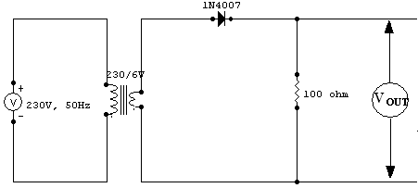
Half Wave Rectifier

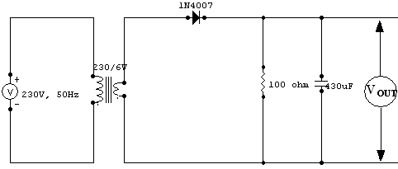

Half Wave Rectifier with capacitor

GRAPHS:

Input Waveform

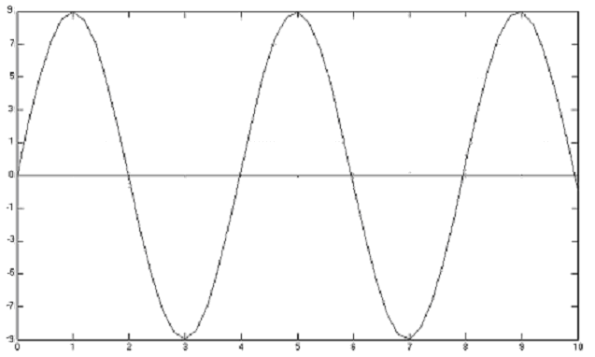

Output without filter

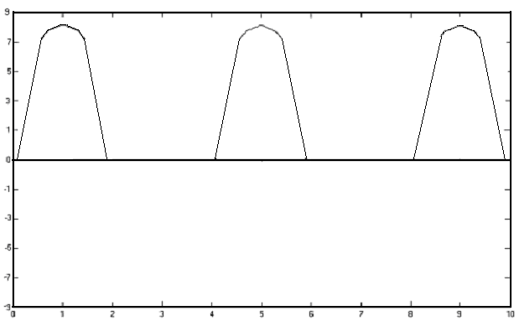

Output with filter

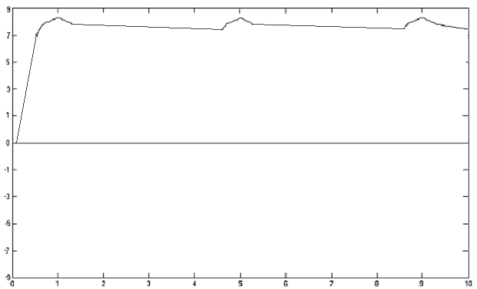

CALCULATIONS:

1) Half wave rectifier:
- Without filter
Vm = 1.8*5 = 9V
Vrms = Vm = 4.5V
2
Vdc = Vm = 9 = 2.86V
- π
r = √[ (4.5)² – 1 ]
(2.86)

b) With filter:
Vrpp = .6*.5 = 0.3V
Vr-rms = 0.3 = 0.086V
2*√3
Vdc = Vm – Vrpp = 9 – 0.3 = 8.85V
- 2
r = 0.086 = 9.71*10⁻³
8.85

RESULTS:

- The ripple factor of the Half Wave Rectifier without filter is 1.53.
2. The ripple factor of the Half Wave Rectifier with filter is 0.010.

CONCLUSION:

The outputs of the half wave rectifier was successfully plotted and their ripple factors calculated

Expt no: 4
Date: 16/08/05
FULL WAVE RECTIFIERS

INTRODUCTION:

The rectifier is a circuit which converts the sinusoidal ac voltage into a pulsating dc voltage. The rectifier is basically a diode circuit having 1,2,4 diodes depending on whether it is a half wave rectifier , full wave rectifier(center tapped) or a full wave rectifier(bridge). The basic principle used is that a PN diode conducts electricity when it is forward biased and practically does not conduct electricity when reverse biased. The output voltage from the rectifier is pulsating i.e. it contains an unwanted ac component and a dc component. In order to remove we required a filter circuit. Filters are typically constructed from elements such as capacitor and/or inductor and resistor. Here we setup a half wave rectifier using diode and to plot the input and output waveforms.

PROBLEM DEFINITION:

To design a full wave and bridge rectifier using diode 1N4007.
- Full wave rectifier.
- Full wave rectifier with capacitor filter.
- Bridge Rectifier.
- Bridge rectifier with capacitor filter.

THEORITICAL BACKGROUND:

A full wave rectifier consists of a transformer with center-tapped secondary, two PN junction diodes, a load resistor. The center tap of the transformer is grounded along with one end of the output. One diode is connected to each secondary terminal.
During the positive half cycle of the input ac signal, the diode D1 is forward biased. It conducts. The current flows through the load resistor and to the midpoint of the transformer with one point positive with respect to the other point, which is at negative or at ground potential. DC voltage is developed across the load resistor. During this interval, the diode D2 is reverse biased. It remains off. No current flows through the diode D2. The rectified or the output current flows through the load for a duration of 180 deg. DC voltage is not constant. It has a shape similar to that of the input positive or negative half cycle ie it is pulsating. The average value of the output is greater than that of the half wave rectifier.
Vdc = 2*Vmax = Idc*R_{L}
π
The current flowing through the load is also pulsating. To obtain smooth d.c output voltage, filters are to be connected across the output.
During the negative half cycle, the diode D1 is reverse biased and D2 is forward biasd. D2 conducts (D1 remains off) and the current Idc flows through the load resistor in the same direction. Hence during all this time the ground remains negative. The current flows for another duration of π radians.
In a full wave rectifier the load current is flowing for the full input signal cycle.(360 deg of input ). But current reduces to zero at regular intervals of 180 deg, because the input ac voltage is also going to zero value at these intervals of 180 deg.

- Without Filter:
Ripple factor r = √( (Vrms)²- 1 )
(Vdc)

Vrms = Vm
√2
Vdc = 2Vm
Π
- With Filter:
Expected Ripple factor, r = 1
4√3R_{L}fc
Vr-rms = Vrp-p
2√3
Vdc = Vm – Vrp-p
2
Obtained ripple factor, r = Vr-rms
Vdc

PROCEDURE:

- Components are tested using the multimeter.
- The circuit are setup on the board.
- Output waveforms were plotted after observing them in the CRO.
- Measure Vm from CRO, Vdc and Idc from the voltmeter and ammeter.
- Calculate the ripple factor using the formulae.

COMPONENTS REQUIRED:

Components/Equipments | Specification | Quantity
Transformer | 6-0-6,230/6V | 1
Resistor | 1KΩ | 1
Diode | 1N4007 | 1
Capacitor | 470µF | 1
Voltmeter | 0-10V | 1
Ammeter | 0-100mA | 1
CRO | 25MHz | 1
Bread board |  | 1
Multimeter | Digital | 1
Connecting wires |  | Lump sum

CIRCUIT DIAGRAM:

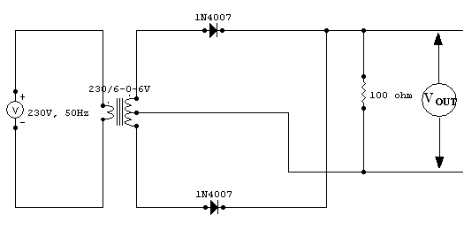

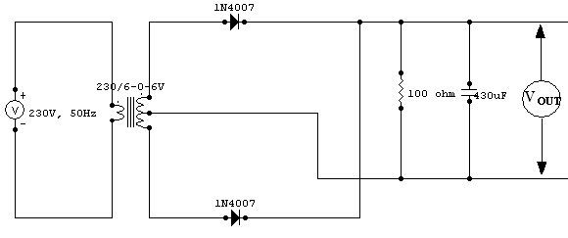
Full Wave Rectifier

Full Wave Rectifier With Capacitor

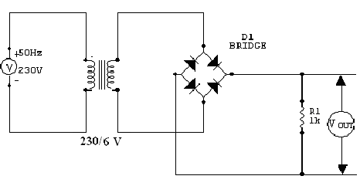

Full Wave Bridge Rectifier

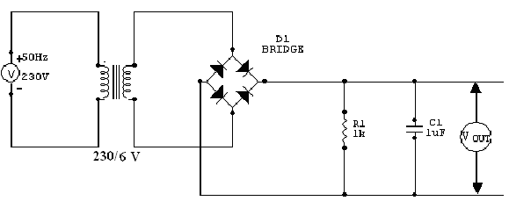

Full Wave Bridge Rectifier With Capacitor

GRAPHS:

Input waveform

Fullwave rectifier

Output without filter

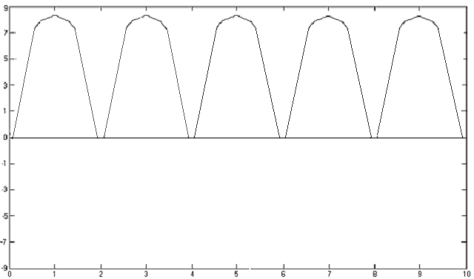

Output with filter

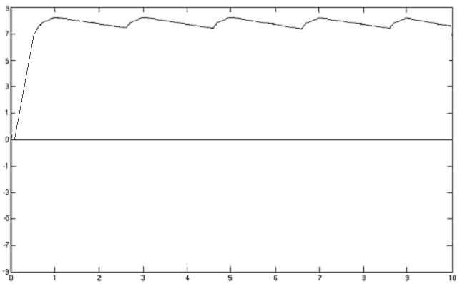

Bridge Rectifier

Output without filter

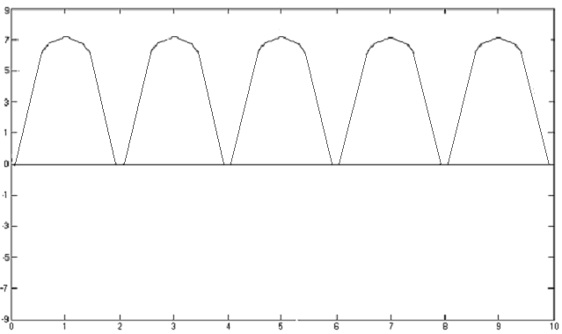

Output with filter
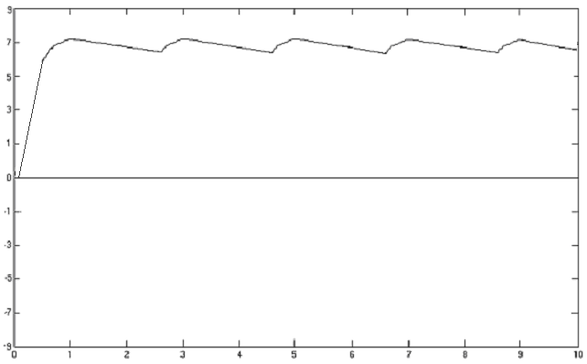

CALCULATIONS:

1) Full Wave rectifier

a) Without Filter:
Vm = 1.8*5 = 9V
Vrms = 9 = 6.36V
√2
Vdc = 2*9 = 5.732
π
Ripple factor, r = √(Vrms)² – 1 = 0.481
Vdc

- With Filter:
Vrpp = 1.6*.1 = 0.16V
Vr-rms = 0.16 = 0.046V
2√3
Vdc = 9 - .16 = 8.92V
2
Ripple factor, r = 0.046 = 5.15*10⁻³
8.92

- Bridge wave rectifier:
  - Without filter:
Vm = 18V
Vms = 18 = 12.72V
√2
Vdc = 2*18 = 11.46V
π
Ripple factor, r = √(12.72)² – 1 = 0.481V
(11.46)

  - With Filter:
Vrpp = 1.2*5 = 0.6V
Vr-rms = 0.6 = 0.1732
2√3
Vdc = 9 – 0.6 = 8.97V
2
Ripple factor, r = 0.1732 =0.019
8.97

RESULT:

- The ripple factor of the full wave and bridge wave rectifier, without filter = 0.481
- The ripple factor of the full wave and bridge wave rectifier, with filter = 5.15*10⁻³

CONCLUSION:

The outputs of the full wave and bridge rectifiers were successfully plotted and their ripple factors calculated.

Expt no: 5
Date: 22/09/05
CLIPPING CIRCUITS

INTRODUCTION:

Clipping circuits are used to select for transmission that part of an arbitrary waveform lies above or below some reference level. They are also referred to as voltage limiters, amplitude selectors or slicer.
A clipping circuit consists of basically non-linear or linear devices. The non-linear devices generally used are diodes and transistors. They can therefore also be classified as Diode Clippers and Transistor Clippers. The diode clippers are classified as Series and Shunt clippers. If the diode is connected in series with input in a clipper then it is a Series Clipper. IF the diode is in parallel with the input, that clipper is a Shunt Clipper

PROBLEM DEFINITION:

To setup the clipping circuits using diode and to plot output wave for a sine wave input.

THEORETICAL BACKGROUND:

The clipping circuits employ the components like diode, resistor and dc battery. The diodes are assumed to be ideal. In practice, the resistors is used to limit the current flowing through the diode when it is forward biased. There are four general categories of clippers 1) positive clipper 2) negative clipper 3) biased clipper 4) combination clipper

1) Positive clipper: In the series positive clipper, when the input voltage is positive, the diode does not conduct and acts an open circuit and hence the positive half cycle does not appear at the output, that is the positive half cycle is clipped off. When the input cycle is negative, the diode conducts and acts as a closed switch (short circuit), the negative half cycle appears at the output. In the stunt positive clipper, when the input voltage is positive, the diode conducts and acts as a short-circuit and hence there is zero signal at the output, i.e. the positive half cycle is clipped off. When the input signal is negative, the diode does not conduct and acts as an open switch, the negative half cycle appears at the output. It is evident that positive clippers introduce as half wave rectifier. Thus the positive clipper has clipped the positive half cycle completely and allowed to pass the negative half cycle of the input signal.

2)Negative clipper: In a negative clipper, the diode is connected in a direction opposite to that of a positive clipper. In the series negative clipper, during the positive half cycle of the input signal, the diode conducts and acts as a short-circuit and hence, the positive half cycle of the input signal will appear at the output. During the negative half cycle of the input signal, the diode does not conduct and acts as an open circuit. The negative half cycle will not appear at the output, i.e the negative half cycle is clipped off. It is evident that the negative clipper of both series and shunt types work as half wave rectifier. Thus, the negative clipper has clipped the negative half cycle completely and allowed to pass the positive half cycle of the input signal.

PROCEDURE:

- Setup the circuit as shown in the figure.
- Setup the function generator in the sine wave mode and fix the amplitude. Connecting directly with one channel of CRO.
- Using another prob connect the sine generator output to the output of the circuit.
- Observe the clipping wave form on the CRO by connecting the output of the circuit to the another channel of CRO so as to see the input as well as output of the circuit simultaneously.

COMPONENTS REQUIRED:

Components/Equipments | Specification | Quantity
Resistor | 1KΩ | 1
Diode | 1N4007 | 1
CRO | 20MHz | 1
Bread board |  | 1
Function generator | 1MHz | 1
Connecting wires |  | Lump sum
DC Power source |  | 1

CIRCUIT DIAGRAM:

Positive Clipping

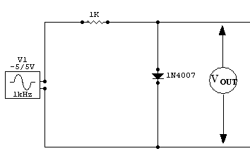

Biased positive clipping
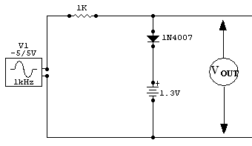

Negative clipping

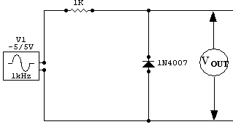

Biased Negative clipping

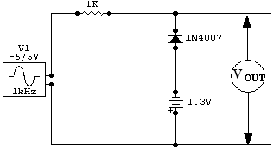

Combinational Clipping

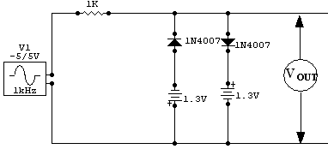

INPUT AND OUTPUT GRAPH:

Input waveform:

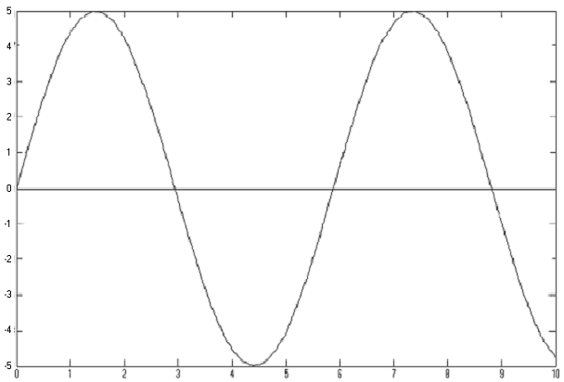
Output waveforms:

Clipping:

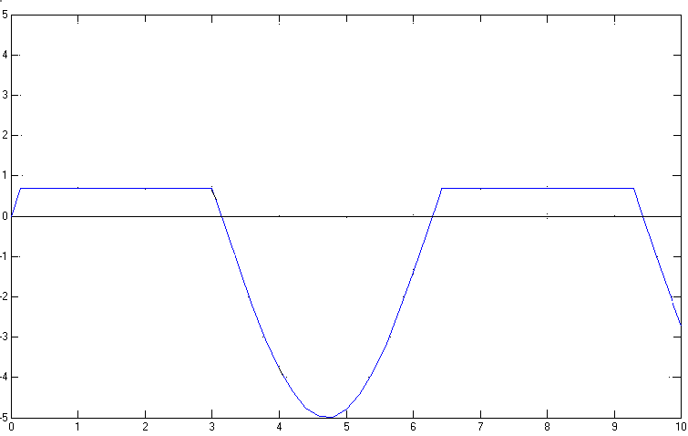
Positive Clipping at 0V

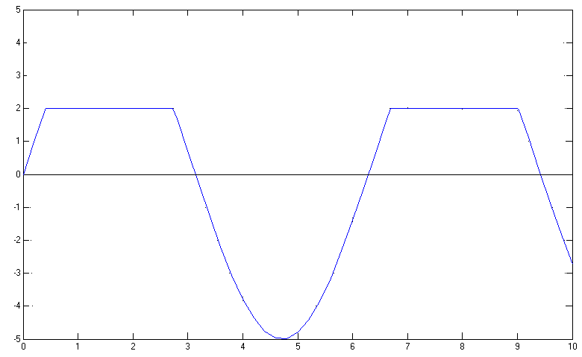
Positive Clipping at 2V

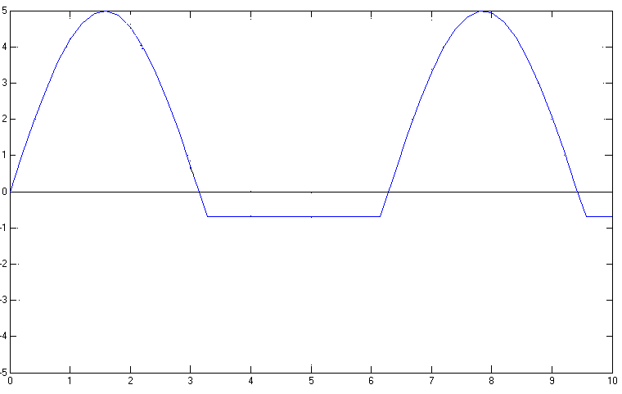
Negative Clipping at 0V

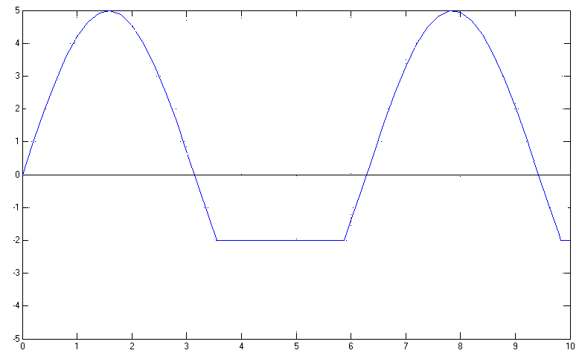
Negative Clipping at 2V

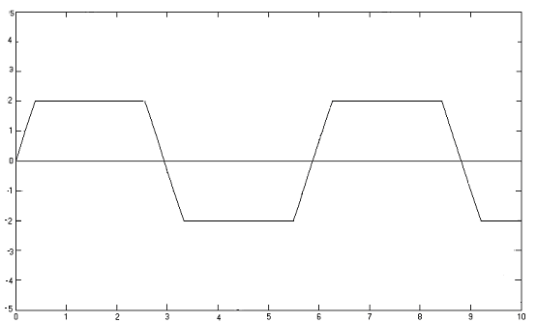
Trapezoidal Clipping

RESULT:

- The experiment was successfully done. Various waveforms have been tested and the output waveforms are observed in CRO. The levels of clipping is for normal and biased clipping respectively.
- The various clamping circuits were designed and setup using 1N4001 diode and the corresponding waveforms were plotted

CONCLUSION:

The circuits to perform clipping and clamping were successfully designed and tested. The output waveforms of the clipping circuits were successfully plotted and its output obtained. The output waveforms of the clamping circuits were successfully plotted and their output obtained.

Expt no: 6
Date: 22/08/05
CLAMPING CIRCUITS

INTRODUCTION:

We have seen that limiters prevent a waveform from rising above or falling below a pre-determined voltage by cutting off part of the waveform. However in radar there is also a need to change the reference level of a waveform without reducing its amplitude. Circuits which move waveforms 'up' or 'down' in this way are known as clamping circuits because their effect is to fix or clamp the top or bottom level of the waveform to a required voltage.
A clamping circuit clamps restrains either the upper or lower extremity of a waveform to a fixed dc potential. This circuit is also known as a direct current restorer or a base line stabilizer. Such circuits are used in test equipment, radar systems, electronic countermeasure systems, and sonar systems. Depending upon the equipment, you could find negative or positive clampers with or without bias.

PROBLEM DEFINITION:

To setup the clamping circuits using diode and to plot output wave for a sine wave input.

THEORETICAL BACKGROUND:

The circuit that places either the positive or negative peak of the signal at desired DC level is known as a clamping circuit. The circuit essential adds a dc component to the signal. It may be seen that the shape of the original signal has not change; only there is vertical shift in the signal. Such clamper is called a Positive Clamper. The negative clamper does the reverse i.e it pushes the signal downwards so that the positive peaks fall on the zero level.

Positive Clamper:
The positive clamper is shown in the circuit diagram. During the negative half cycle at the input signal, the diode conducts and acts like a short circuit. The output voltage Vo = 0 V . The capacitor is charged to the peak value of the input voltage Vm and it behaves like a battery. During the positive half of th input signal, the diode does not conduct and acts like an open circuit. Hence the output voltage Vo = Vm + Vm. This gives a positively clamped voltage.

Negative Clamper:
During the positive half cycle the diode conducts and acts like a short circuit. The capacitor charges to the peak value of the input voltage Vm. During this interval the output Vo which is taken across the short circuit will be zero. During the negative half cycle, the diode is open. The output voltage can be found by applying KVL
– Vm – Vm - Vo = 0.
Vo = -2Vm.

PROCEDURE:

- Setup the circuit after testing the components.
- 2) Set the amplitude of the input sine wave. If the input sine wave has any dc level, nullify it by tuning the offset knob of the function generator.
- Observe the input and output on the CRO screen simultaneously keeping AC-DC switch on CRO in dc position.

COMPONENTS REQUIRED:

Components/Equipments | Specification | Quantity
Resistor | 1KΩ | 1
Diode | 1N4007 | 1
CRO | 20MHz | 1
Bread board |  | 1
Function generator | 1MHz | 1
Connecting wires |  | Lump sum
DC Power source |  | 1

CIRCUIT DIAGRAM:

Positive clamping at 0V

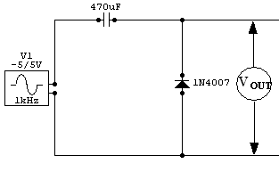

Positive clamping at -2V
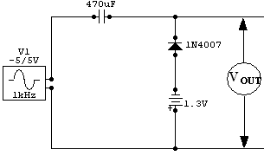
Positive clamping at +2V
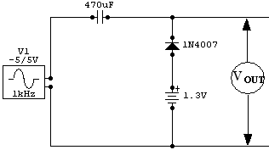

Negative clamping at 0V
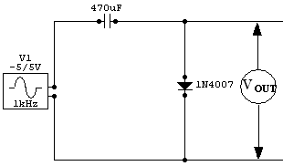

Negative clamping at -2V
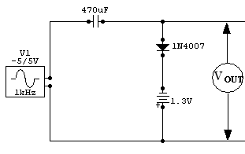

Negative clamping at +2V

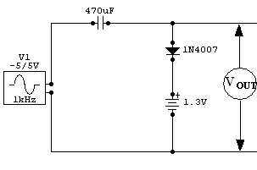

INPUT AND OUTPUT GRAPH:

Input wave form
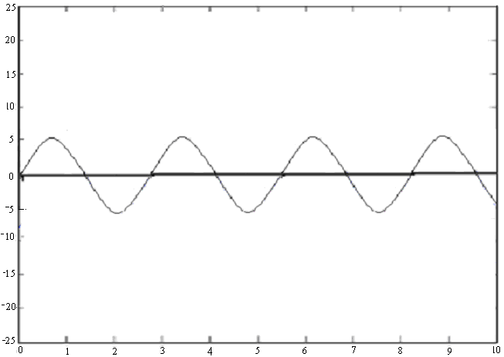

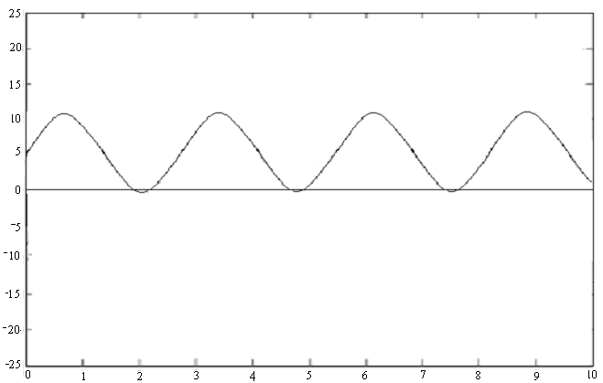
Positive Clamping at 0V

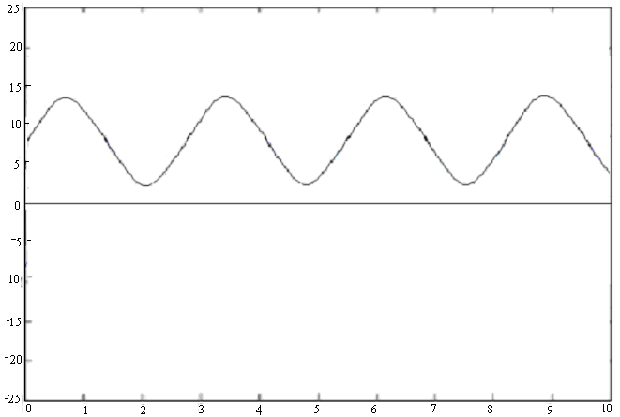

Positive Clamping at +2V
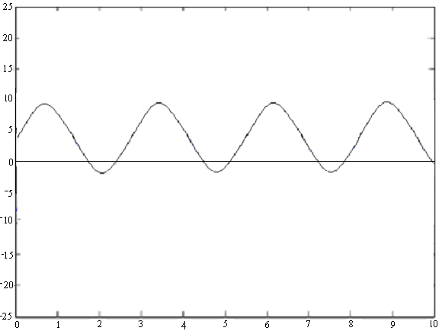
Positive Clamping at -2
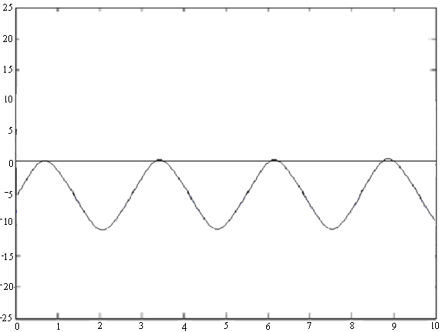
Negative Clamping at 0V
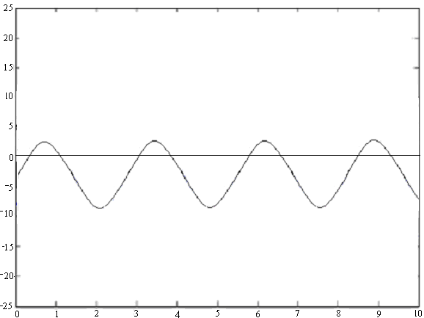
Negative Clamping at +2V

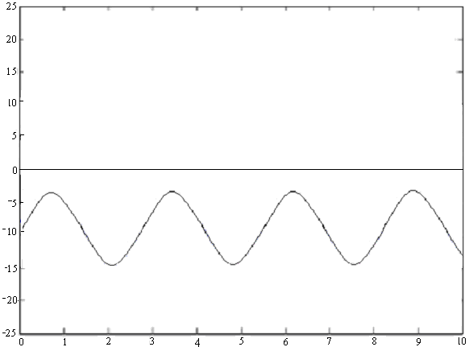
Negative Clamping at -2V

RESULT:

- The experiment was successfully done. Various waveforms have been tested and the output waveforms are observed in CRO. The levels of clipping is for normal and biased clipping respectively.
- The various clamping circuits were designed and setup using 1N4001 diode and the corresponding waveforms were plotted.

CONCLUSION:

The circuits to perform clamping were successfully designed and tested. The output waveforms of the clamping circuits were successfully plotted and their output obtained.

Expt no: 7
Date: 06/09/05
R C DIFFERENTIATOR

INTRODUCTION:

A RC differentiator circuit uses a resistor and capacitor to perform the operation of differentiator. This is made possible by the charging and discharging action of the capacitor. The R and C values have to be selected according to the need. The capacitor charges and discharges linearly according to the formula (e)^{x} , which gives rise to a parabolic path of charging and discharging. This wave when interpreted in the right way can be used in the construction of many specialty circuits.

PROBLEM DEFINITION:

To setup a RC differentiator and study the output waveform for sine, square and triangular inputs. To study the change in time constant taking any one wave as the input.

THEORETICAL BACKGROUND:

An RC circuit with a time constant larger than the time period of the input signal is called an differentiator.
The voltage drop across C will be much larger than that across R. The current through the circuit is C dVin. Hence the output voltage will be Vo = R * C dVin
dt dt

the differentiating circuit is a simple RC series circuit with output taken across the resistor R. The circuit is suitably design so that the out is proportional to the derivative of the input. Thus a dc or constant input is applied to such a circuit, the output will be zero. It is because the derivative of a constant is zero.

PROCEDURE:

- Setup the circuit after testing the components.
- Switch on the function generator and set the square wave output at 20V,1KHz
- Observe the input and output on the two channels of CRO.
- Note down the output waveforms for different conditions like
RC<<t, RC>>t, RC=I by varying the resistance.

DESIGN:

For a good integrator at RC <= 0.0016T
Let T= 1ms
Therefore C=0.001μF
Since RC has to be <=0.0016 T,
R< 1600Ω
Hence we select the value of R as 1.5 kΩ

COMPONENTS REQUIRED:

Components/Equipments | Specification | Quantity
Resistor | 1k ohm | 1
Capacitor | 0.001µF | 1
CRO | 20MHz | 1
Bread board |  | 1
Function generator | 1MHz | 1
Connecting wires |  | Lump sum

CIRCUIT DIAGRAM:

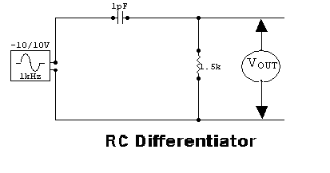

INPUT AND OUTPUT GRAPH:

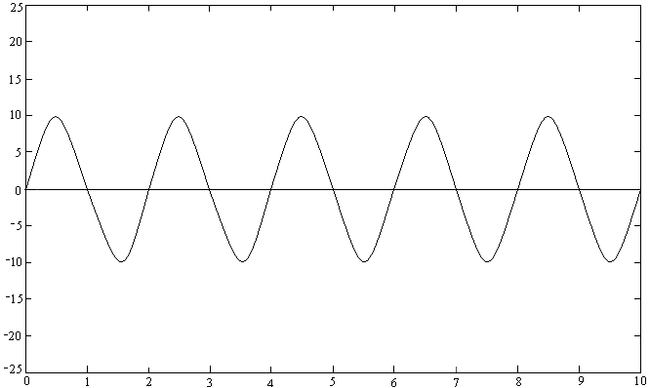
Sine wave input

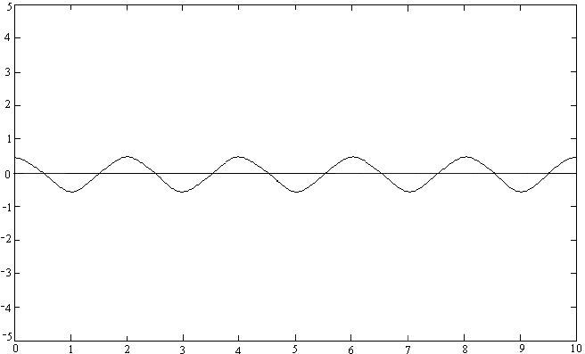
Sine wave output

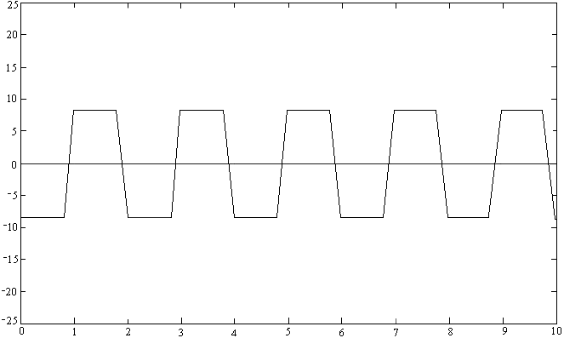
Square wave input

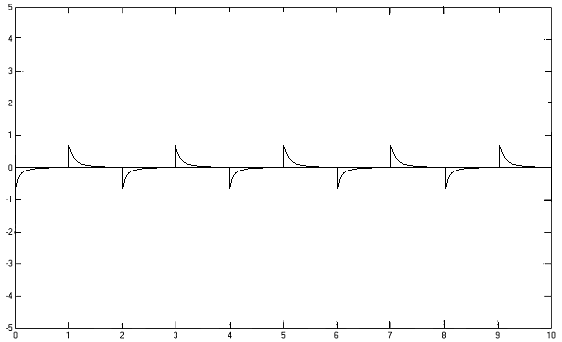
Square wave output

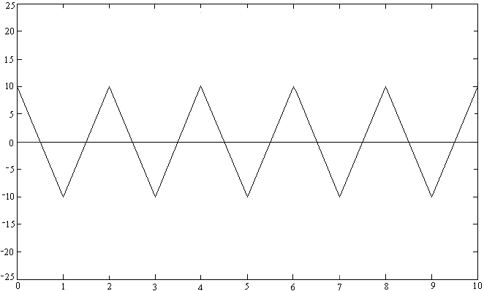
Triangle wave input

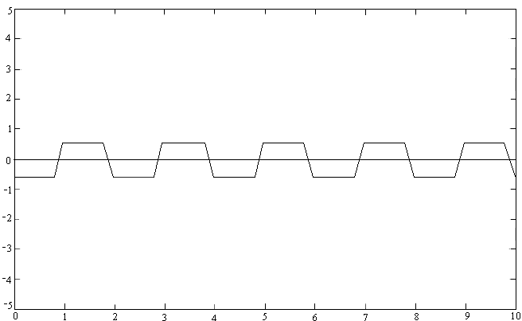
Triangle wave output

RESULT:

Various waveforms were tested for RC=T, RC<<T and the output waveforms were plotted.

CONCLUSION:

Output of the circuit is the differential form of the input. The output for a sine wave input is a cosine wave. The output for a square wave input is a spike wave. The output of the differentiator for a triangular wave input is a square wave.

Expt no: 8
Date: 06/09/05

R C INTEGRATOR

INTRODUCTION:

The RC integrator is typically a series RC circuit that uses the capacitor to develop its output. Since voltage cannot change instantly across a capacitor, because it takes time to charge, the output of an integrator lags the input voltage. Or integrator circuit is used when delaying the standing-up of the square wave signal. Also, in the case having to do with the pulse of the input signal, it uses for the circuit as it changes the output voltage gradually by the occurrence frequency of the pulse, too. The integrator is sometimes referred to as a wave shaper. This is because, although the integrator does not distort sine waves, it greatly distorts non-sinusoidal waveforms such as square waves.

PROBLEM DEFINITION:

To setup a RC integrator and study the output waveform for sine, square and triangular inputs. To study the change in time constant taking any one wave as the input.

THEORETICAL BACKGROUND:

An RC circuit or a circuit which give the output as the integration of input is known as an integrator circuit
output = ∫ input

The voltage drop across C will be much smaller than that across R. Hence output voltage across C will be Vo = 1 ∫ i d t = 1 ∫ Vin dt
C RC
Thus the output is proportional to the integral of the input.

The output is proportional to the integral of the input. Voltage drop across C increases as time passes. For satisfactory integration, it is that RC >=15T , where T is the time period of the input square wave. This is because charging current will not vary much in a resistor and a constant current is supplied to the capacitor.
When a pulse waveform is given at the input, capacitor charges through R and output voltage builds up. Capacitor continues to charge as long as input voltage is present. When input is terminated, capacitor discharges and output falls to zero .As the value of RC increases the amplitude of the output decreases and the output waveform becomes linear. This happens because the charging current does not vary much through a high value resistor.
Constant current through a capacitor gives a linear output.

PROCEDURE:

- Setup the circuit after testing the components.
- Switch on the function generator and set the square wave output at 20V,1KHz
- Observe the input and output on the two channels of CRO.
- Note down the output waveforms for different conditions like
RC<<t, RC>>t, RC=I by varying the resistance.

DESIGN:

For a good integrator at RC >= 16T
Let T= 1ms
Therefore C=0.1μF
Since RC has to be >=16 T,
R>150 kΩ
Hence we select the value of R as 220 kΩ

COMPONENTS REQUIRED:

Components/Equipments | Specification | Quantity
Resistor | 1K | 1
Capacitor | 0.1µF | 1
CRO | 20MHz | 1
Bread board |  | 1
Function generator | 1MHz | 1
Connecting wires |  | Lump sum

CIRCUIT DIAGRAM:

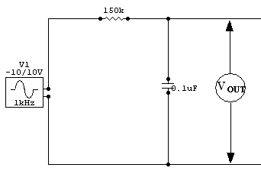
RC Integrator

INPUT AND OUTPUT GRAPH:

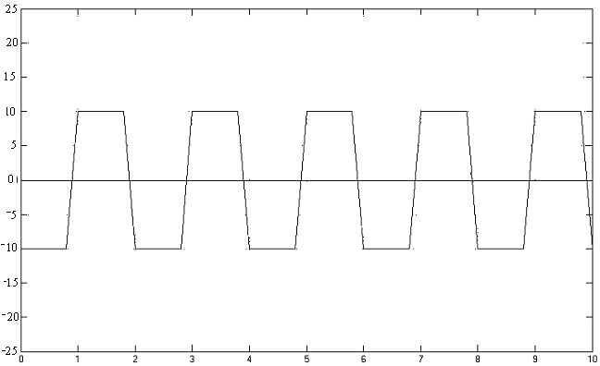
square wave input

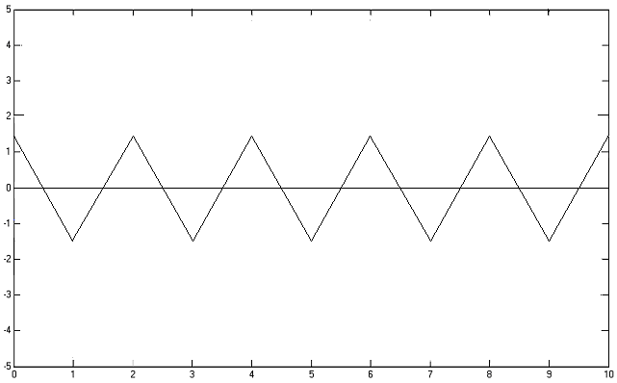
square wave output

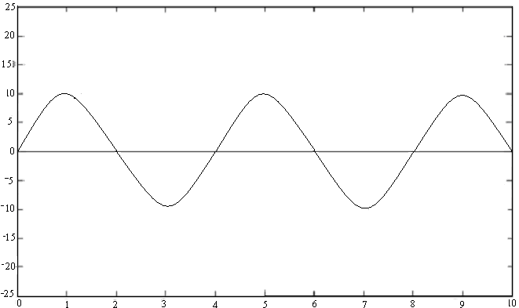
Sine wave input

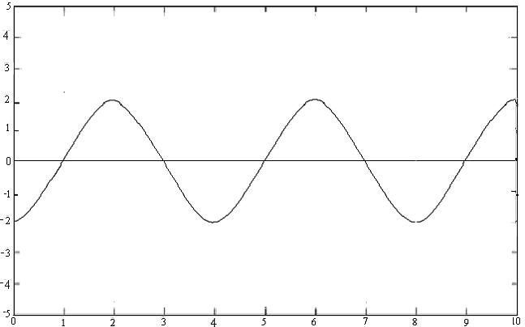
Sine wave output

Triangular wave input

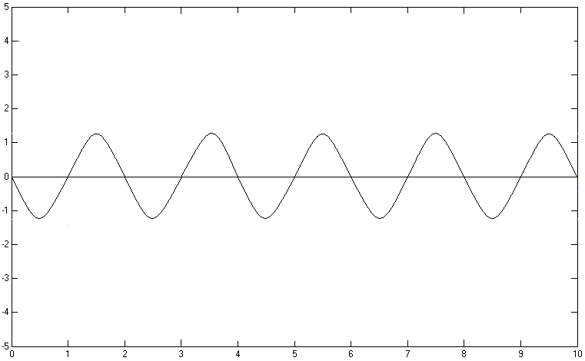
Triangular wave output

RESULT:

Various waveforms were tested for RC=T, RC<<T and the output waveforms were plotted.

CONCLUSION:

The integrator circuit was setup and its response to various input waveforms were observed.
When a square wave form was given as the input the output obtained was triangular waveform
The most important function of an integrator is that it is used as A.M demodulator

Expt no: 9
Date: 15/09/05

COMMON BASE CHARACTERISTICS

INTRODUCTION:

The transistor is a solid state semiconductor device which can be used for amplification, switching, voltage stabilization, signal modulation and many other functions. It acts as a variable valve which, based on its input voltage, controls the current drawn by it from a connected voltage supply. Transistors are divided into two main categories: Bipolar Junction Transistors BJTs and Field Effect Transistors FETs. Transistors have three terminals On the BJT they are named Emitter, Base and Collector. On the FET they are named Source, Gate and Drain. The bipolar junction transistor BJT was the first type of transistor to be commercially mass-produced. Bipolar transistors are so named because the main conduction channel uses both electrons and holes to carry the main electric current. Although commonly described as a current operated device, the collector current is actually controlled by the voltage difference between base and emitter terminals.

PROBLEM DEFINITION:

To study the input and output characteristics of NPN transistor in common base configuration and to plot the characteristics.

THEORETICAL BACKGROUND:

Bipolar transistors, having 2 junctions, are 3 terminal semiconductor devices. The three terminals are emitter, collector, and base.
A basic two-junction semiconductor must necessarily have one type of region sandwiched between two of the other type. To the right is an example of a semiconductor device consisting of a narrow P-type region between two N-type regions. For reasons we will see shortly, the three regions are designated the emitter (E), base (B), and collector (C), respectively. In modern versions of this device, the emitter region is heavily doped with the appropriate impurity, while the base region is very lightly doped. The collector region has a moderate doping level so it will have a low internal resistance.
The semiconductor device with a small forward bias applied to the emitter-base junction, and a larger reverse bias applied to the collector-base junction. these are the normal operating conditions of this device. But a funny thing happens inside the base region. The forward bias on this junction does indeed attract electrons from the emitter into the base, but there the forward momentum of the electrons carries them across most of the base region and into the depletion region around the collector junction. From there, the higher positive collector voltage attracts these electrons across the collector junction and into the collector region.

PROCEDURE:

INPUT CHARACTERISTICS:

  - Identify the leads of the transistor and test it using a multimeter. Setup the
circuit as in the figure
  - Fix V_{CE} to zero volts.
  - Note I_{B} for different values of V_{BE}, varying from 0-1V in steps of .1V. Enter the
values into the table.
  - Repeat the step 3 for different values of V_{CE} .
  - Plot input characteristics with V_{BE} along X-axis and I_{E} along Y-axis.

OUTPUT CHARASTERISTICS:

1. Fix I_{B} at 0mA. Note the values of I_{C} for different values of V_{CE} from 0-10V in
steps of .5V. IC will be almost zero.
- Fix I_{B} at a definite value by adjusting V_{BE}. Note values of I_{C} for different values of V_{E} ranging from 0-10V in steps of .5V.

COMPONENTS REQUIRED:

Components/Equipments | Specification | Quantity
Transistor | BC 547 | 1
Ammeter | 0-100mA | 1
 | 0-100mA | 1
Voltmeter | 0-10V | 1
 | 0-1V | 1
Bread Board |  | 1
DC power supply |  | 1
Rheostat | 330ohm,1.1A | 2

CIRCUIT DIAGRAM:

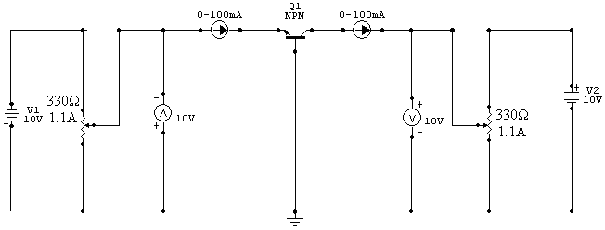

OBSERVATION TABLE:

Input characteristics:

At V_{CB} = 0 V

V_{BE} (V) | I_{E} (mA)
0.1 | 0
0.2 | 0
0.3 | 0
0.4 | 0
0.5 | 0
0.6 | 0
0.7 | 4
0.8 | 9
0.82 | 10
0.86 | 14
0.9 | 18

At V_{CB} = 3 V

V_{BE} (V) | I_{E} (mA)
0.1 | 0
0.2 | 0
0.3 | 0
0.4 | 0
0.5 | 0
0.6 | 0
0.7 | 6
0.8 | 14
0.82 | 20
0.86 | 24
0.9 | 30

At V_{CB} = 5 V

V_{BE} (V) | I_{E} (mA)
0.1 | 0
0.2 | 0
0.3 | 0
0.4 | 0
0.5 | 0
0.6 | 0
0.7 | 6
0.8 | 20
0.82 | 24
0.86 | 30
0.9 | 34

Output characteristics:

At I_{E} = 10 mA

V_{CB} (V) | I_{C} (mA)
0.4 | 8
0.8 | 8
1.2 | 8
1.6 | 8
2.0 | 8
2.4 | 8
2.8 | 8
3.2 | 8

At I_{E} = 20 mA

V_{CB} (V) | I_{C} (mA)
0.4 | 12
0.8 | 12
1.2 | 12
1.6 | 12
2.0 | 12
2.4 | 12
2.8 | 12
3.2 | 12

At I_{E} = 30 mA

V_{CB} (V) | I_{C} (mA)
0.4 | 18
0.8 | 18
1.2 | 18
1.6 | 18
2.0 | 18
2.4 | 18
2.8 | 18
3.2 | 18

INPUT AND OUTPUT GRAPH:

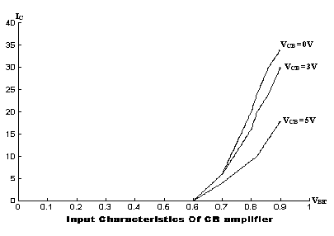

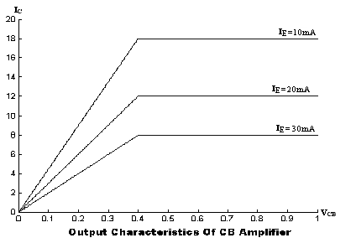

CALCULATIONS:

Ri = d(Vbe)/d(Ie) = (0.9 – 0.7)/(18 – 4)*10⁻³ = 14.28ohm

Ro = d(Vcb)/d(Ic) = (1.6 – 0.4)/(8 – 6)*10⁻³ = 800ohm

α = 18/20 = 0.9

RESULT:

The dynamic input resistance is = 14.28Kohm
The dynamic output resistance is = 800ohm
Alpha = 0.9

CONCLUSION:

    - The common base input characteristics plotted between emitter current IE and emitter
base voltage VBE resembles a PN junction diode which is forward bias. As the
emitter base voltage increases. The curve tends to become more and more vertical.
    - From the common base output characteristics curve plotted between output current IC
and collector base voltage VCB. We can see that the collector current IC is
approximately equal to the emitter current IE. This is only trace in the active region.
    - As the emitter current increases the collector current values correspondingly increases
and the curve remain flat.

Expt no: 10
Date: 15/09/05

COMMON EMITTER CHARACTERISTICS

INTRODUCTION:

The transistor is a solid state semiconductor device which can be used for amplification, switching, voltage stabilization, signal modulation and many other functions. It acts as a variable valve which, based on its input voltage, controls the current drawn by it from a connected voltage supply. Transistors are divided into two main categories: Bipolar Junction Transistors BJTs and Field Effect Transistors FETs. Transistors have three terminals On the BJT they are named Emitter, Base and Collector. On the FET they are named Source, Gate and Drain. The bipolar junction transistor BJT was the first type of transistor to be commercially mass-produced. Bipolar transistors are so named because the main conduction channel uses both electrons and holes to carry the main electric current. Although commonly described as a current operated device, the collector current is actually controlled by the voltage difference between base and emitter terminals.

PROBLEM DEFINITION:

To study the input and output characteristics of NPN transistor in common base configuration and to plot the characteristics.

THEORETICAL BACKGROUND:

On the characteristics th value of Ib is in micro ampere, compared to milli amperes of Ic. Consider also that the curve of Ib are not those obtained for Ie in the common base configuration, indicating that the collector – emitter voltage will influence the magnitude of the collector current. The active region for the common emitter configuration is that portion of the upper right quadrant that has greatest linearity, that is, that region in which the curves for Ib are nearly straight and equally spaced. In this region exists to the right of the vertical line . The left of this line is called saturation region. The cut off region was not properly defined for the CE configuration. Note on the collector that Ic is not equal to zero when Ib is zero. For CB configuration the value of Ic was Ico for low values of Ie.
The input characteristics are similar o that of the common base configuration which resembled the diode characteristics.
In the CE configuration , the emitter is made common to the input and output .The signal is applied between the base and emitter. Whether the transistor works in CB or CE configuration ,it is to be ensured that it works in the active region .It means the emitter base junction is forward biased and the collector base junction is reversed biased . Such biasing is achieved in CE configuration by connecting batteries Vbb and Vcc. Hence npn transistor is used . Emitter base junction is forward biased by Vbb .The net potential of

collector with respect to the base is Vcc-Vbb. The collector base junction is reverse biased by the potential .

PROCEDURE:

Input Characteristic:

- The components are tested and verified
- The circuit is set up as shown in the circuit diagram .
- Fix Vce at 0V
- Note different values of Ib by varying Vbb in the step of 0.1
- These steps are repeated for different values of Vce .

Output Characteristic:

1)The components are tested and verified .
2)The circuit is set up as shown in the circuit diagram
3) Fix the value of Ib at 0mA .
4) The different values of Ic are noted for varying Vce .
The above steps are repeated for different values of Ib .

COMPONENTS REQUIRED:

Components/Equipments | Specification | Quantity
Transistor | BC 547 | 1
Ammeter | 0-100mA | 1
 | 0-100mA | 1
Voltmeter | 0-10V | 1
 | 0-1V | 1
Bread Board |  | 1
DC power supply |  | 1
Rheostat | 330ohm,1.1A | 2

CIRCUIT DIAGRAM:

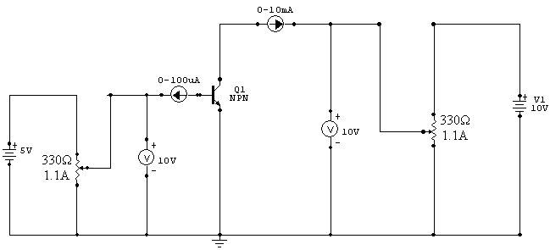

OBSERVATION TABLE:

Input characteristics:

At V_{CE} = 0 V

V_{BE} (V) | I_{B}(μA)
0.1 | 0
0.2 | 0
0.3 | 0
0.4 | 0
0.5 | 4
0.6 | 12
0.7 | 32
0.72 | 37
0.74 | 40
0.76 | 46
0.8 | 58

At V_{CE} = 3 V

V_{BE} (V) | I_{B}(μA)
0.1 | 0
0.2 | 0
0.3 | 0
0.4 | 0
0.5 | 0
0.6 | 4
0.7 | 16
0.72 | 20
0.74 | 23
0.76 | 28
0.78 | 34
0.8 | 40

At V_{CE} = 5 V

V_{BE} (V) | I_{B}(μA)
0.1 | 0
0.2 | 0
0.3 | 0
0.4 | 0
0.5 | 0
0.6 | 3
0.7 | 10
0.72 | 12
0.74 | 14
0.76 | 16
0.78 | 19
0.8 | 23

Output characteristics:

At I_{B} = 10 μA

V_{CE} (V) | I_{C}(μA)
0.4 | 3.3
0.8 | 3.4
1.2 | 3.5
1.6 | 3.6
2.0 | 3.7
2.4 | 3.8
2.8 | 3.9
3.2 | 4.0

At I_{B} = 20 μA

V_{CE} (V) | I_{C}(μA)
0.4 | 5
0.8 | 5.1
1.2 | 5.2
1.6 | 5.3
2.0 | 5.4
2.4 | 5.5
2.8 | 5.6
3.2 | 5.7

At I_{B} = 30 μA

V_{CE} (V) | I_{C}(μA)
0.4 | 9
0.8 | 9.1
1.2 | 9.2
1.6 | 9.3
2.0 | 9.4
2.4 | 9.5
2.8 | 9.6
3.2 | 9.7

INPUT AND OUTPUT GRAPH:

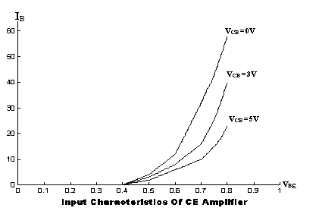

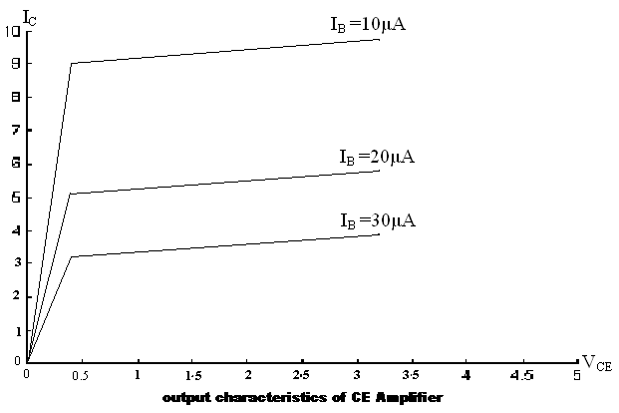

CALCULATIONS:

Ri = d(Vbe)/d(Ib) = (0.8 – 0.72)/(58 – 40)*10⁻⁶ = 4.44Kohm.

Ro = d(Vce)/d(Ic) = (1.2-0)/(3.4-0) * 10³ = 352.9 ohm.

β = (5.5 – 3.2)/(10*10⁻⁶) = 230

RESULT:

The dynamic input resistance is = 4.4Kohm
The dynamic output resistance is = 352.9Kohm
Current gain β = 230

CONCLUSION:

1. The common emitter input characteristics plotted between emitter current Ic and
collector emitter voltage V_{CE} resembles a PN junction diode which is forward bias.
as the collector emitter voltage increases. The curve tends to become more and more
vertical.
- From the common emitter output characteristics curve plotted between output current
IC and collector base voltage V_{CE}. We can see that the collector current Ic is
approximately equal to the emitter current IE. This is only trace in the active region.
- As the base current increases the collector current values correspondingly increases
and the curve remain flat.

