Chapter 2 Data Transmission
2.1 Concepts and Terminology

2.1.1 Time-Domain Concepts
2.1.2 Frequency Domain Concepts
2.2 Why digital communication?
2.3 Bandwidth, Data rate and Channel Capacity
2.3.1 Nyquist sampling rate
2.3.2 Shannon Channel Capacity
2.4 Line Coding
2.5 Modems and Digital Modulation
2.6 Transmission Media
2.6.1 Guided Transmission Media
2.6.2 Wireless (Radio) Transmission
2.7 Multiplexing
2.7.1 Frequency-Division Multiplexing (FDM)
2.7.2 Time Division Multiplexing TDM
2.7.3 Wavelength Division Multiplexing
2.8 Circuit Switching
2.8.1 Space-Division Switches
2.8.2 Time-Division Switches

Successful transmission of data depends principally on two factors: the quality of the signal being transmitted and the characteristics of the transmission medium. The objective of this chapter is to provide the student with an intuitive feeling for the nature of these two factors.

2.1 Concepts and Terminology
In this section we introduce some concepts and terms that will be referred to throughout the rest of the chapter.
Data transmission occurs between transmitter and receiver over some transmission medium. Transmission media may be classified as guided or unguided. In both cases, communication is in the form of electromagnetic waves. With guided media, the waves are guided along a physical path; examples of guided media are twisted pair, coaxial cable, and optical fiber. Unguided media provide a means for transmitting electromagnetic waves but do not guide them: examples are propagation through air, vacuum and seawater.
The term direct link is used to refer to the transmission path between two devices in which signals propagate directly from transmitter to receiver with no intermediate devices, other than amplifiers or repeaters used to increase signal strength. A guided transmission medium is point-to-point if, first, it provides a direct link between two devices and, second, those are the only two devices sharing the medium (Figure 2.1a).

Transmitter /
Receiver

Transmitter /
Receiver
Medium
Amplifier or Repeater
Medium

Figure 2.1a Point-to-Point Transmission Configuration

In a multipoint configuration, more than two devices share the same medium (Figure 2.1b).

Transmitter /
Receiver

Transmitter /
Receiver

Transmitter /
Receiver

Transmitter /
Receiver

Medium
Medium
Amplifier or Repeater

0 or More

Figure 2.1b Multi-Point Transmission Configuration
A transmission may be simplex, half-duplex, or full-duplex. In simplex transmission, signals are transmitted in only one direction; one station is the transmitter and the other is the receiver. In half-duplex operation, both stations may transmit, but only one at a time. In full-duplex operation, both stations may transmit simultaneously. In the latter case, the medium is carrying signals in both directions at the same time.

Frequency, Spectrum and Bandwidth
Here, we are concerned with electromagnetic signals, used as a means to transmit data. The electromagnetic signal is generated by the transmitter and transmitted over a medium. The signal is a function of time, but it can also be expressed as a function of frequency; that is, the signal consists of components of different frequencies. It turns out that the frequency-domain view of a signal is far more important to the understanding of data transmission than the time-domain view. Both views are introduced here.

2.1.1 Time-Domain Concepts
Viewed as a function of time, an electromagnetic signal can be either continuous or discrete. A continuous signal is one in which the signal intensity or signal strength varies in a smooth fashion over time. In other words there are no breaks or discontinuities in the signal. A discrete signal is one in which the signal intensity maintains a constant level for some period of time and then changes to another constant level. Figure2.2 shows of both kinds of signals. The continuous signal might represent speech, and the discrete signal might represent binary 1s and 0s.
Amplitude (Volts)

Time
Figure 2.2a Continuos Signal
Amplitude (Volts)

Time
Figure 2.2b Discrete Signal

Periodic signal
The simplest sort of signal is a periodic signal, in which the same signal pattern repeats over time. Figure 2.3 shows an example of a periodic analog signal (sine wave) and a periodic digital signal (square wave). Mathematically, a signal s(t) is defined to be periodic if and only if
s(t +T) = s(t) for -00 < t < +00
where the constant T is the period of the signal. (T is the smallest value that satisfies the equation.) Otherwise, the signal is aperiodic.
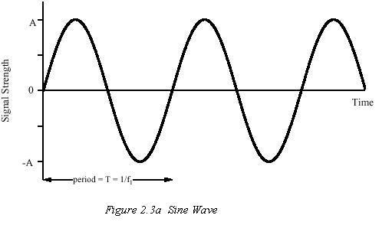
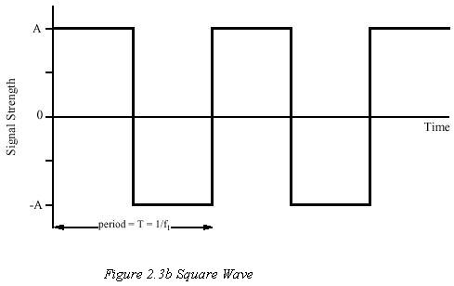
The sine wave is the fundamental continuous signal. A general sine wave can be represented by three parameters: amplitude (A), frequency (f), and phase (ф). The amplitude is the peak value of strength of the signal over time; typically, this value is measured in volts or watts. The frequency is the rate (in cycles per second, or Hertz (Hz)) at which the signal repeats. An equivalent parameter is the period (T) of a signal, which is the amount of time it takes for one repetition; therefore, T = 1/f. Phase is a measure of the relative position in time within a single period of a signal, as illustrated below. The general sine wave can be written as
s(t) = A sin (2 п f t + Ф)
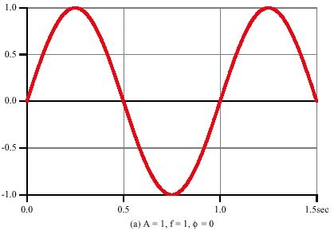
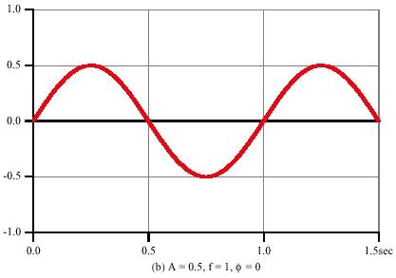
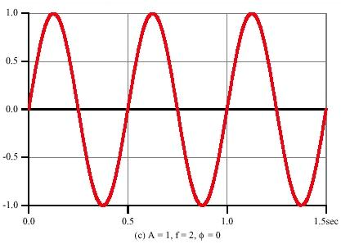
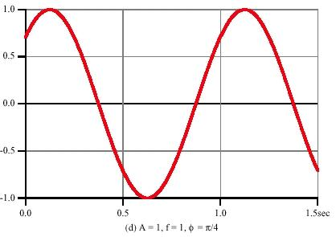
Figure 2.4 A sin (2 пft + Ф )

Figure 2.4 shows the effect of varying each of the three parameters. In part (a) of the figure, the frequency is 1 Hz; thus, the period is T = 1 second. Part (b) has the same frequency and phase but an amplitude of 1/2. In part (c), we have f = 2, which is equivalent to T = ½ seconds. Finally, part (d) shows the effect of a phase shift of п / 4 radians, which is 45 degrees (2 п radians = 360° = 1 period). In Figure 2.4, the horizontal axis is time; the graphs display the value of the signal strength at a given point in space as a function of time.

2.1.2 Frequency Domain Concepts
In practice, an electromagnetic signal will be made up of many frequencies. For example, the signal
s(t) = sin (2 п f₁t) +1/3 sin (2 п (3f₁)t)
is shown in Figure 2.5.
The components of this signal are just sine waves of frequencies f₁ and 3f_{1;} parts (a) and (b) of the figure show these individual components. There are several interesting points that can be made about this figure: the second frequency is an integer multiple of the first frequency. When all of the frequency components of a signal are integer multiples of one frequency, the latter frequency is referred to as the fundamental frequency.
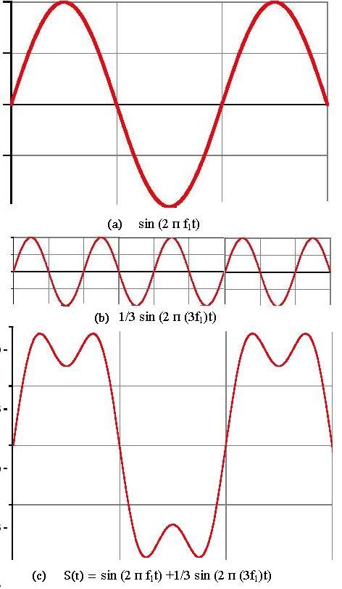
Figure 2.5 Addition of frequency components

The period of the total signal is equal to the period of the fundamental frequency. The period of the fundamental signal sin(2 пf₁ t) is T= 1/ f₁, and the period of s(t) is also T, as can be seen from Figure 2.5c. It can be shown, using a discipline known as Fourier Analysis that any signal is made up of components at various frequencies, in which case each component is sinusoid. This result is of tremendous importance, because the effects of various transmission media on a signal can be expressed in terms of frequencies and the signal can be analysed to great extent.
The Spectrum of a signal is the range of frequencies that it contains. For the signal in Figure 2.5c, the spectrum extends from f₁ to 3f_{1.} The absolute bandwidth of the signal is the width of spectrum; in the above case it would be 3f₁ - f₁ = 2f₁Hz. However most of the energy in an actual signal will be contained in a relatively narrow band of frequencies, which is known as bandwidth.

2.2Why digital communication
A transmission system makes use of a physical transmission media or channel that allows the propagation of electromagnetic energy in the form of pulses or variations in voltage, current, or light intensity. In analog communication the objective is to transmit a signal waveform, which is a function that varies continuously with time, as shown in Figure 2.6a. For example, the electrical signal coming out of a microphone corresponds to the variation in air pressure corresponding to sound. This function of time must be reproduced exactly at the receiver output of the analog communication system. In practice, communications channels do not satisfy this condition, so some degree of distortion is unavoidable.
In digital transmission the objective is to transmit a given symbol that is selected from some finite set of possibilities. For example, in binary digital transmission the objective is to transmit either a 0 or a 1. This can be done, for instance, by transmitting positive voltage for a certain period of time to convey a 1 or a negative voltage to convey a 0, as shown in Figure 2.6b. The task of the receiver is to determine the input symbol with high probability. The positive or negative pulses that were transmitted for the given symbols can undergo a great degree of distortion. Where signaling uses positive or negative voltages, the system will operate correctly as long as the receiver can determine whether the original voltage was positive or negative.
The cost advantages of digital transmission over analog transmission become apparent when transmitting over a long distance. Consider, for example, a system that involves transmission over a pair of copper wires. As the length of the pair of wires increases, the signal at the output is attenuated and the original shape of the signal is increasingly distorted.
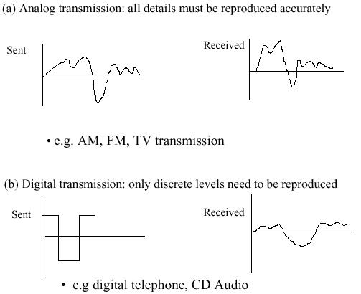
Figure 2.6 Analog versus Digital signal transmission

In addition, interference from extraneous sources, such as radiation from car ignitions and power lines, as well as noise inherent in electronic systems result in the addition of random noise to the transmitted signal. To transmit over long distances, it is necessary to introduce repeaters periodically to regenerate the signal, as shown in Figure 2.7. Such signal regeneration is fundamentally different for analog and digital transmissions.
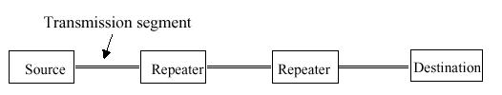
Figure 2.7 Typical long-distance link

Repeater
In an analog communication system, the task of the repeater is to regenerate a signal that resembles as closely as possible the signal at the input of the repeater segment. Figure 2.8 shows the basic functions carried out by the analog repeater.
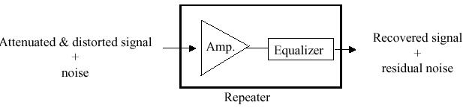
Figure 2.8 Analog repeater
The input to the repeater is an attenuated and distorted version of the original transmitted signal plus the random noise added in the segment. First the repeater deals with the attenuation by amplifying the received signal. To do so the repeater multiplies the signal by a factor that is the reciprocal of the attenuation a. The resulting signal is still distorted by the channel.
The repeater next uses a device called an equalizer in an attempt to eliminate the distortion. The source of the distortion in the signal shape has two primary causes. The first cause is that different frequency components of the signal are attenuated differently. In general, high frequency components are attenuated more than low-frequency components. The equalizer compensates for this situation by amplifying different frequency components by different amounts. The second cause is that different frequency components of a signal are delayed by different amounts as they propagate through the channel. The equalizer attempts to provide differential delays to realign the frequency components. In practice it is very difficult to carry out the two functions of the equalizer. For the sake of argument, suppose that the equalizer is perfect. The output of the repeater then consists of the original signal plus the noise.
In the case of analog signals the repeater is limited in what it can do to deal with noise. If it is known that the original signal does not have components outside a certain frequency band, then the repeater can remove noise components that are outside the signal band. However, the noise within the signal band cannot be reduced and consequently the signal that is finally recovered by repeater will contain some noise. The repeater then proceeds to send the recovered signal over the next transmission segment. By the time signal reaches the destination after going through many repeaters as in the case of long distance transmission its quality degrades considerably as the noises accumulates at each segment.
Next consider the same copper wire transmission system for digital communications. Suppose that a string of 0s and 1s is conveyed by a sequence of positive and negative voltages. As the length of the pair of wires increases, the pulses are increasingly distorted and more noise is added. A digital repeater is required as shown in Figure2.7. The sole objective of the repeater is to determine with high probability the original binary stream. The repeater also uses an equalizer to compensate for the distortion introduced by the channel. However, the repeater does not need to completely regenerate the original shape of the transmitted signal. It only needs to determine whether the original pulse was positive or negative. To do so, the repeater is organized in the manner shown in Figure 2.9.
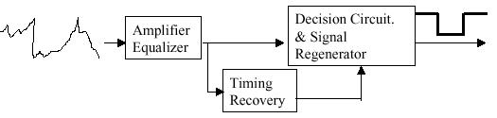
Figure 2.9 A Digital repeater
A timing recovery circuit keeps track of the intervals that define each pulse. The decision circuit then samples the signal at the midpoint of each interval to determine the polarity of the pulse. In a properly designed system, in the absence of noise, the original symbol would be recovered every time, and consequently the binary stream would be regenerated exactly over any number of repeaters and hence over arbitrarily long distances. However, noise is unavoidable, which implies that errors will occur from time to time. An error occurs when the noise signal is sufficiently large to change the polarity of the original signal at the sampling point. Digital transmission systems are designed for very low bit error rates, for example, 10⁻⁷,10⁻⁹, or even 10⁻¹², which corresponds to one error in every trillion bits!
The impact on signal quality in multiple digital repeaters is similar to the digital recording of music where the signal is stored as a file of binary information. We can copy the file digitally any number of times with extremely small probabilities of errors being introduced in the process. In effect, the quality of the sound is unaffected by the number of times the file is copied.
The preceding discussion shows that digital transmission has superior performance over analog transmission. Digital repeaters eliminate the accumulation of noise that takes place in analog systems and provide for long-distance transmission that is nearly independent of distance. Digital transmission systems can operate with lower signal levels or with greater distances between repeaters than analog systems can. This factor translates into lower overall system cost and was the original motivation for the introduction of digital transmission.
Over time, other benefits of digital transmission have become more prominent. Networks based on digital transmission are capable of handling any type of information that can be represented in digital form. Thus digital networks are suitable for handling many types of services. Digital transmission also allows networks to exploit the advances in digital computer technology to increase not only the volume of information that can be transmitted but also the types of processing that can be carried out within the network, that is, error correction, data encryption, and the various types of network protocol processing that are the subject of this book.

2.3 Bandwidth, Data Rate and Channel Capacity
We have seen that there are a variety of impairments that distort or corrupt a signal. For digital data, the question that then arises is to what extent these impairments limit the data rate that can be achieved. The rate at which data can be transmitted over a given communication path, or channel, under given conditions, is referred to as the channel capacity.
There are four concepts here that we are trying to relate to one another:
Data rate. This is the rate, in bits per second (bps), at which data can be communicated.
Bandwidth. This is the maximum bandwidth of the transmitted signal as constrained by the nature of the transmission medium or transmission channel, expressed in cycles per second, or hertz (Hz).
Noise. The average level of noise over the communications path.
Error rate. The rate at which errors occur, where an error is the reception of a 1 when a 0 was transmitted, or the reception of a 0 when a 1 was transmitted.
The problem we are addressing is this: communications facilities are expensive, and, in general, the greater the bandwidth of the transmission facility, the greater the cost. Furthermore, all transmission channels of any practical interest are of limited bandwidth. The limitations arise from the physical properties of the transmission medium or from deliberate limitations at the transmitter on the bandwidth to prevent interference from other sources. Accordingly, we would like to make as efficient use as possible of a given bandwidth. For digital data, this means that we would like to get as high a data rate as possible at a particular limit of error rate for a given bandwidth. The main constraint on achieving this efficiency is noise.

2.3.1 Nyquist sampling rate
To begin, let us consider the case of a channel that is noise-free. In this environment, the limitation on data rate is simply the bandwidth of the signal. A formulation of this limitation, due to Nyquist, states that if the signal with frequencies components not greater than W Hz (cycles per second) is given, then it is possible to represent completely that signal by sampling it at 2W samples per second.
Extending this to the transmission media, given a transmission medium of bandwidth W Hz, the highest signal rate that can be carried by it is 2W samples per second.
Note that in the last paragraph, we referred to samples. If the signals to be transmitted are binary (two voltage levels), then each sample would represent a binary bit, and the data rate that can be supported by W Hz is 2W bps. As an example, consider a voice channel being used, via modem, to transmit digital data. Assume a bandwidth of 3100 Hz. Then the capacity, C, of the channel is 2W = 6200 bps. However, signals or samples with more than two levels can be used; that is, each signal element can represent more than one bit. For example, if four possible voltage levels are used as sampled signals, then each signal element can represent two bits. With multilevel signaling, the Nyquist formulation becomes
C = 2W log₂ M
where M is the number of discrete signal or voltage levels. Thus, for M = 8, a value used with some modems, channel capacity C becomes 18,600 bps. So, for a given bandwidth, the data rate can be increased by increasing the number of different signals. However, this places an increased burden on the receiver: Instead of distinguishing one of two possible signals during each signal time, it must distinguish one of M possible signals. Noise and other impairments on the transmission line will limit the practical value of M.
Thus, all other things being equal, doubling the bandwidth doubles the data rate. Now consider the relationship between data rate, noise, and error rate. The presence of noise can corrupt one or more bits. If the data rate is increased, then the duration of bit becomes shorter so that more bits are affected by a given pattern of noise. Thus, at a given noise level, the higher the data rate, the higher the error rate.

2.3.2 Shannon Channel Capacity
All of these concepts can be tied together neatly in a formula developed by the mathematician Claude Shannon. As we have just illustrated, the higher the data rate, the more damage that unwanted noise can do. For a given level of noise, we would expect that greater signal strength would improve the ability to correctly receive data in the presence of noise. The key parameter involved in this reasoning is the signal-to-noise ratio (S/N), which is the ratio of the power in a signal to the power contained in the noise that is present at a particular point in the transmission. Typically, this ratio is measured at a receiver, as it is at this point that an attempt is made to process the signal and eliminate the unwanted noise. For convenience, this ratio is often reported in decibels:
(S/N)_{db} = 10 log ( signal power / noise power)
This expresses the amount, in decibels, that the intended signal exceeds the noise level. A high S/N will mean a high-quality signal and a low number of required intermediate repeaters. The effect of noise on signal is shown in the Figure 2.10.
The signal-to-noise ratio is important in the transmission of digital data because it sets the upper bound on the achievable data rate. Shannon's result is that the theoretical maximum channel capacity, in bits per second, obeys the equation
C=W log₂(l + (S/N) )
where C is the capacity of the channel in bits per second and W is the bandwidth of the channel in hertz.
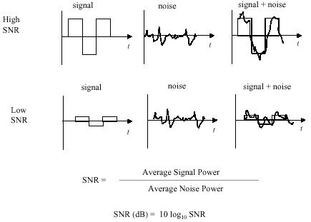
Figure 2.10 Effect of noise on signal
As an example, consider a voice channel being used, via modem, to transmit digital data. Assume a bandwidth of 3100 Hz. A typical value of S/N for a voice-grade line is 30 dB, or a ratio of 1000:1. Thus,
C = 3100 log₂(l + 1000)
C = 30,894 bps
This represents the theoretical maximum channel capacity that can be achieved.

2.4 Line Coding
Line coding is the method used for converting a binary information sequence into a digital signal in a digital communications system. The selection of a line coding technique involves several considerations. Maximizing bit rate is the main concern in digital transmission when bandwidth is at a premium. However, in other situations, such as in LANs, other concerns are also of interest. For example, another important design consideration is the ease with which the bit timing information can be recovered from the digital signal. Also, some line coding methods have built-in error detecting capabilities, and other methods have better immunity to noise and interference. Finally, the complexity and the cost of the line code implementations are always factors in the selection for a given application.

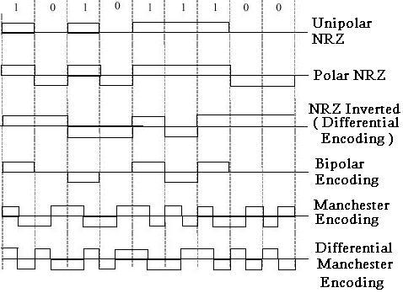
Figure 2.11 Line coding methods
Figure 2.11 shows various line codes that are used in practice. The figure shows the digital signals that are produced by the line codes for the binary sequence 101011100. The simplest scheme is the unipolar non-return-to-zero (NRZ) encoding in which a binary 1 is transmitted by sending a +A voltage level, and a 0 is transmitted by sending a 0 voltage. If binary 0s and 1s both occur with probability 1/2, then the average transmitted power for this line code is
(1/2)A² + (1/2)0² = A²/2
The polar NRZ encoding method that maps a binary 1 to +A/2 and binary 0 to –A/2 is more efficient than unipolar NRZ in terms of average transmitted power. Its average power is given by
(1/2)(+A/2)² + (1/2)(-A/2)² = A²/4
The spectrum that results from applying a given line code is of interest. We usually assume that the binary information is equally likely to be 0 or 1 and that they are statistically independent of each other, much as if they were produced by a sequence of independent coin flips. The unipolar and the polar NRZ encoding methods have the same frequency components because they produce essentially the same variations in a signal as a function of time. Strings of consecutive 0s and consecutive 1s lead to periods where the signal remains constant for long time producing low frequency components. These strings of 0s and 1s occur frequently enough to produce a spectrum that has its components concentrated at the lower frequencies as shown in Figure 2.12. This situation presents a problem when the communications channel does not pass low frequencies. For example, most telephone transmission systems do not pass the frequencies below about 200 Hz.

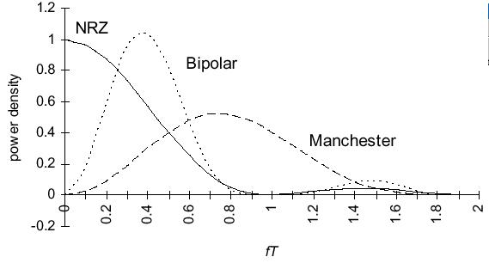
Figure 2.12 Spectra for different line coding
The bipolar encoding method was developed to produce a spectrum that is more amenable to channels that do not pass low frequencies. In this method binary 0s are mapped into 0 voltage, thus making no contribution to the digital signals; consecutive 1s are alternately mapped into +A/2 and -A/2. Thus a string of consecutive 1s will produce a square wave with the frequency (1 / 2T) Hz. As a result, the spectrum for the bipolar code has its frequency content centered around the frequency (1/2T) Hz and has small content at low frequencies as shown in Figure 2.12.
Timing recovery is an important consideration in the selection of a line code. The timing-recovery circuit in the receiver monitors the transitions at the edge of the bit intervals to determine the boundary between bits. Long strings of 0s and 1s in the binary and the polar binary encoding can cause the timing circuit to lose synchronization because of the absence of transitions. In the bipolar encoding long strings of 1s result in a square wave that has strong timing content; however, long strings of 0s still pose a problem. To address this problem, the bipolar line codes used in telephone transmission systems place a limit on the minimum number of 0s that may be encoded into the digital signal. Whenever a string of N consecutive 0s occurs, the string is encoded into a special binary sequence that contains 0s and 1s. To alert the receiver that a substitution has been made, the sequence is encoded so that the mapping in the bipolar line code is violated; that is, two consecutive 1s do not alternate in polarity.
A problem with polar coding is that a systematic error in polarity can cause all 0s to be detected as 1s and all 1s as 0s. The problem can be avoided by mapping the binary information into transitions at the beginning of each interval. A binary 1 is transmitted by enforcing a transition at the beginning of a bit time, and a 0 by having no transition. The signal level within the actual bit time remains constant. Figure 2.11 shows an example of how differential encoding, or NRZ inverted, carries out this mapping. Starting at a given level, the sequence of bits determines the subsequent transitions at the beginning of each interval.
Note that differential encoding will lead to the same spectrum as binary and polar encoding. However, errors in differential encoding tend to occur in pairs. An error in one bit time will provide the wrong reference for the next time, thus leading to an additional error in the next bit.
Note that the Manchester encoding can be viewed as the transmission of two pulses for each binary bit. A binary 1 is mapped into the binary pair of 10, and the corresponding polar encoding for these two bits is transmitted: A binary 0 is mapped into 01.

2.5 Modems and Digital Modulation
For the past 100 years, analog transmission has dominated all the communication. In particular, the telephone system was originally based entirely on analog signaling. With the advance technology, the long-distance trunks between telephone exchanges are converted to digital, but the local loops between a telephone exchange and the telephone at the user are still analog. Consequently, when a computer which wishes to send digital data it produces, over the telephone line, the data must be first converted to analog form by a device for transmission over telephone line and at the receiver end this received analog signal must be converted back to digital data.
A device that accepts a serial stream of digital bits as input and produces modulated analog carrier signal as output (or vice versa) is called a modem (for modulator- demodulator); The modem is inserted between the (digital) computer and the analog) telephone system. A continuous tone in the 1000 to 2000 Hz range, called a sine wave carrier is modulated according to the input digital signal at the transmitting end and at the receiver end the received modulated signal is converted back to digital stream of bits by the process of demodulation.
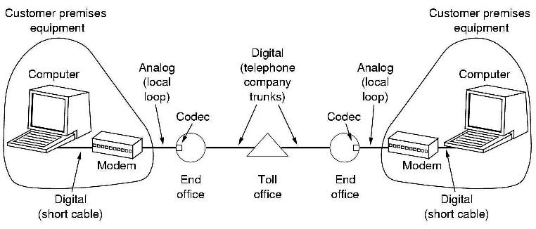
Figure 2-13 Use of both analog and digital transmission for a computer to computer call. Conversion is done by the modems

Various parameters of sine wave carrier like amplitude, frequency, or phase can be modulated to transmit information. In amplitude modulation, two different voltage levels are used to represent bits 0 and 1. In frequency modulation, also known as frequency shift keying, two (or more) different tones or frequencies are used. In the simplest form of phase modulation, the carrier wave is systematically shifted 45, 135, 225, or 315 degrees at uniformly spaced intervals. Each phase shift transmits 2 bits of information. Figure 2.14 illustrates the three forms of modulation.

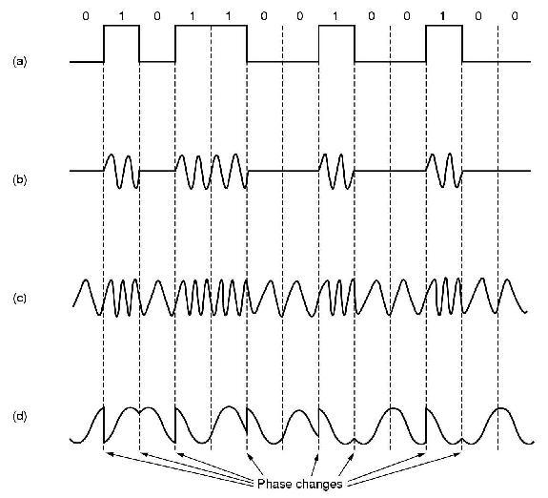

Figure 2-14 (a) A binary signal. (b) Amplitude modulation (c) Frequency Modulation
(d) Phase Modulation
To go to higher and higher speeds, it is not possible to just keep increasing the sampling rate. The Nyquist theorem says that even with a perfect 3000-Hz line (which a dial-up telephone is not), there is no point in sampling the signal faster than 6000 Hz as all frequency components higher than 3000Hz in the input signal are going to be filtered out by the 3000Hz telephone line. Thus all research on faster modem is focused on getting more bits per sample (i.e. per baud).
Most modems use a combination of modulation techniques to transmit multiple bits per-baud. In Figure 2.15a we see dots at 0,90, 180, and 270 degrees, with two amplitude levels per phase shift. Amplitude is indicated by the distance from the origin. In Figure 2.15b we see a different modulation scheme, in which 16 different combinations of amplitude and phase shift are used.
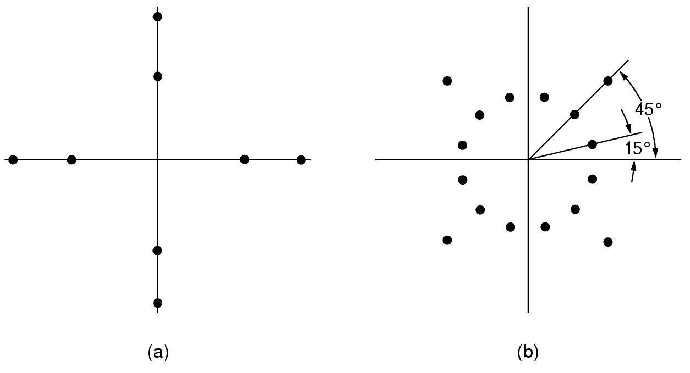
Figure 2-15 (a) 3 bits / baud modulation (b) 4 bits / baud modulation
Number of combination used will be a power of 2 and each sample or baud represents number of bits that is equal to the power. For example with 8 = 2³ different combination each baud represents 3 bits and with 16 = 2⁴ different combination each baud represents 4 bits. The scheme of Figure 2.15b when used to transmit 9600 bps over a 2400 baud line is called QAM (Quadrature Amplitude Modulation).

2.6 Transmission Media
The transmission medium is the physical path between transmitter and receiver in a data transmission system. Transmission media can be classified as guided or unguided. In both cases, communication is in the form of electromagnetic waves. With guided media, the waves are guided along a solid medium, such as copper twisted pair, copper coaxial cable, and optical fiber. The atmosphere and outer space are examples of unguided media that provide a means of transmitting electromagnetic signals but do not guide them; this form of transmission is usually referred to as wireless transmission.
The characteristics and quality of a data transmission are determined both by the characteristics of the medium and the characteristics of the signal. In the case of guided media, the medium itself is more important in determining the limitations of transmission.
For unguided media, the bandwidth of the signal produced by the transmitting
antenna is more important than the medium in determining transmission characteristics. One key property of signals transmitted by antenna is directionality. In general, signals at lower frequencies are omnidirectional; that is, the signal propagates in all directions from the antenna. At higher frequencies, it is possible to focus the signal into a directional beam.
In considering the design of data transmission systems, a key concern, generally, is data rate and distance: the greater the data rate and distance, the better. A number of design factors relating to the transmission medium and the signal determine the data rate and distance:
• Bandwidth. All other factors remaining constant, greater the bandwidth of the signal allowed over the transmission line, higher the data rate that can be achieved.
•Transmission impairments. Impairments, such as attenuation, limit the distance. For guided media, twisted pair generally suffers more impairment than coaxial cable, which in turn suffers more than optical fiber.
• Interference. Interference from competing signals in overlapping frequency bands can distort or wipe out a signal. Interference is of particular concern for unguided media, but it is also a problem with guided media. For guided media, interference can be caused by emanations from nearby cables. For example, twisted pair cables are often bundled together, and conduits often carry multiple cables. Interference can also be experienced from unguided transmissions. Proper shielding of a guided medium can minimize this problem.
•Number of receivers. A guided medium can be used to construct a point-to-point link or a shared link with multiple attachments. In the latter case, each attachment introduces some attenuation and distortion on the line, limiting distance and/or data rate.
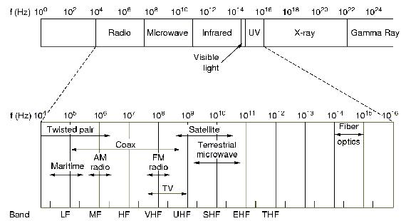
Figure 2-16 Electromagnetic spectrum and its uses for communication
Figure 2.16 depicts the electromagnetic spectrum and indicates the frequencies at which various guided media and unguided transmission techniques operate. In this section, we examine these guided and unguided alternatives.

2.6.1 Guided Transmission Media
For guided transmission media, the transmission capacity, in terms of either data-rate or bandwidth, depends critically on the distance and on whether the medium is point-to-point or multipoint such as in a local area network (LAN). Table 3.1 indicates the type of performance typical for the common guided medium for long-distance point-to-point applications
TABLE 2.1 Point-to-point transmission characteristics of guided media.
Transmission medium | Total data rate | Bandwidth | Repeater spacing
Twisted pair | 4 Mbps | 3 MHz | 2 to 10 km
Coaxial cable | 500 Mbps | 350 MHz | 1 to 10 km
Optical fiber | 2Gbps | 2 GHz | 10 to 100 km
Mbps: Mega bits per second = 10⁶ bps, Gbps: Giga bits per second = 10⁹ bps
MHz: Mega Hertz per second = 10⁶ Hz, GHz: Giga Hertz per second = 10⁹ Hz

The three, guided media commonly used for data transmission are twisted pair, coaxial cable, and optical fiber.
Twisted Pair
The oldest and still most common transmission medium is twisted pair. It is also the least-expensive one.
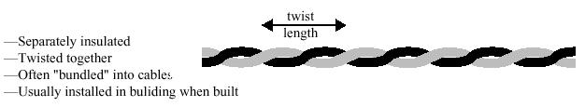
Figure 2.17. Twisted pair cable.
A twisted pair consists of two insulated copper wires arranged in a regular spiral pattern, just like a DNA molecule. A wire pair acts as a single communication link. Typically, a number of these pairs are bundled together into cable by wrapping them in a tough protective sheath. Over longer distances, cables may contain hundreds of pairs. The twisting tends to decrease the cross-talk interference between adjacent pairs in a cable. Neighboring pairs in a bundle typically have somewhat different twist lengths to enhance the cross-talk interference.
It is the most commonly used medium in the telephone network as well as being the workhorse for communications within buildings. In the telephone system, individual residential telephone sets are connected to the local telephone exchange, or end office, by twisted-pair wire. These are referred to as subscriber loops. Within an office building, each telephone is also connected to a twisted pair, which goes to the in-house private branch exchange (PBX) system. Twisted pair is much less expensive than the other commonly used guided transmission media (coaxial cable, optical fiber) and is easier to work with. It is more limited in terms of data rate and distance.
Twisted pair may be used to transmit both analog and digital signals. For analog signals, amplifiers are required about every 5 to 6 km. For digital signals, repeaters are required every 2 or 3 km. For point-to-point analog signaling, a bandwidth of up to about 250 kHz is possible. This accommodates a number of voice channels. For long-distance digital point-to-point signaling, data rates of up to a few Mbps are possible; for very short distances, data rates of up to 100Mbps have been achieved in commercially available products.

Coaxial Cable
Coaxial cable, like twisted pair, consists of two conductors, but is constructed differently to permit it to operate over a wider range of frequencies. It consists of a hollow outer cylindrical conductor that surrounds a single inner wire conductor. The inner conductor is held in place by either regularly spaced insulating rings or a solid dielectric material. The outer conductor is covered with a jacket or shield. A single coaxial cable has a diameter of from 0.4 to about 1 in. Because of its shielding, concentric construction, coaxial cable is much less susceptible to interference and cross-talk than is twisted pair. Coaxial cable can be used over longer distances and supports more stations on a shared line than twisted pair.
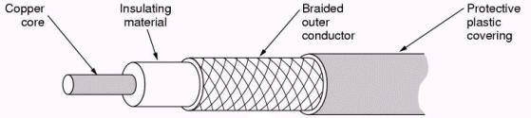
Figure 2-18 Coaxial cable.
Coaxial cable is perhaps the most versatile transmission medium and is enjoying widespread use in a wide variety of applications; the most important of these are
- Television distribution
- Long-distance telephone transmission
- Short-run computer system links
- Local Area Networks
Coaxial cable is spreading rapidly as a means of distributing TV signals to individual homes - cable TV. A cable TV system can carry dozens or even hundreds of TV channels at ranges up to a few tens of miles.
Coaxial cable has traditionally been an important part of the long-distance telephone network. Today, it is getting replaced by optical fiber, terrestrial microwave, and satellite. Using frequency-division multiplexing, a coaxial cable can carry over 10,000 voice channels simultaneously. Coaxial cable is also commonly used for short-range connections between devices. Using digital signaling, coaxial cable can be used to provide high-speed I/O channels on computer systems.
Another application area for coaxial cable is local area networks. Coaxial cable can support a large number of devices with a variety of data and traffic types, over distances that encompass a single building or a complex of buildings.
Coaxial cable is used to transmit both analog and digital signals. Coaxial cable has frequency characteristics that are superior to those of twisted pair, and can hence be used effectively at higher frequencies and data rates. The principal constraints on performance are attenuation, thermal noise, and inter modulation noise.
For long-distance transmission of analog signals, amplifiers are needed every few kilometers, with closer spacing required if higher frequencies are used. The usable spectrum for analog signaling extends to about 400 MHz. For digital signaling, repeaters are needed every kilometer or so, with closer spacing needed for higher data rates.
Optical transmission system and Optical Fiber.
An optical transmission system has three components; the light source, the transmission medium, and the detector. Conventionally, a pulse of light indicates a bit 1 and absence of light indicates bit 0. Transmission medium is an ultra thin fiber of glass. The transmitter generates the light pulses based on the input electrical signal. The detector regenerates the electrical signal based on the light signal it detects on the transmission medium. By attaching a light source to one end of an optical fiber and a detector to the other, we have an unidirectional data transmission system that accepts an electrical signal, converts and transmits it by light pulse, and then reconverts the output to an electrical signal at the receiving end.
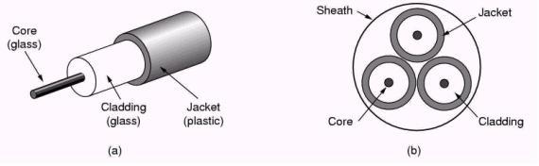
Figure 2-19 Optical fiber
An optical fiber is a thin (2 to 125 nm – nana meter – 10⁻⁹ meter), flexible medium capable of conducting an optical ray. Various glasses and plastics can be used to make optical fibers. The lowest losses have been obtained using fibers of ultrapure fused silica. Ultrapure fiber is difficult to manufacture; higher-loss multicomponent glass fibers are more economical and still provide good performance. Plastic fiber is even less costly and can be used for short-haul links, for which moderately high losses are acceptable.
An optical fiber cable has a cylindrical shape and consists of three concentric sections: the core, the cladding, and the jacket. The core is the innermost section and consists of one or more very thin strands, or fibers, made of glass or plastic. Each fiber is surrounded by its own cladding, a glass or plastic coating that has optical properties different from those of the core. The outermost layer, surrounding one or a bundle of cladded fibers, is the jacket. The jacket is composed of plastic and other material layered to protect against moisture, abrasion, crushing and other environmental dangers.
One of the most significant technological breakthroughs in data transmission has been the development of practical fiber optic communications systems. Optical fiber already enjoys considerable use in long-distance telecommunications. The continuing improvements in performance and decline in prices, together with the inherent advantages of optical fiber, have made it increasingly attractive for local area networking and metropolitan networks. The following characteristics distinguish optical fiber from twisted pair or coaxial cable:
Greater capacity. The potential bandwidth, and hence data rate of optical fiber is immense; data rates of 2 Gbps over tens of kilometers have been demonstrated. Compare this capability to the practical maximum of hundreds of Mbps over about 1 km for coaxial cable and just a few Mbps over 1 km or up to 100 Mbps over a few tens of meters for twisted pair.
Smaller size and lighter weight. Optical fibers are considerably thinner than coaxial cable or bundled twisted-pair cable - at least an order of magnitude thinner for comparable information-transmission capacity. For cramped conduits in buildings and underground along public rights-of-way, the advantage of small size is considerable. The corresponding reduction in weight reduces structural support requirements.
Lower attenuation. Attenuation is significantly lower for optical fiber than for coaxial cable or twisted pair and is constant over a wide range.
Electromagnetic isolation. Optical fiber systems are not affected by external electromagnetic fields. Thus, the system is not vulnerable to interference, impulse noise, or cross-talk. By the same token, fibers do not radiate energy, thereby causing little interference with other equipment and thus providing a high degree of security from eavesdropping. In addition, fiber is inherently difficult to tap.
Greater repeater spacing. Fewer repeaters mean lower cost and fewer sources of error. The performance of optical fiber systems from this point of view has been steadily improving. For example, AT&T has developed a fiber transmission system that achieves a data rate of 3.5 Gbps over a distance of 318 km without repeaters. Coaxial and twisted-pair systems generally have repeaters every few kilometers.

2.6.2 Wireless (Radio) Transmission
Radio encompasses the electromagnetic spectrum in the range of 3 KHz to 300 GHz. In radio communications the signal is transmitted into the air or space, using an antenna that radiates energy at some carrier frequency. For example, in QAM modulation the information sequence determines a point in the signal constellation that specifies the amplitude and phase of the cosine wave that is transmitted. Depending on the frequency and the antenna, this energy can propagate in either a unidirectional or omni-directional fashion. In the unidirectional case a properly aligned antenna receives the modulated signal, and an associated receiver in the direction of the transmission recovers the original information. In the omnidirectional case any receiver with an antenna in the area of coverage can pick up the signal.
Radio communication systems are subject to a variety of transmission impairments. The attenuation in radio links varies logarithmically with the distance. Attenuation for radio systems also increases with rainfall. Radio systems are subject to multipath fading and interference. Multipath fading refers to the interference that results at a receiver when two or more versions of the same signal arrive at slightly different times because of reflections from different objects. If the arriving signals differ in polarity, then they will cancel each other. Multipath fading can result in wide fluctuations in the amplitude and phase of the received signal. Interference refers to energy that appears at the receiver from sources other than the transmitter. Interference can be generated by other users of the same frequency band or by equipment that inadvertently transmits energy outside its band and into the bands of adjacent channels. Interference can seriously affect the performance of radio systems, and for this reason regulatory bodies apply strict requirements on the emission properties of electronic equipment.
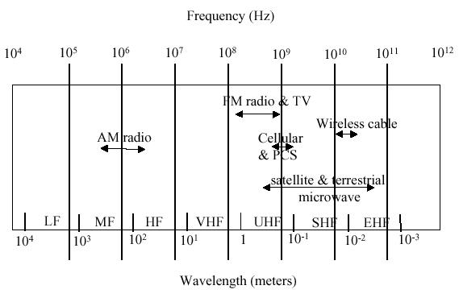
Figure 2.20 Radio Spectra
Figure 2.20 gives the range of various frequency bands and their applications. The frequency bands are classified according to wavelengths. Thus the low frequency (LF) band spans the range 30 kHz to 300 kHz, which corresponds to a wavelength of 1 km to 10 km, whereas the extremely high frequency (EHF) band occupies the range from 30 to 300 GHz corresponding to wavelengths of 1 millimeter to 1 centimeter. Note that the progression of frequency bands in the logarithmic frequency scale have increasingly larger bandwidths, for example, the band from 10¹¹ to 10¹² Hz has a bandwidth of 0.9 x 10¹² Hz, whereas the band from 10⁵ to 10⁶ Hz has a bandwidth of 0.9 x 10⁶ Hz.
The propagation properties of radio waves vary with the frequency. Radio waves at the VLF, LF, and MF bands follow the surface of the earth in the form of ground waves. VLF waves can be detected at distances up to about 1000 km, and MF waves, for example, AM radio, at much shorter distances. Radio waves in the HF band are reflected by the ionosphere and can be used for long-distance communications. These waves are detectable only within certain specific distances from the transmitter. Finally, radio waves in the VHF band and higher are not reflected back by the ionosphere and are detectable only within line-of-sight.
In general, radio frequencies below 1 GHz are more suitable for omnidirectional applications. For example, paging systems (beepers) are an omnidirectional application that provides one-way communications. Cordless telephones are example of an omnidirectional application that provides two-way communications. Here a simple base station connects to a telephone outlet and relays signaling and voice information to a cordless phone. This technology allows the user to move around in an area of a few tens of meters while talking on the phone. Other applications of wireless transmission are given below.
Cellular Communications
Cellular telephone networks extend the basic telephone service to mobile users with portable telephones. Unlike conventional telephone service where a cable carries signal between the telephone exchange and the telephone equipment at the user end, here the radio signal is used for transmission. Both portable telephone equipment and the interface at the telephone exchange are capable of broadcasting and receiving the voice signal which modulates the radio carrier signal.
There are two standards in cellular telephone systems. GSM - Global System for Mobile (GSM), Code Division Multiple Access (CDMA)

Wireless LANs
Wireless LANs are another application of omnidirectional wireless communications. A Wireless LAN (WLAN) is a flexible data communication system implemented as an extension to, or as an alternative for, a wired LAN within a building or campus. Using electromagnetic waves, WLANs transmit and receive data over the air, minimizing the need for wired connections. Thus, WLANs combine data connectivity with user mobility, and, through simplified configuration, enable movable LANs. In recent past, WLANs have gained strong popularity.
Wireless LANs use electromagnetic airwaves (radio and infrared) to communicate information from one point to another without relying on any physical connection. The data being transmitted is superimposed on the radio carrier so that it can be accurately extracted at the receiving end.
Multiple radio carriers can exist in the same space at the same time without interfering with each other if the radio waves are transmitted on different radio frequencies. To extract data, a radio receiver tunes in (or selects) one radio frequency while rejecting all other radio signals on different frequencies.

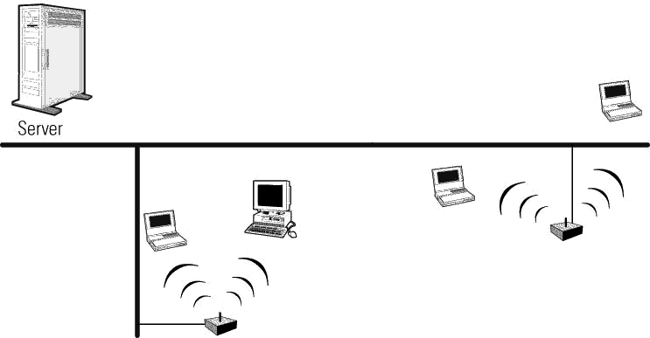
Figure 2.21 Wireless LAN

In a typical WLAN configuration, a transmitter/receiver (transceiver) device, called an access point, connects to the wired network from a fixed location using standard Ethernet cable. At a minimum, the access point receives, buffers, and transmits data between the WLAN and the wired network infrastructure. A single access point can support a small group of users and can function within a range of less than one hundred to several hundred feet. The access point (or the antenna attached to the access point) is usually mounted high but may be mounted essentially anywhere that is practical as long as the desired radio coverage is obtained.
End users access the WLAN through wireless LAN adapters, which are implemented as PC cards in notebook computers, or use ISA or PCI adapters in desktop computers, or fully integrated devices within hand-held computers.

WLAN technology - Spread Spectrum
Most wireless LAN systems use spread-spectrum technology, a wideband radio frequency technique developed by the military for use in reliable, secure, mission-critical communications systems. Spread-spectrum is designed to trade off bandwidth efficiency for reliability, integrity, and security.

Satellite Communications
Early satellite communications systems can be viewed as microwave systems with a single repeater in the sky. A (Geostationary) satellite is placed at an altitude of about 36,000 km above the equator where its orbit is stationary relative to the rotation of the earth. A modulated microwave radio signal is beamed to the satellite on an uplink carrier frequency. A transponder in the satellite receives the uplink signal, regenerates it, and beams it down back to earth on a downlink carrier frequency. A satellite typically contains 12 to 20 transponders so it can handle a number of simultaneous transmissions. Each transponder typically handles about 50 Mbps. Satellites operate in the 4/6, 11/14, and 20/30 GHz bands, where the first number indicates the downlink frequency and the second number the uplink frequency.
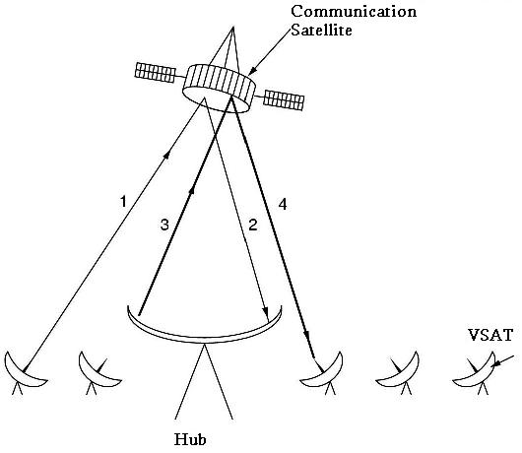
Figure 2.22 satellite Communication
Geostationary satellite systems have been used to provide point-to-point digital communications to carry telephone traffic between two points. Satellite systems have an advantage over fiber systems in situations where communications needs to be established quickly or where deploying the infrastructure is too costly. Satellite systems are inherently broadcast in nature, so they are also used to simultaneously beam television, and other signals, to a large number of users.
Satellite systems are also used to reach mobile users who roam wide geographical areas. Constellations of low-earth orbit satellites (LEOS) are deployed. These include the Iridium and Teledesic systems. The satellites are not stationary with respect to the earth, but they rotate in such a way that there is continuous coverage of the earth. The component satellites are interconnected by high-speed links forming a network in the sky.

2.7 Multiplexing
Multiplexing involves the sharing of expensive network resources by several connections or information flows. The network resource of primary importance is bandwidth of the communication channel, which is measured in Hertz for analog transmission system and bits/second for digital transmission system. Here we consider multiplexing techniques that are used to share a set of transmission lines among a community of users.

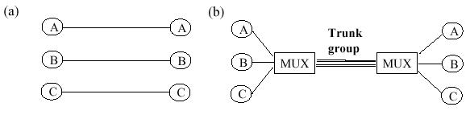
Figure 2.23 Multiplexing
Figure 2.23a shows an example where three pairs of users communicate by using three separate sets of wires. This method becomes inefficient as the number of users increases. A better approach is to dynamically share the network resources among a community of users. Figure 2.23b show a multiplexer which allows this sharing. When a user wants to communicate with another user at the other end the multiplexer dynamically assigns a communication line for the duration of the call. When the call is completed, the transmission line is returned to the pool that is available to meet new connection requests. Note that signaling is required between two multiplexer to set up and terminate each call.
These multiplexing schemes can be divided into two basic categories: FDM (Frequency Division Multiplexing), and TDM (Time Division Multiplexing). In FDM the frequency spectrum is divided among the logical channels, with each user having exclusive possession of some frequency band. In TDM the users take turns (in a round robin), each one periodically getting the entire bandwidth for a little burst of time.

2.7.1 Frequency-Division Multiplexing (FDM)
Suppose that the transmission system line has a bandwidth that is much greater than the required by a single connection. For example in Figure 2.24 each user has a signal of W Hz and the channel that is available is greater than 3W Hz. In such a case available bandwidth can be shared by the individual users and each user will have the required bandwidth at his disposal for the complete duration of allotment.
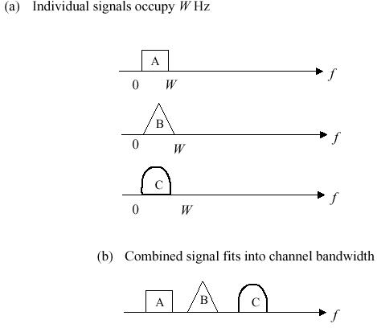
Figure 2.24 Frequency Division Multiplexing, FDM
In Frequency-division multiplexing (FDM), the bandwidth is divided into a number of frequency slots, each of which can accommodate the signal of an individual connection. The multiplexer assigns a frequency slot to each connection and uses modulation with appropriate carrier frequencies to place the signal of the different connection in corresponding frequency slot.
This process results in an overall combined signal that carries all the connections as shown in Figure 2.24b. The combined signal is transmitted, and the demultiplexer recovers the signals corresponding to each connection. Reducing the number of wires that need to be handled reduces the overall cost of the system.
FDM was introduced in the telephone network in the 1930s. The basic analog multiplexer combines 12 voice channels in one line. Each voice signal occupies 4 kHz of bandwidth. The multiplexer modulates each voice signal so that it occupies a 4 kHz slot in the band between 60 and 108 kHz. The combined signal is called a group. A hierarchy of analog multiplexers has been defined. For example, a supergroup (that carries 60 voice signals) is formed by multiplexing five groups, each of bandwidth 48 kHz, into the frequency band from 312 to 552 kHz. Note that for the purposes of multiplexing, each group is treated as an individual signal. Ten supergroups can then be multiplexed to form a mastergroup of 600 voice signals that occupies the band 564 to 3084 kHz. Various combinations of mastergroups have also been defined.
Familiar examples of FDM are broadcast radio and broadcast cable television, where each station has an assigned frequency band. Stations in AM, FM, and television are assigned frequency bands of 10 kHz, 200 kHz, and 6 MHz, respectively. FDM is also used in cellular telephony where a pool of frequency slots, typically of 25 to 30 kHz each, are shared by the users within a geographic cell. Each user is assigned a frequency slot for each direction. Note that in FDM the user information can be in analog or digital form and that the information from all the users flows simultaneously.

2.7.2 Time Division Multiplexing TDM
In time-division multiplexing (TDM), the transmission between the multiplexers is provided by a single high-speed digital transmission line. Each connection produces a digital information flow that is then inserted into the high-speed line. For example in Figure 2.25a each connection generates a signal that produces one unit of information every 3T seconds. This unit of information could be a bit, a byte, or a fixed-size block of bits. Typically, the transmission line is organized into frames that in turn are divided into equal-sized slots. For example, in Figure 2.25b the transmission line can send one unit of information every T seconds, and the combined signal has a frame structure that consists of three slots, one for each user. During connection setup each connection is assigned a slot that can accommodate the information produced by the connection.
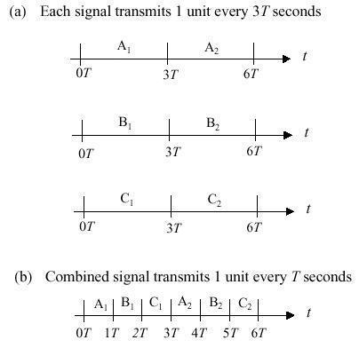
Figure 2.25 Time Division Multiplexing
TDM was introduced in the telephone network in the early 1960s. The T1 carrier system that carries 24 digital telephone connections is shown in Figure 2.26
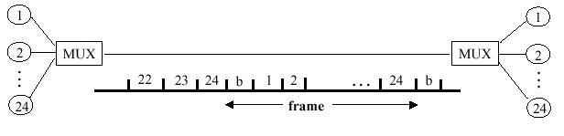
Figure 2.26 Time Division Multiplexing – T1 Carrier System
2.7.3 Wavelength Division Multiplexing
For fiber optic channels, a variation of frequency division multiplexing is used. It is called WDM (Wavelength Division Multiplexing). A simple way of achieving FDM on fibers is depicted in Figure 2.27. Here two fibers come together at a prism (or more likely, a diffraction grating), each with its energy in a different band. The two beams are passed through the prism or grating, and combined onto a single shared fiber for transmission to a distant destination, where they are split again.

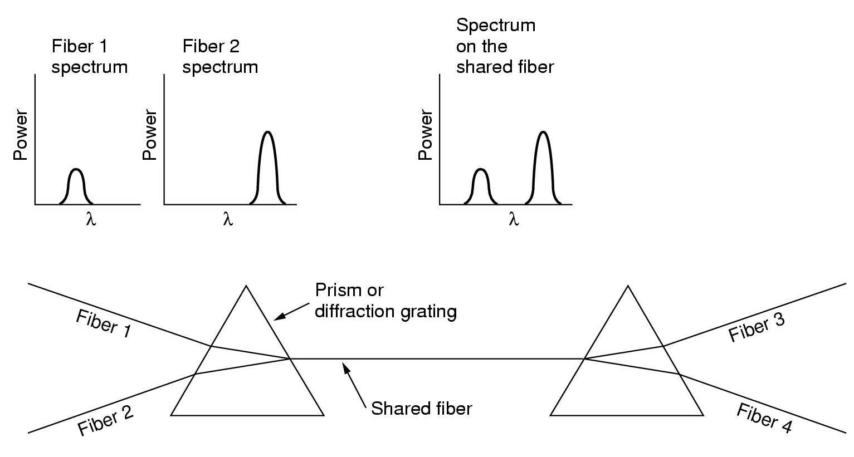
Figure 2.27 Wavelength Division Multiplexing WDM
There is really nothing new here. As long as each channel has its own frequency range, and all the ranges are disjoint, they can be multiplexed together on the long-haul fiber. The only difference with electrical FDM is that an optical system using a diffraction grating is completely passive, and thus highly reliable.
It should be noted that the reason WDM is popular is that the energy on a single fiber is typically only a few Gigahertz (10⁹ Hz) wide because it is currently impossible to convert between electrical and optical media any faster and since the bandwidth of a single fiber band is about 25,000 GHz, there is great potential for multiplexing many channels together over long-haul routes. A necessary condition, however, is that the incoming channels use different frequencies.

2.8 Circuit Switching
A network is frequently represented as a cloud that connects multiple users as shown in Figure 2.28a. A circuit-switched network is a generalization of a physical cable in the sense that it provides connectivity that allows information to flow between inputs and outputs to the network. Unlike a cable, however, a network is geographically distributed and consists of a graph of transmission lines (that is, links) interconnected by switches (nodes).
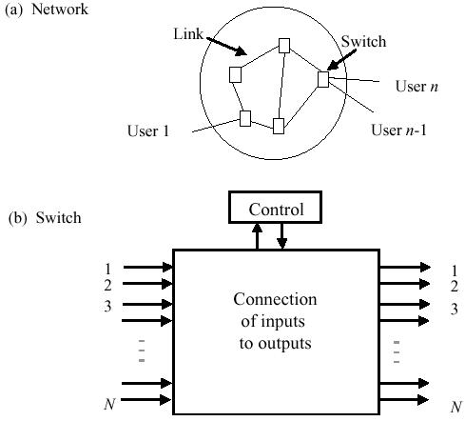

Figure 2.28 Network consists of links and switches

As shown in Figure 2.28b, the function of a circuit switch is to transfer the signal that arrives at a given input to an appropriate output. The interconnection of a sequence of transmission links and circuit switches enables the flow of information between inputs and outputs in the network.

2.8.1 Space-Division Switches
Space-division switches provide a separate physical connection between inputs and outputs so the different signals are separated in space. Figure 2.29 shows the crossbar switch, which is an example of this type of switch. The crossbar switch consists of an N x N array of crosspoints that can connect any input to any available output. When a request comes in from an incoming line for an outgoing line, the corresponding crosspoint is closed to enable information to flow from the input to the output. The crossbar switch is said to be nonblocking; in other words, connection requests are never denied because of lack of connectivity resources, that is, crosspoints. Connection requests are denied only when the requested outgoing line is already engaged in another connection.
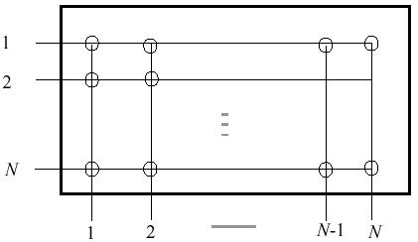
Figure 2.29 Crossbar Switch
The complexity of the crossbar switch as measured by the number of cross-points is N². This number grows quickly with the number of input and output ports. Thus a 1000-input-by-1000-output switch requires 10⁶crosspoints, and a 100,000 by 100,000 switch requires 10¹⁰crosspoints. In the next section we show how the number of crosspoints can be reduced by using multistage switches.

Multistage Switches
Figure 2.30 shows a multistage switch that consists of three stages of smaller space-division switches. The N inputs are grouped into N/n groups of n input lines. Each group of n input lines enters a small switch in the first stage that consists of an n x n array of crosspoints. Each input switch has one line connecting it to each of k intermediate stage N/n x N/n switches. Each intermediate switch in turn has one line connecting it to each of the N/n switches in the third stage. The latter switches are k x n. In effect each set of n input lines shares k possible paths to any one of the switches at the last stage, that is, the first path goes through the first intermediate switch, the second path goes through the second intermediate switch, and so on. The resulting multistage switch is not necessarily nonblocking. For example, if k < n, then as soon as a switch in the first stage has k connections, all other connections will be blocked.
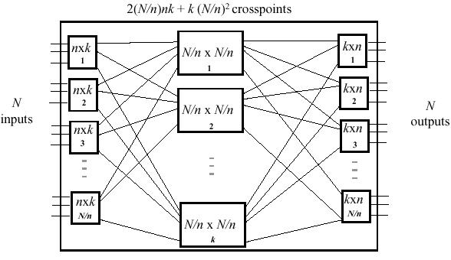
Figure 2.30 Multistage switch
The number of crosspoints required in a three-stage switch is the sum of the following components:
- N/n input switches x nk crosspoints/input switch.
- k intermediate switches x (N/n)² crosspoints/intermediate switch.
- N/n output switches x nk crosspoints/output switch.
In this case the total number of crosspoints is
2Nk + k(N/n)².
The number of crosspoints required to make the switch nonblocking is
2N(2n —1) + (2n-1)(N/n)²
The number of crosspoints can be minimized through the choice of group size n. By differentiating the above expression with respect to n, we find that the number of crosspoints is minimized if n ~ = (N/2) ^{1/2}. The minimum number of crosspoints is then 4N((2N)^{1/2} - 1). We then see that the minimum number of crosspoints grows at a rate proportional to N^{1.5} which is less than the N ² growth rate of a crossbar switch.

2.8.2 Time-Division Switches
In the previous section, we explained how Time Division Multiplexing (TDM) could replace multiple physical lines by a single high-speed line. In TDM a slot within a frame corresponds to a single connection. The time-division switch uses time-slot interchange (TSI) technique to do the switching operation. It basically switches the time slots of the input frame in the output frame.
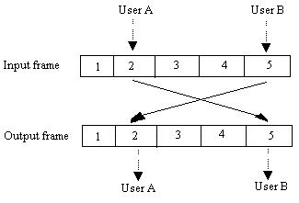
Figure 2.31 Time slot interchange TSI technique in Time division switch
Consider users A & B who wishes to talk to each other. Suppose User A is assigned slot 3 and user B is assigned slot 5 then the time division switch will take the data information in the slot 3 in the input frame and puts it into the slot 5 in the output frame. In effect information bits in the slot 3 which came from user A is going into the slot allocated to the user B in the output frame. This results in the one way connection from A to B. Similarly the time division switch put the information in the slot 5 in the input frame to the slot 3 in the output frame resulting in connection from B to A.
The development of the TSI technique was crucial in completing the digitization of the telephone network. Starting in 1961 digital transmission techniques were introduced in the trunks that interconnected telephone central offices. Initially, at each office the digital streams would be converted back to analog form and switched by using space switches of the type discussed above. The introduction of TSI in digital time-division switches led to significant reductions in cost and to improvements in performance by obviating the need to convert back to analog form. Most modern telephone backbone networks are now entirely digital in terms of transmission and switching.

Exercise
- Differentiate between a continuous signal and discrete signal.
- What is a periodic signal? Explain.
- Discuss the frequency domain concepts of electromagnetic signal.
- Explain analog and digital repeaters.
- Briefly discuss why digital transmission is preferred over analog transmission.
- What is Nyquist sampling rate?
- Discuss Shannon’s channel capacity.
- Discuss various line coding techniques.
- What are modems? Explain how higher data rates are achieved in modems.
- Explain different modulation techniques.
- List different guided transmission mediums. Discuss properties of optical fiber cable.
- Discuss propagation properties of various radiowaves.
- List the application of wireless transmission of signal in data communication. Discuss two of them.
- What is multiplexing? List the different kind of multiplexing schemes.
- How Wavelength Division Multiplexing is different from Frequency Division Multiplexing.
- What is Circuit Switching?
- Discuss Crossbar switch. How the cross-points required are reduced in the Multistage Switches?
- Discuss the working of Time Division Multiplexing.

