Chapter 3 Data Link Control
3.0 Introduction
3.1 Error Detection
3.1.1 Single Parity Check
3.1.2 Cyclic Redundancy Check (CRC)
3.2 Error Control mechanisms
3.2.1 Stop-and-Wait ARQ
3.2.2 Go-Back-NARQ
3.2.3 Selective Repeat ARQ
3.3 Flow Control
3.4 High-Level Data Link Control (HDLC)
3.4.1 Basic Characteristics of HDLC
3.4.2 HDLC Frame Structure
3.4.3 HDLC Operation

3.0 Introduction
Discussion so far was focused towards sending signals over a transmission link. For effective digital data communications, much more is needed to control and manage the exchange. In this chapter, we shift our emphasis to that of sending data over a data communications link. To achieve the necessary control, a layer of logic is added above the physical transmission layer; this logic is referred to as data link control or a data link control protocol. When a data link control protocol is used, the transmission medium between systems is referred to as a data link.
To see the need for data link control, we list some of the requirements and objectives for effective data communication between two directly connected transmitting-receiving stations:
• Frame synchronization. Data are sent in blocks called frames. The beginning and end of each frame must be recognizable.
• Flow control. The sending station must not send frames at a rate faster than the receiving station can absorb them.
•Error control. Any bit errors introduced by the transmission system must be corrected.
• Addressing. On a multipoint line, such as a local area network (LAN), the identity of the two stations involved in a transmission must be specified.
• Control and data on same link. It is usually not desirable to have a physically separate communications path for control information. Accordingly, the receiver must be able to distinguish control information from the data being transmitted.
• Link management. The initiation, maintenance, and termination of a sustained data exchange requires a fair amount of coordination and cooperation among stations. Procedures for the management of this exchange are required.
A data link protocol that satisfies these requirements is a rather complex affair. First we look into the various techniques used to implement the error control and flow control mechanism. Then we look at the most important example of a data link control protocol: HDLC (High-level Data Link Control). This protocol is important for two reasons: First, it is a widely used standardized data link control protocol. And secondly, HDLC serves as a baseline from which virtually all other important data link control protocols are derived.

3.1 Error Detection
In this section we discuss the idea of error detection in general terms, using the single parity check code as an example throughout the discussion. Also we briefly discuss Cyclic Redundancy Check (CRC), a most commonly used error detection mechanism. The basic idea in performing error detection is simple.
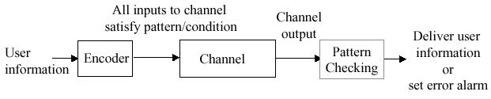
Figure 3.1 General Error detection system
As illustrated in Figure 3.1, the information produced by an application programme is encoded so that the stream that is input into the communication channel satisfies a specific pattern or condition. The receiver checks the stream coming out of the communication channel to see whether the pattern is satisfied. If it is not, the receiver can be certain that an error has occurred and therefore sets an alarm to alert the user. This certainty stems from the fact that, no such pattern would have been transmitted by the encoder.

3.1.1 Single Parity Check
The Simplest code is the single parity check code that takes k information bits and appends a single check bit to form a codeword, which will be transmitted over the channel. The parity check at the receiver ensures that the total number of 1s in the received codeword is even; that is, the codeword has even parity. The check bit in this case is called a parity bit. Here the received codeword is valid if it has even number of 1s, otherwise it is invalid and there is some error in the received codeword. This error-detection code is used in ASCII where characters are represented by seven bits and the eighth bit consists of a parity bit. This code is an example of the so-called linear codes because the parity bit is calculated as the modulo 2 sum of the information bits:
b_{k+1} = ( b₁ + b₂ + b₃ + …. + b_{k} ) modulo 2
where b₁, b₂ ,b₃ , …. ,b_{k} are the information bits. And b_{k+1} is the parity bit generated. The modulo 2 arithmetic is given below
0 0 1 1
+0 +1 +0 +1
----- ------ ------ ------
0 1 1 0
Thus, if the information bits contain an even number of 1s, then the parity bit will be 0; and if they contain an odd number of 1s, then the parity bit will be 1. Consequently, the above rule will assign the parity bit a value that will produce a codeword that always contains an even number of Is. This pattern defines the single parity check code.
If a codeword undergoes a single error during transmission, then the corresponding binary block at the output of the channel will contain an odd number of 1s and the error will be detected. More generally, if the codeword undergoes an odd number of errors, the corresponding output block will also contain an odd number of 1s. Therefore, the single parity bit allows us to detect all error patterns that introduce an odd number of errors. On the other hand, the single parity bit will fail to detect any error patterns that introduce an even number of errors, since the resulting codeword will have even parity which is a valid codeword. Nonetheless, the single parity bit provides a remarkable amount of error-detection capability, since the addition of a single check bit results in making half of all possible error patterns detectable, regardless of the value of k.
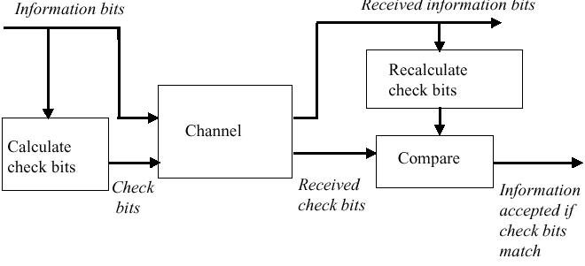
Figure 3.2 Error detection system using check bits
Figure 3.2 shows an alternative way of looking at the operation of this example. At the transmitter a checksum is calculated from the information bits and transmitted along with the information. At the receiver, the checksum is recalculated, based on the received information. The received and recalculated checksums are compared, and the error alarm is set if they disagree.
This simple example can be used to present two fundamental observations about error detection. The first observation is that error detection requires redundancy in that the amount of information that is transmitted is over and above the required minimum. For a single parity check code of length k+ 1, k bits are information bits, and one bit is the parity bit. Therefore, the fraction l/(k+1) of the transmitted bits is redundant.
The second fundamental observation is that every error-detection technique will fail to detect some errors. In particular, an error-detection technique will always fail to detect transmission errors that convert a valid codeword into another valid codeword. For the single parity check code, an even number of transmission errors will always convert a valid codeword to another valid codeword.
The objective in selecting an error-detection code is to select the codewords that reduce the likelihood of the transmission channel converting one valid codeword into another. To visualize how this is done, suppose we depict the set of all possible binary blocks as the space shown in Figure 3.3, with codeword shown by xs in the space and noncodeword by o s.
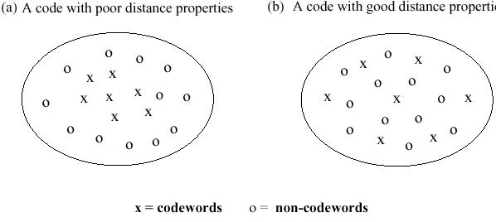
Figure 3.3 Distance properties of codes.
To minimize the probability of error-detection failure, we want the codewords to be selected so that they are spaced as far away from each other as possible. Thus the code in Figure 3.3a is a poor code because the codewords are close to each other or in other words distance between two valid codewords are low. On the other hand, the code in Figure 3.3b is good because the distance between codewords is maximized.
The effectiveness of a code clearly depends on the types of errors that are introduced by the channel.

3.1.2 Cyclic Redundancy Check (CRC)
One of the most common, and most powerful, error-detecting code is the Cyclic Redundancy Check (CRC), which can be described as follows. Given a k-bit block of bits, or message, the transmitter generates an n-bit sequence, known as a Frame Check Sequence (FCS), so that the resulting frame, consisting of k +n bits, is exactly divisible by some predetermined number called CRC polynomial. The receiver then divides the incoming frame of k+n bits by the same CRC polynomial number and, if there is no remainder, assumes there was no error. The CRC polynomial number by which the information frame bits are divided are selected such that distance between two valid codeword is high and with proper selection of CRC polynomial it is possible to detect errors with very high probability i.e. more than 99.9% of the errors can be detected. Even it is possible to find out which bits are in error when only few bits are corrupted in the information bit stream. So with CRC it is also possible to correct the error though it is not possible for all possible errors. Even interesting thing about CRC is that the generation of the FCS can be implemented with very simple electronic circuitry. The generation of FCS does not take any extra time – at the end of transmission of k information bits, n bits FCS will be ready. Theory behind the CRC would make very interesting reading.

3.2 Error Control mechanisms
Error control refers to mechanisms to detect errors that occur in the transmission of frames and take corrective steps to make sure frames are received correctly. In the model used, which covers the typical case, data are sent as a sequence of frames; frames arrive in the same order in which they are sent; and each transmitted frames suffer an arbitrary and variable amount of delay before reception. Two types of error are possible:
- Lost frame. A frame fails to arrive at the receiver. For example, a noise burst may damage a frame to the extent that the receiver is not aware that a frame as been transmitted.
- Damaged Frame. A recognizable frame arrives but part of its content is in error.
The most common techniques for error control are based on some or all of the following steps.
- Error detection. This is done as discussed in previous section.
- Positive acknowledgement. The destination returns a positive acknowledgement to successfully received, error-free frames.
- Retransmission after timeout. The source retransmits a frame that has not been acknowledged after a predetermined amount of time.
- Negative acknowledgement and retransmission. The receiver returns a negative acknowledgement to frames in which an error is detected. The source retransmits those frames again.
Collectively these mechanisms are referred to as Automatic repeat ReQuest(ARQ). In effect ARQ provides reliability over an unreliable data link. ARQ is a technique used to ensure that a data stream is delivered accurately to the user despite errors that occur during transmission. And we refer to the set of rules that govern the operation of the transmitter and receiver based on ARQ as the ARQ protocol. ARQ forms the basis for Data Link Control protocols that provide for the reliable transfer of information. In this section we discuss the three basic types of ARQ protocols, starting with the simplest and up to the most complex.
There are three version of ARQ, which are standardized.
- Stop-and-wait-ARQ
- Go-back-N ARQ
- Selective-reject ARQ
In the data transmission model, which covers the typical case it is assumed that a user generates a sequence of information blocks for transmission. The ARQ mechanism requires the block to contain a header with control information that is essential to proper operation, as shown in Figure 3.4.
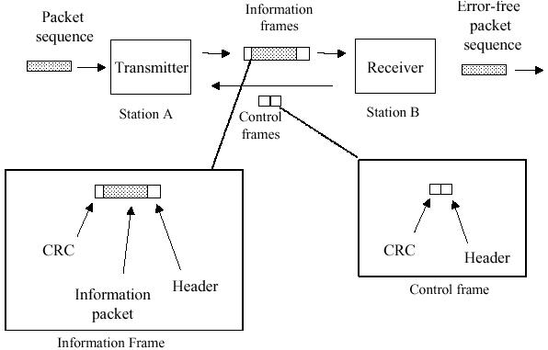
Figure 3.4 Basic elements of ARQ
The transmitter will also append CRC check bits that cover the header and the information bits to enable the receiver to determine whether errors have occurred during transmission. We assume that the design of the CRC ensures that transmission errors can be detected with very high probability, as discussed in previous section.
In addition to the error-detection code, the other basic elements of ARQ protocols consist of information frames (I-frames) that transfer the user packets, control frames, and time-out mechanisms, as shown in Figure 3.4. Control frames are short binary blocks that consist of a header that provides the control information followed by the CRC. The control frames include ACKs bits, which acknowledge the correct receipt of a given frame or group of frames; NAKs bits, which indicate that a frame has been received in error and that the receiver is taking certain action; and an enquiry frame ENQ, which commands the receiver to report its status. The time-out mechanisms are required to prompt certain actions to maintain the flow of frames. We can visualize the transmitter and receiver as working jointly on ensuring the correct and orderly delivery of the sequence of packets provided by the sender.

3.2.1 Stop-and-Wait ARQ
The first protocol considered is Stop-and-Wait ARQ where the transmitter and receiver work on the delivery of one frame at a time through an alternation of actions. Figure 3.5a shows how ACKs and time-outs can be used to provide recovery from transmission errors, in this case a lost frame. At the initial point in the figure, stations A and B are working on the transmission of frame 0. Note that each time station A sends an I-frame, it starts an I-frame timer that will expire after some time-out period. The time-out period is selected so that it is greater than the time required to receive the corresponding ACK frame. Figure 3.5a shows the following sequence of events:
1. Station A transmits frame 0 and then waits for an ACK frame from the receiver.
2. Frame 0 is transmitted without error, so station B transmits an ACK frame.
3. The ACK from station B is also received without error, so station A knows the frame 0 has been received correctly.
4. Station A now proceeds to transmit frame 1 and then resets the timer.
5. Frame 1 undergoes errors in transmission. It is possible that station B receives frame 1 and detects the errors through the CRC check; it is also possible that frame 1 was so badly garbled that station B is unaware of the transmission. In either case station B does not take any action.
6. The time-out period expires, and frame 1 is retransmitted.
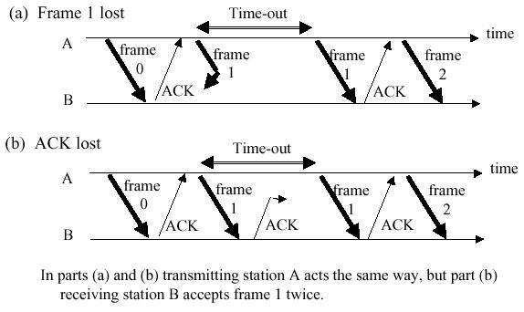

Figure 3.5 Possible ambiguities when frames are unnumbered
The protocol continues in this manner until frame 1 is received and acknowledged. The protocol then proceeds to frame 2, and so on.
Transmission errors in the reverse channel lead to ambiguities in the Stop-and-Wait protocol that need to be corrected. Figure 3.5b shows the situation that begins as in Figure 3.5a, but where frame 1 is received correctly, and its acknowledgment undergoes errors. After receiving frame 1 station B delivers its contents to the destination. Station A does not receive the acknowledgment for frame 1, so the time-out period expires. Note that at this point station A cannot distinguish between the sequence of events in parts (a) and (b) of Figure 3.5. Station A proceeds to retransmit the frame. If the frame is received correctly by station B, as shown in the figure, then station B will accept frame 1 as a new frame and redeliver it to the user. Thus we see that the loss of an ACK can result in the delivery of a duplicate packet. The ambiguity can be eliminated by including a sequence number in the header of each I-frame. Station B would then recognize that the second transmission of frame 1 was a duplicate, discard the frame, and resend the ACK for frame 1.
A second type of ambiguity arises if the ACKs do not contain a sequence number. In Figure 3.6 frame 0 is transmitted, but the time-out expires prematurely. Frame 0 is received correctly, and the (unnumbered) ACK is returned. In the meantime station A has resent frame 0.
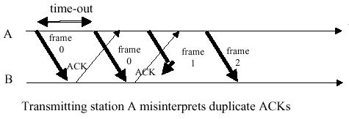

Figure 3.6 Possible ambiguities when ACKs are unnumberec
Shortly thereafter, station A receives an ACK and assumes it is for the last frame. Station A then proceeds to send frame 1, which incurs transmission errors. In the meantime the second transmission of frame 0 has been received and acknowledged by station B. When station A receives the second ACK, the station assumes the ACK is for frame 1 and proceeds to transmit frame 2. The mechanism fails because frame 1 is not delivered. This example shows that premature time-outs (or delayed ACKs) combined with loss of I-frames can result in gaps in the delivered packet sequence. This ambiguity is resolved by providing a sequence number in the acknowledgment frames that enables the transmitter to determine which frames have been received.
Stop-and-Wait ARQ becomes inefficient when the propagation delay is much greater than the time to transmit a frame. For example, suppose that we are transmitting frames that are 1000 bits long over a channel that has a speed of 1.5 megabits/second and suppose that the time that elapses from the beginning of the frame transmission to the receipt of its acknowledgment is 40 ms. The number of bits that can be transmitted over this channel in 40 ms is 40 x 10⁻³ x 1.5 x 10⁶ = 60,000 bits. However, Stop-and-Wait ARQ can transmit only 1000 bits in this period time. This severe inefficiency is due to the requirement that the transmitter wait for the acknowledgment of a frame before proceeding with other transmissions. The situation becomes much worse in the presence of transmission errors that trigger retransmissions.
The delay-bandwidth product is the product of the bit rate and the delay that elapses before an action can take place. In the preceding example the delay-bandwidth product is 60,000 bits. In Stop-and-Wait ARQ the delay-bandwidth product can be viewed as a measure of lost opportunity in terms of transmitted bits. This factor arises as a fundamental limitation in many network problems.

3.2.2 Go-Back-N ARQ
In this section we show that the inefficiency of Stop-and-Wait ARQ can be overcome by allowing the transmitter to continue sending enough frames so that the channel is kept busy while the transmitter waits for acknowledgments. Suppose for now that frames are numbered 0,1,2,3,... The transmitter has a limit on the number of frames W_{s} that can be outstanding. W_{s} is chosen larger than the delay-band-width product to ensure that the channel can be kept busy.
The idea of the basic Go-Back-N ARQ is as follows: Consider the transfer of a reference frame, say, frame 0. After frame 0 is sent, the transmitter sends (Ws – 1) additional frames into the channel, optimistic that frame 0 will be received correctly and not require retransmission. If things turn out as expected, an ACK for frame 0 will arrive in due course while the transmitter is still busy sending frames into the channel, as shown in Figure 3.7. The system is now done with frame 0. Note, however, that the handling of frame 1 and subsequent frames is already well underway. A procedure where the processing of a new task is begun before the completion of the previous task is said to be pipelined. In effect Go-Back-N ARQ pipelines the processing of frames to keep the channel busy.
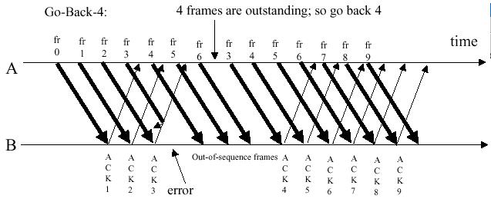
Figure 3.7 Basic Go-Back-N ARQ
Go-Back-N ARQ gets its name from the action that is taken when an error occurs. As shown in Figure 3.7, after frame 3 undergoes transmission errors, the receiver ignores frame 3 and all subsequent frames. Eventually the transmitter reaches the maximum number of outstanding frames. It is then forced to go back N frames, where N = Ws, and begin retransmitting all packets from 3 onwards.
The Go-Back-N ARQ as stated above depends on the transmitter exhausting its maximum number of outstanding frames to trigger the retransmission of a frame. Thus this protocol works correctly as long as the transmitter has an unlimited supply of packets that need to be transmitted. In situations where packets arrive sporadically, there may not be (Ws – 1) subsequent transmissions. In this case retransmissions are not triggered, since the window is not exhausted. This problem is easily resolved by modifying Go-Back-N ARQ such that a timer is associated with each transmitted frame.
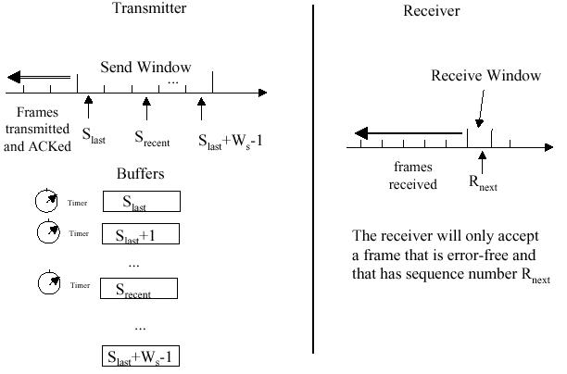
Figure 3.8 Go-Back-N ARQ

Figure 3.8 shows how the resulting Go-Back-N ARQ protocol operates. The transmitter must now maintain a list of the frames it is processing, where Slast is the number of the last transmitted frame that remains unacknowledged and Srecent is the number of the most recently transmitted frame. The transmitter must also maintain a timer for each transmitted frame and must also buffer all frames that have been transmitted but have not yet been acknowledged. At any point in time the transmitter has a send window of available sequence numbers. The lower end of the window is given by Slast, and the upper limit of the transmitter window is (Slast + Ws –1). If Srecent reaches the upper limit of the window, the transmitter is not allowed to transmit further new frames until the send window slides forward with the receipt of a new acknowledgment.

3.2.3 Selective Repeat ARQ
In channels that have high error rates, the Go-Back-N ARQ protocol is inefficient because of the need to retransmit the frame in error and all the subsequent frames. A more efficient ARQ protocol can be obtained by adding two new features: first, the receive window is made larger than one frame so that the receiver can accept frames that are out of order but error free; second, the retransmission mechanism is modified so that only individual frames are retransmitted. This protocol is referred to as Selective Repeat ARQ.
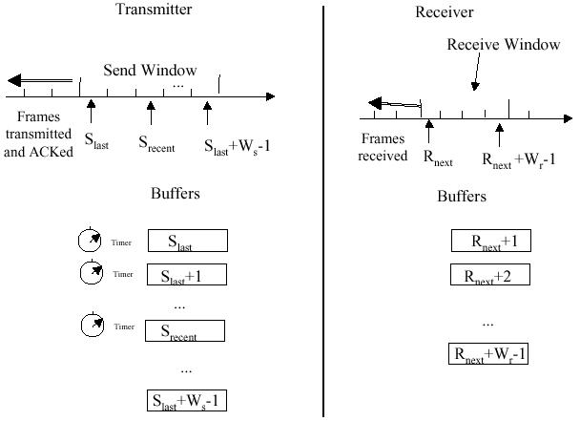
Figure 3.9 Selective Repeat ARQ
We continue to work under the constraint that the ARQ protocol must deliver an error-free and ordered sequence of packets to the destination. Figure 3.9 shows that the send window at the transmitter is unchanged but that the receive window now consists of a range of frame numbers spanning from Rnext to (Rnext + Wr –1), where Wr is the maximum number of frames that the receiver is willing to accept at a given time. As before, the basic objective of the protocol is to advance the values of Rnext and Slast through the delivery of the oldest outstanding frame. Thus ACK frames carry Rnext the oldest frame that has not yet been received. The receive window is advanced with the receipt of an error-free frame with sequence number Rnext.
Unlike the case of Go-Back-N ARQ, the receive window may be advanced by several frames. This step occurs when one or more frames that follow Rnext have already been received correctly and are buffered in the receiver. Rnext and the following consecutive packets are delivered to the destination at this point. Now consider the retransmission mechanism in Selective Repeat ARQ. The handling of timers at the transmitter is done as follows. When the timer expires, only the corresponding frame is retransmitted.

3.3 Flow Control
Flow control is a technique used for assuring that a receiving entity is not overwhelmed by the data from the transmitting entity. At the receiving entity the data received from the transmitter are buffered till they are processed and passed on to the higher layer software and it allocates some finite data memory for this buffering purpose. In the absence of flow control, the receiver’s buffer may fill up and overflow while it is still processing old data.

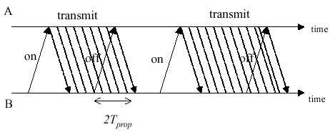
Figure 3.10 On-OFF Flow Control
The simplest procedure for exercising flow control is to use signals that direct the sender to stop transmitting the data. Suppose entity A is transmitting to entity B at a rate R bps. If entity B detects that its buffer are filling up, it issues a stop signal to entity A. After approximately one propagation delay Tprop entity A stops transmitting as shown in Figure 3.10
From the instant that B sent its signal, it receives an additional 2Tprop R bits, which is equal to the delay-bandwidth product of the link. Thus entity B must send the off signal when its buffer contents exceed a threshold value. This type of flow control is used in the X-ON / X-OFF protocol that is used between a terminal and a computer. This is also used in various Data link controls.
In the previous section we discussed ARQ sliding-window protocols. The objective there was to provide a reliable transfer of a sequence of data over an unreliable communication channel. Here we show how some of the elements of ARQ protocols can in fact provide flow control functionality also.

Sliding-Window Flow Control
The sliding-window protocols that were used in ARQ mechanism can also be used for flow control. In the simplest case the size of the send window Ws is made equal to the number of buffers that are available at the receiver. Because Ws is the maximum number of outstanding frames from the transmitter, buffer overflow cannot occur at the receiver.
Figure 3.11 shows an example where receiver sends an acknowledgement after the last frame in a window has been received. In this figure tcycle is the basic delay that elapses from the time the first frame is transmitted to the receipt of its acknowledgement.
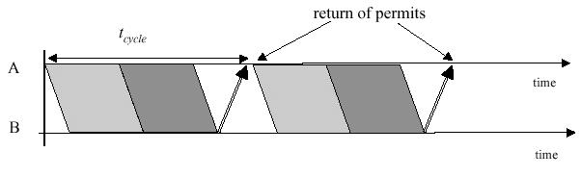
Figure 3.11 Sliding window Flow Control
The delay in sending the acknowledgements has the effect of pacing or controlling the rate at which the transmitter sends frames to the receiver.

3.4 High-level Data Link Control (HDLC)
The most important data link control protocol is HDLC (ISO 33009, ISO 4335). Not only is HDLC widely used, but also it is the basis for many other important data link control protocols, which use the same or similar formats and the same mechanisms as employed in HDLC. Accordingly, in this section we provide a detailed discussion of HDLC.

3.4.1 Basic Characteristics of HDLC
To satisfy a variety of applications, HDLC defines three types of stations, two link configurations, and three data-transfer modes of operation.
The three station types are
• Primary station. Has the responsibility for controlling the operation of the link. Frames issued by the primary are called commands.
• Secondary station. Operates under the control of the primary station. Frames issued by a secondary are called responses. The primary maintains a separate logical link with each secondary station on the line.
• Combined station. Combines the Features of primary and secondary. A combined station may issue both commands and responses.

The two link configurations are
• Unbalanced configuration. Consists of one primary and one or more secondary stations and supports both full-duplex and half-duplex transmission.
• Balanced configuration. Consists of two combined stations and supports both full-duplex and half-duplex transmission.

The three data transfer modes are
• Normal Response Mode (NRM). Used with an unbalanced configuration. The primary may initiate data transfer to a secondary, but a secondary may only transmit data in response to a command from the primary.
• Asynchronous balanced mode (ABM). Used with a balanced configuration. Either combined station may initiate transmission without receiving permission from the other combined station.
• Asynchronous response mode (ARM). Used with an unbalanced configuration. The secondary may initiate transmission without explicit permission of the primary. The primary still retains responsibility for the line, including initialization, error recovery, and logical disconnection.
NRM is used on mulitdrop lines, in which a number of terminals are connected to a host computer. The computer polls each terminal for input. NRM is also sometimes used on point-to-point links, particularly if the link connects a terminal or other peripheral to a computer. ABM is the most widely used of the three modes; it makes more efficient use of a full-duplex point-to-point link as there is no polling overhead. ARM is rarely used; it is applicable to some special situations in which a secondary may need to initiate transmission.

3.4.2 HDLC Frame Structure
HDLC uses synchronous transmission. All transmissions are in the form of frames, and a single frame format suffices for all types of data and control exchanges. Figure3.12a depicts the structure of the HDLC frame. The flag, address, and control fields that precede the information field are known as a header. The FCS and flag fields following the data or information field are referred to as a trailer.

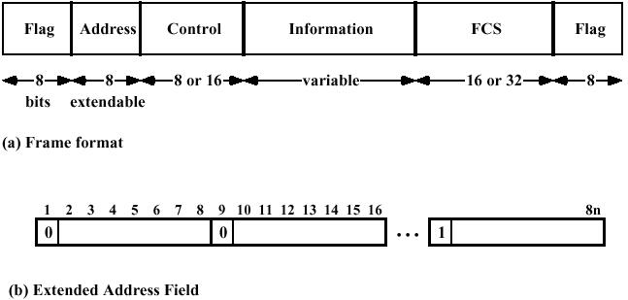
Figure 3.12(a), (b) HDLC frame structure
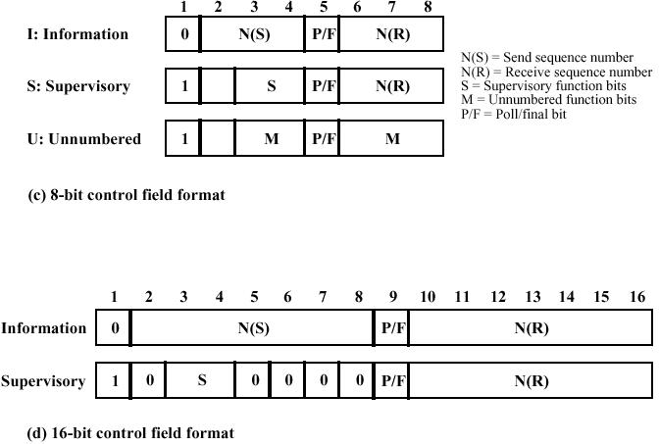
Figure 3.12(c), (d) HDLC frame structure

Flag Fields
Flag fields delimit the frame at both ends with the unique pattern 01111110. A single flag may be used as the closing flag for one frame and the opening flag for the next. On both sides of the user-network interface, receivers are continuously hunting for the flag sequence to synchronize on the start of a frame. While receiving a frame, a station continues to hunt for that sequence to determine the end of the frame. However, it is possible that the pattern 01111110 will appear somewhere inside the frame, thus destroying frame-level synchronization. To avoid this, a procedure known as bit stuffing is used.
Between the transmission of the starting and ending flags, the transmitter will always insert an extra 0 bit after each occurrence of five 1s in the frame. After detecting a starting flag, the receiver monitors the bit stream. When a pattern of five 1s appears, the sixth bit is examined. If this bit is 0, it is deleted. If the sixth bit is a 1 and the seventh bit is a 0, the combination is accepted as a flag. If the sixth and seventh bits are both 1, the sender is indicating an abort condition.
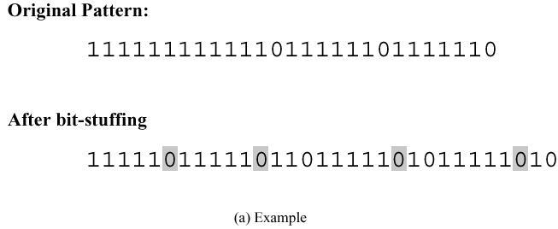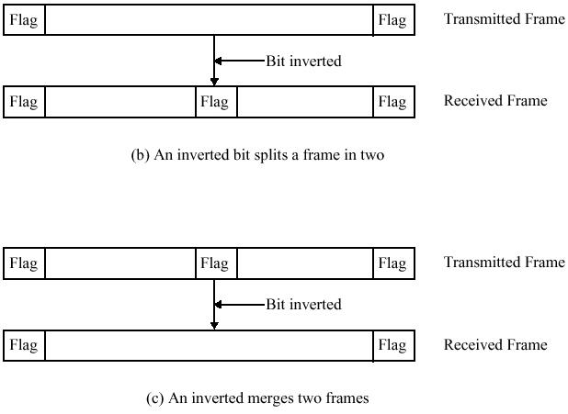
Figure 3.13 Bit stuffing.

With the use of bit stuffing, arbitrary bit patterns can be inserted into the data field of the frame. This property is known as data transparency.
Figure 3.13 shows an example of bit stuffing. Note that in the first two cases, the extra 0 is not strictly necessary for avoiding a flag pattern, but is necessary for the operation of the algorithm. The pitfalls of bit stuffing are also illustrated in this figure. When a flag is used as both an ending and a starting flag, a 1-bit error merges two frames into one; conversely, a 1-bit error inside the frame could split it in two. However these errors will be detected by the CRC checksum - FCS field and there will be retransmission of those frames.

Address field
The address field identifies the secondary station that transmitted or is to receive the frame. This field is not needed for point-to-point links, but is always included for the sake of uniformity. The address field is usually eight bits long but, by prior agreement, an extended format may be used in which the actual address length is a multiple of seven bits (Figure 3.12b). The least significant bit of each octet is 1 or 0 depending on whether it is or is not the last octet of the address field. The remaining seven bits of each octet form part of the address. The single-octet address of 11111111 is interpreted as the all-stations address in both basic and extended formats. It is used to allow the primary to broadcast a frame for reception by all secondaries.

Control field
HDLC defines three types of frames, each with a different control field format. Information frames (I-frames) carry the data to be transmitted for the user (the logic above HDLC that is using HDLC). Additionally, flow and error-control data using the ARQ mechanism, are piggybacked on an information frame. Supervisory frames (S-frames) provide the ARQ mechanism when piggybacking is not used. Unnumbered frames (U-frames) provide supplemental link control functions. The first one or two bits of the control field serves to identify the frame type. The remaining bit positions are organized into subfields as indicated in Figure 3.12c and d. Their use is explained below in the discussion of HDLC operation.
Note that the basic control field for S and I-frames uses 3-bit sequence numbers. With the appropriate set-mode command, an extended control field can be used for S- and I-frames that employs 7-bit sequence numbers. U-frames always contain an 8-bit control field.
Information Field
The information field is present only in I-frames and some U-frames. The field can contain any sequence of bits but must consist of an integral number of octets. The length of the information field is variable up to some system-defined maximum.
Frame Check Sequence Field
The frame check sequence (FCS) is an error-detecting code calculated from the remaining bits of the frame, exclusive of flags. The normal code is the 16-bit CRC. An optional 32-bit FCS, using CRC-32, may be employed if the frame length or the line reliability dictates this choice.

3.4.3 HDLC Operation
HDLC operation consists of the exchange of I-frames, S-frames, and U-frames between two stations. In describing HDLC operation, we will discuss these three types of frames.
The operation of HDLC involves three phases. First, one side or another initializes the data link so that frames may be exchanged in an orderly fashion. During this phase, the options that are to be used are agreed upon. After initialization, the two sides exchange user data and the control information to exercise flow and error control. Finally, one of the two sides signals the termination of the operation.
Initialization
Initialization may be requested by either side by issuing one of the six set-mode commands. This command serves three purposes:
1. It signals the other side that initialization is requested.
2. It specifies which of the three modes (NRM, ABM, ARM) is requested.
3. It specifies whether 3- or 7-bit sequence numbers are to be used.
If the other side accepts this request, then the HDLC module on that end transmits an unnumbered acknowledged (UA) frame back to the initiating side. If the request is rejected, then a disconnected mode (DM) frame is sent.
Data Transfer
When the initialization has been requested and accepted, then a logical connection is established. Both sides may begin to send user data in I-frames, starting with sequence number 0. The N(S) and N(R) fields of the I-frame are sequence numbers that support flow control and error control. An HDLC module sending a sequence of I-frames will number them sequentially, modulo 8 or 128, depending on whether 3- or 7-bit sequence numbers are used, and place the sequence number in N(S). N(R) is the acknowledgment for I-frames received; it enables the HDLC module to indicate which number I-frame it expects to receive next. S-frames are also used for flow control and error control.
Disconnect
Either HDLC module can initiate a disconnect, either on its own initiative if there is some sort of fault, or at the request of its higher-layer user. HDLC issues a disconnect by sending a disconnect (DISC) frame. The other side must accept the disconnect by replying with an acknowledgement.

Exercise
- List some of the requirements and objectives of data link control, for effective data communication between two directly connected transmitting-receiving stations.
- Discuss Single parity check error detection.
- Discuss error detection system. What are the limitations of error detection systems? What is the objective in selecting an error-detection codeword?
- What is Cyclic Redundancy Check? Discuss.
- What are the types of error possible in a frame transmission over a channel?
- What is ARQ protocol? What are the mechanisms involved in it? Discuss basic elements of ARQ mechanism.
- List various ARQ protocols. Discuss at least two of them.
- Why Flow control is required? Discuss Sliding Window Flow Control mechanism.
- What is HDLC? Discuss the basic characteristics of HDLC.
- Discuss the HDLC frame structure.
- Discuss different HDLC operations.

