Chapter 4 Local Area Networks and
MAC Protocols
4.0 Introduction
4.1 LAN Architecture
4.2 LAN Topologies
4.2.1 Bus and Tree Topologies
4.2.2 Ring Topology
4.2.3 Star Topology
4.3 Medium Access Control
4.3.1 Round Robin
4.3.2 Reservation
4.3.3 Contention
4.4 MAC Frame Format
4.5 Logical Link Control
4.6 LAN Systems
4.6.1 Ethernet and Fast Ethernet (csma/cd)
4.6.2 Token Ring
4.6.2.1 IEEE 802.5 Medium Access Control
4.6.2.2 FDDI
4.7 Interconnection of LANs - Bridges

4.0 Introduction
Basically there are two types of Networks Technology: Switched Networks and Broadcast Networks. In Switched Networks, systems are interconnected by means of point-to-point transmission lines, multiplexers and switches, which are covered in Chapter 2. In Switched Networks, the transfer of packet across networks requires routing, to direct packets from source to destination, as the source and destination stations will not be connected by a single transmission link most of the cases. But in Broadcast Networks, all the systems are connected to common transmission medium, which acts as a broadcast medium making routing unnecessary. In its simplest form, a transmission from any one system is broadcast to and received by all other systems and if the received packet is meant for the system, it will process it, otherwise discards. Since the transmission medium is shared by all the connected systems, there is a need for additional layer, consisting of Medium Access Control (MAC) Protocol to orchestrate the transmissions from various systems. The role of the MAC protocol is to co-ordinate the access to the transmission medium so that packets transmitted from the systems do not interfere with other packets.
There are two networks based on broadcast medium.
Local Area Networks (LANs) and Metropolitan Area Networks (MANs). The definitions of LANs and MANs, taken from one of the IEEE 802 standards documents are as follows.
The LANs are distinguished from other types of data networks in that they are optimized for a moderate size geographic area such as a single office building or a campus. The LAN is a shared medium peer-to-peer communications network that broadcasts information for all stations to receive. As a consequence, it does not inherently provide privacy. The LAN enables stations to communicate directly using a common physical medium on a point-to-point basis without any intermediate switching node being required. There is always need for an access sub-layer in order to arbitrate the access to the shared medium. The network is generally owned, used, and operated by a single organization.
A MAN is optimized for a larger geographical area than a LAN, ranging from several blocks of buildings to entire city. As with local networks, MANs can also depend on communications channels of moderate-to-high data rates. Error rates and delay may be slightly higher than might be obtained on a LAN. A MAN might be owned and operated by a single organization, but usually will be used by many individuals and organizations. They will often provide means for internetworking of local area networks.

The key technology ingredients that determine the nature of a LAN or MAN are
• Topology
• Transmission medium
• Medium Access Control technique
Various topologies and transmission medium that are most commonly used for LANs and MANs, various Medium Access Control Protocols and the concept of a bridge, which play a critical role in extending LAN coverage, are discussed in this Chapter. However LAN is the most widely implemented network amongst the two and with the usage of bridges they cover wider area also and underlying technologies used in LAN and MAN bearing many similarities we concentrate here on LAN.

4.1 LAN Architecture
The architecture of a LAN is best described in terms of a layering of protocols that organize the basic functions of a LAN. This section opens with a description of the standardized protocol architecture for LANs, which encompasses physical, medium access control, and logical link control layers. Each of these layers is then examined in turn.

LAN Protocol Architecture
Protocols defined specifically for LAN and MAN transmission address issues relating to the transmission of blocks of data over the network. In OSI terms, higher layer protocols (layer 3 or 4 and above) are independent of network architecture and are applicable to LANs, MANs, and WANs. Thus, a discussion of LAN protocols is concerned principally with lower layers of the OSI model.
Figure 4.1 relates the LAN protocols to the OSI architecture. This LAN architecture was developed by the IEEE 802 committee and has been adopted by all organizations working on the specification of LAN standards. It is generally referred to as the IEEE 802 reference model.
Working from the bottom up, the lowest layer of the IEEE 802 reference model corresponds to the physical layer of the OSI model, and includes such functions as
• Encoding / decoding of signals
• Preamble generation / removal (for synchronization)
• Bit transmission / reception
In addition, the physical layer of the 802 models includes a specification of the transmission medium and the topology. Generally, this is considered below the lowest layer of the OSI model. However, the choice of transmission medium and topology
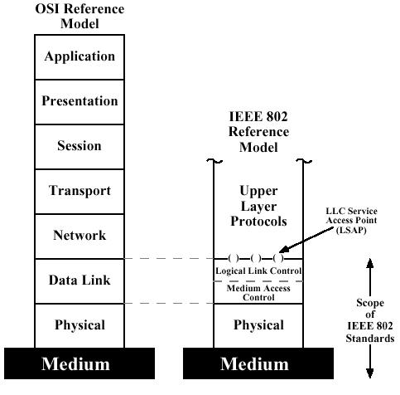

Figure 4.1 IEEE 802 protocol layers compared to OSI mode
is critical in LAN design, and so a specification of the medium is included.
Above the physical layer are the functions associated with providing service to LAN users. These include
• On transmission, assemble data into a frame with address and error-detection fields.
• On reception, disassemble frame, perform address recognition and error detection.
• Govern access to the LAN transmission medium.
• Provide an interface to higher layers and perform flow and error control.
These are functions typically associated with OSI layer 2 and are grouped into a logical link control (LLC) layer. The functions in the first three items are treated as a separate layer, called medium access control (MAC). The separation is done for the following reasons:
• The logic required to manage access to a shared-access medium is not found in traditional layer-2 data link control.
• For the same LLC, several MAC options may be provided.
Some of the standards that have been issued by IEEE are listed below
Standard | Topology | Network | Medium
IEEE 802.3  CSMA/CD | Bus / Tree / Star | LAN | Co-axial cable, Twisted Pair cable, Optical Fiber
IEEE 802.4  Token Bus | Bus / Tree / Star | LAN | Co-axial cable,  Optical Fiber
IEEE 802.5  Token Ring | Ring topology | LAN | Twisted Pair cable
FDDI  Token Ring | Ring topology | LAN | Optical Fiber,  Unshielded Twisted Pair
IEEE 802.6  DQDB | Dual Bus topology | MAN | Optical Fiber
IEEE 802.11  CSMA Polling | Wireless Infrared | LAN | Spread Spectrum
IEEE 802 LAN / MAN Standards
Most of the standards were developed by a committee IEEE 802, sponsored by the Institute for Electrical and Electronics Engineers. All of these standards have subsequently been adopted as international standards by the International Organization for Standardization (ISO).
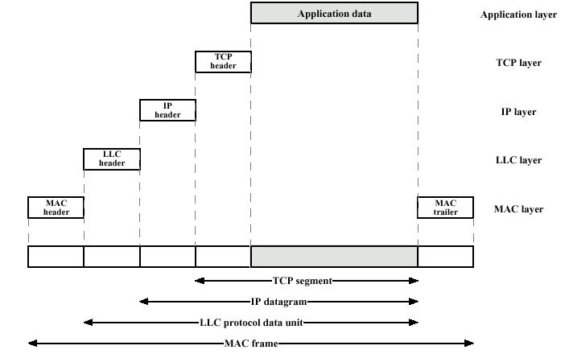

Figure 4.2 LAN protocols in context
Figure 4.2 illustrates the relationship between the levels of the architecture. User data are passed down to LLC, which appends control information as a header, creating an LLC protocol data unit (PDU). This control information is used in the operation of the LLC protocol. The entire LLC PDU is then passed down to the MAC layer, which appends control information header and trailer at the front and back of the packet, forming a MAC frame. Again, the control information in the frame is needed for the operation of the MAC protocol. For context, the figure also shows the use of TCP/IP and an application layer above the LAN protocols.

4.2 LAN Topologies
The common topologies for LANs are bus, tree, ring, and star (Figure 4.3). The bus is a special case of the tree, with only one trunk and no branches.
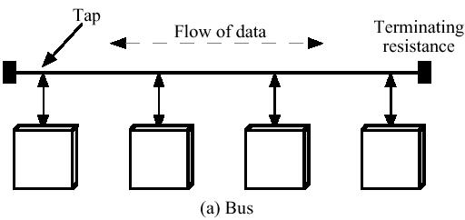
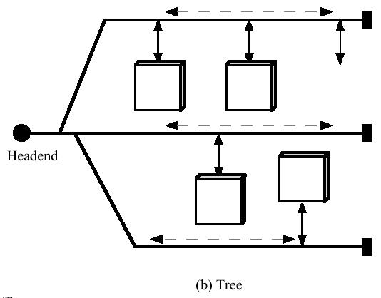
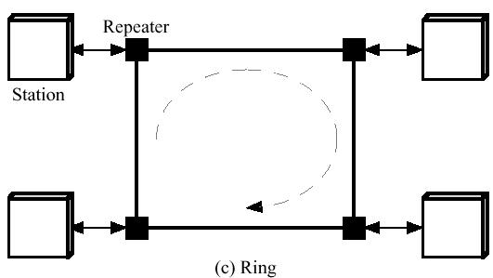
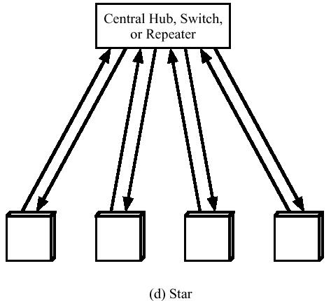

Figure 4.3 LAN/MAN topologies

4.2.1 Bus and Tree Topologies
Both bus and tree topologies are characterized by the use of a multipoint medium. For the bus, all stations attach, through appropriate hardware interfacing known as a tap, directly to a linear transmission medium, or bus. Full-duplex operation between the station and the tap allows data to be transmitted onto the bus and received from the bus. A transmission from any station propagates the length of the medium in both directions and can be received by all other stations. At each end of the bus is a terminator, which absorbs any signal, removing it from the bus.
The tree topology is a generalization of the bus topology. The transmission medium is a branching cable with no closed loops. The tree layout begins at a point known as the headend , where one or more cables start, and each of these may have branches. The branches in turn may have additional branches to allow quite complex layouts. Again, a transmission from any station propagates throughout the medium and can be received by all other stations.
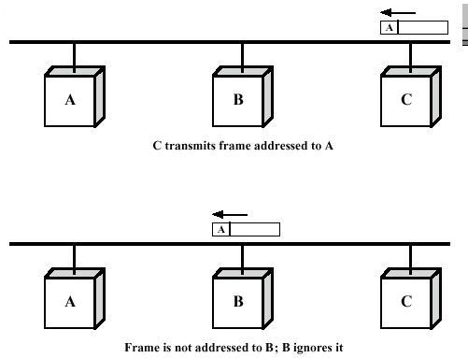
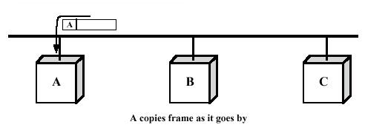
Figure 4.4 Frame transmission on a bus LAN.
Two problems present themselves in this arrangement. First, because a transmission from any one station can be received by all other stations, there needs to be some way of indicating for whom the transmission is intended. Second, a mechanism is needed to regulate transmission. To see the reason for this, consider that if two stations on the bus attempt to transmit at the same time, their signals will overlap and become garbled. Or, consider that one station decides to transmit continuously for a long period of time.
To solve these problems, stations transmit data in small blocks, known as frames. Each frame consists of a portion of the data that a station wishes to transit, plus a frame header that contains control information. Each station on the bus is assigned a unique address, or identifier, and the destination address for a frame is included in its header.
Figure 4.4 illustrates the scheme. In this example, station C wishes to transmit a frame of data to A. The frame header includes A's address. As the frame propagates along the bus, it passes B, which observes the address and ignores the frame. A, on the other hand, sees that the frame is addressed to itself and therefore copies the data from the frame as it goes by.
So the frame structure solves the first problem mentioned above: It provides a mechanism for indicating the intended recipient of data. It also provides the basic tool for solving the second problem, the regulation of access. In particular, the stations take turns sending frames in some cooperative fashion; this involves putting additional control information into the frame header.
With the bus or tree, no special action needs to be taken to remove frames from the medium. When a signal reaches the end of the medium, it is absorbed by the terminator.

4.2.2 Ring Topology
In the ring topology, the network consists of a set of repeaters joined by point-to-point links to form a closed loop. The repeater is a comparatively simple device, capable of receiving data on one link and transmitting them, bit by bit, on the other link as fast as they are received, with no buffering at the repeater. The links are unidirectional; that is, data are transmitted in one direction only and all are oriented in the same way. Thus, data circulate around the ring in one direction (clockwise or counterclockwise).
Each station attaches to the network at a repeater and can transmit data onto the network through that repeater.
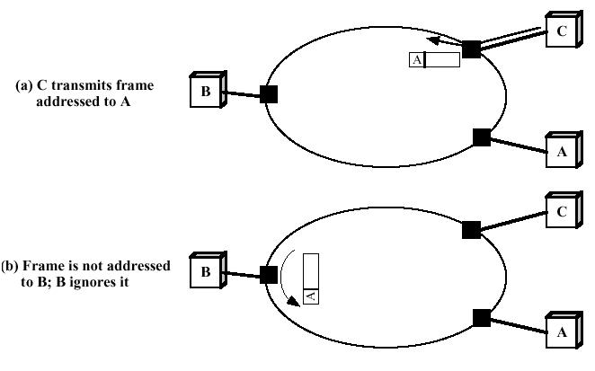
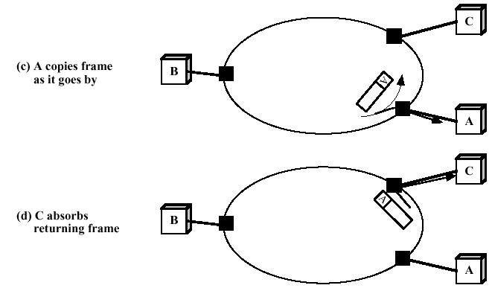
Figure 4.5 Frame transmission on a ring LAN.
As with the bus and tree, data are transmitted in frames. As a frame circulates past all the other stations, the destination station recognizes its address and copies the frame into a local buffer as it goes by. The frame continues to circulate until it returns to the source station, where it is removed (Figure 4.5). Because multiple stations share the ring, medium access control is needed to determine at what time each station may insert frames.

4.2.3 Star Topology
In the star LAN topology, each station is directly connected to a common central node. Typically, each station attaches to a central node, referred to as the star coupler, via two point-to-point links, one for transmission in each direction.
In general, there are two alternatives for the operation of the central node. One approach is for the central node to operate in a broadcast fashion. A transmission of a frame from one station to the node is retransmitted on all of the outgoing links. In this case, although the arrangement is physically a star, it is logically a bus; a transmission from any station is received by all other stations, and only one station at a time may successfully transmit.
Another approach is for the central node to act as a frame-switching device. An incoming frame is buffered in the node and then retransmitted on an outgoing link to the destination station.

4.3 Medium Access Control
All LANs and MANs consist of collections of devices that must share the network's transmission capacity. Some means of controlling access to the transmission medium is needed to provide for an orderly and efficient use of that capacity. This is the function of a Medium Access Control (MAC) protocol.
The key parameters in any medium access control technique are where and how. Where refers to whether control is exercised in a centralized or distributed fashion. In a centralized scheme, a controller is designated that has the authority to grant access to the network. A station wishing to transmit must wait until it receives permission from the controller. In a decentralized network, the stations collectively perform a medium access control function to dynamically determine the order in which stations transmit.
A centralized scheme has certain advantages, such as the following:
• It may afford greater control over access for providing such things as priorities, overrides, and guaranteed capacity.
• It enables the use of relatively simple access logic at each station.
• It avoids problems of distributed coordination among peer entities.
The principal disadvantages of centralized schemes are
• It creates a single point of failure; that is, there is a point in the network that, if it fails, causes the entire network to fail.
• It may act as a bottleneck, reducing performance.
The second parameter, how, is constrained by the topology and is a trade-off between competing factors, including cost, performance, and complexity. In general, we can categorize access control techniques as being either synchronous or asynchronous. With synchronous techniques, a specific capacity is dedicated to a connection; this is the same approach used in circuit switching, frequency-division multiplexing (FDM), and synchronous time-division multiplexing (TDM). Such techniques are generally not optimal in LANs and MANs because the needs of the stations are unpredictable. It is preferable to be able to allocate capacity in an asynchronous (dynamic) fashion, more or less in response to immediate demand. The asynchronous approach can be further subdivided into three categories: round robin, reservation, and contention.

4.3.1 Round Robin
With round robin, each station in turn is given the opportunity to transmit. During that opportunity, the station may decline to transmit or may transmit subject to a specified upper bound, usually expressed as a maximum amount of data transmitted or time for this opportunity. In any case, the station, when it is finished, relinquishes its turn, and the right to transmit passes to the next station in logical sequence. Control of sequence may be centralized or distributed. Polling is an example of a centralized technique.
When many stations have data to transmit over an extended period of time, round robin techniques can be very efficient. If only a few stations have data to transmit over an extended period of time, then there is a considerable overhead in passing the turn from station to station, as most of the stations will not transmit but simply pass their turns. Under such circumstances, other techniques may be preferable, largely depending on whether the data traffic has a stream or bursty characteristic. Stream traffic is characterized by lengthy and fairly continuous transmissions; examples are voice communication, telemetry, and bulk file transfer. Bursty traffic is characterized by short, sporadic transmissions; interactive terminal-host traffic fits this description.

4.3.2 Reservation
For stream traffic, reservation techniques are well suited. In general, for these techniques, time on the medium is divided into slots, much as with synchronous TDM. A station wishing to transmit reserves future slots for an extended or even an indefinite period. Again, reservations may be made in a centralized or distributed fashion.

4.3.3 Contention
For bursty traffic, contention techniques are usually appropriate. With these techniques, no control is exercised to determine whose turn it is; all stations contend for time in a way that can be, as we shall see, rather rough and tumble. These techniques are, of necessity, distributed by nature. Their principal advantage is that they are simple to implement and, under light to moderate load of data traffic, they are efficient. For some of these techniques, however, performance tends to collapse under heavy load.
Although both centralized and distributed reservation techniques have been implemented in some LAN products, round robin and contention techniques are the most common.
The discussion above has been somewhat abstract and should become clearer as specific techniques are discussed in later sections.
The following Table lists the MAC protocols that are defined in LAN and MAN standards.
 | Bus Topology | Ring Topology | Switched Topology
Round Robin | Token Bus  (IEEE 802.4) | Token Ring  (IEEE 802.5) | Request/Priority  (IEEE 802.12)
Reservation | DQDB (IEEE 802.6)
Contention | CSMA/CD (IEEE 802.3)  CSMA (IEEE 802.11) |  | CSMA/CD  (IEEE 802.3)

4.4 MAC Frame Format
The MAC layer receives a block of data from the LLC layer and is responsible for performing functions related to medium access and for transmitting the data. As with other protocol layers, MAC implements these functions, making use of a protocol data unit at its layer; in this case, the PDU is referred to as a MAC frame.
The exact format of the MAC frame differs somewhat for the various MAC protocols in use. In general, all of the MAC frames have a format similar to that of Figure 4.6
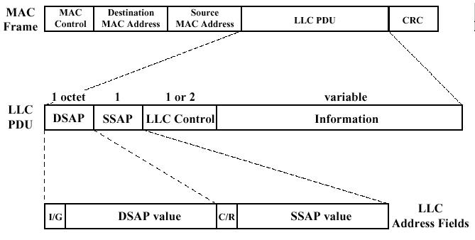

Figure 4.6 LLC PDU with generic MAC frame format
The fields of this frame are
• MAC control. This field contains any protocol control information needed for the functioning of the MAC protocol. For example, a priority level could be indicated here.
• Destination MAC address. The address of the destination device on the LAN for this frame.
• Source MAC address. The address of the source device on the LAN from which this frame is being transmitted.
• LLC. The LLC data from the next higher layer.
• CRC. The cyclic redundancy check field (also known as the frame check sequence, FCS, field). This is an error-detecting code as we have seen in previous chapter.
In most data link control protocols, the data link protocol entity is responsible not only for detecting errors using the CRC, but for recovering from those errors by retransmitting damaged frames. In the LAN protocol architecture, these two functions are split between the MAC and LLC layers. The MAC layer is responsible for detecting errors and discarding any frames that are in error. The LLC layer optionally keeps track of which frames have been successfully received and retransmits unsuccessful frames.

4.5 Logical Link Control
The LLC layer for LANs is similar in many respects to other link layers in common use. Like all link layers, LLC is concerned with the transmission of a link-level protocol data unit (PDU) between two stations, without the necessity of an intermediate switching node. LLC has two characteristics not shared by most other link control protocols:
- It must support the multi-access, shared-medium nature of the link.
- It is relieved of some details of link access by the MAC layer.
Addressing in LLC involves specifying the source and destination LLC users. Typically, a user is a higher-layer protocol or a network management function in the station. These LLC user addresses are referred to as service access points (SAPs), in keeping with OSI terminology for the user of a protocol layer. We look first at the services that LLC provides to a higher-level user, then at the LLC protocol.

LLC Services
LLC specifies the mechanisms for addressing stations across the medium and for controlling the exchange of data between two users. The operation and format of this standard is based on HDLC. Three services are provided as alternatives for attached devices using LLC:
• Unacknowledged connectionless service. This service is a datagram style service. It is a very simple service that does not involve any of the flow and error-control mechanisms. Thus, the delivery of data is not guaranteed. However, in most devices, there will be some higher layer of software that deals with reliability issues.
• Connection-mode service. This service is similar to that offered by HDLC. A logical connection is set up between two users exchanging data, and flow control and error control are provided
• Acknowledged connectionless service. This is a cross between the previous two services. It provides that datagrams are to be acknowledged, but no prior logical connection is set up.
Typically, a vendor will provide these services as options that the customer can select when purchasing the equipment. Alternatively, the customer can purchase equipment that provides two or all three services and select a specific service based on application.
The unacknowledged connectionless service requires minimum logic and is useful in two contexts. First, it will often be the case that higher layers of software will provide the necessary reliability and flow-control mechanism, and it is efficient to avoid duplicating them. For example, either TCP or the ISO transport protocol standard would provide the mechanisms needed to ensure that data are delivered reliably. In a monitoring application, the loss of an occasional data unit would not cause distress, as the next report should arrive shortly. Thus, in most cases, the unacknowledged connectionless service is the preferred option.
The connection-mode service could be used in very simple devices, such as terminal controllers, that have little software operating above this level. In these cases, it would provide the flow control and reliability mechanisms normally implemented at higher layers of the communications software.
The acknowledged connectionless service is useful in several contexts. With the connection-mode service, the logical link control software must maintain some sort of table for each active connection, so as to keep track of the status of that connection. If the user needs guaranteed delivery, but there are a large number of destinations for data, then the connection-mode service may be impractical because of the large number of tables required. Another use is the handling of important and time-critical alarm or emergency control signals in a factory. Because of their importance, an acknowledgment is needed so that the sender can be assured that the signal got through. Because of the urgency of the signal, the user might not want to take the time to first establish a logical connection and then send the data.

4.6 LAN Systems
We now consider specific LAN systems. As was mentioned earlier, the medium access control technique and topology are key characteristics used in the classification of LANs and in the development of standards. Following systems are discussed here:
• Ethernet and Fast Ethernet (CSMA/CD)
• Token Ring
• FDDI

4.6.1 Ethernet and Fast Ethernet (csma/cd)
The most commonly used medium access control technique for bus/tree and star topologies is Carrier Sense Multiple Access with Collision Detection (CSMA/CD). The original baseband version of this technique was developed by Xerox as part of the Ethernet LAN. The original broadband version was developed by MITRE as part of its MITREnet LAN. All of this work formed the basis for the IEEE 802.3 standard.
This Ethernet system derived its name from the luminiferous ether, through which electromagnetic radiations were once thought to propagate. (When British physicist James Clerk Maxwell discovered in nineteenth century that electromagnetic radiation could be described by the wave equation, scientists assumed that space must be filled with some ethereal medium in which medium the radiation was propagating. Only later they found that electromagnetic radiation could propagate in a vacuum.)

Precursors – History of CSMA/CD
The 802.3 has an interesting history. The real beginning was the ALOHA system developed to allow radio communication between machines scattered over Hawaiian Islands. CSMA/CD and its precursors can be termed random access, or contention, techniques. They are random access in the sense that there is no predictable or scheduled time for any station to transmit; station transmissions are ordered randomly.
They exhibit contention in the sense that stations contend for time on the medium. The earliest of these techniques, known as ALOHA, was developed for packet radio networks. However, it is applicable to any shared transmission medium. ALOHA, or pure ALOHA as it is sometimes called, is a true free-for-all.
Whenever a station has a frame to send, it does so. The station then listens for an amount of time equal to the maximum possible round-trip propagation delay on the network (twice the time it takes to send a frame between the two most widely separated stations) plus a small fixed time increment. If the station hears an acknowledgment during that time, fine; otherwise, it resends the frame. If the station fails to receive an acknowledgment after repeated transmissions, it gives up. A receiving station determines the correctness of an incoming frame by examining a frame-check-sequence field, as in HDLC. If the frame is valid and if the destination address in the frame header matches the receiver's address, the station immediately sends an acknowledgment. The frame may be invalid due to noise on the channel or because another station transmitted a frame at about the same time. In the latter case, the two frames may interfere with each other at the receiver so that neither gets through; this is known as a collision. If a received frame is determined to be invalid, the receiving station simply ignores the frame.
ALOHA is as simple as can be, and pays a penalty for it. Because the number of collisions rise rapidly with increased load, the maximum utilization of the channel is only about 18%. To improve efficiency, a modification of ALOHA, known as slotted ALOHA, was developed. In this scheme, time on the channel is organized into uniform slots whose size equals the frame transmission time. Some central clock or other technique is needed to synchronize all stations. Transmission is permitted to begin only at a slot boundary. Thus, frames that do overlap will do so totally. This increases the maximum utilization of the system to about 37%.
Both ALOHA and slotted ALOHA exhibit poor utilization. Both fail to take advantage of one of the key properties of both packet radio and LANs, which is that propagation delay between stations is usually very small compared to frame transmission time. Consider the following observations. If the station-to-station propagation time is large compared to the frame transmission time, then, after a station launches a frame, it will be a long time before other stations know about it. During that time, one of the other stations may transmit a frame; the two frames may interfere with each other and neither gets through. Indeed, if the distances are great enough, many stations may begin transmitting, one after the other, and none of their frames get through unscathed. Suppose, however, that the propagation time is small compared to frame transmission time. In that case, when a station launches a frame, all the other stations know it almost immediately. So, if they had any sense, they would not try transmitting until the first station was done. Collisions would be rare because they would occur only when two stations began to transmit almost simultaneously. Another way to look at it is that a short delay time provides the stations with better feedback about the state of the network; this information can be used to improve efficiency.
The foregoing observations led to the development of carrier-sense multiple access (CSMA). With CSMA, a station wishing to transmit first listens to the medium to determine if another transmission is in progress (carrier sense). If the medium is in use, the station must wait. If the medium is idle, the station may transmit. It may happen that two or more stations attempt to transmit at about the same time. If this happens, there will be a collision; the data from both transmissions will be garbled and not received successfully. To account for this, a station waits a reasonable amount of time, after transmitting, for an acknowledgment, taking into account the maximum round-trip propagation delay, and the fact that the acknowledging station must also contend for the channel in order to respond. If there is no acknowledgment, the station assumes that a collision has occurred and retransmits.
One can see how this strategy would be effective for networks in which the average frame transmission time is much longer than the propagation time. Collisions can occur only when more than one user begins transmitting within a short time (the period of the propagation delay). If a station begins to transmit a frame, and there are no collisions during the time it takes for the leading edge of the packet to propagate to the farthest station, then there will be no collision for this frame because all other stations are now aware of the transmission.
The maximum utilization achievable using CSMA can far exceed that of ALOHA or slotted ALOHA. The maximum utilization depends on the length of the frame and on the propagation time; the longer the frames or the shorter the propagation time, the higher the utilization.
With CSMA, an algorithm is needed to specify what a station should do if the medium is found busy. The most common approach, and the one used in IEEE 802.3, is the 1-persistent technique. A station wishing to transmit listens to the medium and obeys the following rules:
1. If the medium is idle, transmit; otherwise, go to step 2.
2. If the medium is busy, continue to listen until the channel is sensed idle; then transmit immediately.
If two or more stations are waiting to transmit, a collision is guaranteed. Things get sorted out only after the collision.

Description of CSMA/CD
CSMA, although more efficient than ALOHA or slotted ALOHA, still has one glaring inefficiency: When two frames collide, the medium remains unusable for the duration of transmission of both damaged frames. For long frames, compared to propagation time, the amount of wasted capacity can be considerable. This waste can be reduced if a station continues to listen to the medium while transmitting. This leads to the following rules for CSMA/CD:
1. If the medium is idle, transmit; otherwise, go to step 2.
2. If the medium is busy, continue to listen until the channel is idle, then transmit immediately.
3. If a collision is detected during transmission, transmit a brief Jamming signal to assure that all stations know that there has been a collision and then cease transmission.
4. After transmitting the jamming signal, wait a random amount of time, and then attempt to transmit again. (Repeat from step 1.)

Figure 4.7 illustrates the technique for a baseband bus. At time to, station A begins transmitting a packet addressed to D. At t1, both B and C are ready to transmit. B senses a transmission and so defers. C, however, is still unaware of A's transmission and begins its own transmission. When A's transmission reaches C, at t2, C detects the collision and ceases transmission. The effect of the collision propagates back to A, where it is detected some time later, t3, at which time A ceases transmission.
With CSMA/CD, the amount of wasted capacity is reduced to the time it takes to detect a collision. Question: how long does that take? Let us consider first the case of a baseband bus and consider two stations as far apart as possible. For example, in Figure 4.7, suppose that station A begins a transmission and that just before that transmission reaches D, D is ready to transmit. Because D is not yet aware of A's transmission, it begins to transmit. A collision occurs almost immediately and is recognized by D. However, the collision must propagate all the way back to A before A is aware of the collision. By this line of reasoning, we conclude that the amount of time that it takes to detect a collision is no greater than twice the end-to-end propagation delay.
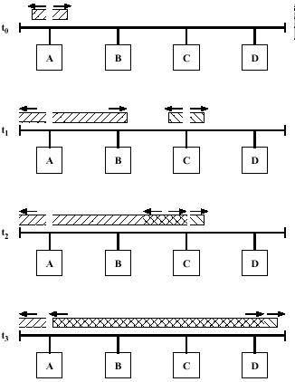
Figure 4.7 CSMA/CD operation.
An important rule followed in most CSMA/CD systems, including the IEEE standard, is that frames should be long enough to allow collision detection prior to the end of transmission. If shorter frames are used, then collision detection does not occur, and CSMA/CD exhibits the same performance as the less efficient CSMA protocol.
Although the implementation of CSMA/CD is substantially the same for baseband and broadband, there are differences. One is the means for performing carrier sense; for baseband systems, this is done by detecting a voltage pulse train and for broadband, the RF carrier is detected.

CSMA/CD MAC Frame
Figure 4.8 depicts the frame format for the 802.3 protocol; it consists of the following fields:
• Preamble. A 7-octet pattern of alternating 0s and 1s used by the receiver to establish bit synchronization.
• Start frame delimiter. The sequence 10101011, which indicates the actual start of the frame and enables the receiver to locate the first bit of the rest of the frame.
• Destination address (DA). Specifies the station(s) for which the frame is intended. It may be a unique physical address, a group address, or a global address. The choice of a 16 or 48-bit address length is an implementation decision, and must be the same for all stations on a particular LAN.
• Source address (SA). Specifies the station that sent the frame.
• Length. Length of the LLC data field.
• LLC data. Data unit supplied by LLC.
• Pad. Octets added to ensure that the frame is long enough for proper CD operation.

Octets | 7 | 1 | 2 or 6 | 2 or 6 | 2 | >= 0 | >= 0 | 4
 | Preamble | SFD | DA | SA | Length | LLC Data | Pad | FCS

Figure 4.8 IEEE 802.3 frame format.
Legend
SFD = Start-frame delimiter SA = Source address
DA = Destination address FCS = Frame-check sequence

4.6.2 Token Ring
Token ring is the most commonly used MAC protocol for ring-topology LANs. In this section, we examine two standard LANs that use token ring: IEEE 802.5 and FDDI.

4.6.2.1 IEEE 802.5 Medium Access Control
MAC Protocol
The token ring technique is based on the use of a small frame, called a token, which circulates when all stations are idle. A station wishing to transmit must wait until it detects a token passing by. It then seizes the token by changing one bit in the token, which transforms it from a token into a start-of-frame sequence for a data frame. The station then appends and transmits the remainder of the fields needed to construct a data frame.
When a station seizes a token and begins to transmit a data frame, there is no token on the ring, so other stations wishing to transmit must wait. The frame on the ring will make a round trip and be absorbed by the transmitting station. The transmitting station will insert a new token on the ring when both of the following conditions have been met:
• The station has completed transmission of its frame.
• The leading edge of the transmitted frame has returned (after a complete circulation of the ring) to the station.
If the bit length of the ring is less than the frame length, the first condition implies the second; if not, a station could release a free token after it has finished transmitting but before it begins to receive its own transmission. The second condition is not strictly necessary, and is relaxed under certain circumstances. The advantage of imposing the second condition is that it ensures that only one data frame at a time may be on the ring and that only one station at a time may be transmitting, thereby simplifying error-recovery procedures.
Once the new token has been inserted on the ring, the next station downstream with data to send will be able to seize the token and transmit. Figure 4.9 illustrates the technique. In the example, A sends a packet to C, which receives it and then sends its own packets to A and D.
Note that under lightly loaded conditions, there is some inefficiency with token ring because a station must wait for the token to come around before transmitting. However, under heavy loads, which is when it matters, the ring functions in a round-robin fashion, which is both efficient and fair. To see this, consider the configuration in Figure 4.9. After station A transmits, it releases a token. The first station with an opportunity to transmit is D. If D transmits, it then releases a token and C has the next opportunity, and so on.
The principal advantage of token ring is the flexible control over access that it provides. In the simple scheme just described, the access if fair. As we shall see schemes can be used to regulate access to provide for priority and for guaranteed bandwidth services.
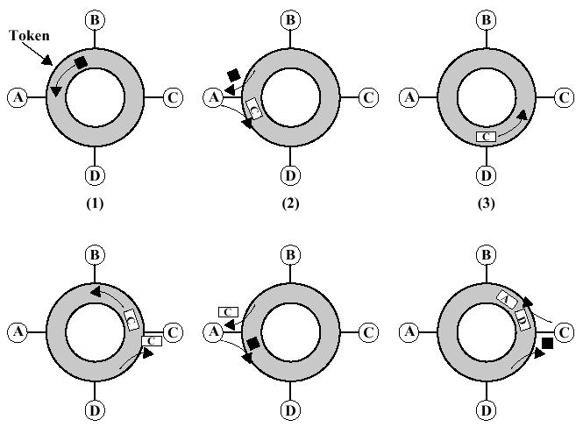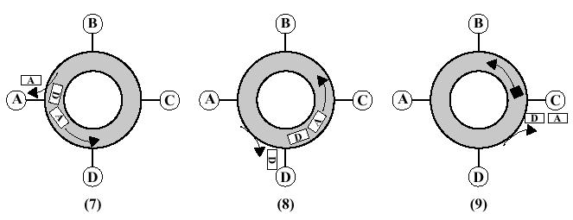
Figure 4.9 Token ring operation
The principal disadvantage of token ring is the requirement for token maintenance. Loss of the token prevents further utilization of the ring. Duplication of the token can also disrupt ring operation. One station must be selected as a monitor to ensure that exactly one token is on the ring and to ensure that a free token is reinserted, if necessary.

Token ring MAC frame format
Figure 4.10 depicts the frame format for the 802.5 protocol. It consists of the following fields:
• Starting delimiter (SD). Indicates start of frame. The SD consists of signaling patterns that are distinguishable from data. It is coded as follows: JK0JK000, where J and K are nondata symbols. The actual form of a nondata symbol depends on the signal encoding on the medium.
• Access control (AC). Has the format PPPTMRRR, where PPP and RRR are 3-bit priority and reservation variables, and M is the monitor bit; their use is explained below. T bit indicates whether this is a token or data frame. In the case of a token frame, the only remaining field is ED.
• Frame control (FC). Indicates whether this is an LLC data frame. If not, bits in this field control operation of the token ring MAC protocol.
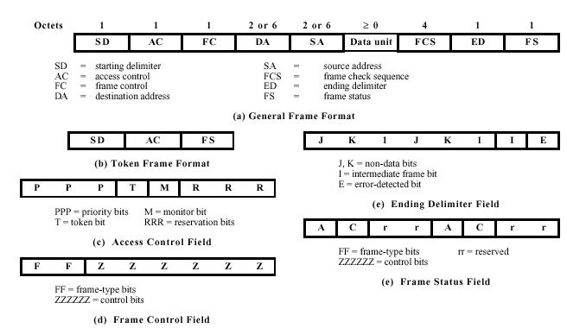
Figure 4.10 IEEE 802.5 frame format.

• Destination address (DA). As with 802.3 CSMA/CD.
• Source address (SA). As with 802.3 CSMA/CD.
• Data unit. Contains LLC data unit.
• Frame check sequence (FCS). As with 802.3 CSMA/CD.
• End delimiter (ED). Contains the error-detection bit (E), which is set if any repeater detects an error, and the intermediate bit (I ), which is used to indicate that this is a frame other than the final one of a multiple-frame transmission.
• Frame status (FS). Contains the address recognized (A) and frame-copied (C) bits, whose use is explained below. Because the A and C bits are outside the scope of the FCS, they are duplicated to provide a redundancy check to detect erroneous settings.
We can now restate the token ring algorithm for the case when a single priority is used. In this case, the priority and reservation bits are set to 0. A station wishing to transmit waits until a token goes by, as indicated by a token bit of 0 in the AC field. The station seizes the token by setting the token bit to 1. The SD and AC fields of the received token now function as the first two fields of the outgoing frame. The station transmits one or more frames, continuing until either its supply of frames is exhausted or a token-holding timer expires. When the AC field of the last transmitted frame returns, the station sets the token bit to 0 and appends an ED field, resulting in the insertion of a new token on the ring. Stations in the receive mode listen to the ring. Each station can check passing frames for errors and can set the E bit to 1 if an error is detected. If a station detects its own MAC address, it sets the A bit to 1; it may also copy the frame, setting the C bit to 1. This allows the originating station to differentiate three results of a frame transmission:
• Destination station nonexistent or not active (A = 0, C = 0)
• Destination station exists but frame not copied (A == I, C = 0)
• Frame received (A = I, C = 1)

4.6.2.2 FDDI
The Fiber Distributed Data Interface (FDDI) is a token-based LAN standard developed by the American National Standards Institute. FDDI uses a ring topology network in which station interfaces are interconnected by optical fiber transmission links operating at 100 Mbps in a ring that spans up to 200 kilometers and accommodates up to 500 stations. FDDI can also operate over twisted-pair cable at lengths of less than 100 meters.
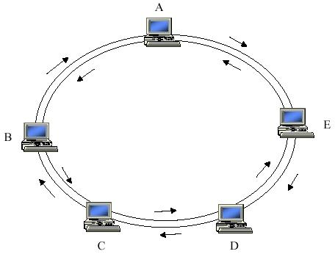

Figure 4.11 FDDI Token-ring network
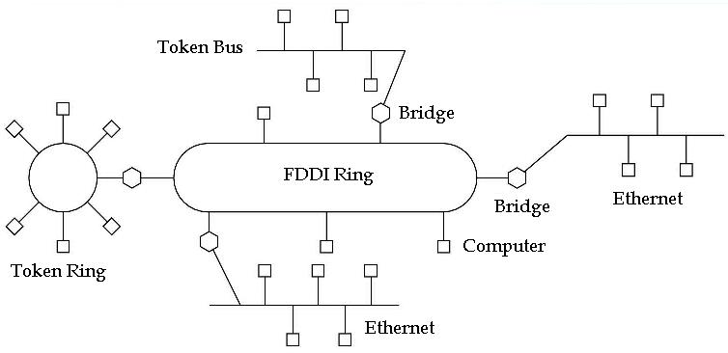
Figure 4-12 An FDDI Ring being used as a backbone to connect LANs and computers
FDDI can be used in the same way as any of the 802 LANs, as shown in Figure4.11, but with its high bandwidth it is more often used as a backbone network to interconnect various Ethernet LAN sub-networks as shown in Figure 4.12.

Optical fiber Taps
With an optical fiber network, either an active or passive tap can be used. In the case of an active tap (Figure 4.13a), the following steps occur:
1. Optical signal energy enters the tap from the bus.
2. Clocking information is recovered from the signal, and the signal is converted to an electrical signal.
3. The converted signal is presented to the node and perhaps modified by the latter.
4. The optical output (a light beam) is modulated according to the electrical signal and launched into the bus.
In effect, the ring consists of a chain of point-to-point links, and each node acts as a repeater. Each tap actually consists of two of these active couplers and requires two fibers; this is because of the inherently unidirectional nature of the device of Figure4.13a.
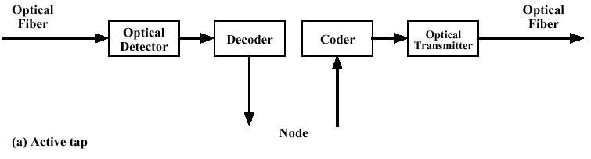
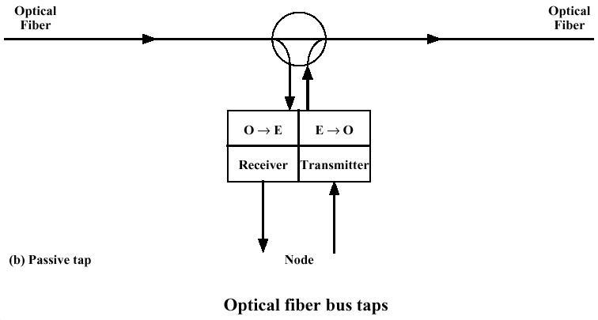
Figure 4.13 Optical Fiber Bus taps
In the case of a passive tap (Figure 4.13b) the tap extracts a portion of the optical energy from the bus for reception and it injects optical energy directly into the medium for transmission. Thus, there is a single run of cable rather than a chain point-to-point link. The electronic complexity and interface cost are drawbacks for the implementation of the active tap. Also, each tap will add some increment of delay. For passive taps the lossy nature of pure optical taps limits the number of devices and the length of the medium. However, the performance of such taps has improved sufficiently in recent years so to make fiber bus networks practical.
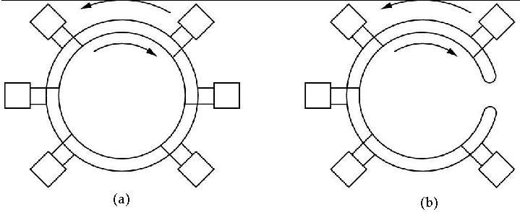
Figure 4.14 (a) FDDI Ring before a break in link. (b) after breakage of link.
To provide reliability with respect to link breakages and interface failure, a dual-ring arrangement is used, as shown in Figure 4.14. The transmission on one ring will be clockwise while on the other ring it will be anti-clockwise. A break in the ring is handled by redirecting the flow in the opposite direction at the last station before the break. This action has the effect of converting the dual ring into a single ring. Figure 4.14(a) illustrates a normal FDDI ring while Figure 4.14(b) illustrate the arrangement in the case of breakage of links at a point.
From Figure 4.15 we can see that the FDDI frame structure is very similar to that of IEEE 802.5 Token Ring frame structure. The frame begins with 16 or more idle control signals that generate a square wave signal that serves to synchronize the receiver. The SD and ED fields contain distinct signal violations that help identify them. The FDDI frame does not contain an AC field or a token bit. Instead the FC field is used to indicate the presence of a token and to provide information about the type of frame. A token frame is indicated by either 10000000 or 11000000 in the FC field. The capture of the token is done, not by flipping a bit, but by removing the token transmission from the ring and replacing it with a data frame. The other remaining fields function as in IEEE 802.5.
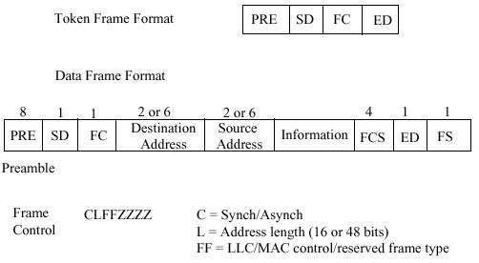
Figure 4.15 FDDI frame structure

4.7 Interconnection of LANs - Bridges
There are several ways of interconnecting networks. When two or more networks interconnected at the physical layer, the type of device is called a repeater. When two or more networks are interconnected at the MAC or data link layer, the device is called a bridge. When two or more networks are interconnected at the network layer, the device is called a router. Interconnection at higher layers is done less frequently. The device that interconnects networks at higher level is usually called a gateway. Gateways usually perform some protocol conversion and security functions. In this section we will focus on bridges as they are used to interconnect LANs at MAC layer.

Bridges
When range extension is the only problem, repeaters may solve the problem as long as the maximum distance between two stations is not exceeded. Local area networks (LANs) that involve sharing of media, such as Ethernet and Token ring, can only handle up to some maximum level of traffic. As the number of stations in the LAN increases, or as the traffic generated per station increases, amount of activity in the LAN medium increases until it reaches a saturation point. A typical approach is to segment the user group into two or, more LANs and to use bridges to interconnect the LANs to form a bridged LAN or an extended LAN.
At times it becomes essential to have multiple LANs. There are several reasons for the use of multiple LANs interconnected:
• Geography. Clearly, two separate LANs are needed to support devices clustered in two geographically distant locations. Even in the case of two buildings separated by a highway, it may be far easier to use a microwave bridge link than to attempt to string coaxial cable between the two buildings.
• Performance. When range extension is the only problem, repeaters may solve the problem as long as the maximum distance between two stations is not exceeded. Local area networks (LANs) that involve sharing of media, such as Ethernet and Token ring, can only handle up to some maximum level of traffic. As the number of stations in the LAN increases, or as the traffic generated per station increases, amount of activity in the LAN medium increases until it reaches a saturation point. In general, performance on a LAN or MAN declines with an increase in the number of devices or with the length of the medium. A typical approach is to segment the user group into two or, more LANs and to use bridges to interconnect the LANs. LANs will often give improved performance if devices can be clustered so that intra-network traffic significantly exceeds inter-network traffic.
• Reliability. The danger in connecting all data processing devices in an organization to one network is that a fault on the network or even a fault in a single device may disable communication for all devices in the network. The network may be required to be partitioned into self-contained units.
• Security. LANs originally assume an element of trust between the users in the LAN. As LAN grows, this assumption breaks down, and security concerns become prominent. The fact that most LANs are broadcast in nature implies that eavesdropping can be done easily. This behavior opens the door for the various security threats. Also it is desirable to keep different types of traffic (e.g., accounting, personnel, strategic planning) that have different security needs on physically separate media. At the same time, the different types of users with different levels of security need to communicate through controlled and monitored mechanisms.
The establishment of multiple LANs and the filtering mechanism at the bridges will improve security of communications.
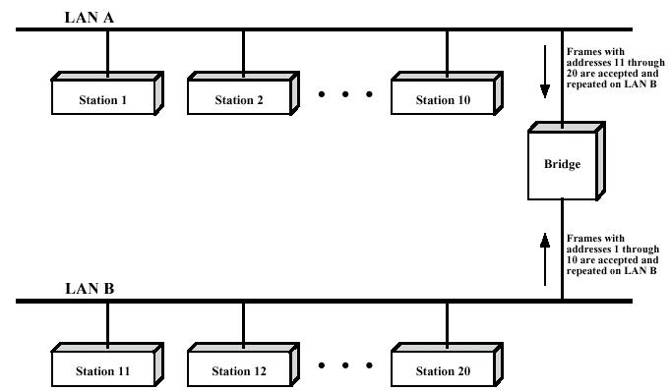
Figure 4.16 Bridge interconnecting two LANs

Functions of a Bridge
Figure 4.16 illustrates the operation of a bridge between two LANs, A and B. The bridge performs the following functions:
• Reads all frames transmitted on A, and accepts those addressed to stations on B.
• Using the medium access control protocol for B, retransmits the frames onto B.

• Does the same for B-to-A traffic.

Several design aspects of a bridge are worth highlighting:
1. The bridge makes no modification to the content of the frames it receives.
2. The bridge should contain enough buffer space to meet peak demands. Over a short period of time, frames may arrive faster than they can be retransmitted.
3. The bridge must contain addressing and routing intelligence. At a minimum, the bridge must know which addresses are on each network in order to know which frames to pass. Further, there may be more than two LANs interconnected by a number of bridges. In that case, a frame may have to be routed through several bridges in its journey from source to destination.
4. A bridge may connect more than two LANs. The bridge provides an extension to the LAN that requires no modification to the communications software in the stations attached to the LANs. It appears to all stations on the two (or more) LANs that there is a single LAN on which each station has a unique address. The station uses that unique address and need not explicitly discriminate between stations on the same LAN and stations on other LANs; the bridge takes care of that.
The description above has applied to the simplest sort of bridge. More sophisticated bridges can be used in more complex collections of LANs. These constructions would include additional functions, such as,
• Each bridge can maintain status information on other bridges, together with the cost and number of bridge-to-bridge hops required to reach each network. This information may be updated by periodic exchanges of information among bridges; this allows the bridges to perform a dynamic routing function.
• A control mechanism can manage frame buffers in each bridge to overcome congestion. Under saturation conditions, the bridge can give precedence to en route packets over new packets just entering the internet from an attached LAN, thus preserving the investment in line bandwidth and processing time already made in the en route frame.

Bridge Protocol Architecture
The IEEE 802.1D specification defines the protocol architecture for MAC bridges. In addition, the standard suggests formats for a globally administered set of MAC station addresses across multiple homogeneous LANs. In this subsection, we examine the protocol architecture of these bridges.
Within the 802 architecture, the endpoint or station address is designated at the MAC level. Thus, it is at the MAC level that a bridge can function. Figure 4.17 shows the simplest case, which consists of two LANs connected by a single bridge.
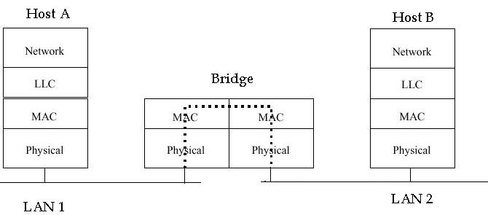

Figure 4.17 Operation of a LAN Bridge from 802.3 to 802.4
The LANs employ the same MAC and LLC protocols. The bridge operates as previously described. A MAC frame whose destination is not on the immediate LAN is captured by the bridge, buffered briefly, and then transmitted on the other LAN. As far as the LLC layer is concerned, there is a dialogue between peer LLC entities in the two endpoint stations. The bridge need not contain an LLC layer, as it is merely serving to relay the MAC frames.

Exercise

- Discuss Switched Networks and Broadcast Networks.
- What is a LAN? Mention the key technology ingredients that determine the nature of a LAN.
- What are the functions of MAC layer in a LAN?
- List the standards issued by IEEE 802 committee for LAN and MAN. Also mention what topology and transmission medium each of them relies on.
- List the various network topologies. Discuss one of them
- What protocol controls access to the transmission media in a LAN? Discuss key parameters in medium access control mechanisms.
- Discuss different asynchronous medium access control mechanisms.
- Discuss MAC frame format.
- What are the types of services provided by LLC layer? Discuss them.
- Discuss the development of CSMA/CD technology.
- Describe how frames are transmitted in CSMA/CD LAN.
- Discuss various fields in the CSMA/CD MAC frame format.
- Discuss Token ring MAC protocol. What is the principal disadvantage of the token ring.
- Discuss various fields in Token ring MAC frame format.
- What is FDDI, in practice how it is used? Discuss different types of optical taps.
- What are the devices available to interconnect LANs? How do they differ?
- Discuss the reasons for having interconnected multiple LANs instead of one single LAN.
- List the design aspects of a bridge.

