Module I
(DataBase Management System) Software that controls the organization, storage, retrieval, security and integrity of data in a database. It accepts requests from the application and instructs the operating system to transfer the appropriate data. The major DBMS vendors are Oracle, IBM, Microsoft and Sybase MySQL is a very popular open source product
DBMSs may work with traditional programming languages (COBOL, C, etc.) or they may include their own programming language for application development.
DBMSs let information systems be changed more easily as the organization's requirements change. New categories of data can be added to the database without disruption to the existing system. Adding a field to a record does not require changing any of the programs that do not use the data in that new field.
Major Features of a DBMS
Data Security
The DBMS can prevent unauthorized users from viewing or updating the database. Using passwords, users are allowed access to the entire database or a subset of it known as a "subschema." For example, in an employee database, some users may be able to view salaries while others may view only work history and medical data.
Data Integrity
The DBMS can ensure that no more than one user can update the same record at the same time. It can keep duplicate records out of the database; for example, no two customers with the same customer number can be entered.
Interactive Query
Most DBMSs provide query languages and report writers that let users interactively interrogate the database and analyze its data. This important feature gives users access to all management information as needed.
Interactive Data Entry and Updating
Many DBMSs provide a way to interactively enter and edit data, allowing you to manage your own files and databases. However, interactive operation does not leave an audit trail and does not provide the controls necessary in a large organization. These controls must be programmed into the data entry and update programs of the application.
This is a common misconception about desktop computer DBMSs. Complex business systems can be developed, but not without programming. This is not the same as creating lists of data for your own record keeping.
Data Independence
With DBMSs, the details of the data structure are not stated in each application program. The program asks the DBMS for data by field name; for example, a coded equivalent of "give me customer name and balance due" would be sent to the DBMS. Without a DBMS, the programmer must reserve space for the full structure of the record in the program. Any change in data structure requires changing all application programs.
DBMS Components
Data: Data stored in a database include numerical data which may be integers (whole numbers only) or floating point numbers (decimal), and non-numerical data such as characters (alphabetic and numeric characters), date or logical (true or false). More advanced systems may include more complicated data entities such as pictures and images as data types.
Standard operations: Standard operations are provided by most DBMS. These operations provide the user basic capabilities for data manipulation. Examples of these standard operations are sorting, deleting and selecting records.
Data definition language (DDL): DDL is the language used to describe the contents of the database. It is used to describe, for example, attribute names (field names), data types, location in the database, etc.
Data manipulation and query language: Normally a query language is supported by a DBMS to form commands for input, edit, analysis, output, reformatting, etc. Some degree of standardisation has been achieved with SQL (Structured Query Language).
Programming tools: Besides commands and queries, the database should be accessible directly from application programs through function calls (subroutine calls) in conventional programming languages.
File structures: Every DBMS has its own internal structures used to organise the data although some common data models are used by most DBMS.

DBMS Advantages
There are three main features of a database management system that make it attractive to use a DBMS in preference to other systems. These features are:
- Centralised data management,
- Data independence
- Systems integration.
In a database system, the data is managed by the DBMS and all access to the data is through the DBMS providing a key to effective data processing. This contrasts with conventional data processing systems where each application program has direct access to the data it reads or manipulates.
In the conventional data processing application programs, the programs usually are based on a considerable knowledge of data structure and format. In such environment any change of data structure or format would require appropriate changes to the application programs. If major changes were to be made to the data, the application programs may need to be rewritten.
In a database system, the database management system provides the interface between the application programs and the data. When changes are made to the data representation, the metadata maintained by the DBMS is changed but the DBMS continues to provide data to application programs in the previously used way. The DBMS handles the task of transformation of data wherever necessary.
This independence between the programs and the data is called data independence. Data independence is important because every time some change needs to be made to the data structure, the programs that were being used before the change would continue to work. To provide a high degree of data independence, a DBMS must include a sophisticated metadata management system.
In DBMS, all files are integrated into one system thus reducing redundancies and making data management more efficient. In addition, DBMS provides centralised control of the operational data. Some of the advantages of data independence, integration and centralised control are:
Redundancies and inconsistencies can be reduced
Better service to the Users
Flexibility of the system is improved
Cost of developing and maintaining systems is lower
Standards can be enforced
Security can be improved
Integrity can be improved
Enterprise requirements can be identified
Data model must be developed
DBMS Disadvantages
A database system generally provides on-line access to the database for many users. In contrast, a conventional system is often designed to meet a specific need and therefore generally provides access to only a small number of users. Because of the larger number of users accessing the data when a database is used, the enterprise may involve additional risks as compared to a conventional data processing system in the following areas.
Confidentiality, Privacy and Security When information is centralized and is made available to users from remote locations, the possibilities of abuse are often more than in a conventional system. To reduce the chances of unauthorized users accessing sensitive information, it is necessary to take technical, administrative and, possibly, legal measures. Most databases store valuable information that must be protected against deliberate trespass and destruction.
Data Quality Since the database is accessible to users remotely, adequate controls are needed to control users updating data and to control data quality. With increased number of users accessing data directly, there are enormous opportunities for users to damage the data. Unless there are suitable controls, the data quality may be compromised.
Data Integrity Since a large number of users could be using a database concurrently, technical safeguards are necessary to ensure that the data remain correct during operation. The main threat to data integrity comes from several different users attempting to update the same data at the same time. The database therefore needs to be protected against inadvertent changes by the users.
Enterprise Vulnerability Centralizing all data of an enterprise in one database may mean that the database becomes an indispensable resource. The survival of the enterprise may depend on reliable information being available from its database. The enterprise therefore becomes vulnerable to the destruction of the database or to unauthorized modification of the database.
The Cost of using a DBMS Conventional data processing systems are typically designed to run a number of well-defined, preplanned processes. Such systems are often "tuned" to run efficiently for the processes that they were designed for. Although the conventional systems are usually fairly inflexible in that new applications may be difficult to implement and/or expensive to run, they are usually very efficient for the applications they are designed for.
The database approach on the other hand provides a flexible alternative where new applications can be developed relatively inexpensively. The flexible approach is not without its costs and one of these costs is the additional cost of running applications that the conventional system was designed for. Using standardized software is almost always less machine efficient than specialized software.

Database Design
A business information system is made up of subjects (customers, employees, vendors, etc.) and activities (orders, payments, purchases, etc.). Database design is the process of organizing this data into related record types. The DBMS that is chosen is the one that can support the organization's data structure while efficiently processing the transaction volume.
Organizations may use one kind of DBMS for daily transaction processing and then move the detail to another DBMS better suited for random inquiries and analysis.
Overall systems design decisions are performed by data administrators and systems analysts. Detailed database design is performed by database administrators.
DEFINITION: A data model is a plan for building a database. The model represents data conceptually, the way the user sees it, rather than how computers store it. Data models focus on required data elements and associations; most often they are expressed graphically using entity-relationship diagrams. On a more abstract level, the term is also used in describing a database's overall structure -- e.g., a relational or hierarchical data model.
Data Modeling With Entity-Relationship Diagrams
In the following sample diagram, rectangles represent entities, diamonds are relationships, and ellipses are attributes of entities. Note that there are many different conventions used in entity-relationship diagrams; this same model could be represented in several other ways using different notation.
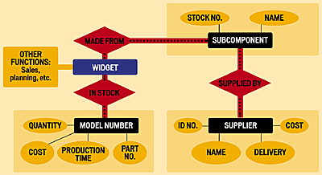

Hierarchical Model
The hierarchical data model organizes data in a tree structure. There is a hierarchy of parent and child data segments. This structure implies that a record can have repeating information, generally in the child data segments. Data in a series of records, which have a set of field values attached to it. It collects all the instances of a specific record together as a record type. These record types are the equivalent of tables in the relational model, and with the individual records being the equivalent of rows. To create links between these record types, the hierarchical model uses Parent Child Relationships
Hierarchical databases link records like an organization chart. A record type can be owned by only one owner. In the following example, orders are owned by only one customer. Hierarchical structures were widely used with early mainframe systems; however, they are often restrictive in linking real-world structures.
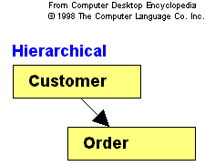

Network Model

In 1971, the Conference on Data Systems Languages (CODASYL) formally defined the network model. The basic data modeling construct in the network model is the set construct. A set consists of an owner record type, a set name, and a member record type. A member record type can have that role in more than one set, hence the multiparent concept is supported. An owner record type can also be a member or owner in another set
In network databases, a record type can have multiple owners. In the example below, orders are owned by both customers and products, reflecting their natural relationship in business.

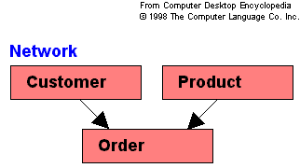

Relational Model

(RDBMS - relational database management system) A database based on the relational model developed by E.F. Codd. A relational database allows the definition of data structures, storage and retrieval operations and integrity constraints. In such a database the data and relations between them are organised in tables. A table is a collection of records and each record in a table contains the same fields.
Values Are Atomic
Each Row is Unique
Column Values Are of the Same Kind
The Sequence of Columns is Insignificant
The Sequence of Rows is Insignificant
Each Column Has a Unique Name
Certain fields may be designated as keys, which means that searches for specific values of that field will use indexing to speed them up. Where fields in two different tables take values from the same set, a join operation can be performed to select related records in the two tables by matching values in those fields. Often, but not always, the fields will have the same name in both tables

Relational databases do not link records together physically, but the design of the records must provide a common field, such as account number, to allow for matching. Often, the fields used for matching are indexed in order to speed up the process.
In the following example, customers, orders and products are linked by comparing data fields and/or indexes when information from more than one record type is needed. This method is more flexible for ad hoc inquiries. Many hierarchical and network DBMSs also provide this capability.

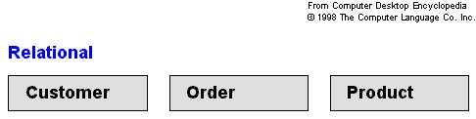

Object-Oriented Model
Object DBMSs add database functionality to object programming languages. They bring much more than persistent storage of programming language objects. Object DBMSs extend the semantics of the C++, Smalltalk and Java object programming languages to provide full-featured database programming capability, while retaining native language compatibility. A major benefit of this approach is the unification of the application and database development into a seamless data model and language environment. As a result, applications require less code, use more natural data modeling, and code bases are easier to maintain. Object developers can write complete database applications with a modest

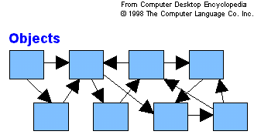

The world of information is made up of data, text, pictures and voice. The relational DBMS was not designed to store multimedia data, because there are so many different types of sound and video formats. Although a relational DBMS may provide a BLOB (binary large object) field that holds anything, extensive use of this field can strain the processing.
An object database is often better suited for multimedia. Using the object model, an object-oriented DBMS can store anything or refer to anything. For example, a video object can reference a video file stored elsewhere on some other hard disk and launch the video player software necessary to play it.
Intelligent Databases
All DBMSs provide some data validation; for example, they can reject invalid dates or alphabetic data entered into money fields. But most validation is left up to the application programs.
Intelligent databases provide more validation; for example, table lookups can reject bad spelling or coding of items. Common algorithms can also be used such as one that computes sales tax for an order based on zip code.
When validation is left up to each application program, one program could allow an item to be entered while another program rejects it. Data integrity is better served when data validation is done in only one place. Mainframe DBMSs were the first to become intelligent, and all the others followed suit.

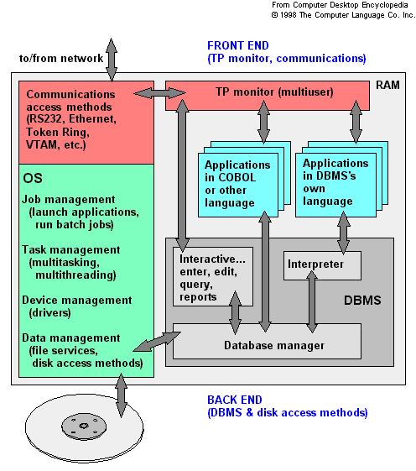

Module II
Relational Model
Relational model and relational databases
Introduced by Codd in 1970 and provides :
–a simple data structure for modelling all data;
–mathematically based;
–becoming a standard for implementation data models.

Consequences :
–Simplicity means that correctness is easier to establish;
–Standardisation means that distributed data can be combined more easily.
–Sharing of improvements to the facilities and the implementation can be shared easily.

All of the information stored in a Relational Database is held in relations
No other data structures
A relation may be thought of as a table

STUDENT
name matric exam1 exam2

Mounia 891023 12 58

Jane 892361 66 90

Thomas 880123 50 65

The relational model consists of three components:
A Structural component - a set of TABLES (also called RELATIONS).
A Manipulative component consisting of a set of high-level operations which act upon and produce whole tables.
A Set of Rules for maintaining the INTEGRITY of the database.
A relation has:
–a name
,an unchanging set of columns; named and typed
and a time varying set of rows
An attribute is a column of a relation:
– domain: the set of values it may take.
–
domain is a set of atomic values (indivisible):

A tuple is a row of a relation
–a set of values which are instances of the attributes of a relation
n

Relational schema:
–a set of attributes and is written R (A1, A2,. . .An)
–e.g., STUDENT (name, matric, exam1, exam2

Relation:
–a set of tuples which accords with some relational schema.

The degree of a relation:
–the number of attributes.

The cardinality:
–the number of tuples.
Keys, or candidate Keys
–any set of attributes which are unique for each row
–
–
Primary key
–one candidate key is chosen to identify the tuples
–it is underlined
–e.g., STUDENT (name, matric, exam1, exam2)

Relational database schema:
–set of relation schemas together with a set of "integrity constraints"

Relational database instance:
–a set of relations realising a relational database schema

Base relation:
–relation which actually exists as a stored file
–(vs. temporary or view relations)

Foreign Key:
–an attribute or set of attributes which match the primary key of another relation and thus link them

Constraints: a set of rules which must hold for all relations in a DB and are enforced by the DBMS.

Key Constraints
–Every candidate Key is unique for every tuple.

Entity Integrity
–No primary Key of a base relation may be null.

–The primary Key acts as an identifier for the objects in the relation
–A null Key implies the existence of unidentifiable objects.

Referential Integrity.
–Any attributes of a relation which are foreign Keys to another relation must take values which either
•exist in the second relation
•or are null

The DBMS must continually check that constraints are not violated every time an update (insertion, deletion, modification) occurs.

Two strategies:
–refuse to perform violating update
–compensate in some way

Compensation is performed by :
–Cascading - make a compensating change to the current tuple then check everything that refers to it.
–Restricting - only change those tuples which do not violate constraints.
–Nullifying - set foreign Keys to null if referential integrity is violated.

v

The terminology associated with relational database theory originates from the branch of mathematics called set theory although there are widely used synonyms for these precise, mathematical terms.
In a relational database, everything is stored in tables. Tables contain columns and rows.
- A column is drawn from a DOMAIN, that is, a set of values from which the actual values are taken. More than one column in a table may draw its values from the same domain.
- A column entry in any row is SINGLE-VALUED, i.e. it contains exactly one item only (e.g. a surname). Repeating groups, i.e. columns which contain sets of values rather than a single value, not allowed.
- Each row of a table is uniquely identified by a PRIMARY KEY composed of one or more columns. This implies that a table may not contain duplicate rows.
- The ENTITY INTEGRITY RULE of the model states that no component of the primary key may contain a NULL value.
- A column, or combination of columns, that matches the primary key of another table is called a FOREIGN KEY.
The REFERENTIAL INTEGRITY RULE of the model states that, for every foreign key value in a table there must be a corresponding primary key value in another table in the database.
Relational Operations
The relational model defines a number of relational operators that can be used to manipulate the database.
These relational operators are:
UNION
INTERSECT
DIFFERENCE
DIVIDE
PRODUCT
SELECT
PROJECT
JOIN
The set operations union, intersection and difference require that the relations have same degree (number of columns) and corresponding attributes must have same domain.
SQL Tutorial
Introduction
SQL (Structured Query Language) allows users to access data in relational database management systems, such as Oracle, Sybase, Informix, Microsoft SQL Server, Access, and others, by allowing users to describe the data the user wishes to see. SQL also allows users to define the data in a database, and manipulate that data. This tutorial will describe how to use SQL, and give examples.

SQL Statements

Command | Description
CREATE DATABASE | Creates a new database
CREATE INDEX | Creates a new index on a table column
CREATE SEQUENCE | Creates a new sequence in an existing database
CREATE TABLE | Creates a new table in an existing database
CREATE TRIGGER | Creates a new trigger definition
CREATE VIEW | Creates a new view on an existing table
SELECT | Retrieves records from a table
INSERT | Adds one or more new records into a table
UPDATE | Modifies the data in existing table records
DELETE | Removes existing records from a table
DROP DATABASE | Destroys an existing database
DROP INDEX | Removes a column index from an existing table
DROP SEQUENCE | Destroys an existing sequence generator
DROP TABLE | Destroys an existing table
DROP TRIGGER | Destroys an existing trigger definition
DROP VIEW | Destroys an existing table view
CREATE USER | Adds a new PostgreSQL user account to the system
ALTER USER | Modifies an existing PostgreSQL user account
DROP USER | Removes an existing PostgreSQL user account
GRANT | Grant rights on a database object to a user
REVOKE | Deny rights on a database object from a user
CREATE FUNCTION | Creates a new SQL function within a database
CREATE LANGUAGE | Creates a new language definition within a database
CREATE OPERATOR | Creates a new SQL operator within a database
CREATE TYPE | Creates a new SQL data type within a database

Introduction to SQL

SQL is a standard computer language for accessing and manipulating databases.

What is SQL?
- SQL stands for Structured Query Language
- SQL allows you to access a database
- SQL is an ANSI standard computer language
- SQL can execute queries against a database
- SQL can retrieve data from a database
- SQL can insert new records in a database
- SQL can delete records from a database
- SQL can update records in a database
- SQL is easy to learn

SQL is a Standard - BUT....
SQL is an ANSI (American National Standards Institute) standard computer language for accessing and manipulating database systems. SQL statements are used to retrieve and update data in a database. SQL works with database programs like MS Access, DB2, Informix, MS SQL Server, Oracle, Sybase, etc.
Unfortunately, there are many different versions of the SQL language, but to be in compliance with the ANSI standard, they must support the same major keywords in a similar manner (such as SELECT, UPDATE, DELETE, INSERT, WHERE, and others).
Note: Most of the SQL database programs also have their own proprietary extensions in addition to the SQL standard!

SQL Database Tables
A database most often contains one or more tables. Each table is identified by a name (e.g. "Customers" or "Orders"). Tables contain records (rows) with data.
Below is an example of a table called "Persons":
LastName | FirstName | Address | City
Hansen | Ola | Timoteivn 10 | Sandnes
Svendson | Tove | Borgvn 23 | Sandnes
Pettersen | Kari | Storgt 20 | Stavanger
The table above contains three records (one for each person) and four columns (LastName, FirstName, Address, and City).

SQL Queries
With SQL, we can query a database and have a result set returned.
A query like this:
SELECT LastName FROM Persons
Gives a result set like this:
LastName
Hansen
Svendson
Pettersen
Note: Some database systems require a semicolon at the end of the SQL statement. We don't use the semicolon in our tutorials.

SQL Data Manipulation Language (DML)
SQL (Structured Query Language) is a syntax for executing queries. But the SQL language also includes a syntax to update, insert, and delete records.
These query and update commands together form the Data Manipulation Language (DML) part of SQL:
- SELECT - extracts data from a database table
- UPDATE - updates data in a database table
- DELETE - deletes data from a database table
- INSERT INTO - inserts new data into a database table

SQL Data Definition Language (DDL)
The Data Definition Language (DDL) part of SQL permits database tables to be created or deleted. We can also define indexes (keys), specify links between tables, and impose constraints between database tables.
The most important DDL statements in SQL are:
- CREATE TABLE - creates a new database table
- ALTER TABLE - alters (changes) a database table
- DROP TABLE - deletes a database table
- CREATE INDEX - creates an index (search key)
- DROP INDEX - deletes an index

SQL The SELECT Statement

The SELECT Statement
The SELECT statement is used to select data from a table. The tabular result is stored in a result table (called the result-set).

Syntax
SELECT column_name(s)
FROM table_name

Select Some Columns
To select the columns named "LastName" and "FirstName", use a SELECT statement like this:
SELECT LastName,FirstName FROM Persons
"Persons" table
LastName | FirstName | Address | City
Hansen | Ola | Timoteivn 10 | Sandnes
Svendson | Tove | Borgvn 23 | Sandnes
Pettersen | Kari | Storgt 20 | Stavanger
Result
LastName | FirstName
Hansen | Ola
Svendson | Tove
Pettersen | Kari

Select All Columns
To select all columns from the "Persons" table, use a * symbol instead of column names, like this:
SELECT * FROM Persons
Result
LastName | FirstName | Address | City
Hansen | Ola | Timoteivn 10 | Sandnes
Svendson | Tove | Borgvn 23 | Sandnes
Pettersen | Kari | Storgt 20 | Stavanger

The Result Set
The result from a SQL query is stored in a result-set. Most database software systems allow navigation of the result set with programming functions, like: Move-To-First-Record, Get-Record-Content, Move-To-Next-Record, etc.
Programming functions like these are not a part of this tutorial. To learn about accessing data with function calls, please visit our ADO tutorial.

Semicolon after SQL Statements?
Semicolon is the standard way to separate each SQL statement in database systems that allow more than one SQL statement to be executed in the same call to the server.
Some SQL tutorials end each SQL statement with a semicolon. Is this necessary? We are using MS Access and SQL Server 2000 and we do not have to put a semicolon after each SQL statement, but some database programs force you to use it.

The SELECT DISTINCT Statement
The DISTINCT keyword is used to return only distinct (different) values.
The SELECT statement returns information from table columns. But what if we only want to select distinct elements?
With SQL, all we need to do is to add a DISTINCT keyword to the SELECT statement:

Syntax
SELECT DISTINCT column_name(s)
FROM table_name

Using the DISTINCT keyword
To select ALL values from the column named "Company" we use a SELECT statement like this:
SELECT Company FROM Orders

"Orders" table

Company | OrderNumber
Sega | 3412
W3Schools | 2312
Trio | 4678
W3Schools | 6798

Result

Company
Sega
W3Schools
Trio
W3Schools

Note that "W3Schools" is listed twice in the result-set.
To select only DIFFERENT values from the column named "Company" we use a SELECT DISTINCT statement like this:

SELECT DISTINCT Company FROM Orders

Result:

Company
Sega
W3Schools
Trio

Now "W3Schools" is listed only once in the result-set.

SQL The WHERE Clause

The WHERE clause is used to specify a selection criterion.

The WHERE Clause
To conditionally select data from a table, a WHERE clause can be added to the SELECT statement.

Syntax
SELECT column FROM table
WHERE column operator value

With the WHERE clause, the following operators can be used:

Operator | Description
= | Equal
<> | Not equal
> | Greater than
< | Less than
>= | Greater than or equal
<= | Less than or equal
BETWEEN | Between an inclusive range
LIKE | Search for a pattern

Note: In some versions of SQL the <> operator may be written as !=

Using the WHERE Clause
To select only the persons living in the city "Sandnes", we add a WHERE clause to the SELECT statement:

SELECT * FROM Persons
WHERE City='Sandnes'

"Persons" table

LastName | FirstName | Address | City | Year
Hansen | Ola | Timoteivn 10 | Sandnes | 1951
Svendson | Tove | Borgvn 23 | Sandnes | 1978
Svendson | Stale | Kaivn 18 | Sandnes | 1980
Pettersen | Kari | Storgt 20 | Stavanger | 1960

Result

LastName | FirstName | Address | City | Year
Hansen | Ola | Timoteivn 10 | Sandnes | 1951
Svendson | Tove | Borgvn 23 | Sandnes | 1978
Svendson | Stale | Kaivn 18 | Sandnes | 1980

Using Quotes
Note that we have used single quotes around the conditional values in the examples.
SQL uses single quotes around text values (most database systems will also accept double quotes). Numeric values should not be enclosed in quotes.
For text values:

This is correct:
SELECT * FROM Persons WHERE FirstName='Tove'
This is wrong:
SELECT * FROM Persons WHERE FirstName=Tove

For numeric values:

This is correct:
SELECT * FROM Persons WHERE Year>1965
This is wrong:
SELECT * FROM Persons WHERE Year>'1965'

The LIKE Condition
The LIKE condition is used to specify a search for a pattern in a column.

Syntax
SELECT column FROM table
WHERE column LIKE pattern
A "%" sign can be used to define wildcards (missing letters in the pattern) both before and after the pattern.

Using LIKE
The following SQL statement will return persons with first names that start with an 'O':

SELECT * FROM Persons
WHERE FirstName LIKE 'O%'

The following SQL statement will return persons with first names that end with an 'a':

SELECT * FROM Persons
WHERE FirstName LIKE '%a'

The following SQL statement will return persons with first names that contain the pattern 'la':

SELECT * FROM Persons
WHERE FirstName LIKE '%la%'

SQL ORDER BY

The ORDER BY keyword is used to sort the result.

Sort the Rows
The ORDER BY clause is used to sort the rows.

Orders:
Company | OrderNumber
Sega | 3412
ABC Shop | 5678
W3Schools | 2312
W3Schools | 6798

Example
To display the companies in alphabetical order:

SELECT Company, OrderNumber FROM Orders
ORDER BY Company

Result:

Company | OrderNumber
ABC Shop | 5678
Sega | 3412
W3Schools | 6798
W3Schools | 2312

Example
To display the companies in alphabetical order AND the ordernumbers in numerical order:

SELECT Company, OrderNumber FROM Orders
ORDER BY Company, OrderNumber

Result:

Company | OrderNumber
ABC Shop | 5678
Sega | 3412
W3Schools | 2312
W3Schools | 6798

Example
To display the companies in reverse alphabetical order:

SELECT Company, OrderNumber FROM Orders
ORDER BY Company DESC
Result:

Company | OrderNumber
W3Schools | 6798
W3Schools | 2312
Sega | 3412
ABC Shop | 5678

Example
To display the companies in reverse alphabetical order AND the ordernumbers in numerical order:

SELECT Company, OrderNumber FROM Orders
ORDER BY Company DESC, OrderNumber ASC

Result:

Company | OrderNumber
W3Schools | 2312
W3Schools | 6798
Sega | 3412
ABC Shop | 5678

SQL AND & OR

AND & OR
AND and OR join two or more conditions in a WHERE clause.
The AND operator displays a row if ALL conditions listed are true. The OR operator displays a row if ANY of the conditions listed are true.

Original Table (used in the examples)
LastName | FirstName | Address | City
Hansen | Ola | Timoteivn 10 | Sandnes
Svendson | Tove | Borgvn 23 | Sandnes
Svendson | Stephen | Kaivn 18 | Sandnes

Example
Use AND to display each person with the first name equal to "Tove", and the last name equal to "Svendson":

SELECT * FROM Persons
WHERE FirstName='Tove'
AND LastName='Svendson'

Result:

LastName | FirstName | Address | City
Svendson | Tove | Borgvn 23 | Sandnes

Example
Use OR to display each person with the first name equal to "Tove", or the last name equal to "Svendson":

SELECT * FROM Persons
WHERE firstname='Tove'
OR lastname='Svendson'

Result:

LastName | FirstName | Address | City
Svendson | Tove | Borgvn 23 | Sandnes
Svendson | Stephen | Kaivn 18 | Sandnes

Example
You can also combine AND and OR (use parentheses to form complex expressions):

SELECT * FROM Persons WHERE
(FirstName='Tove' OR FirstName='Stephen')
AND LastName='Svendson'

Result:

LastName | FirstName | Address | City
Svendson | Tove | Borgvn 23 | Sandnes
Svendson | Stephen | Kaivn 18 | Sandnes

SQL IN

IN
The IN operator may be used if you know the exact value you want to return for at least one of the columns.

SELECT column_name FROM table_name
WHERE column_name IN (value1,value2,..)

Original Table (used in the examples)
LastName | FirstName | Address | City
Hansen | Ola | Timoteivn 10 | Sandnes
Nordmann | Anna | Neset 18 | Sandnes
Pettersen | Kari | Storgt 20 | Stavanger
Svendson | Tove | Borgvn 23 | Sandnes

Example 1
To display the persons with LastName equal to "Hansen" or "Pettersen", use the following SQL:

SELECT * FROM Persons
WHERE LastName IN ('Hansen','Pettersen')

Result:
LastName | FirstName | Address | City
Hansen | Ola | Timoteivn 10 | Sandnes
Pettersen | Kari | Storgt 20 | Stavanger

SQL BETWEEN

BETWEEN ... AND
The BETWEEN ... AND operator selects a range of data between two values. These values can be numbers, text, or dates.
SELECT column_name FROM table_name
WHERE column_name
BETWEEN value1 AND value2

Original Table (used in the examples)
LastName | FirstName | Address | City
Hansen | Ola | Timoteivn 10 | Sandnes
Nordmann | Anna | Neset 18 | Sandnes
Pettersen | Kari | Storgt 20 | Stavanger
Svendson | Tove | Borgvn 23 | Sandnes

Example 1
To display the persons alphabetically between (and including) "Hansen" and exclusive "Pettersen", use the following SQL:

SELECT * FROM Persons WHERE LastName
BETWEEN 'Hansen' AND 'Pettersen'

Result:
LastName | FirstName | Address | City
Hansen | Ola | Timoteivn 10 | Sandnes
Nordmann | Anna | Neset 18 | Sandnes

IMPORTANT! The BETWEEN...AND operator is treated differently in different databases. With some databases a person with the LastName of "Hansen" or "Pettersen" will not be listed (BETWEEN..AND only selects fields that are between and excluding the test values). With some databases a person with the last name of "Hansen" or "Pettersen" will be listed (BETWEEN..AND selects fields that are between and including the test values). With other databases a person with the last name of "Hansen" will be listed, but "Pettersen" will not be listed (BETWEEN..AND selects fields between the test values, including the first test value and excluding the last test value). Therefore: Check how your database treats the BETWEEN....AND operator!

Example 2
To display the persons outside the range used in the previous example, use the NOT operator:

SELECT * FROM Persons WHERE LastName
NOT BETWEEN 'Hansen' AND 'Pettersen'

Result:

LastName | FirstName | Address | City
Pettersen | Kari | Storgt 20 | Stavanger
Svendson | Tove | Borgvn 23 | Sandnes

SQL Aliases

With SQL, aliases can be used for column names and table names.

Column Name Alias
The syntax is:
SELECT column AS column_alias FROM table

Table Name Alias
The syntax is:
SELECT column FROM table AS table_alias

Example: Using a Column Alias
This table (Persons):
LastName | FirstName | Address | City
Hansen | Ola | Timoteivn 10 | Sandnes
Svendson | Tove | Borgvn 23 | Sandnes
Pettersen | Kari | Storgt 20 | Stavanger

And this SQL:

SELECT LastName AS Family, FirstName AS Name
FROM Persons

Returns this result:
Family | Name
Hansen | Ola
Svendson | Tove
Pettersen | Kari

Example: Using a Table Alias
This table (Persons):
LastName | FirstName | Address | City
Hansen | Ola | Timoteivn 10 | Sandnes
Svendson | Tove | Borgvn 23 | Sandnes
Pettersen | Kari | Storgt 20 | Stavanger

And this SQL:
SELECT LastName, FirstName
FROM Persons AS Employees

Returns this result:

Table Employees:
LastName | FirstName
Hansen | Ola
Svendson | Tove
Pettersen | Kari

SQL Join

Joins and Keys
Sometimes we have to select data from two or more tables to make our result complete. We have to perform a join.
Tables in a database can be related to each other with keys. A primary key is a column with a unique value for each row. The purpose is to bind data together, across tables, without repeating all of the data in every table.
In the "Employees" table below, the "Employee_ID" column is the primary key, meaning that no two rows can have the same Employee_ID. The Employee_ID distinguishes two persons even if they have the same name.
When you look at the example tables below, notice that:
- The "Employee_ID" column is the primary key of the "Employees" table
- The "Prod_ID" column is the primary key of the "Orders" table
- The "Employee_ID" column in the "Orders" table is used to refer to the persons in the "Employees" table without using their names

Employees:
Employee_ID | Name
01 | Hansen, Ola
02 | Svendson, Tove
03 | Svendson, Stephen
04 | Pettersen, Kari

Orders:
Prod_ID | Product | Employee_ID
234 | Printer | 01
657 | Table | 03
865 | Chair | 03

Referring to Two Tables
We can select data from two tables by referring to two tables, like this:

Example
Who has ordered a product, and what did they order?

SELECT Employees.Name, Orders.Product
FROM Employees, Orders
WHERE Employees.Employee_ID=Orders.Employee_ID

Result
Name | Product
Hansen, Ola | Printer
Svendson, Stephen | Table
Svendson, Stephen | Chair

Example
Who ordered a printer?

SELECT Employees.Name
FROM Employees, Orders
WHERE Employees.Employee_ID=Orders.Employee_ID
AND Orders.Product='Printer'

Result
Name
Hansen, Ola

Using Joins
OR we can select data from two tables with the JOIN keyword, like this:

Example INNER JOIN
Syntax

SELECT field1, field2, field3
FROM first_table
INNER JOIN second_table
ON first_table.keyfield = second_table.foreign_keyfield

Who has ordered a product, and what did they order?

SELECT Employees.Name, Orders.Product
FROM Employees
INNER JOIN Orders
ON Employees.Employee_ID=Orders.Employee_ID

The INNER JOIN returns all rows from both tables where there is a match. If there are rows in Employees that do not have matches in Orders, those rows will not be listed.

Result
Name | Product
Hansen, Ola | Printer
Svendson, Stephen | Table
Svendson, Stephen | Chair

Example LEFT JOIN
Syntax

SELECT field1, field2, field3
FROM first_table
LEFT JOIN second_table
ON first_table.keyfield = second_table.foreign_keyfield

List all employees, and their orders - if any.

SELECT Employees.Name, Orders.Product
FROM Employees
LEFT JOIN Orders
ON Employees.Employee_ID=Orders.Employee_ID

The LEFT JOIN returns all the rows from the first table (Employees), even if there are no matches in the second table (Orders). If there are rows in Employees that do not have matches in Orders, those rows also will be listed.

Result
Name | Product
Hansen, Ola | Printer
Svendson, Tove
Svendson, Stephen | Table
Svendson, Stephen | Chair
Pettersen, Kari

Example RIGHT JOIN
Syntax

SELECT field1, field2, field3
FROM first_table
RIGHT JOIN second_table
ON first_table.keyfield = second_table.foreign_keyfield

List all orders, and who has ordered - if any.

SELECT Employees.Name, Orders.Product
FROM Employees
RIGHT JOIN Orders
ON Employees.Employee_ID=Orders.Employee_ID

The RIGHT JOIN returns all the rows from the second table (Orders), even if there are no matches in the first table (Employees). If there had been any rows in Orders that did not have matches in Employees, those rows also would have been listed.
Result
Name | Product
Hansen, Ola | Printer
Svendson, Stephen | Table
Svendson, Stephen | Chair

Example
Who ordered a printer?

SELECT Employees.Name
FROM Employees
INNER JOIN Orders
ON Employees.Employee_ID=Orders.Employee_ID
WHERE Orders.Product = 'Printer'

Result
Name
Hansen, Ola

SQL UNION and UNION ALL

UNION
The UNION command is used to select related information from two tables, much like the JOIN command. However, when using the UNION command all selected columns need to be of the same data type.
Note: With UNION, only distinct values are selected.

SQL Statement 1
UNION
SQL Statement 2

Employees_Norway:
Employee_ID | E_Name
01 | Hansen, Ola
02 | Svendson, Tove
03 | Svendson, Stephen
04 | Pettersen, Kari

Employees_USA:
Employee_ID | E_Name
01 | Turner, Sally
02 | Kent, Clark
03 | Svendson, Stephen
04 | Scott, Stephen

Using the UNION Command

Example
List all different employee names in Norway and USA:

SELECT E_Name FROM Employees_Norway
UNION
SELECT E_Name FROM Employees_USA

Result
Name
Hansen, Ola
Svendson, Tove
Svendson, Stephen
Pettersen, Kari
Turner, Sally
Kent, Clark
Scott, Stephen

Note: This command cannot be used to list all employees in Norway and USA. In the example above we have two employees with equal names, and only one of them is listed. The UNION command only selects distinct values.

UNION ALL
The UNION ALL command is equal to the UNION command, except that UNION ALL selects all values.
SQL Statement 1
UNION ALL
SQL Statement 2

Using the UNION ALL Command

Example
List all employees in Norway and USA:

SELECT E_Name FROM Employees_Norway
UNION ALL
SELECT E_Name FROM Employees_USA

Result
Name
Hansen, Ola
Svendson, Tove
Svendson, Stephen
Pettersen, Kari
Turner, Sally
Kent, Clark
Svendson, Stephen
Scott, Stephen

SQL Functions

SQL has a lot of built-in functions for counting and calculations.

Function Syntax
The syntax for built-in SQL functions is:

SELECT function(column) FROM table

Types of Functions
There are several basic types and categories of functions in SQL. The basic types of functions are:
- Aggregate Functions
- Scalar functions

Aggregate functions
Aggregate functions operate against a collection of values, but return a single value.
Note: If used among many other expressions in the item list of a SELECT statement, the SELECT must have a GROUP BY clause!!

"Persons" table (used in most examples)
Name | Age
Hansen, Ola | 34
Svendson, Tove | 45
Pettersen, Kari | 19

Aggregate functions in MS Access
Function | Description
AVG(column) | Returns the average value of a column
COUNT(column) | Returns the number of rows (without a NULL value) of a column
COUNT(*) | Returns the number of selected rows
FIRST(column) | Returns the value of the first record in a specified field
LAST(column) | Returns the value of the last record in a specified field
MAX(column) | Returns the highest value of a column
MIN(column) | Returns the lowest value of a column
STDEV(column)
STDEVP(column)
SUM(column) | Returns the total sum of a column
VAR(column)
VARP(column)

SQL GROUP BY and HAVING

Aggregate functions (like SUM) often need an added GROUP BY functionality.

GROUP BY...
GROUP BY... was added to SQL because aggregate functions (like SUM) return the aggregate of all column values every time they are called, and without the GROUP BY function it was impossible to find the sum for each individual group of column values.

The syntax for the GROUP BY function is:

SELECT column,SUM(column) FROM table GROUP BY column

GROUP BY Example
This "Sales" Table:
Company | Amount
W3Schools | 5500
IBM | 4500
W3Schools | 7100

And This SQL:
SELECT Company, SUM(Amount) FROM Sales

Returns this result:
Company | SUM(Amount)
W3Schools | 17100
IBM | 17100
W3Schools | 17100

The above code is invalid because the column returned is not part of an aggregate. A GROUP BY clause will solve this problem:

SELECT Company,SUM(Amount) FROM Sales
GROUP BY Company

Returns this result:
Company | SUM(Amount)
W3Schools | 12600
IBM | 4500

HAVING...
HAVING... was added to SQL because the WHERE keyword could not be used against aggregate functions (like SUM), and without HAVING... it would be impossible to test for result conditions.

The syntax for the HAVING function is:

SELECT column,SUM(column) FROM table
GROUP BY column
HAVING SUM(column) condition value

This "Sales" Table:
Company | Amount
W3Schools | 5500
IBM | 4500
W3Schools | 7100

This SQL:
SELECT Company,SUM(Amount) FROM Sales
GROUP BY Company
HAVING SUM(Amount)>10000

Returns this result
Company | SUM(Amount)
W3Schools | 12600

SQL The SELECT INTO Statement

The SELECT INTO Statement
The SELECT INTO statement is most often used to create backup copies of tables or for archiving records.

Syntax
SELECT column_name(s) INTO newtable [IN externaldatabase]
FROM source

Make a Backup Copy
The following example makes a backup copy of the "Persons" table:
SELECT * INTO Persons_backup
FROM Persons

The IN clause can be used to copy tables into another database:
SELECT Persons.* INTO Persons IN 'Backup.mdb'
FROM Persons

If you only want to copy a few fields, you can do so by listing them after the SELECT statement:
SELECT LastName,FirstName INTO Persons_backup
FROM Persons

You can also add a WHERE clause. The following example creates a "Persons_backup" table with two columns (FirstName and LastName) by extracting the persons who lives in "Sandnes" from the "Persons" table:
SELECT LastName,Firstname INTO Persons_backup
FROM Persons
WHERE City='Sandnes'

Selecting data from more than one table is also possible. The following example creates a new table "Empl_Ord_backup" that contains data from the two tables Employees and Orders:
SELECT Employees.Name,Orders.Product
INTO Empl_Ord_backup
FROM Employees
INNER JOIN Orders
ON Employees.Employee_ID=Orders.Employee_ID

Product Spotlight

SQL The CREATE VIEW Statement

A view is a virtual table based on the result-set of a SELECT statement.

What is a View?
In SQL, a VIEW is a virtual table based on the result-set of a SELECT statement.
A view contains rows and columns, just like a real table. The fields in a view are fields from one or more real tables in the database. You can add SQL functions, WHERE, and JOIN statements to a view and present the data as if the data were coming from a single table.
Note: The database design and structure will NOT be affected by the functions, where, or join statements in a view.

Syntax
CREATE VIEW view_name AS
SELECT column_name(s)
FROM table_name
WHERE condition

Note: The database does not store the view data! The database engine recreates the data, using the view's SELECT statement, every time a user queries a view.

Using Views
A view could be used from inside a query, a stored procedure, or from inside another view. By adding functions, joins, etc., to a view, it allows you to present exactly the data you want to the user.
The sample database Northwind has some views installed by default. The view "Current Product List" lists all active products (products that are not discontinued) from the Products table. The view is created with the following SQL:

CREATE VIEW [Current Product List] AS
SELECT ProductID,ProductName
FROM Products
WHERE Discontinued=No

We can query the view above as follows:

SELECT * FROM [Current Product List]

Another view from the Northwind sample database selects every product in the Products table that has a unit price that is higher than the average unit price:

CREATE VIEW [Products Above Average Price] AS
SELECT ProductName,UnitPrice
FROM Products
WHERE UnitPrice>(SELECT AVG(UnitPrice) FROM Products)

We can query the view above as follows:
SELECT * FROM [Products Above Average Price]

Another example view from the Northwind database calculates the total sale for each category in 1997. Note that this view select its data from another view called "Product Sales for 1997":

CREATE VIEW [Category Sales For 1997] AS
SELECT DISTINCT CategoryName,Sum(ProductSales) AS CategorySales
FROM [Product Sales for 1997]
GROUP BY CategoryName

We can query the view above as follows:

SELECT * FROM [Category Sales For 1997]

We can also add a condition to the query. Now we want to see the total sale only for the category "Beverages":

SELECT * FROM [Category Sales For 1997]
WHERE CategoryName='Beverages'

SQL The INSERT INTO Statement

The INSERT INTO Statement
The INSERT INTO statement is used to insert new rows into a table.

Syntax
INSERT INTO table_name
VALUES (value1, value2,....)

You can also specify the columns for which you want to insert data:

INSERT INTO table_name (column1, column2,...)
VALUES (value1, value2,....)

Insert a New Row
This "Persons" table:
LastName | FirstName | Address | City
Pettersen | Kari | Storgt 20 | Stavanger

And this SQL statement:

INSERT INTO Persons
VALUES ('Hetland', 'Camilla', 'Hagabakka 24', 'Sandnes')

Will give this result:

LastName | FirstName | Address | City
Pettersen | Kari | Storgt 20 | Stavanger
Hetland | Camilla | Hagabakka 24 | Sandnes

Insert Data in Specified Columns
This "Persons" table:

LastName | FirstName | Address | City
Pettersen | Kari | Storgt 20 | Stavanger
Hetland | Camilla | Hagabakka 24 | Sandnes

And This SQL statement:

INSERT INTO Persons (LastName, Address)
VALUES ('Rasmussen', 'Storgt 67')

Will give this result:

LastName | FirstName | Address | City
Pettersen | Kari | Storgt 20 | Stavanger
Hetland | Camilla | Hagabakka 24 | Sandnes
Rasmussen |  | Storgt 67

SQL The UPDATE Statement

The Update Statement
The UPDATE statement is used to modify the data in a table.

Syntax
UPDATE table_name
SET column_name = new_value
WHERE column_name = some_value

Person:
LastName | FirstName | Address | City
Nilsen | Fred | Kirkegt 56 | Stavanger
Rasmussen |  | Storgt 67

Update one Column in a Row
We want to add a first name to the person with a last name of "Rasmussen":

UPDATE Person SET FirstName = 'Nina'
WHERE LastName = 'Rasmussen'

Result:
LastName | FirstName | Address | City
Nilsen | Fred | Kirkegt 56 | Stavanger
Rasmussen | Nina | Storgt 67

Update several Columns in a Row
We want to change the address and add the name of the city:

UPDATE Person
SET Address = 'Stien 12', City = 'Stavanger'
WHERE LastName = 'Rasmussen'

Result:
LastName | FirstName | Address | City
Nilsen | Fred | Kirkegt 56 | Stavanger
Rasmussen | Nina | Stien 12 | Stavanger

SQL The Delete Statement

The Delete Statement
The DELETE statement is used to delete rows in a table.

Syntax
DELETE FROM table_name
WHERE column_name = some_value

Person:
LastName | FirstName | Address | City
Nilsen | Fred | Kirkegt 56 | Stavanger
Rasmussen | Nina | Stien 12 | Stavanger

Delete a Row
"Nina Rasmussen" is going to be deleted:
DELETE FROM Person WHERE LastName = 'Rasmussen'

Result

LastName | FirstName | Address | City
Nilsen | Fred | Kirkegt 56 | Stavanger

Delete All Rows
It is possible to delete all rows in a table without deleting the table. This means that the table structure, attributes, and indexes will be intact:

DELETE FROM table_name
or
DELETE * FROM table_name

DML

SQL Create Database, Table, and Index

Create a Database
To create a database:
CREATE DATABASE database_name

Create a Table
To create a table in a database:
CREATE TABLE table_name
(
column_name1 data_type,
column_name2 data_type,
.......
)

Example
This example demonstrates how you can create a table named "Person", with four columns. The column names will be "LastName", "FirstName", "Address", and "Age":

CREATE TABLE Person
(
LastName varchar,
FirstName varchar,
Address varchar,
Age int
)

This example demonstrates how you can specify a maximum length for some columns:
CREATE TABLE Person
(
LastName varchar(30),
FirstName varchar,
Address varchar,
Age int(3)
)
The data type specifies what type of data the column can hold. The table below contains the most common data types in SQL:

Data Type | Description
integer(size)  int(size)  smallint(size)  tinyint(size) | Hold integers only. The maximum number of digits are specified in parenthesis.
decimal(size,d)  numeric(size,d) | Hold numbers with fractions. The maximum number of digits are specified in "size". The maximum number of digits to the right of the decimal is specified in "d".
char(size) | Holds a fixed length string (can contain letters, numbers, and special characters). The fixed size is specified in parenthesis.
varchar(size) | Holds a variable length string (can contain letters, numbers, and special characters). The maximum size is specified in parenthesis.
date(yyyymmdd) | Holds a date

Create Index
Indices are created in an existing table to locate rows more quickly and efficiently. It is possible to create an index on one or more columns of a table, and each index is given a name. The users cannot see the indexes, they are just used to speed up queries.
Note: Updating a table containing indexes takes more time than updating a table without, this is because the indexes also need an update. So, it is a good idea to create indexes only on columns that are often used for a search.
A Unique Index
Creates a unique index on a table. A unique index means that two rows cannot have the same index value.

CREATE UNIQUE INDEX index_name
ON table_name (column_name)

The "column_name" specifies the column you want indexed.

A Simple Index
Creates a simple index on a table. When the UNIQUE keyword is omitted, duplicate values are allowed.

CREATE INDEX index_name
ON table_name (column_name)
The "column_name" specifies the column you want indexed.

Example
This example creates a simple index, named "PersonIndex", on the LastName field of the

Person table:
CREATE INDEX PersonIndex
ON Person (LastName)

If you want to index the values in a column in descending order, you can add the reserved word DESC after the column name:
CREATE INDEX PersonIndex
ON Person (LastName DESC)

If you want to index more than one column you can list the column names within the parentheses, separated by commas:
CREATE INDEX PersonIndex
ON Person (LastName, FirstName)

SQL Drop Index, Table and Database

Drop Index
You can delete an existing index in a table with the DROP statement.

DROP INDEX table_name.index_name

Delete a Table or Database
To delete a table (the table structure, attributes, and indexes will also be deleted):

DROP TABLE table_name

To delete a database:

DROP DATABASE database_name

Truncate a Table
What if we only want to get rid of the data inside a table, and not the table itself? Use the
TRUNCATE TABLE command (deletes only the data inside the table):

TRUNCATE TABLE table_name

SQL ALTER TABLE

ALTER TABLE
The ALTER TABLE statement is used to add or drop columns in an existing table.

ALTER TABLE table_name
ADD column_name datatype
ALTER TABLE table_name
DROP COLUMN column_name

Note: Some database systems don't allow the dropping of a column in a database table (DROP COLUMN column_name).

Person:
LastName | FirstName | Address
Pettersen | Kari | Storgt 20

Example
To add a column named "City" in the "Person" table:
ALTER TABLE Person ADD City varchar(30)

Result:
LastName | FirstName | Address | City
Pettersen | Kari | Storgt 20

Example
To drop the "Address" column in the "Person" table:
ALTER TABLE Person DROP COLUMN Address

Result:
LastName | FirstName | City
Pettersen | Kari

PL/SQL

Oracle's Procedural SQL
Usually PL/SQL programs are written within other applications (such as forms or reports).
- Variable Declaration
variable_name data_type;
- Reference Variable declarations inherit their data type from a referenced database field.
variable_name table_name.field_name%TYPE;
- Scalar Data Types
Database Scalar data types
  - VARCHAR2
  - CHAR
  - DATE
  - LONG
  - NUMBER

Non-Database Scalar data types
  - Integers
  - Decimal Numbers
  - Boolean

- PL/SQL Program Structure
DECLARE
Variable Declarations
BEGIN
Program Statements
EXCEPTION
Error-handling Statements
END;
- Comments
Multiline comments are delimited with /* ... */
Single line comments begin with two hyphens --
- Operators
+ - * / and **
=, <> or !=, >, <, >=, <= assignment is :=
string concatenation is ||
- Activate Memory Buffer
SQL> SET SERVEROUPUT ON SIZE buffer_size; (typical = 4000)
This command must be executed to activate the internal buffer that displays program output.
- Output Data
DBMS_OUTPUT.PUT_LINE('output_string');
You can only write one line at a time and can display only character data.
- / will execute PL/SQL in SQL*PLUS
- Data Type Conversion Functions
TO_DATE(date_string, date_format_string);
TO_NUMBER(number_string);
TO_CHAR(date_type, date/time_format_string);
- Character String Functions
RTRIM(string)
LENGTH(string)
UPPER(string), LOWER(string)
start_location = INSTR(string_to_search, string_searched_for);
sub_string = SUBSTR(string, location, number_of_chars);
- IF-THEN-ELSE-END IF
IF condition THEN
statements
ELSE
statements
END IF;
- LOOPS
Loop
statements
IF condition
EXIT;
END IF;
statements
END LOOP;
LOOP
statements
EXIT WHEN condition;
END LOOP;
WHILE condition;
LOOP
statements
END LOOP;
FOR counter
IN start_val .. end_val
LOOP
statements
END LOOP;
- Cursors
A cursor is a pointer that references the context area which contains command information such as the number of rows processed and the active set (the set of data rows returned by the query).
Cursor Attributes
  - %NOTFOUND - True when no rows left to fetch
  - %FOUND - True when rows left to fetch
  - %ROWCOUNT - Number of rows a cursor has fetched so far
  - %ISOPEN - True if cursor is open
Implicit Cursors are created automatically for each INSERT, UPDATE, DELETE and SELECT command.
The command may return only one record to use an implicit cursor.
SELECT field_names
INTO declared_variable_names
FROM table_names
WHERE join_condition
AND record_selection_condition_for_exactly_one_record;
Explicit cursors must be declared and can be used with queries that return any number of records.
DECLARE
variable declarations
CURSOR cursor_name IS
Select_statement;
BEGIN
OPEN cursor_name;
LOOP
FETCH cursor_name INTO
variable_name(s);
EXIT WHEN cursor_name%NOTFOUND;
END LOOP
CLOSE cursor_name;
END;
/

DECLARE
variable declarations
CURSOR cursor_name IS
Select_statement;
%ROWTYPE declaration
BEGIN
FOR variable_name(s) in cursor_name LOOP
statements
END LOOP;
END;
/

DECLARE
variable declarations
CURSOR cursor_name IS
SELECT field_names
FROM table_name
WHERE record_selection_condition
FOR UPDATE;
row_variable cursor_name%ROWTYPE
BEGIN
FOR variable_name(s) in cursor_name LOOP
UPDATE table_name
SET field_name = value
WHERE CURRENT OF cursor_name;
END LOOP;
END;
/
NOTE: WHERE CURRENT OF is a reference to the current row.
- Tables are indexed arrays of data from a field in a table.
First define the appropriate user-defined data subtype.
Then declare the table itself.
TYPE user-defined_data_subtype_name IS TABLE OF item_data_type
INDEX BY BINARY_INTEGER;
table_name user-defined_data_subtype_name;
Insert data into a table with an ordinary array assignment.
table_variable_name(index) := value;
Example:
DECLARE
TYPE state_code_table IS TABLE OF VARCHAR2(2);
state_codes state_code_table;
state_codes(1) := 'AK';

PL/SQL Table Attributes
  - COUNT - number of rows in the table
  - DELETE(range) - deletes rows
  - EXISTS(row_key) - returns true or false
  - FIRST - returns key of 1st item
  - LAST - returns key of last item
  - NEXT(row_key) - returns next key
  - PRIOR(row_key) - returns previous key

- Table of Records
A table of records stores one or more entire records from a table in memory for fast access; especially useful for lookups involving small tables.
Define a table of records using the following syntax.
TYPE table_data_type_name
IS TABLE OF database_table_name%ROWTYPE
INDEX BY BINARY_INTEGER;
To assign a value to a field of a record in a table of records use the following syntax.
table_name(key_value).database_field_name := field_value;
- Error Handling in PL/SQL Programs.
Code to handle run-time errors in a PL/SQL program is located in the EXCEPTION section of a PL/SQL program.
PL/SQL Program Structure
DECLARE
Variable Declarations
BEGIN
Program Statements
EXCEPTION
Error-handling Statements
END;
Date Functions
Name | Description
ADD_MONTHS | Adds the specified number of months to a date.
LAST_DAY | Returns the last day in the month of the specified date.
MONTHS_ BETWEEN | Calculates the number of months between two dates.
NEW_TIME | Returns the date/time value, with the time shifted as requested by the specified time zones.
NEXT_DAY | Returns the date of the first weekday specified that is later than the date.
ROUND | Returns the date rounded by the specified format unit.
SYSDATE | Returns the current date and time in the Oracle Server.
TRUNC | Truncates the specified date of its time portion according to the format unit provided.

12.1 Date Function Descriptions
This section describes each date function and includes examples to give you a solid feel for how you can put the function to use in your programs.
NOTE: In the examples in this chapter, a date contained in single quotation marks is a character string. PL/SQL converts the string to a true date datatype when it applies the function. (This is an implicit conversion.) Date values that are displayed in the format DD-MON-YYYY and are not contained in single quotation marks represent actual date values in the database.
A true date value looks like this in the examples:
12-DEC-1997
A character representation looks like this in the examples:
'12-DEC-1997'
Remember, a date has its own internal storage format and cannot be viewed or entered directly. These examples also assume that the default format mask for dates is DD-MON-YYYY.

12.1.1 The ADD_MONTHS function
The ADD_MONTHS function returns a new date with the specified number of months added to the input date. The specification for ADD_MONTHS is as follows:
FUNCTION ADD_MONTHS (date_in IN DATE, month_shift NUMBER) RETURN DATE
FUNCTION ADD_MONTHS (month_shift NUMBER, date_in IN DATE) RETURN DATE
ADD_MONTHS is an overloaded function. You can specify the date and the number of months by which you want to shift that date, or you can list the month_shift parameter first and then the date. Both arguments are required.

Date Arithmetic
PL/SQL allows you to perform arithmetic operations directly on date variables. You may add numbers to a date or subtract numbers from a date. To move a date one day in the future, simply add 1 to the date as shown below:
hire_date + 1
You can even add a fractional value to a date. For example, adding 1/24 to a date adds an hour to the time component of that value. Adding 1/(24*60) adds a single minute to the time component, and so on.
If the month_shift parameter is positive, ADD_MONTHS returns a date for that number of months into the future. If the number is negative, ADD_MONTHS returns a date for that number of months in the past. Here are some examples that use ADD_MONTHS:
Move ahead date by three months:
ADD_MONTHS ('12-JAN-1995', 3) ==> 12-APR-1995
Specify negative number of months in first position:
ADD_MONTHS (-12, '12-MAR-1990') ==> 12-MAR-1989
ADD_MONTHS always shifts the date by whole months. You can provide a fractional value for the month_shift parameter, but ADD_MONTHS will always round down to the whole number nearest zero, as shown in these examples:
ADD_MONTHS ('28-FEB-1989', 1.5) same as
ADD_MONTHS ('28-FEB-1989', 1) ==> 31-MAR-1989

ADD_MONTHS ('28-FEB-1989', 1.9999) same as
ADD_MONTHS ('28-FEB-1989', 1) ==> 31-MAR-1989

ADD_MONTHS ('28-FEB-1989', -1.9999) same as
ADD_MONTHS ('28-FEB-1989', -1) ==> 31-JAN-1989

ADD_MONTHS ('28-FEB-1989', .5) same as
ADD_MONTHS ('28-FEB-1989', 0) ==> 28-FEB-1989
If you want to shift a date by a fraction of a month, simply add to or subtract from the date the required number of days. PL/SQL supports direct arithmetic operations between date values.
If the input date to ADD_MONTHS does not fall on the last day of the month, the date returned by ADD_MONTHS falls on the same day in the new month as in the original month. If the day number of the input date is greater than the last day of the month returned by ADD_MONTHS, the function sets the day number to the last day in the new month. For example, there is no 31st day in February, so ADD_MONTHS returns the last day in the month:
ADD_MONTHS ('31-JAN-1995', 1) ==> 28-FEB-1995
This is perfectly reasonable. However, what if the input date falls on the last day of the month and the new month has more days in it than the original month? If I shift two months forward from 28-FEB-1994, do I get back 30-APR-1994 (the last day of the month) or 28-APR-1994 (the same day in the new month as in the old month)? The answer is:
ADD_MONTHS ('28-FEB-1994', 2) ==> 30-APR-1995
If you pass to ADD_MONTHS a day representing the last day in the month, PL/SQL always returns the last day in the resulting month, regardless of the number of actual days in each of the months. This quirk can cause problems. I offer a solution in the section entitled Section 12.2.1, "Customizing the Behavior of ADD_MONTHS"" later in this chapter

12.1.2 The LAST_DAY function
The LAST_DAY function returns the date of the last day of the month for a given date. The specification is:
FUNCTION LAST_DAY (date_in IN DATE) RETURN DATE
This function is useful because the number of days in a month varies throughout the year. With LAST_DAY, for example, you do not have to try to figure out if February of this or that year has 28 or 29 days. Just let LAST_DAY figure it out for you.
Here are some examples of LAST_DAY:
- Go to the last day in the month:
LAST_DAY ('12-JAN-99') ==> 31-JAN-1999
- If already on the last day, just stay on that day:
LAST_DAY ('31-JAN-99') ==> 31-JAN-1999
- Get the last day of the month three months after being hired:
LAST_DAY (ADD_MONTHS (hiredate, 3))
- Tell me the number of days until the end of the month:
LAST_DAY (SYSDATE) - SYSDATE

12.1.3 The MONTHS_BETWEEN function
The MONTHS_BETWEEN function calculates the number of months between two dates and returns that difference as a number. The specification is:
FUNCTION MONTHS_BETWEEN (date1 IN DATE, date2 IN DATE)
RETURN NUMBER
The following rules apply to MONTHS_BETWEEN:
If date1 comes after date2, then MONTHS_BETWEEN returns a positive number.
If date1 comes before date2, then MONTHS_BETWEEN returns a negative number.
If date1 and date2 are in the same month, then MONTHS_BETWEEN returns a fraction (a value between -1 and +1).
If date1 and date2 both fall on the last day of their respective months, then MONTHS_BETWEEN returns a whole number (no fractional component).
If date1 and date2 are in different months and at least one of the dates is not a last day in the month, MONTHS_BETWEEN returns a fractional number. The fractional component is calculated on a 31-day month basis and also takes into account any differences in the time component of date1 and date2.
Here are some examples of the uses of MONTHS_BETWEEN:
Calculate two ends of month, the first earlier than the second:
MONTHS_BETWEEN ('31-JAN-1994', '28-FEB-1994') ==> -1
Calculate two ends of month, the first later than the second:
MONTHS_BETWEEN ('31-MAR-1995', '28-FEB-1994') ==> 13
Calculate when both dates fall in the same month:
MONTHS_BETWEEN ('28-FEB-1994', '15-FEB-1994') ==> 0
Perform months_between calculations with a fractional component:
MONTHS_BETWEEN ('31-JAN-1994', '1-MAR-1994') ==> -1.0322581
MONTHS_BETWEEN ('31-JAN-1994', '2-MAR-1994') ==> -1.0645161
MONTHS_BETWEEN ('31-JAN-1994', '10-MAR-1994') ==> -1.3225806
If you detect a pattern here you are right. As I said, MONTHS_BETWEEN calculates the fractional component of the number of months by assuming that each month has 31 days. Therefore, each additional day over a complete month counts for 1/31 of a month, and:
1 divided by 31 = .032258065--more or less!
According to this rule, the number of months between January 31, 1994 and February 28, 1994 is one -- a nice, clean integer. But to calculate the number of months between January 31, 1994 and March 1, 1994, I have to add an additional .032258065 to the difference (and make that additional number negative because in this case MONTHS_BETWEEN counts from the first date back to the second date.

12.1.4 The NEW_TIME function
I don't know about you, but I am simply unable to remember the time in Anchorage when it is 3:00 P.M. in Chicago (and I really doubt that a lot of people in Anchorage can convert to Midwest U.S. time). Fortunately for me, PL/SQL provides the NEW_TIME function. This function converts dates (along with their time components) from one time zone to another. The specification for NEW_TIME is:
FUNCTION NEW_TIME (date_in DATE, zone1 VARCHAR2, zone2 VARCHAR2)
RETURN DATE
where date_in is the original date, zone1 is the starting point for the zone switch (usually, but not restricted to, your own local time zone), and zone2 is the time zone in which the date returned by NEW_TIME should be placed.
The specification of time zones to NEW_TIME is not case-sensitive, as the following example shows:
TO_CHAR (NEW_TIME (TO_DATE ('09151994 12:30 AM', 'MMDDYYYY HH:MI AM'),
'CST', 'hdt'),
'Month DD, YYYY HH:MI AM')
==> 'September 14, 1994 09:30 PM'

12.1.5 The NEXT_DAY function
The NEXT_DAY function returns the date of the first day after the specified date which falls on the specified day of the week. Here is the specification for NEXT_DAY:
FUNCTION NEXT_DAY (date_in IN DATE, day_name IN VARCHAR2) RETURN DATE
The day_name must be a day of the week in your session's date language (specified by the NLS_DATE_LANGUAGE database initialization parameter). The time component of the returned date is the same as that of the input date, date_in. If the day of the week of the input date matches the specified day_name, then NEXT_DAY will return the date seven days (one full week) after date_in. NEXT_DAY does not return the input date if the day names match.
Here are some examples of the use of NEXT_DAY. Let's figure out the date of the first Monday and Wednesday in 1997 in all of these examples.
- You can use both full and abbreviated day names:
- NEXT_DAY ('01-JAN-1997', 'MONDAY') ==> 06-JAN-1997
NEXT_DAY ('01-JAN-1997', 'MON') ==> 06-JAN-1997
- The case of the day name doesn't matter a whit:
NEXT_DAY ('01-JAN-1997', 'monday') ==> 06-JAN-1997
- If the date language were Spanish:
NEXT_DAY ('01-JAN-1997', 'LUNES') ==> 06-JAN-1997
- NEXT_DAY of Wednesday moves the date up a full week:
NEXT_DAY ('01-JAN-1997', 'WEDNESDAY') ==> 08-JAN-1997

12.1.6 The ROUND function
The ROUND function rounds a date value to the nearest date as specified by a format mask. It is just like the standard numeric ROUND function, which rounds a number to the nearest number of specified precision, except that it works with dates. The specification for ROUND is as follows:
FUNCTION ROUND (date_in IN DATE [, format_mask VARCHAR2]) RETURN DATE
The ROUND function always rounds the time component of a date to midnight (12:00 A.M.). The format mask is optional. If you do not include a format mask, ROUND rounds the date to the nearest day. In other words, it checks the time component of the date. If the time is past noon, then ROUND returns the next day with a time component of midnight.
The set of format masks for ROUND is a bit different from those masks used by TO_CHAR and TO_DATE. (See Chapter 14, Conversion Functions, for more information on these functions.) The masks are listed in Table 12.3. These same formats are used by the TRUNC function, described later in this chapter, to perform truncation on dates.

Table 12.3: Format Masks for ROUND and TRUNC
Format Mask | Rounds or Truncates to
CC or SSC | Century
SYYY, YYYY, YEAR, SYEAR, YYY, YY, or Y | Year (rounds up to next year on July 1)
IYYY, IYY, IY, or I | Standard ISO year
Q | Quarter (rounds up on the sixteenth day of the second month of the quarter)
MONTH, MON, MM, or RM | Month (rounds up on the sixteenth day, which is not necessarily the same as the middle of the month)
WW | Same day of the week as the first day of the year
IW | Same day of the week as the first day of the ISO year
W | Same day of the week as the first day of the month
DDD, DD, or J | Day
DAY, DY, or D | Starting day of the week
HH, HH12, HH24 | Hour
MI | Minute
Here are some examples of ROUND dates:
- Round up to the next century:
- TO_CHAR (ROUND (TO_DATE ('01-MAR-1994'), 'CC'), 'DD-MON-YYYY')
==> 01-JAN-2000
- Round back to the beginning of the current century:
- TO_CHAR (ROUND (TO_DATE ('01-MAR-1945'), 'CC'), 'DD-MON-YYYY')
==> 01-JAN-1900
- Round down and up to the first of the year:
- ROUND (TO_DATE ('01-MAR-1994'), 'YYYY') ==> 01-JAN-1994
ROUND (TO_DATE ('01-SEP-1994'), 'YEAR') ==> 01-JAN-1995
- Round up and down to the quarter (first date in the quarter):
- ROUND (TO_DATE ('01-MAR-1994'), 'Q') ==> 01-APR-1994
ROUND (TO_DATE ('15-APR-1994'), 'Q') ==> 01-APR-1994
- Round down and up to the first of the month:
- ROUND (TO_DATE ('12-MAR-1994'), 'MONTH') ==> 01-MAR-1994
ROUND (TO_DATE ('17-MAR-1994'), 'MM') ==> 01-APR-1994
- Day of first of year is Saturday:
TO_CHAR (TO_DATE ('01-JAN-1994'), 'DAY') ==> 'SATURDAY'
So round to date of nearest Saturday for `01-MAR-1994':
ROUND (TO_DATE ('01-MAR-1994'), 'WW') ==> 26-FEB-1994
- First day in the month is a Friday:
TO_CHAR (TO_DATE ('01-APR-1994'), 'DAY') ==> FRIDAY
So round to date of nearest Friday from April 16, 1994:
TO_CHAR ('16-APR-1994'), 'DAY') ==> SATURDAY
ROUND (TO_DATE ('16-APR-1994'), 'W') ==> 15-APR-1994
TO_CHAR (ROUND (TO_DATE ('16-APR-1994'), 'W'), 'DAY') ==> FRIDAY
In the rest of the examples I use TO_DATE in order to pass a time component to the ROUND function, and TO_CHAR to display the new time.
- Round back to nearest day (time always midnight):
- TO_CHAR (ROUND (TO_DATE ('11-SEP-1994 10:00 AM',
- 'DD-MON-YY HH:MI AM'), 'DD'),
- 'DD-MON-YY HH:MI AM')
==> 11-SEP-1994 12:00 AM
- Round forward to the nearest day:
- TO_CHAR (ROUND (TO_DATE ('11-SEP-1994 4:00 PM',
- 'DD-MON-YY HH:MI AM'), 'DD'),
- 'DD-MON-YY HH:MI AM')
==> 12-SEP-1994 12:00 AM
- Round back to the nearest hour:
- TO_CHAR (ROUND (TO_DATE ('11-SEP-1994 4:17 PM',
- 'DD-MON-YY HH:MI AM'), 'HH'),
- 'DD-MON-YY HH:MI AM')
- ==> 11-SEP-1994 04:00 PM

12.1.7 The SYSDATE function
The SYSDATE function returns the current system date and time as recorded in the database. The time component of SYSDATE provides the current time to the nearest second. It takes no arguments. The specification for SYSDATE is:
FUNCTION SYSDATE RETURN DATE
SYSDATE is a function without parameters; as a result, it looks like a system-level variable and programmers tend to use it as if it is a variable. For example, to assign the current date and time to a local PL/SQL variable, you would enter the following:
my_date := SYSDATE;
However, SYSDATE is not a variable. When you use SYSDATE, you are calling a function, which executes underlying code.
NOTE: In Oracle Version 6 and the earliest releases of the Oracle Server, when you called SYSDATE, PL/SQL issued an implicit cursor to the database to get the current date and time, as follows:
SELECT SYSDATE FROM dual;
Because this is no longer the case, you do not need to be as concerned about extra calls to SYSDATE as you would have in earlier releases.

12.1.8 The TRUNC function
The TRUNC function truncates date values according to the specified format mask. The specification for TRUNC is:
FUNCTION TRUNC (date_in IN DATE [, format_mask VARCHAR2]) RETURN DATE
The TRUNC date function is similar to the numeric FLOOR function discussed in Chapter 13, Numeric, LOB, and Miscellaneous Functions. Generally speaking, it rounds down to the beginning of the minute, hour, day, month, quarter, year, or century, as specified by the format mask.
TRUNC offers the easiest way to retrieve the first day of the month or first day of the year. It is also useful when you want to ignore the time component of dates. This is often the case when you perform comparisons with dates, such as the following:
IF request_date BETWEEN start_date AND end_date
THEN
...
The date component of date_entered and start_date might be the same, but if your application does not specify a time component for each of its dates, the comparison might fail. If, for example, the user enters a request_date and the screen does not include a time component, the time for request_date will be midnight or 12:00 A.M. of that day. If start_date was set from SYSDATE, however, its time component will reflect the time at which the assignment was made. Because 12:00 A.M. comes before any other time of the day, a comparison that looks to the naked eye like a match might well fail.
If you are not sure about the time components of your date fields and variables and want to make sure that your operations on dates disregard the time component, TRUNCate them:
IF TRUNC (request_date) BETWEEN TRUNC (start_date) AND TRUNC (end_date)
THEN
...
TRUNC levels the playing field with regard to the time component: all dates now have the same time of midnight (12:00 A.M.). The time will never be a reason for a comparison to fail.
Here are some examples of TRUNC for dates (all assuming a default date format mask of DD-MON-YYYY):
- Without a format mask, TRUNC sets the time to 12:00 A.M. of the same day:
- TO_CHAR (TRUNC (TO_DATE ('11-SEP-1994 9:36 AM', 'DD-MON-YYYY HH:MI AM'))
==> 11-SEP-1994 12:00 AM
- Trunc to the beginning of the century in all cases:
- TO_CHAR (TRUNC (TO_DATE ('01-MAR-1994'), 'CC'), 'DD-MON-YYYY')
- ==> 01-JAN-1900

- TO_CHAR (TRUNC (TO_DATE ('01-MAR-1945'), 'CC'), 'DD-MON-YYYY')
==> 01-JAN-1900
- Trunc to the first of the current year:
- TRUNC (TO_DATE ('01-MAR-1994'), 'YYYY') ==> 01-JAN-1994
TRUNC (TO_DATE ('01-SEP-1994'), 'YEAR') ==> 01-JAN-1994
- Trunc to the first day of the quarter:
- TRUNC (TO_DATE ('01-MAR-1994'), 'Q') ==> 01-JAN-1994
TRUNC (TO_DATE ('15-APR-1994'), 'Q') ==> 01-APR-1994
- Trunc to the first of the month:
- TRUNC (TO_DATE ('12-MAR-1994'), 'MONTH') ==> 01-MAR-1994
TRUNC (TO_DATE ('17-MAR-1994'), 'MM') ==> 01-APR-1994
In the rest of the examples I use TO_DATE to pass a time component to the TRUNC function, and TO_CHAR to display the new time:
- Trunc back to the beginning of the current day (time is always midnight):
- TO_CHAR (TRUNC (TO_DATE ('11-SEP-1994 10:00 AM',
- 'DD-MON-YYYY HH:MI AM'), 'DD'),
- 'DD-MON-YYYY HH:MI AM')
- ==> 11-SEP-1994 12:00 AM

- TO_CHAR (TRUNC (TO_DATE ('11-SEP-1994 4:00 PM',
- 'DD-MON-YYYY HH:MI AM'), 'DD'),
- 'DD-MON-YYYY HH:MI AM')
==> 11-SEP-1994 12:00 AM
- Trunc to the beginning of the current hour:
- TO_CHAR (TRUNC (TO_DATE ('11-SEP-1994 4:17 PM',
- 'DD-MON-YYYY HH:MI AM'), 'HH'),
- 'DD-MON-YYYY HH:MI AM')
- ==> 11-SEP-1994 04:00 PM

The Tuple Relational Calculus
- The tuple relational calculus is a nonprocedural language. (The relational algebra was procedural.)
We must provide a formal description of the information desired.
- A query in the tuple relational calculus is expressed as
i.e. the set of tuples for which predicate is true.
- We also use the notation
  - to indicate the value of tuple on attribute .
  - to show that tuple is in relation .

Example Queries
- For example, to find the branch-name, loan number, customer name and amount for loans over $1200:
This gives us all attributes, but suppose we only want the customer names. (We would use project in the algebra.)
We need to write an expression for a relation on scheme (cname).
- In English, we may read this equation as ``the set of all tuples such that there exists a tuple in the relation borrow for which the values of and for the cname attribute are equal, and the value of for the amount attribute is greater than 1200.''
The notation means ``there exists a tuple in relation such that predicate is true''.
How did we get the above expression? We needed tuples on scheme cname such that there were tuples in borrow pertaining to that customer name with amount attribute .
The tuples get the scheme cname implicitly as that is the only attribute is mentioned with.
Let's look at a more complex example.
Find all customers having a loan from the SFU branch, and the the cities in which they live:
In English, we might read this as ``the set of all (cname,ccity) tuples for which cname is a borrower at the SFU branch, and ccity is the city of cname''.
Tuple variable ensures that the customer is a borrower at the SFU branch.
Tuple variable is restricted to pertain to the same customer as , and also ensures that ccity is the city of the customer.
The logical connectives (AND) and (OR) are allowed, as well as (negation).
We also use the existential quantifier and the universal quantifier .
Some more examples:
- 1. Find all customers having a loan, an account, or both at the SFU branch:
Note the use of the connective.
As usual, set operations remove all duplicates.
2. Find all customers who have both a loan and an account at the SFU branch.
Solution: simply change the connective in 1 to a .
3. Find customers who have an account, but not a loan at the SFU branch.
4. Find all customers who have an account at all branches located in Brooklyn. (We used division in relational algebra.)
For this example we will use implication, denoted by a pointing finger in the text, but by here.
The formula means implies , or, if is true, then must be true.

Formal Definitions
- A tuple relational calculus expression is of the form
where is a formula.
Several tuple variables may appear in a formula.
- A tuple variable is said to be a free variable unless it is quantified by a or a . Then it is said to be a bound variable.
- A formula is built of atoms. An atom is one of the following forms:
  - , where is a tuple variable, and r is a relation ( is not allowed).
  - , where and are tuple variables, and and are attributes, and is a comparison operator ().
  - , where is a constant in the domain of attribute .
- Formulae are built up from atoms using the following rules:
  - An atom is a formula.
  - If is a formula, then so are and .
  - If and are formulae, then so are , and .
  - If is a formula containing a free tuple variable , then
are formulae also.
- Note some equivalences:

Safety of Expressions
- A tuple relational calculus expression may generate an infinite expression, e.g.
- There are an infinite number of tuples that are not in borrow! Most of these tuples contain values that do not appear in the database.
- Safe Tuple Expressions
We need to restrict the relational calculus a bit.
  - The domain of a formula , denoted dom(), is the set of all values referenced in .
  - These include values mentioned in as well as values that appear in a tuple of a relation mentioned in .
  - So, the domain of is the set of all values explicitly appearing in or that appear in relations mentioned in .
  - is the set of all values appearing in borrow.
  - is the set of all values appearing in borrow.
We may say an expression is safe if all values that appear in the result are values from dom().
- A safe expression yields a finite number of tuples as its result. Otherwise, it is called unsafe.

Deletion
Deletion is expressed in much the same way as a query. Instead of displaying, the selected tuples are removed from the database. We can only delete whole tuples.
In relational algebra, a deletion is of the form
where is a relation and is a relational algebra query.
Tuples in for which is true are deleted.
Some examples:
1. Delete all of Smith's account records.
2. Delete all loans with loan numbers between 1300 and 1500.
3. Delete all accounts at Branches located in Needham.
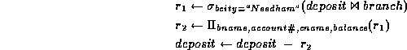Insertions
To insert data into a relation, we either specify a tuple, or write a query whose result is the set of tuples to be inserted. Attribute values for inserted tuples must be members of the attribute's domain.
An insertion is expressed by
where is a relation and is a relational algebra expression.
Some examples:
1. To insert a tuple for Smith who has $1200 in account 9372 at the SFU branch.
2. To provide all loan customers in the SFU branch with a $200 savings account.
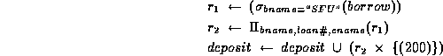

Updating
Updating allows us to change some values in a tuple without necessarily changing all.
We use the update operator, П, with the form
∏ _{A}=E ( r)
where is a relation with attribute , which is assigned the value of expression .
The expression is any arithmetic expression involving constants and attributes in relation .
Some examples:
1. To increase all balances by 5 percent.
∏ _{balance=balance*1.05}(deposit)
This statement is applied to every tuple in deposit.
2. To make two different rates of interest payment, depending on balance amount:
∏_{balance=balance*1.05}(σ balance>10000(deposit))
∏ _{balance=balance*1.05}(σ balance<=10000(deposit))
Note: in this example the order of the two operations is important. (Why?)
Views
- We have assumed up to now that the relations we are given are the actual relations stored in the database.
- For security and convenience reasons, we may wish to create a personalized collection of relations for a user.
- We use the term view to refer to any relation, not part of the conceptual model, that is made visible to the user as a ``virtual relation''.
- As relations may be modified by deletions, insertions and updates, it is generally not possible to store views. (Why?) Views must then be recomputed for each query referring to them.
View Definition
- A view is defined using the create view command:
where <query expression> is any legal query expression.
The view created is given the name .
- To create a view all-customer of all branches and their customers:
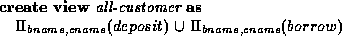
- Having defined a view, we can now use it to refer to the virtual relation it creates. View names can appear anywhere a relation name can.
- We can now find all customers of the SFU branch by writing

Updates Through Views and Null Values
- Updates, insertions and deletions using views can cause problems. The modifications on a view must be transformed to modifications of the actual relations in the conceptual model of the database.
- An example will illustrate: consider a clerk who needs to see all information in the borrow relation except amount.
Let the view loan-info be given to the clerk:
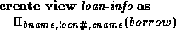
- Since SQL allows a view name to appear anywhere a relation name may appear, the clerk can write:
This insertion is represented by an insertion into the actual relation borrow, from which the view is constructed.
However, we have no value for amount. A suitable response would be
  - Reject the insertion and inform the user.
  - Insert (``SFU'',3,``Ruth'',null) into the relation.
The symbol null represents a null or place-holder value. It says the value is unknown or does not exist.
- Another problem with modification through views: consider the view
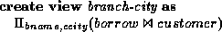
This view lists the cities in which the borrowers of each branch live.
Now consider the insertion
Using nulls is the only possible way to do this (see Figure 3.22 in the textbook).
If we do this insertion with nulls, now consider the expression the view actually corresponds to:
As comparisons involving nulls are always false, this query misses the inserted tuple.

Module III

Transaction Concept
- A transaction is a unit of program execution that accesses and possibly updates various data items.
- A transaction must see a consistent database.
- During transaction execution the database may be inconsistent.
- When the transaction is committed, the database must be consistent.
- Two main issues to deal with:
  - Failures of various kinds, such as hardware failures and system crashes
  - Concurrent execution of multiple transactions
Data processing folks like to talk about the "ACID test" when deciding whether or not a database management system is adequate for handling transactions. An adequate system has the following properties:

Atomicity
Results of a transaction's execution are either all committed or all rolled back. All changes take effect, or none do. That means, for Joe User's money transfer, that both his savings and checking balances are adjusted or neither are.

Consistency
The database is transformed from one valid state to another valid state. This defines a transaction as legal only if it obeys user-defined integrity constraints. Illegal transactions aren't allowed and, if an integrity constraint can't be satisfied then the transaction is rolled back. For example, suppose that you define a rule that, after a transfer of more than $10,000 out of the country, a row is added to an audit table so that you can prepare a legally required report for the IRS. Perhaps for performance reasons that audit table is stored on a separate disk from the rest of the database. If the audit table's disk is off-line and can't be written, the transaction is aborted.

Isolation
The results of a transaction are invisible to other transactions until the transaction is complete. For example, if you are running an accounting report at the same time that Joe is transferring money, the accounting report program will either see the balances before Joe transferred the money or after, but never the intermediate state where checking has been credited but savings not yet debited.

Durability
Once committed (completed), the results of a transaction are permanent and survive future system and media failures. If the airline reservation system computer gives you seat 22A and crashes a millisecond later, it won't have forgotten that you are sitting in 22A and also give it to someone else. Furthermore, if a programmer spills coffee into a disk drive, it will be possible to install a new disk and recover the transactions up to the coffee spill, showing that you had seat 22A.
Example of Fund Transfer

- Transaction to transfer $50 from account A to account B:
1. read(A) 4. read(B)
2. A := A – 50 5. B := B + 50
3. write(A) 6. write(B)
- Consistency requirement – the sum of A and B is unchanged by the execution of the transaction.
- Atomicity requirement — if the transaction fails after step 3 and before step 6, the system should ensure that its updates are not reflected in the database, else an inconsistency will result.
- Durability requirement — once the user has been notified that the transaction has completed (i.e., the transfer of the $50 has taken place), the updates to the database by the transaction must persist despite failures.
Example …
- Isolation requirement — if between steps 3 and 6, another transaction is allowed to access the partially updated database, it will see an inconsistent database
(the sum A + B will be less than it should be).
Can be ensured trivially by running transactions serially, that is one after the other. However, executing multiple transactions concurrently has significant benefits, as we will see.

Transaction States
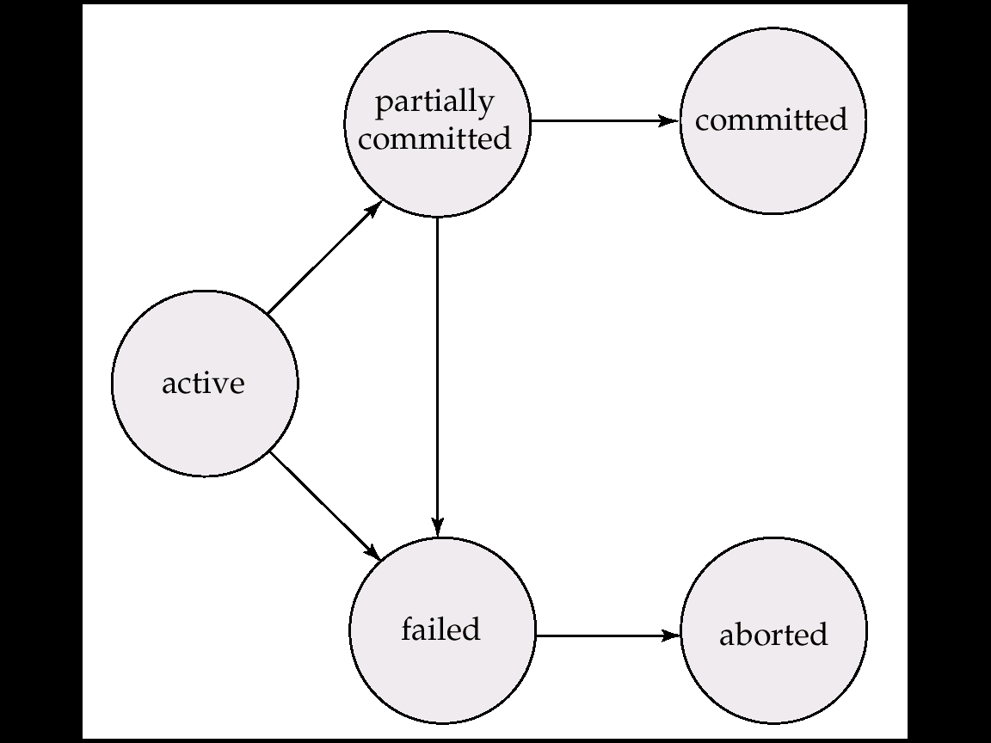

Concurrent Executions
- Multiple transactions are allowed to run concurrently in the system. Advantages are:
  - increased processor and disk utilization, leading to better transaction throughput: one transaction can be using the CPU while another is reading from or writing to the disk
  - reduced average response time for transactions: short transactions need not wait behind long ones.
- Concurrency control – provides mechanisms to achieve isolation, i.e., to control the interaction among the concurrent transactions in order to prevent them from destroying the consistency of the database
Serializability
- Basic Assumption – Each transaction preserves database consistency.
- Thus serial execution of a set of transactions preserves database consistency.
- A schedule defines sequence in which operations were done
- A (possibly concurrent) schedule is serializable if it is equivalent to a serial schedule. Different forms of schedule equivalence give rise to the notions of:
1. conflict serializability
2. view serializability
- We ignore operations other than read and write instructions, Our simplified schedules consist of only read and write instructions.
Conflict Serializability
- Instructions li and lj of transactions Ti and Tj respectively, conflict if and only if there exists some item Q accessed by both li and lj, and at least one of these instructions wrote Q.
1. li = read(Q), lj = read(Q). li and lj don’t conflict.
2. li = read(Q), lj = write(Q). They conflict.
3. li = write(Q), lj = read(Q). They conflict
4. li = write(Q), lj = write(Q). They conflict
- Intuitively, a conflict between li and lj forces a (logical) temporal order between them. If li and lj are consecutive in a schedule and they do not conflict, their results would remain the same even if they had been interchanged in the schedule.
View Serializability
- Let S and S´ be two schedules with the same set of transactions. S and S´ are view equivalent if the following three conditions are met:
1. For each data item Q, if transaction Ti reads the initial value of Q in schedule S, then Ti must, in schedule S´, also read the initial value of Q.
2. For each data item Q if Ti executes read(Q) in schedule S, and that value was produced by transaction Tj (if any), then Ti must in schedule S´ also read the value of Q that was produced by transaction Tj .
3. For each data item Q, the transaction (if any) that performs the final write(Q) operation in schedule S must perform the final write(Q) operation in schedule S´.
As can be seen, view equivalence is also based purely on reads and writes alone.
Recoverability
Need to address the effect of transaction failures on concurrently
running transactions.
- Recoverable schedule — if Tj reads a data items previously written by Ti , the commit operation of Ti appears before the commit operation of Tj.
- The following schedule is not recoverable if T9 commits immediately after the read
- If T8 should abort, T9 would have read (and possibly shown to the user) an inconsistent database state. Hence database must ensure that schedules are recoverable.
- Cascading rollback – a single transaction failure leads to a series of transaction rollbacks. Consider the following schedule where none of the transactions has yet committed (so the schedule is recoverable)
If T10 fails, T11 and T12 must also be rolled back.
- Can lead to the undoing of a significant amount
- Cascadeless schedules — where cascading rollbacks cannot occur; for each pair of transactions Ti and Tj such that Tj reads a data item previously written by Ti, the commit operation of Ti appears before the read operation of Tj.
- Every cascadeless schedule is also recoverable
- It is desirable to restrict the schedules to those that are cascadeless.
Transaction Definition in SQL
- Data manipulation language must include a construct for specifying the set of actions that comprise a transaction.
- In SQL, a transaction begins implicitly.
- A transaction in SQL ends by:
  - Commit work commits current transaction and begins a new one.
  - Rollback work causes current transaction to abort.
  - Levels of consistency specified by SQL-92:
    - Serializable — default
    - Repeatable read
    - Read committed
    - Read uncommitted
Levels of Consistency in SQL-92
- Serializable — default
- Repeatable read — only committed records to be read, repeated reads of same record must return same value. However, a transaction may not be serializable – it may find some records inserted by a transaction but not find others.
Lock-Based Protocols
- A lock is a mechanism to control concurrent access to a data item
- Data items can be locked in two modes :
1. exclusive (X) mode. Data item can be both read as well as written. X-lock is requested using lock-X instruction.
2. shared (S) mode. Data item can only be read. S-lock is requested using lock-S instruction.
- Lock requests are made to concurrency-control manager. Transaction can proceed only after request is granted.
- Lock-compatibility matrix

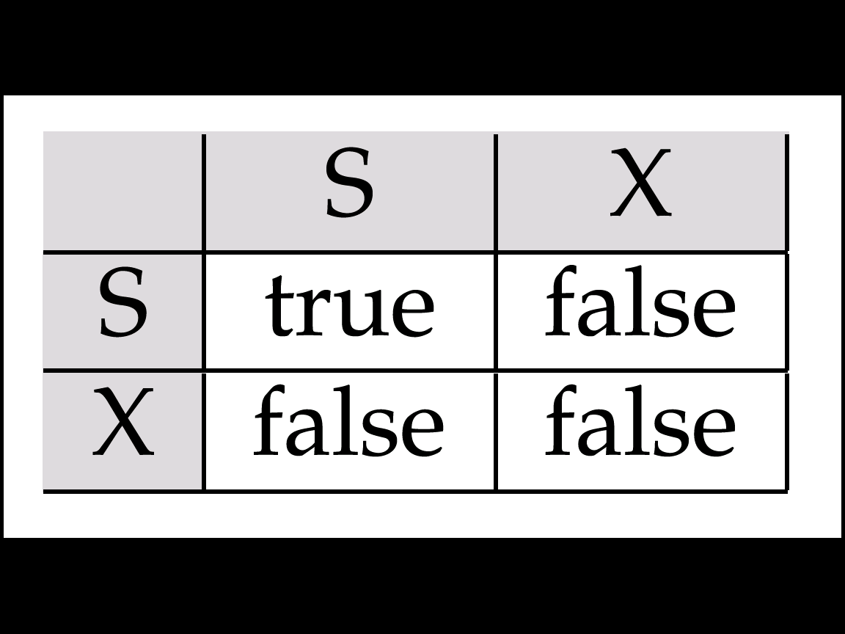

- A transaction may be granted a lock on an item if the requested lock is compatible with locks already held on the item by other transactions
- Any number of transactions can hold shared locks on an item, but if any transaction holds an exclusive on the item no other transaction may hold any lock on the item.
- If a lock cannot be granted, the requesting transaction is made to wait till all incompatible locks held by other transactions have been released. The lock is then granted.
The Two-Phase Locking Protocol
- This is a protocol which ensures conflict-serializable schedules.
- Phase 1: Growing Phase
  - transaction may obtain locks
  - transaction may not release locks
- Phase 2: Shrinking Phase
  - transaction may release locks
  - transaction may not obtain locks
- The protocol assures serializability. It can be proved that the transactions can be serialized in the order of their lock points (i.e. the point where a transaction acquired its final lock).
- Two-phase locking does not ensure freedom from deadlocks

- Cascading roll-back is possible under two-phase locking. To avoid this, follow a modified protocol called strict two-phase locking. Here a transaction must hold all its exclusive locks till it commits/aborts.
- Rigorous two-phase locking is even stricter: here all locks are held till commit/abort. In this protocol transactions can be serialized in the order in which they commit.
Pitfalls of Lock-Based Protocols (Cont.)
- The potential for deadlock exists in most locking protocols. Deadlocks are a necessary evil.
- Starvation is also possible if concurrency control manager is badly designed. For example:
  - A transaction may be waiting for an X-lock on an item, while a sequence of other transactions request and are granted an S-lock on the same item.
  - The same transaction is repeatedly rolled back due to deadlocks.
- Concurrency control manager can be designed to prevent starvation.
Deadlock Handling
- System is deadlocked if there is a set of transactions such that every transaction in the set is waiting for another transaction in the set.
- Deadlock prevention protocols ensure that the system will never enter into a deadlock state. Some prevention strategies :
  - Require that each transaction locks all its data items before it begins execution (predeclaration).
  - Impose partial ordering of all data items and require that a transaction can lock data items only in the order specified by the partial order (graph-based protocol).
More Deadlock Prevention Strategies
- Following schemes use transaction timestamps for the sake of deadlock prevention alone.
- wait-die scheme — non-preemptive
  - older transaction may wait for younger one to release data item. Younger transactions never wait for older ones; they are rolled back instead.
  - a transaction may die several times before acquiring needed data item
- wound-wait scheme — preemptive
  - older transaction wounds (forces rollback) of younger transaction instead of waiting for it. Younger transactions may wait for older ones.
  - may be fewer rollbacks than wait-die
- Both in wait-die and in wound-wait schemes, a rolled back transactions is restarted with its original timestamp. Older transactions thus have precedence over newer ones, and starvation is hence avoided.
- Timeout-Based Schemes :
  - a transaction waits for a lock only for a specified amount of time. After that, the wait times out and the transaction is rolled back.
  - thus deadlocks are not possible
  - simple to implement; but starvation is possible. Also difficult to determine good value of the timeout interval.
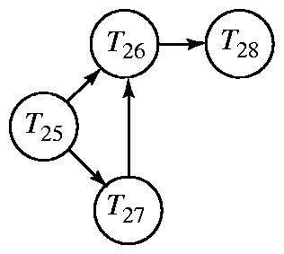

Wait-for graph without a cycle
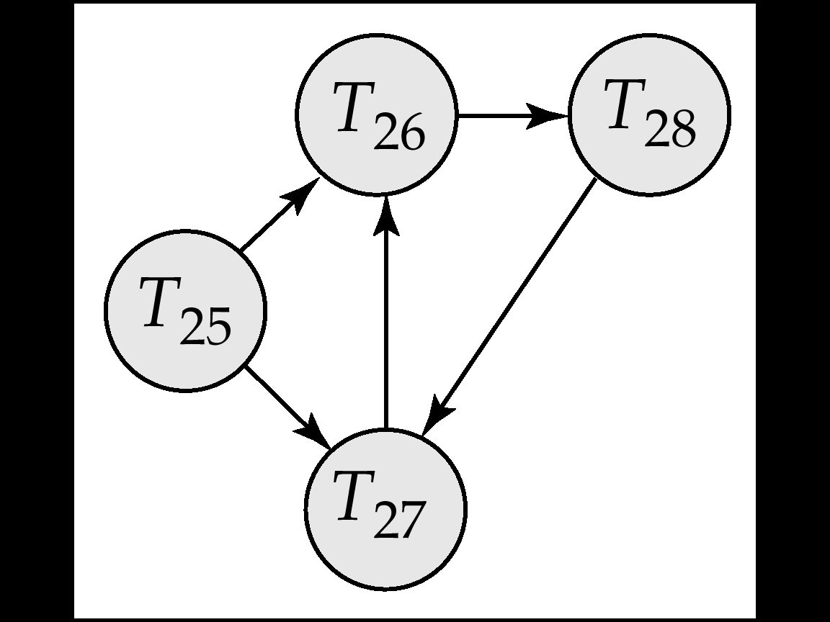

Wait-for graph with a cycle
Deadlock Recovery
- When deadlock is detected :
Some transaction will have to rolled back (made a victim) to break deadlock. Select that transaction as victim that will incur minimum
  - cost.
  - Rollback -- determine how far to roll back transaction
    - Total rollback: Abort the transaction and then restart it.
    - More effective to roll back transaction only as far as necessary to break deadlock.
  - Starvation happens if same transaction is always chosen as victim. Include the number of rollbacks in the cost factor to avoid starvation
Recovery mechanism

Failure Classification
- Transaction failure :
  - Logical errors: transaction cannot complete due to some internal error condition
  - System errors: the database system must terminate an active transaction due to an error condition (e.g., deadlock)
- System crash: a power failure or other hardware or software failure causes the system to crash.
  - Fail-stop assumption: non-volatile storage contents are assumed not to be corrupted by system crash
    - Database systems have numerous integrity checks to prevent corruption of disk data
- Disk failure: a head crash or similar disk failure destroys all or part of disk storage
  - Destruction is assumed to be detectable: disk drives use checksums to detect failures

TRIGGERS

In a DBMS, a trigger is a SQL procedure that initiates (fires) an action when an event (INSERT, DELETE, or UPDATE) occurs. Since triggers are event-driven specialized procedures, the DBMS stores and manages them. A trigger cannot be called or executed; the DBMS automatically fires the trigger as a result of a data modification to the associated table. Triggers maintain the referential integrity of data by changing the data in a systematic fashion.
A trigger has the following components:
- Constraint: The integrity constraint or business rule enforced by the trigger -- in other words, the "purpose" of the trigger. Practically speaking, this should appear in the header of the trigger, which should be reflected in its name. For example, the "Positive Opening Balance" constraint requires that all new accounts must have non-negative balances.
* Event: A specific situation occurring in the database, which indicates when the constraint should be enforced. The event is said to be "raised" when the situation occurs. The event is often specified in two ways: as a state change on the database (for example, an insert into the Accounts table) and as an optional predicate condition used to filter out some of the state changes (for example, only those inserts into the Accounts table with a negative value for the Balance column). Specific moments are also very interesting events. Note that "event" in this generic definition should not be confused with the database event alerters supported by some DBMSs such as CA-OpenIngres.
* Action: A procedure or a sequence of procedural operations that implement the processing logic required to enforce the constraint. For example, the action must enforce the business rule that accounts may not have negative opening balances. This can be done by refusing the insert operation if the opening balance is negative, or by replacing the negative balance with zero and inserting an entry in a journaling table. The implied "if" condition highlights another point: conventional database manipulation operations (that is, SQL select, insert, update, and delete statements) are usually too limited to implement the required actions. They must be extended with procedural constructs such as iteration (while, for, and repeat) and conditional (if and case) statements. A trigger is therefore an event that "fires" an action to enforce a constraint.

Advantages of Triggers
The most attractive feature of triggers is that they are stored and executed in the database. This has the following advantages:
* The triggers always fire when the associated events occur. Application developers do not have to remember to include the functionality in each application, and users cannot bypass the triggers through interactive tools. (But every skilled DBA knows how to bypass the triggers on his or her system.) Most DBMSs have some mechanism to bypass the trigger, either by temporarily deactivating the triggers or by using a "trace point" or some similar mechanism.
* Triggers are administered centrally. They are coded once, tested once, and then centrally enforced for all the applications accessing the database. The triggers are usually controlled, or at least audited, by a skilled DBA. The result is that the triggers are implemented efficiently.
* The central activation and processing of triggers fits the client/
server architecture well. A single request from a client can result in a whole sequence of checks and subsequent operations performed on the database. The data and operations are not "dragged" across the network between the client and the server.
Because triggers are so powerful, they must be managed well and they must be used correctly. Inefficient triggers can bring the database server to its knees, due to the amount of work fired off in the database. Incorrect triggers can corrupt the integrity of the data.

What are Triggers Used For?
Triggers are extremely powerful constructs and can be used for various purposes, for example:
* Integrity control: You can use triggers to implement domain integrity, column integrity, referential integrity, and unconventional integrity constraints. I will address the declarative vs. the do-it-yourself (that is, using triggers) approaches to integrity control in my next column.
* Business rules: You can use triggers to centrally enforce business rules. Business rules are constraints that are enforced over the relationships between tables or between different rows in the same table. For example, the sum of the amounts of the InvoiceItems rows must add up to the total on the row in the Invoices table for the corresponding invoice -- that is, if your organization's standards and/or DBAs let you have denormalized derived attributes in your physical data model.
* Application logic: You can use triggers to enforce business logic centrally, for example, to insert rows automatically in the Orders and OrderItems tables when the QuantityOnHand value in the Stocks table drops below a given threshold. Business rules could be formalized and could actually be defined declaratively, if only the declarative syntax allowed it; but application logic requires more complex functionality than can be specified declaratively.
* Security: You can use triggers to check value-based security constraints. When an operation is performed on a sensitive table, the trigger fires to check that the operation is allowed for the user. For example, you may only insert a row in a table if the department column contains the value of your own department. In most systems, however, you cannot use triggers to restrict the data that is visible to users. The only exception I came across is the Progress Database Server (release 7.3 and later), in which you can define triggers to fire on select operations. This makes it possible to inspect or filter the data a user is about to see. For example, you can restrict a user to only retrieve the details of orders placed for his department.
* Audit trails: Triggers can insert records into an audit trail table to log all the operations on sensitive tables. The problem with this approach is that most trigger actions are under transactional control. When an operation is rolled back, all its triggered operations are also rolled back. The triggers will therefore only record the effects of successful operations. When an unsuccessful operation is rolled back, the audit trail entry of that operation will also be rolled back. The audit trail will therefore not contain attempted threats at violating data integrity constraints or security restrictions.
* Replication: Many DBMS vendors and consultants (including my corporation) have implemented replicators using triggers as the recording mechanism. In essence, when the replicated tables change, the triggers fire and record the changes in buffer tables. A replication server then propagates the operations from the buffer tables to the various target databases. (It is, however, not quite as simple as it sounds.) In this situation, the transactional control on the triggers is extremely useful, as you only want to replicate successfully completed transactions.
* Updatable views: In Borland's InterBase, you can define triggers on views and tables. You can then use the view triggers to propagate the actions performed on the view to the underlying base table(s). You can use this extremely powerful feature to update theoretically non-updatable views. For example, the triggers on a view that does not contain the keys of the underlying tables can query the key values of the underlying tables and can then perform the necessary operations.

Here is the syntax for these triggers:
CREATE [OR REPLACE] TRIGGER <trigger_name>

{BEFORE|AFTER} {INSERT|DELETE|UPDATE} ON <table_name>

[REFERENCING [NEW AS <new_row_name>] [OLD AS <old_row_name>]]

[FOR EACH ROW [WHEN (<trigger_condition>)]]

<trigger_body>
Some important points to note:
- You can create only BEFORE and AFTER triggers for tables. (INSTEAD OF triggers are only available for views; typically they are used to implement view updates.)
- You may specify up to three triggering events using the keyword OR. Furthermore, UPDATE can be optionally followed by the keyword OF and a list of attribute(s) in <table_name>. If present, the OF clause defines the event to be only an update of the attribute(s) listed after OF. Here are some examples:
- ... INSERT ON R ...

- ... INSERT OR DELETE OR UPDATE ON R ...

... UPDATE OF A, B OR INSERT ON R ...
- If FOR EACH ROW option is specified, the trigger is row-level; otherwise, the trigger is statement-level.
- Only for row-level triggers:
  - The special variables NEW and OLD are available to refer to new and old tuples respectively. Note: In the trigger body, NEW and OLD must be preceded by a colon (":"), but in the WHEN clause, they do not have a preceding colon! See example below.
  - The REFERENCING clause can be used to assign aliases to the variables NEW and OLD.
  - A trigger restriction can be specified in the WHEN clause, enclosed by parentheses. The trigger restriction is a SQL condition that must be satisfied in order for Oracle to fire the trigger. This condition cannot contain subqueries. Without the WHEN clause, the trigger is fired for each row.
- <trigger_body> is a PL/SQL block, rather than sequence of SQL statements. Oracle has placed certain restrictions on what you can do in <trigger_body>, in order to avoid situations where one trigger performs an action that triggers a second trigger, which then triggers a third, and so on, which could potentially create an infinite loop. The restrictions on <trigger_body> include:
  - You cannot modify the same relation whose modification is the event triggering the trigger.
  - You cannot modify a relation connected to the triggering relation by another constraint such as a foreign-key constraint.

Viewing Defined Triggers
To view a list of all defined triggers, use:
select trigger_name from user_triggers;
For more details on a particular trigger:
select trigger_type, triggering_event, table_name, referencing_names, trigger_body
from user_triggers
where trigger_name = '<trigger_name>';

Dropping Triggers
To drop a trigger:
drop trigger <trigger_name>;

Disabling Triggers
To disable or enable a trigger:
alter trigger <trigger_name> {disable|enable};

Module IV

Database normalization
- (also spelt database normalisation) relates to the level of redundancy in a database's structure. Well-normalized databases have a schema that reflects the true dependencies between tracked quantities. This means that updates can be quickly performed with little risk of data becoming inconsistent.
In the relational model, formal methods exist for quantifying "how normalized" a database is. These classifications are called normal forms (or NFs), and there are algorithms for converting a given database between them.
Any increase in normalization generally involves splitting existing tables into multiple ones, which must be re-joined each time a query is issued. This can sometimes lead to poor performance, so intentional denormalization is used for applications like on-line analytical processing

Normal Forms
One can only ascribe a normal form to a database if relationships between quantities have been rigorously defined. It is possible to use set theory to express this knowledge once a problem domain has been fully understood. Such formality is usually sidestepped by database designers, who instead model the relationships in terms of an "idealized schema". (The mathematical underpinnings come back into play in proofs regarding the process of transforming from one form to another.)
Edgar F. Codd originally established three normal forms: 1NF, 2NF and 3NF. There are now others that are generally accepted, but 3NF is sufficient for many practical applications, as most relations when reaching 3NF are also in BCNF, 4NF and 5NF, and 6NF only applies to temporal databases. Normalizing beyond that point can be tricky in SQL technology, nevertheless a non-fully normalised database may be vulnerable to update anomalies — in other words, data corruption. Thus, full normalisation, even when not fully implemented in the target technology, is a good exercise to help discover all potential internal database consistency problems.

First normal form
First normal form (or 1NF) requires that all column values in a table are atomic (e.g., a number is an atomic value, while a list or a set is not). This basic format eliminates repeating groups and attributes by putting each into a separate table, then connecting them with a primary key-foreign key relationship.
Consider a relation for capturing an order as follows:
ORDER_NUMBER (PRIMARY_KEY)
CUSTOMER_NAME
CUSTOMER_ADDRESS
ITEM_1_NAME
ITEM_1_PRICE
ITEM_1_QUANTITY
ITEM_2_NAME
ITEM_2_PRICE
ITEM_2_QUANTITY
…
ITEM_N_NAME
ITEM_N_PRICE
ITEM_N_QUANTITY
The attributes for holding information about each Item on the Order are repeated for the number of different Items ordered. These attributes should instead be placed on a separate relation called ORDER_ITEM containing the following attributes
ITEM_NAME (PRIMARY KEY)
ORDER_NUMBER (FOREIGN KEY)
ITEM_PRICE
ITEM_QUANTITY
An ORDER relation can then reference many ORDER_ITEMs.

Second normal form
Second normal form (or 2NF) applies to relations that have Composite Primary Keys, where 2 or more attributes comprise the primary key. It requires that there are no non-trivial functional dependencies of a non-key attribute on a part (subset) of a candidate key. A relation is said to be in the 2NF if and only if it is in the 1NF and every non-key attribute is irreducibly dependent on the primary key (i.e.,not partially dependent on candidate key).
Consider a table describing Parts with the following attributes:
PART_NUMBER (PRIMARY_KEY)
SUPPLIER_NAME (PRIMARY_KEY)
PRICE
SUPPLIER_ADDRESS
The part number and supplier name form the composite primary key, because the same part can be supplied by multiple suppliers. In this example, price is correctly placed on the Part relation, because it is fully dependent on the Primary Key i.e. different suppliers will charge a different price for the same part.
Supplier Address, however, is only dependent on the Supplier Name, and therefore this relation breaks 2NF. This attribute should be placed on a second relation comprising:
SUPPLIER_NAME (PRIMARY_KEY)
SUPPLIER_ADDRESS
In order to find if a relation is in 2NF, ask whether any of the non-key attributes of the table could be derived from a subset of the composite key, rather than the whole composite key. If the answer is yes, it's not in 2NF. (Hint: This is solved sometimes by using a correlation file, such as the SUPPLIER_NAME/SUPPLIER_ADDRESS table above.)

Third normal form
Third normal form (or 3NF) requires that there are no non-trivial functional dependencies of non-key attributes on something other than a superset of a candidate key. A relation is in 3NF if none of the non-Primary Key attributes are a fact about any other non-Primary Key attribute. Another way of saying this is that all non-key attributes are mutually independent (i.e. there should not be transitive dependencies).
Consider a relation that defines a Part as having the following attributes.
PART_NUMBER (PK)
MANUFACTURER_NAME
MANUFACTURER_ADDRESS
In this case, the manufacturer address does not belong on this relation, because it is a fact about the Manufacturer of the Part, rather than the Part itself. Manufacturer should therefore be made into a separate relation with the attributes
MANUFACTURER_NAME (PRIMARY_KEY)
MANUFACTURER_ADDRESS
and the Part relation should be redefined as
PART_NUMBER (PRIMARY_KEY)
MANUFACTURER_NAME
The problem with a table not being in 3NF is that for every MANUFACTURER_NAME we have to maintain a MANUFACTURER_ADDRESS which is redundant.

Boyce-Codd normal form
Boyce-Codd normal form (or BCNF) requires that there are no non-trivial functional dependencies of attributes on something else than a superset of a candidate key. At this stage, all attributes are dependent on a key, a whole key and nothing but a key (excluding trivial dependencies, like A->A). A relation is said to be in the BCNF if and only if it is in the 3NF and every non-trivial, left-irreducible functional dependency has a candidate key as its determinant. In more informal terms, a relation is in BCNF if it is in 3NF and the only determinants are the candidate keys.

Fourth normal form
Fourth normal form (or 4NF) requires that there are no non-trivial multi-valued dependencies of attribute sets on something else than a superset of a candidate key. A relation is said to be in 4NF if and only if it is in the BCNF and multi-valued dependencies are functional dependencies. The 4NF removes unwanted data structures: multi-valued dependencies.
Consider a case where an Employee relation has multiple job categories and multiple locations where they work. It might be tempting to create a relation as follows to capture this information:
EMPLOYEE_ID
JOB_CATEGORY_ID
LOCATION_ID
The problem with this relation is that we might have to enter Employee's Job Category more than once if they fulfill the same Job Category at more than one location. Therefore this relation is not in 4NF.
There are actually 3 distinct many-to-many relationships here, one between Employee and Job Category, one between Employee and Location, and one between Job Category and Location. So 3 relations should be created to capture these.
EMPLOYEE_JOB_CATEGORY relation:
EMPLOYEE_ID
JOB_CATEGORY_ID
EMPLOYEE_LOCATION relation:
EMPLOYEE_ID
LOCATION_ID
JOB_CATEGORY_LOCATION relation:
JOB_CATEGORY_ID
LOCATION_ID
Ronald Fagin demonstrated that it is always possible to achieve 4NF (but not always desirable). Rissanen's theorem is also applicable on multi-valued dependencies.

Fifth normal form
Fifth normal form (or 5NF or PJ/NF) requires that there are no non-trivial join dependencies that do not follow from the key constraints. A relation R is said to be in the 5NF if and only if it is in 4NF and every join dependency in R is implied by the candidate keys.

Domain/key normal form
Domain/key normal form (or DKNF) requires that each key uniquely identifies each row in a table. A domain is the set of permissible values for an attribute. By enforcing key and domain restrictions, the database is assured of being freed from modification anomalies.
While sometimes called the 6NF, the DKNF should not be considered together with the seven other normal forms (1–6 and Boyce-Codd), because contrary to them it is not always achievable; furthermore, relations in the real 6NF are not always in the DKNF.

Sixth normal form
The most recent one, the sixth normal form (actually seventh, by counting the Boyce-Codd one) was only defined when extending the relational model to take into account the temporal dimension; unfortunately, current SQL technology doesn't take into account this work, and the temporal extensions to SQL are not relational.

NORMALISATION

“First Normal Form (1NF) ”
Definition: A relation is said to be in First Normal Form (1NF) if and only if each attribute of the relation is atomic. More simply, to be in 1NF, each column must contain only a single value and each row must contain the same columns.
A table is in first normal form (1NF) if there are no repeating groups.
A repeating group is a set of logically related fields or values that occur multiple times in one record.
A Practical Approach
The sample tables below do not comply with first normal form. Look for fields that contain too much data and repeating group of fields.
EMPLOYEES_PROJECTS_TIME
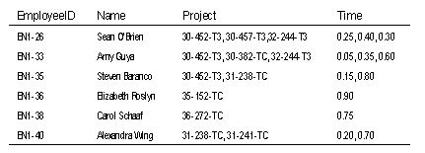
A table with fields containing too much data.
The example above is also related to another design issue, namely, that each field should hold the smallest meaningful value and that there should not be multiple values in a single field.
Why is this table design a problem?
There would be no way to sort by last names nor to know which allocation of time belonged to which project.
EMPLOYEES_PROJECTS_TIME
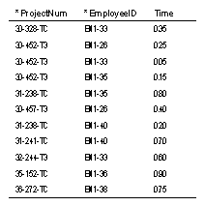
A table with repeating groups of fields.
So why is this one a problem?
If an employee was assigned to a fourth project, you would have to add two new fields to the table. Also, it would be very difficult to total the amount of time devoted to a particular project.
The design problems addressed are very common-particularly among new designers who are accustomed to tracking data in a spreadsheet. Often, when building a spreadsheet, we arrange the data horizontally, laying it out across the spreadsheet. When designing tables, we have to think more vertically. Similar data belongs in the same column or field with a single value in each row.
Designing to meet first normal form
Now we will take the table you saw above and redesign it so it will comply with first normal form.
EMPLOYEES_PROJECTS_TIME
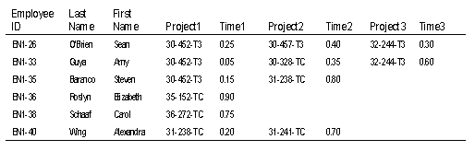
Look at the repeating groups of data. Identify tables and fields that will hold this data without the repeating groups. Think vertically and remember that similar data belongs in the same field.
Enter the sample data from the table to make sure you don't have repeating groups. If necessary, include foreign key field(s) to connect the tables.

EMPLOYEES
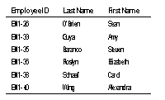

PROJECTS_EMPLOYEES_TIME
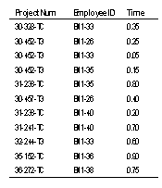
Mark the primary key field(s) and foreign keys in each table. Shown below with * indicating the Primary Key.
EMPLOYEES
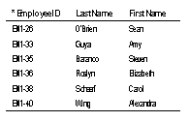
PROJECTS_EMPLOYEES_TIME
If an employee was assigned to an additional project, it would involve merely adding a new record. Also, it would be much easier to search for a particular project number as they are all held in a single column.
Introducing Functional Dependency
Before we go any further, there's a new concept you need to be aware of and that's functional dependency. A functional dependency is a relationship between fields so that the value in Field A determines the value in Field B, and there can be only one value in Field B. In that case, Field B is functionally dependent on Field A. Consider the following sample table:
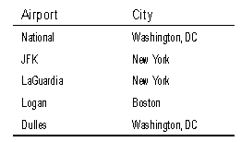
Each airport name is unique and each airport can be in only one city. Therefore, City is functionally dependent on Airport. The value in the Airport field determines what the value will be in the City field (making Airport the determinant field) and there can be only one value in the City field. This does not need to work in the reverse. As shown in the table, a city can have more than one airport, so Airport is not functionally dependent on City; the value in City does not necessarily determine what the value in Airport will

Boyce-Codd Normal Form
- A relation schema R is in Boyce-Codd Normal Form (BCNF) with respect to a set F of functional dependencies if for all functional dependencies in of the form , where and , at least one of the following holds:
  - is a trivial functional dependency (i.e. ).
  - is a superkey for schema R.
- A database design is in BCNF if each member of the set of relation schemas is in BCNF.
- Let's assess our example banking design:
- Customer-schema = (cname, street, ccity)

- cname street ccity

- Branch-schema = (bname, assets, bcity)

- bname assets bcity

- Loan-info-schema = (bname, cname, loan#, amount)

- loan# amount bname

Customer-schema and Branch-schema are in BCNF.
- Let's look at Loan-info-schema:
  - We have the non-trivial functional dependency loan# amount, and
  - loan# is not a superkey.
  - Thus Loan-info-schema is not in BCNF.
  - We also have the repetition of information problem.
  - For each customer associated with a loan, we must repeat the branch name and amount of the loan.
  - We can eliminate this redundancy by decomposing into schemas that are all in BCNF.
- If we decompose into
- Loan-schema = (bname, loan#, amount)

- Borrow-schema = (cname, loan#)

we have a lossless-join decomposition. (Remember why?)
To see whether these schemas are in BCNF, we need to know what functional dependencies apply to them.
  - For Loan-schema, we have loan# amount bname applying.
  - Only trivial functional dependencies apply to Borrow-schema.
  - Thus both schemas are in BCNF.
We also no longer have the repetition of information problem. Branch name and loan amount information are not repeated for each customer in this design.

Fourth Normal Form (4NF)
- We saw that BC-schema was in BCNF, but still was not an ideal design as it suffered from repetition of information. We had the multivalued dependency cname street ccity, but no non-trivial functional dependencies.
- We can use the given multivalued dependencies to improve the database design by decomposing it into fourth normal form.
- A relation schema R is in 4NF with respect to a set D of functional and multivalued dependencies if for all multivalued dependencies in of the form , where and , at least one of the following hold:
  - is a trivial multivalued dependency.
  - is a superkey for schema R.
- A database design is in 4NF if each member of the set of relation schemas is in 4NF.
- The definition of 4NF differs from the BCNF definition only in the use of multivalued dependencies.
  - Every 4NF schema is also in BCNF.
  - To see why, note that if a schema is not in BCNF, there is a non-trivial functional dependency holding on R, where is not a superkey.
  - Since implies , by the replication rule, R cannot be in 4NF.

MODULE 5

Distributed Database

A logically interrelated collection of shared data (and a description of this data), physically distributed over a computer network.

Distributed DBMS

Software system that permits the management of the distributed database and makes the distribution transparent to users.

Concepts

Collection of logically-related shared data.

Data split into fragments.

Fragments may be replicated.

Fragments/replicas allocated to sites.

Sites linked by a communications network.

Data at each site is under control of a DBMS.

DBMSs handle local applications autonomously.

Each DBMS participates in at least one global application.

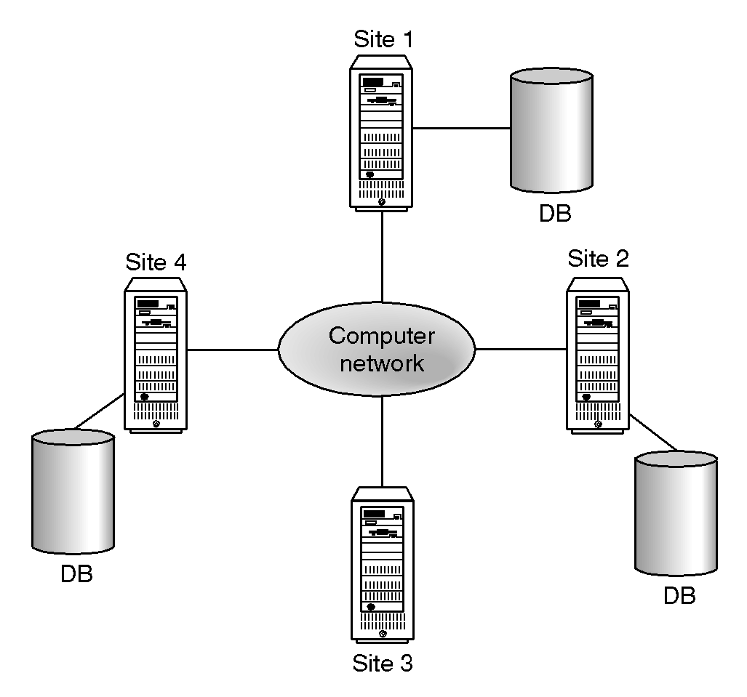

Distributed Processing

A centralised database that can be accessed over a computer network.

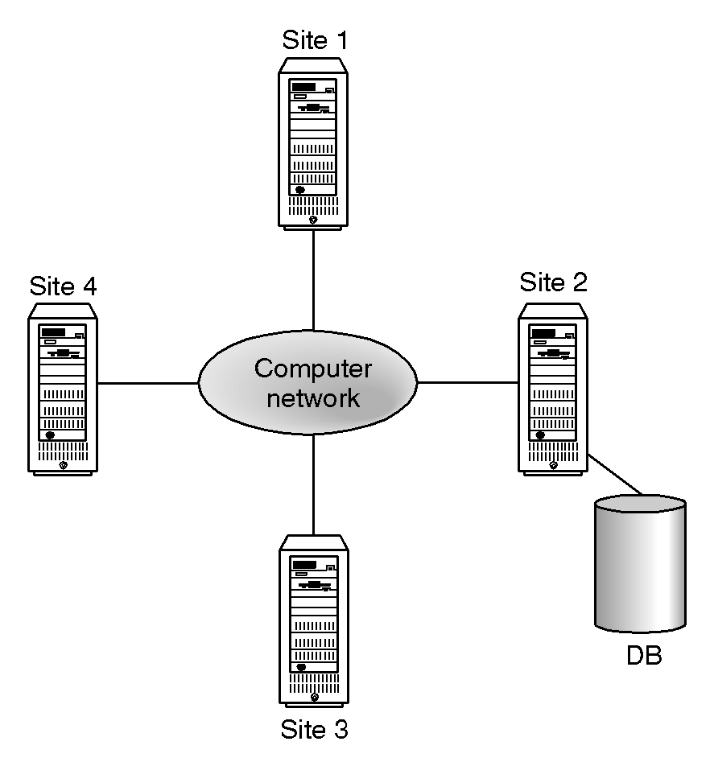

Advantages of DDBMSs

1)Organisational Structure

2)Shareability and Local Autonomy

3)Improved Availability

4)Improved Reliability

5)Improved Performance

6)Economics

7)Modular Growth

Disadvantages of DDBMSs

1)Complexity

2)Cost

3)Security

4)Integrity Control More Difficult

5)Lack of Standards

6)Lack of Experience

7)Database Design More Complex

Types of DDBMS

1)Homogeneous DDBMS

2)Heterogeneous DDBMS

Homogeneous DDBMS

1)All sites use same DBMS product.

2)Much easier to design and manage.

3)Approach provides incremental growth and allows increased performance.

Heterogeneous DDBMS

1)Sites may run different DBMS products, with possibly different underlying data models.

2)Occurs when sites have implemented their own databases and integration is considered later.

3)Translations required to allow for:

Different hardware.

Different DBMS products.

Different hardware and different DBMS products.

4)Typical solution is to use gateways.

Functions of a DDBMS

1)Expect DDBMS to have at least the functionality of a DBMS.

2)Also to have following functionality:

Extended communication services.

Extended Data Dictionary.

Distributed query processing.

Extended concurrency control.

Extended recovery services.

Reference Architecture for DDBMS
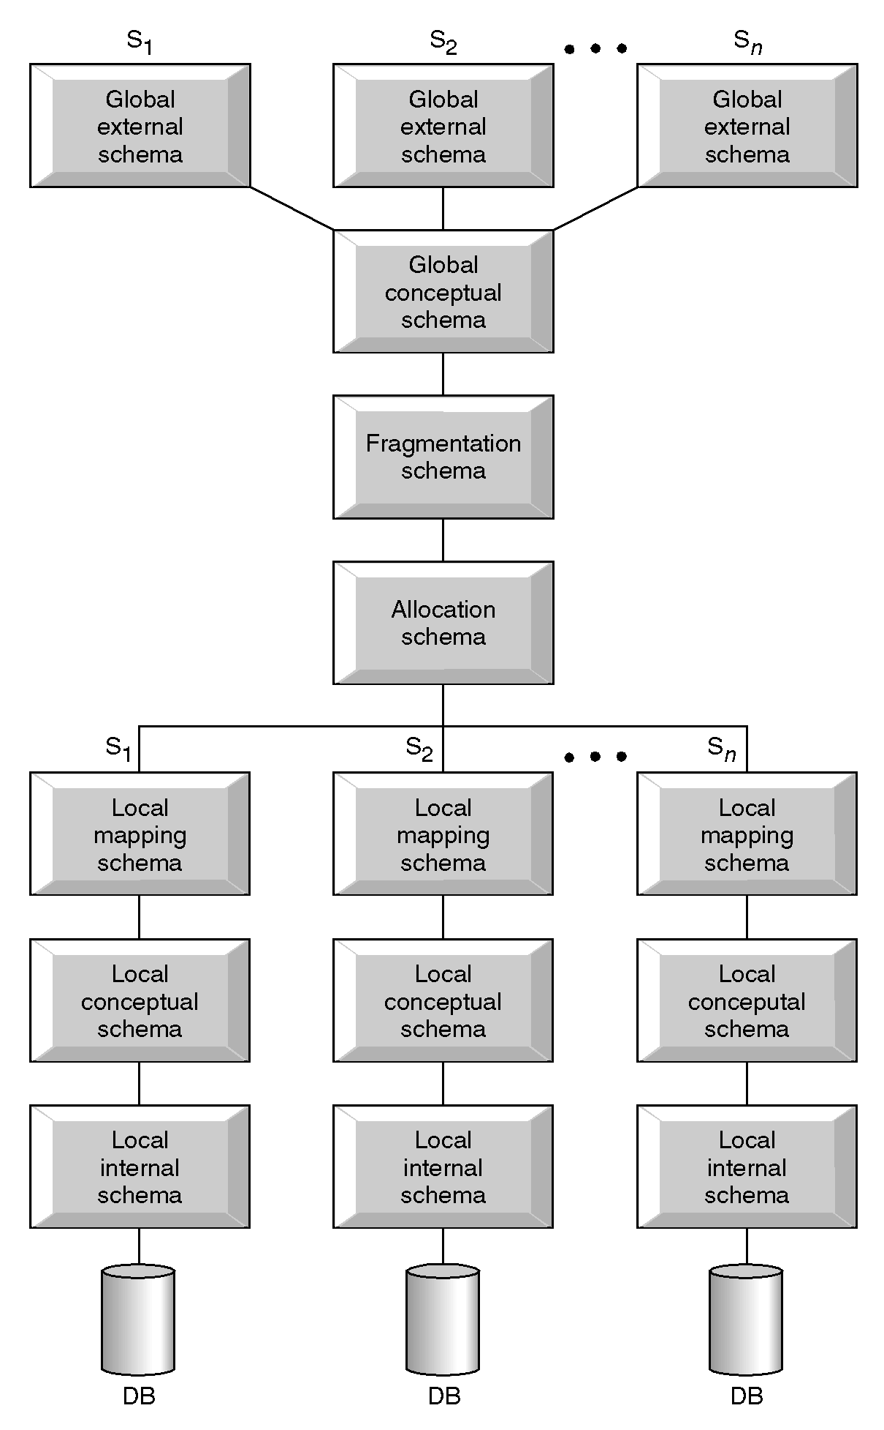

Distributed Database Design

Three key issues:

Fragmentation.

Allocation

Replication

Distributed Database Design

Fragmentation

Relation may be divided into a number of sub-relations, which are then distributed.
- Types of Fragmentation:
  - Horizontal – break up relation into subsets of the tuples in that relation, based on a restriction on one or more attributes. E.g. – we could break up a table with student info into one subset for undergrads and one subset for postgrads.
  - Vertical – breaking up a relation into subsets of attributes. E.g. – breaking up a hypothetical student table into grade/course related columns and contact/personal related columns.
  - Mixed – fragments the data multiple times, in different ways. We could do our postgrad/undergrad split and then our grades/course split to each of the fragments
  - Derived – fragmenting a relation to correspond with the fragmentation of another relation upon which the 1st relation is dependent in some way.

Allocation

Each fragment is stored at site with "optimal" distribution.

Replication

Copy of fragment may be maintained at several sites.

Transparencies in a DDBMS
Transparency
• Data independence
– logical data independence: user applications are not
affected by changes in the logical structure of the DB
(schema definition)
– physical data independence: hiding the details of the
storage structure
– the only form that is important in centralized DBMSs as
well
• Network (distribution) transparency
– location transparency: an operation on data is independent
of both the location and the system where it is executed
- naming transparency: unique name is provided for each
object in the DB.
.Replication transparency
– Data is replicated for reliability and performance
considerations.
– The user should not be aware of the existence of copies
• Fragmentation transparency
– DB relations are divided into smaller fragments for
performance and availability reasons
- The global queries should be translated to fragment queries
– A question of query processing.

