Storage media

Introduction
The collection of data that makes up a computerized database must be stored physically on some computer storage medium. The DBMS software can then retrieve update and process this data as needed. The computer storage medium forms a storage hierarchy that includes the 2 main categories.

a)Primary storage
1) Cache memory
2) Main memory
b) Secondary storage
1) Hard disk
2) Flash memory
3) CD ROMS
4) DVD
5) Magnetic tapes

Record storage
Databases are stored physically as the files of records. The files are stored on magnetic disks. The DBMS software can then retrieve update and process this data as needed. This storage media can be divided in to 2 categories namely

1) Primary storage
Computers main memory and faster and smaller cache memories come under this category. They are directly operated by the CPU.primary storage provides faster access to data but is of limited storage capacity.

2) Secondary storage.
This includes magnetic disks, optical disks and tapes. They have larger capacity, less cost and provide slower access to data than do primary storage. Data in secondary storage is copied to primary storage and then processed by the CPU.

memory hierarchy in detail.

1) Primary storage
A) Cache memory. It is Static RAM (Random Access memory used by the CPU to speed up the execution of programs. Static random access memory (SRAM) is a type of semiconductor memory. The word "static" indicates that the memory retains its contents as long as power remains applied, unlike Dynamic RAM (DRAM) that needs to be periodically refreshed.

B) Main memory:
-Dynamic RAM
-Main work area of CPU.
-low cost
-Volatile memory and speed less compared to SRAM.

2) Secondary storage
A) Hard disk-magnetic disks
-capacity measured in giga bytes or tera bytes.
-Non volatile memory
-Programs reside in hard disk.

B) Flash memory
-exists between DRAM and disk storage
-Its non volatile.
-high density, high performance memory.
-uses EEPROM
-fast access.
-the entire block must be erased and written over at a time.
-used for transferring data from one system to another.
C) CD ROMS
-stores data optically and are read by the laser.
-contains pre recorded data that can’t be over written.
-hold about half GB of data.
-They are WORMS (write once read many disks)
D) DVD

(Also known as "Digital Versatile Disc" or "Digital Video Disc") is an optical disc storage media format that can be used for data storage, including movies with high video and sound quality. DVDs resemble compact discs as their physical dimensions are the same (120 mm (4.72 inches) or occasionally 80 mm (3.15 inches) in diameter) but they are encoded in a different format and at a much higher density. The official DVD specification is maintained by the DVD Forum. Dual Layer recording allows DVD-R and DVD+R discs to store significantly more data, up to 8.5 Gigabytes per disc, compared with 4.7 Gigabytes for single-layer discs.

E) Magnetic tapes-used for archiving and back up storage of data. Magnetic tape is a non-volatile storage medium consisting of a magnetic coating on a thin plastic strip. Nearly all recording tape is of this type, whether used for video, audio storage or general purpose digital data storage using a computer.
-Sequential access devices
-a tape drive required to read and write data.

Summary
With this we got an idea of the storage Medias used to store data. We have seen the memory hierarchy. In particular we focus on magnetic disks because they are used more often to store online database.

Exercise questions
1. What is the difference between primary storage and secondary storage?
2. What is the difference between dynamic RAM and static RAM?

: Hardisk

Introduction
In the previous class we have seen the different types of storage media. In today’s lecture we see in detail the storage media-hard disk. We will emphasize the following
a) Make of the disk

b) Read /write operation

Hard disk
Make
Hard disks are made of magnetic material shaped as circular and protected by a plastic or acrylic cover. Disks are single sided if the information is stored on one side and double sided if the data is stored on both the sides. Disks are assembled in to disk pack. Information is stored on disk on concentric circles called tracks. Tracks with same diameter on various surfaces are called a cylinder. There may be 1000s of tracks on the disk and the capacity of each track goes up to 150 KB.
Actuator
Arm
Read/write head
Spindle
Cylinder

A disk pack with read/write hardware

A track is divided in to sectors. The division of the track in to sectors is hard coded on the disk and can’t be changed. Not all disks have tracks divided in to sectors. The division of tracks in to equal sized disk blocks or pages is set by the operating system during disk formatting. The block size is fixed during the initialization and can’t be changed dynamically. A block size ranges from 512 to 4096 bytes. Blocks are separated by fixed size inter block gap.
A disk is random access device. Transfer of data between the main memory and the disk takes place in units of disk blocks.
Hardware address of a block is a combination of the surface number, track number within the surface and the block number within the track. It is supplied to the I/O device.

Read operation

The block from the disk is copied to a buffer. The read/write head is attached to a mechanical arm. There are several read/write heads one for each surface. All arms are connected to an actuator, attached to another electrical motor, which moves the read/write heads. Disk pack rotate continuously at a constant speed(ranging from 3600 rpm to 7200 rpm).Once the head is positioned on the right track and the block specified in the block address moves under the read /write head, the electronic component of the read/write head is activated to transfer the data.

A disk controller embedded in the disk drive controls the disk drive and the interfaces it to the computer system. One of the standard interfaces used today for disk drives on PC and work stations is called SCSI (Small Compute Storage Interface)

Seek time

The time taken by the disk controller to position the read/write head on the correct track is called seek time. It is 12 to 14 msec on desktops and 8 or 9 msec on servers.

Rotational delay or latency.

The time taken by the disk to rotate and position the desired block under the read/write head is called rotational delay.

Block transfer time.

The time taken to transfer the data from the block to the buffer is called block transfer time.

Magnetic tape:-

They are sequential access devices, to access the nth block on tape, we must scan over the preceding n-1 blocks. A tape drive is required to read the data from or to write the data to a tape reel. Tapes help in backing up the database. To get a block in the middle of the reel of tape, the tape is mounted and then scanned until the required block gets under the read /write head.

Summary
Data on disk is stored in blocks; accessing a disk block is expensive because of the seek time, rotational delay and the block transfer time. Double buffering can be used when accessing consecutive disk blocks to reduce the average block access time. We will see this method in the coming lecturers.

Exercise questions

1) Define the following terms
a) Disk b) disk pack c) track d) block e) cylinder f) sector g) inter block gap
2) Discuss the mechanism used to read data from the disk.
3) What are the components of disk block address?
4) Why is accessing a disk block expensive? Discuss the time components
involved in accessing a disk block.

Computational assignments
Consider a disk with the following characteristics: block size B=512 bytes; interblock gap size G=128 bytes; no of blocks per track=20; number of tracks per surface=400.A disk pack consists of 15 double sided disks.
a) What is the total capacity of a track, and what is its useful capacity?
b) How many cylinders are there?
c) What are the total capacity and useful capacity of a cylinder?
d) Suppose the disk drive rotates the disk pack at a speed of 2400 rpm;what is the transfer rate in bytes/msec and the block transfer time in msec?what is the average rotational delay in msec?what is the bulk transfer rate?
e) Suppose the average seek time is 30 msec.How much time does it take in msec to locate and transfer a single block, given its block address?

Buffering of blocks

Introduction
I think all of you are thorough with the hard disk organization. Most of the files are stored in the hard disk. We will emphasize the following topics regarding the files stored on the hard disk.
1) Double buffering
2) File records
3) Fixed length record
4) Variable length record
5) Mixed files
Buffering of blocks

Buffers are used to store blocks to speed up the transfer when several blocks need to be transferred from the disk to main memory. While one buffer is being read or written, CPU can process data in the other buffer.

Double buffering

CPU can start processing a block once its transfer to main memory is completed; at the same time the disk I/O processor can be reading and transferring the next block in to a different buffer. This is double buffering.
i
Fill A
i+1
Fill B
i+2
Fill A
i+3
Fill B
Disk
Block
I/O

Fill A
Disk
Block
Processing

Fill A
i
i+1
i+2
Process A
Process B
Process A

Time

Files on disk

Record: Data is usually stored in the form of records .Record consists of a collection of related data values or items. Records consist of entities and then attributes.

Example:-An employee record represents an employee entity and each field value in the record specifies some attribute of that employee such as NAME, BIRTHDATE, SALARY, SUPERVISOR.A data type associated with each field specifies the type of values a field can take.

Files:-
A file is a sequence of records. Mostly all the records in a file are of the same record type.

Fixed length record
If every record in the file has exactly the same size, then file is said to be made of fixed length records.

Name | SSN | Salary | Job code | Department | Hire date

Variable length record

If different records in the file have different sizes, the file is said to be made of variable length records.

Variable length fields
If the records are of same record type, but fields are of varying size.

Name | SSN | Salary | Job code | Department | Hire date
 |  | XXXX | XXX

Here salary and job code are of variable length .Since we don’t know the size of the data stored, special separator characters can be used (%,$)

Repeating field
Records are of same type, but one or more of the fields may have multiple values for individual records.

Optional fields

File records are of same record type, but one or more of the fields are optional.

Mixed file

Contains records of different record types and hence of varying size

Spanned and unspanned records
The unit of data transfer between the disk and memory is a block. So records in a file are transferred to the blocks in the disk. When block size is larger than the record size a single block on the disk hold many records.
Suppose block size is B bytes
Let record size be R bytes.
B>=R then bfr=B/R records per block.
Bfr= blocking factor for the file. The remainder of this division will be the unused space in that block which is B-(bfr*R) bytes.
To utilize the unused space, we can store a part of the record on one block and the rest on the other. A pointer at the end of the first block points to the block containing the remainder of the record. This organization is called spanned.

Record 1 | Record2 | Record 3 | Record 4 | pointer

Record 4(rest) | Record 5 | Record 6 | Record 7 | pointer

Spanned organization

For variable length records using spanned organization, each block may store a different no of records. So blocking factor bfr should be modified to represent the average number of records /block for that file.
Consider the file with r records
Now bfr=B/R
B=r/bfr blocks

Unspanned records.
If the records are not allowed to cross the block boundaries, the organization is called unspanned.

Record 1 | Record 2 | Record 3 | Record 4 | Unused space

Record 5 | Record 6 | Record 7 | Record 8 | Unused space

summary

Double buffering can be used while accessing consecutive disk blocks, to reduce the average block access time. Records of a file are grouped in to disk blocks and can be fixed type, variable type, spanned, unspanned etc.

Exercise questions

1) How does double buffering improve block access time?
2) What are the reasons for having variable length records? What type of separator characters is needed?
3) Discuss the techniques for allocating file blocks on disk.

Computational assignments

Suppose that a disk unit has the following parameters; seek time=s=20 msec;
Rotational delay rd=10 msec;
Block transfer time btt= 1 msec;
Block size B=2400 bytes
Inter block gap size G=600 bytes

An EMPLOYEE file has the following fields
SSN= 9 bytes;
LAST NAME=20 bytes.
FIRST NAME =20 bytes
MIDDLE INIT =1 byte.
BIRTH DATE =10 bytes
ADDRESS=35 bytes;
PHONE =12 bytes;
SUPERVISORSSN=9 bytes;
DEPT=4 bytes;
JOBCODE =4 bytes;
DELETIONMARKER =1 byte;
The file has 30,000 records fixed-length format, unspanned blocking.
Calculate
a) Record size R (including the deletion marker, the blocking factor bfr and the no of disk blocks b;
b) Calculate the wasted space in each record due to the unspanned organization
c) Calculate the transfer rate tr and the bulk transfer rate btr

File allocation methods

Introduction
In the previous class we saw what a file record is and the different types of records. Today we will see how the file are allocated on the disk. We will proceed towards the exposition of the item mentioned in the
synopsis. We will emphasize the following.
a) Contiguous allocation
b) Linked allocation
c) Indexed allocation

Contiguous allocation
A occupies a set of contiguous blocks on the disk. Contiguous allocation is defined by the disk address and the length (in blocks).If the file is n blocks long and starts at the location b, then it occupies b, b+1, b+2…..b+n-1.

The directory entry for each file indicates the address of the starting block and no of blocks allocated.
2
3
4
5
6
7
File Start length
A 0 2
B 8 2
0
1
8
9
Directory
Disk

Here the file A consists of 2 blocks and file B also consists of 2 blocks.

Advantages:-
1. Head movement is minimum.
2. Acessing file is easy.
Disadvantages:-
1) As files are allocated and deleted, the free disk space is broken in to pieces ie, external fragmentation.To solve this compaction of free space is done. But this consumes more time.So there is more down town for this system.
2) The second problem is determining how much space is needed for a file.For an input file once it is allocated it can’t be extended because of this.
3) Suppose we preallocate more space for an input file, this file may grow only slowly, so most of the space remains unused. This is internal fragmentation.

Linked allocation
Here each file is a linked list of disk blocks which are scattered any where on the disk.The directory contains a pointer to the first and the last block of the file.

2
3
4
5
6
7
10
11
12
13
14
15
16
17
18
19
File Start end
A 1 3

0
1
8
9
Directory
Disk

Advantages:-
1. No external fragmentation
2. No need to declare the size of the file, when that file is created.
3. A file can continue to grow as long as there are free blocks
4. No compaction needed for the disk.

Disadvantages:-
1. To find the ith block of the file, we must start at the beginning of the file and follow
the pointers until we get the ith block. Each access to the pointer requires a disk read
and sometimes a disk seek.
2. Space required for pointers.
3. If a pointer is lost or damaged then blocks can’t be read.A solution to this is to use a
doubly linked list .a variation of this method uses a file allocation table FAT for each
file .The directory has the file name and the starting block address.

A | …… | 217
Start block
Name

0
217
618
End –of-file
339
618
339

File-allocation table.

Indexed allocation

Indexed allocation brings all the pointers to one location: the index block.
Each file has its own index block which is an array of disk block addresses.
The ith entry in the index block points to the ith block of the file. The directory
contains the address of the ith block.
2
3
4
5
6
7
10
11
12
13
14
15
16
17
18
File index block
A 19

0
1
8
9
Directory
Disk
3
10
16
18
Index block
19

Advantages:-
1) No external fragmentation.
2) Supports direct access.

Disadvantages:-
-Suffer from wasted space.
-Pointer overhead of the index block.

summary

The various files can be allocated space on the disk in 3 ways. through
i) Contiguous
ii) Linked
iii) Indexed allocation.
Contiguous allocation suffers from external fragmentation.
Direct allocation is very inefficient in linked allocation.
Indexed allocation may require substantial over head for its index block.

Exercises
1) Consider a system that supports strategies of contiguous, linked and indexed allocation
What criteria should be used in deciding which strategy should be best utilized for a
particular file.

Heap files, Sorted files

Introduction
We will proceed towards the exposition of the item mentioned in the
synopsis. We will emphasize the following.
a) Insertion of blocks
b) Deletion of records
c) Modification of records
d) Sorting the records

Files of unordered records (heap files)
Records are placed in the file in the order in which they are inserted; so new records are inserted at the end of the file.
Selection in Heaps
The heap is scanned from the first to the last page:

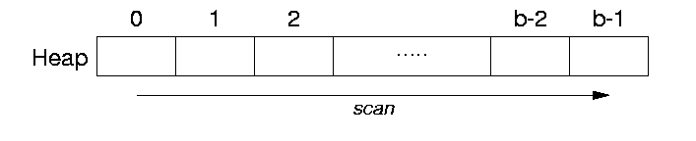

Insertion
The last block of the file is copied into a buffer, the new record is added, and the block is then written back to the disk.
Records are simply appended to the file (i.e. in last block).
read final block P
IF block P full THEN
create empty block P+1
insert record into block P+1
write out block P+1
note that extra block appended to file
ELSE
insert record into block P
write out block P
END

Searching
Searching for a record using any search involves a linear search through the file block by block.

Delete
To delete a record a program must first find its block, copy the block in to a buffer and then delete the record from the buffer and finally rewrite the block back to the disk. Another method is to have an extra byte or bit called deletion marker stored with each record. A record is deleted by setting the deletion marker to a certain value.
Steps for deletions:
- scan all pages
- mark matching records as deleted
- write affected pages to disk
Block-level view of deletion:
FOR every block P in file DO
read block P
FOR each record R in block P DO
IF R satisfies conditions THEN
mark R as deleted
END
END
IF any matches in block P THEN
write out block P
END
END

Dealing with free slots:
- re-use on subsequent insertions (requires modified insertion method)
- periodic file reorganization (e.g. compaction if <I> i 30%<>of slots free)

Modification
Modifying a variable length record may require deleting the old record and inserting a modified record, because the modified record may not fit in its old space.
The analysis for updates is almost the same as for deletion
- scan all pages
- replace any updated records
- write affected pages to disk

Sorting:-
To read all records in order of the values of some field, we create a sorted copy of the file. Special techniques for external sorting are used
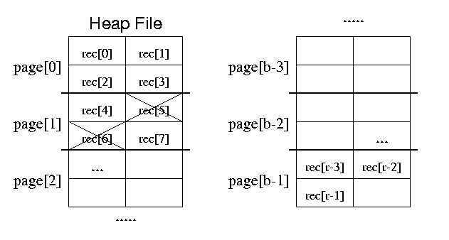
Files of ordered records (sorted files)
Files can be physically ordered based on he values of one of their fields(ordering field).If the ordering field is having a unique value in each record then the field is called ordering key for the file.
Selection
For one queries on sort key, use binary search.
Find R.k = Val in a file sorted on k:
Lo: = 0; Hi: = b-1
WHILE (Lo < Hi) DO
Mid: = (Lo+Hi) DIV 2
read block Mid
IF Val < smallest R.k value in block THEN
Hi: = Mid - 1
ELSIF Val > largest R.k value in block THEN
Lo: = Mid + 1
ELSE
FOR each record R in block Mid and its overflow blocks DO
IF R.k = Val THEN
return R
END
END
END
END
Insertion
Insertion is more complex than for Heaps.
- find appropriate block for record
- if room, insert into block in order
- otherwise, insert into overflow block
Deletion
Deletion involves:
- find matching record(s)
- mark them as deleted

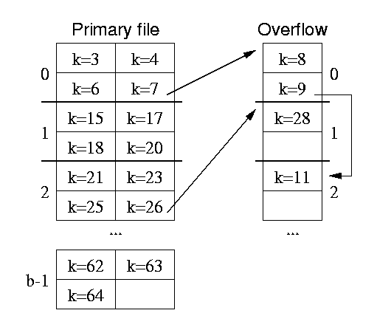

Advantages:-
1) Reading the records in order of the ordering key value is very efficient because
no sorting is required.
2) Finding the next record requires no additional block access, because the next
record will be in the same block
3) Binary search can be done.

Disadvantages:-
1) Not advantageous for ordered access of the records based on values of other
non ordering fields of the file.
2) Inserting and deleting records are expensive operations for an unordered file
because the records must remain physically ordered.
3) To insert a record, we must find its correct position in the file, based on its
ordering field value and then make space in the file to insert the record. For a
large file, this is time consuming

Summary
In heap files Insertion is a very efficient operation. All other operations require linear scan of entire relation (or worse e.g. sort). Overall, heaps are inefficient for typical mix of database operations. Useful if most common operation is insertion and the only ``search'' is exhaustive reading in no particular order. Example: archive or log files. Sorted Files are most efficient for ordered scan on sorting key. Reasonably efficient (log₂ b) for search on sorting key. Operations involving non-sorting keys are inefficient. Overall, inefficient for typical mix of database operations.

Exercises
1) What is a heap file (University exam nov 2004)
2) Distinguish between heap files and sorted files.

Methods for insertion of records in sorted files
a) Keep some unused space in each block for new records.
b) Create a temporary unordered file called an overflow or transaction file. Now the actual ordered file is called the main or master file. New records are inserted at the end of the overflow file. Periodically the overflow file is sorted and merged with the master file during file reorganization.

Name | SSN | DOB | JOB | SALARY
Aaron
Block1
Aby
.
.
.
Acosta

Name | SSN | DOB | JOB | SALARY
Adams
Block2
Adnan
.
.
.
Akil

:
:
:

Name | SSN | DOB | JOB | SALARY
Xavier
Block n
Zenith
.
.
.
Zimmer
.
Ordered sequential file of employee records with name as the ordering key field

Index
Indexes are the auxiliary access structures used to speed up the retrieval of records in response to certain search conditions .Any filed of the file can be used to create an index and the multiple indexes on different fields can be constructed on the same file.
Indexes are divided in to
1) Single level indexes
a) Primary
b) Secondary
c) Clustering
2) Multilevel indexes (B⁺ trees)

1) Single level ordered Indexes:-
The idea behind index is similar to that of an index used in the text book where important terms are arranged in the alphabetical order along with a list of page numbers where the term appears in the book. We can search an index to find a list of addresses to locate a term in the text book by searching the specified pages.
For a file with record structure consisting of several fields, an index is defined on several field of a file called an indexing field (Indexing attribute).The index stores each value of the index field along with a list of pointers to all disk blocks that contains records with that field value.

a)Primary index
Primary index is an ordered file whose records are of the fixed length with 2 fields. There is an index entry (or index record) for each block in the data file. Each index entry has the value of the primary key field and pointer to that block.
Index entry i is shown as <k (i), p (i)>

E.g. :-< K (1) = Aaron, P (1) = address of block 1>
< K (2) = Adams, P (2) = address of block2 >
< K (3) = Alexander, P (3) = address of block3>

The total no of entries in the index is same as the number of disk blocks in the ordered data file.

Index file DATA FILE
Name | SSN | DOB | JOB | SALARY
Aaron
Aby
.
.
.
Acosta
Block 1
(K(i),p(i)>)
Block anchor primary key | Block pointer
Aaron
Adams
:
:
:

Wong

Name | SSN | DOB | JOB | SALARY
Adams
.
.
.
Akers
Block 2

:
:
:
Name | SSN | DOB | JOB | SALARY
Wong
.
.
.
Zenith
Block n

A record whose primary key value is K lies in the block whose address is P(i), where k (i) <=K< K(i+1).to retrieve a record, given the value of K of its primary key field, we do a binary search on the index file to find the appropriate index entry i ;and then retrieve the data file block whose address is P(i).
Summary
The first record in each block of the data file is called anchor record of the block or block anchor. A dense index has an index entry for very search key value (hence every record) in the data file. A sparse index is a non dense where there are index entries for only some of the search values. The above example is sparse index, since it includes an entry of each disk block of the data file rather than for every record.

Exercises
Consider a file with r = 30,000 records, block size b=1024 bytes, one record length =100 bytes
1) Find the blocking factor bfr.
2) The no of blocks needed for the file.
Secondary index (based on a key field which has distinct value for every record)
Secondary index is also an ordered file with 2 fields.
1) Non ordering field of the data file.
2) Block pointer or record pointer.
Index file
(<K (i), P (i)>)

Secondary key field
Index field | Block pointer
1
2
3
4
5
6
7
8
9
9
5
13
8

6
15
3
17
21
11
16
2

24
10
20
1

In this case there is one index entry for each record in the data file, Which contains the value of the secondary key for the record and a pointer either to the block in which the record is stored or to the record itself. Such an index is dense
Clustering indexes
If the records of a file are physically ordered on a non key field, which does not have a distinct value for each record that field is the clustering field.
A clustering index consists of 2 fields.
1) Field of the data file
2) Block pointer
There is one entry in the clustering index for each distinct value of the clustering field, containing the value and a pointer to the first block in the data file that has a record with that value for its clustering field.
A clustering index is another example for a non dense index, because it has an entry for every distinct value of the indexing field rather than for every record in the file.
Index file
(<K (i), P (i)>)
Dept No name SSN Job
Index field | Block pointer
1
2
3
4
5
6
7
8
9
1
1
1
2

2
3
3
3

3
3
4
4

5
5
5
5

6
6
6

In another method one more pointer is introduced to point to next block where the data field is repeated.
Clustering Block
Field pointer
Value
1
1
1
Block pointer
1
2
3
4
Null pointer
2
2
2

Null pointer
3
3
3
Block pointer

3
3
Block pointer

Null pointer
4
4
4
Block pointer

4
4

6.0) Summary
Three types of ordered single level indexes were introduced
1) Primary 2) secondary 3) clustering. Each index is specified on a field of the file. Primary and clustering indexes are constructed on the physical ordering field of a file, where as secondary indexes are specified on non ordering fields.

7.0) Exercises

1) Define the following terms:
a) Indexing field b) primary key field c) clustering field d) secondary key field
e)block anchor f)dense index g)non dense(sparse index)
2) What are the differences among primary, secondary and clustering indexes? How do these differences affect the ways in which these indexes are implemented? Which of the indexes are dense, which are not?

8.0) Computational assignments

1) Consider a disk with block size B=512 bytes. A block pointer is P=6 bytes long and record pointer is Pr =7 bytes long. A file has r=30,000 EMPLOYEE records of fixed length. Each record has the following fields:
NAME 30 bytes
SSN 9 bytes
DEPT 9 bytes
ADDRESS 40 bytes
PHONE 9 bytes
BIRTH DATE 8 bytes
SEX 1 byte
JOBCODE 4 bytes
SALARY 4 bytes
An additional byte is used as a deletion marker.
a) Calculate the record size R in bytes.
b) Calculate the blocking factor bfr and the number of file blocks b assuming an unspanned organization.

Secondary index based on a non key field where numerous records can have the same value
Introduction
We have already seen secondary index structure on a key field that has a distinct value for every record. We can also create a secondary index on a non key field of a file. In this case numerous records in the data file can have the same value for the indexing field.
There are several options for implementing indexing based on non key field.

The different options for implementing indexing based on non key field are
5.1) Include several index entries with same K(i) value –on for each record. This is a dense index

5.2) Have a variable length record for index entries with a repeating filed for the pointer. We keep a list of pointers <p(i,1),…..p(i,k)> in the index entry for k(i)-one pointer to each block that contains a record whose indexing filed value equals k(i).

5.3) keep the index entries themselves at a fixed length and have a single entry for each index filed value but an extra level of indirection is created to handle multiple pointers.

In this non dense scheme, the pointer p)i) in index entry <k(i),p(i)>,points to a block of record pointers. Each record pointer in that block points to one of the data file records with value k(i) for the indexing field

Index file
(<k(i),p(i)>
Field value Block pointer Dept Name
No
3
5
1
6

1
2
3
4
5
6
7

2
3
4
1

6
8
4
2

The figure shows a secondary index (with record pointers) on a non key field implemented using one level of indirection
Types of indexes
 | Ordering field | Non ordering field
Key field | Primary index | Secondary index(key)
Non key field | Clustering index | Secondary index(nonkey)

Properties of index types

Type of index |  | No of index entries | Dense or non dense
Type of index | Primary | No of blocks in the data file | Non dense
Type of index | Clustering | No of distinct index field values | Non dense
Type of index | Secondary(key) | No of records in the data file | Dense
Type of index | Secondary(nonkey) | No of records(option  1)  -No of distinct index field values(option 2) | Dense or non dense

Multilevel indexes (Indexed Sequential Files)
For the indexing schemes so far discussed, a binary search is applied to the index to locate pointers to a disk block or to a record in the file having a specific index value.
The idea behind multilevel index is to reduce the part of the index that we continue to search by bfr.Hence the search space is reduced much faster.
The value bfr i is called the fan-out of the multilevel index and we will refer it as f0.In a multilevel index scheme there are different levels of index files (first level)base level ,second level, Third level etc.

2
5
2
8
15
24

8
12

35
39
44
51
2
35
55
85
15
21

24
29

35
36
39
41
44
46

55
63
71
80

51
52

Two level primary index organization

Multi level index reduces the no of blocks accessed when searching for a record, given its indexing filed value.

Summary
A common file organization used in business data processing is an ordered file with a multi level primary index on its ordering key field. Such an organization is called indexed sequential file and was used in large number of IBM systems .Insertion is handled by some overflow file which is then merged periodically with the data file. The index is recreated during file reorganization. IBM’s ISAM organization incorporates a 2 level index that is closely related to that of a disk. The first level is cylinder index, which has the key value of an anchor record for each cylinder of a disk pack and a pointer to the track index of a cylinder. The track index has the key value of an anchor record for each track in the cylinder and a pointer to the track. The track can then be searched sequentially for the desired record or block.

Exercises
a) Why can we have at most one primary or clustering index on a file, but several secondary indexes?

b) How does multilevel indexing improves the efficiency of searching an index file?

Direct files

Direct or hash files provide very fast access to records on certain search conditions. The search condition must be an equality condition on a single field, called the hash field of the file. In most cases the hash field is also called a key field of the file in which case it is called the hash key.
The hash function (randomizing function) is applied to the hash field value of a record and yields the address of a disk block in which the record is stored. Then a search for the record in the block can be carried out.
In direct files the key value is applied to some arithmetic manipulations and is mapped directly to the storage location .This process is called hashing.

Hash function
Key value (k)
Address h(k)

Here the value K is mapped to h(k).This h(k) should lie with some range S1 & S2 where the address are for the records lie between S1 and S2.
A hash function which maps many different key values to the same address is a bad hash function. This is collision.
1) Colliding records may be assigned to the next available space.
2) Or to an over flow area.

Hashed Key-The result of applying a hash function to a key.

Hash table
A hash table is made up of two parts: an array (the actual table where the data to be searched is stored) and a mapping function, known as a hash function. The hash function is a mapping from the input space to the integer space that defines the indices of the array. In other words, the hash function provides a way for assigning numbers to the input data such that the data can then be stored at the array index corresponding to the assigned number.
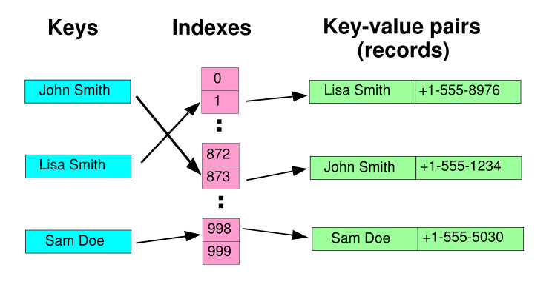

A small phone book as a hash table.

Let's take a simple example. First, we start with a hash table array of strings (we'll use strings as the data being stored and searched in this example). Let's say the hash table size is 12:
Hash table (strings)
0 | (null)
1 | (null)
2 | (null)
3 | (null)
4 | (null)
5 | (null)
6 | (null)
7 | (null)
8 | (null)
9 | (null)
10 | (null)
11 | (null)

1.1: The empty hash table of strings
Next we need a hash function. There are many possible ways to construct a hash function. We'll discuss these possibilities more in the next section. For now, let's assume a simple hash function that takes a string as input. The returned hash value will be the sum of the ASCII characters that make up the string mod the size of the table:
int hash(char *str, int table_size)
{
int sum;

/* Make sure a valid string passed in */
if (str==NULL) return -1;

/* Sum up all the characters in the string */
for( ; *str; str++) sum += *str;

/* Return the sum mod the table size */
return sum % table_size;
}
Now that we have a framework in place, let's try using it. First, let's store a string into the table: "Steve". We run "Steve" through the hash function, and find that hash("Steve",12) yields 3:
0 | (null)
1 | (null)
2 | (null)
3 | “steve”
4 | (null)
5 | (null)
6 | (null)
7 | (null)
8 | (null)
9 | (null)
10 | (null)
11 | (null)

Figure 1.2: The hash table after inserting "Steve"
Let's try another string: "Spark". We run the string through the hash function and find that hash("Spark",12) yields 6. Fine. We insert it into the hash table:

0 | (null)
1 | (null)
2 | (null)
3 | “steve”
4 | (null)
5 | (null)
6 | “spark”
7 | (null)
8 | (null)
9 | (null)
10 | (null)
11 | (null)

Figure 1.3: The hash table after inserting "Spark"
Let's try another: "Notes". We run "Notes" through the hash function and find that hash("Notes",12) is 3. Ok. We insert it into the hash table:
0 | (null)
1 | (null)
2 | (null)
3 | “steve””Notes”
4 | (null)
5 | (null)
6 | “spark”
7 | (null)
8 | (null)
9 | (null)
10 | (null)
11 | (null)

Figure 1.4: A hash table collision
What happened? A hash function doesn't guarantee that every input will map to a different output (in fact, as we'll see in the next section, it shouldn't do this). There is always the chance that two inputs will hash to the same output. This indicates that both elements should be inserted at the same place in the array, and this is impossible. This phenomenon is known as a collision.

Summary

There are many algorithms for dealing with collisions, such as linear probing and separate chaining. While each of the methods has its advantages, we will only discuss separate chaining here.
Separate chaining requires a slight modification to the data structure. Instead of storing the data elements right into the array, they are stored in linked lists. Each slot in the array then points to one of these linked lists. When an element hashes to a value, it is added to the linked list at that index in the array. Because a linked list has no limit on length, collisions are no longer a problem. If more than one element hashes to the same value, then both are stored in that linked list.

Hash tables

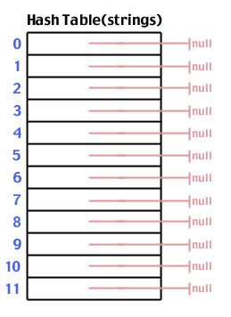
Reference: www.sparknotes.com
Again, let's try adding "Steve" which hashes to 3:
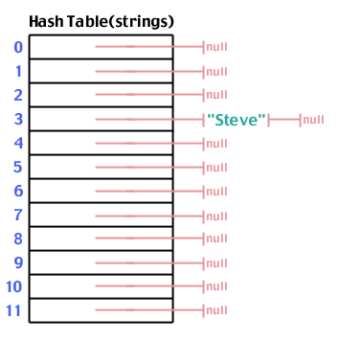
Figure 1.6: After adding "Steve" to the table

And "Spark" which hashes to 6:
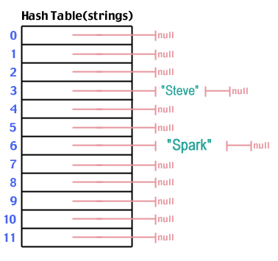
Figure 1.7: After adding "Spark" to the table
Now we add "Notes" which hashes to 3, just like "Steve":
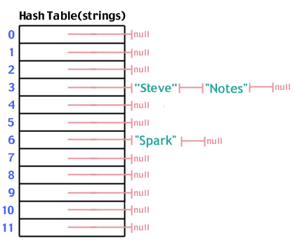
Figure 1.8: Collision solved - "Notes" added to table
Once we have our hash table populated, a search follows the same steps as doing an insertion. We hash the data we're searching for, go to that place in the array, look down the list originating from that location and see if what we're looking for is in the list. The number of steps is O (1).
Separate chaining allows us to solve the problem of collision in a simple yet powerful manner. Of course, there are some drawbacks. Imagine the worst case scenario where through some fluke of bad luck and bad programming, every data element hashed to the same value. In that case, to do a lookup, we'd really be doing a straight linear search on a linked list, which means that our search operation is back to being O (n). The worst case search time for a hash table is O (n). However, the probability of that happening is so small that, while the worst case search time is O (n), both the best and average cases

Hash Functions

As mentioned briefly in the previous section, there are multiple ways for constructing a hash function. Remember that hash function takes the data as input (often a string), and return s an integer in the range of possible indices into the hash table. Every hash function must do that, including the bad ones. So what makes for a good hash function?

5.2) Characteristics of a Good Hash Function
There are four main characteristics of a good hash function:
1) The hash value is fully determined by the data being hashed.
If something else besides the input data is used to determine the hash, then the hash value is not as dependent upon the input data, thus allowing for a worse distribution of the hash values.
2) The hash function uses all the input data.
If the hash function doesn't use all the input data, then slight variations to the input data would cause an inappropriate number of similar hash values resulting in too many collisions
3) The hash function "uniformly" distributes the data across the entire set of possible hash values.
If the hash function does not uniformly distribute the data across the entire set of possible hash values, a large number of collisions will result, cutting down on the efficiency of the hash table.
4) The hash function generates very different hash values for similar strings.
In real world applications, many data sets contain very similar data elements. We would like these data elements to still be distributable over a hash table.

So let's take as an example the hash function used in the last section:
int hash(char *str, int table_size)
{
int sum;

// Make sure a valid string passed in
if (str==NULL) return -1;

// Sum up all the characters in the string
for( ; *str; str++) sum += *str;

// Return the sum mod the table size
return sum % table_size;
}

For this example
Rule 1: Satisfies. The hash value is fully determined by the data being hashed. The hash value is just the sum of all the input characters.
Rule 2: Satisfies. Every character is summed.
Rule 3: Breaks. From looking at it, it isn't obvious that it doesn't uniformly distribute the strings, but if you were to analyze this function for a large input you would see certain statistical properties bad for a hash function.
Rule 4: Breaks. Hash the string "bog". Now hash the string "gob". They're the same. Slight variations in the string should result in different hash values, but with this function they often don't.
So this hash function isn't so good. It's a good introductory example but not so good in the long run.

Exercises
Exercise 1: How does a hash table allow for O (1) searching? What is the worst case efficiency of a look up in a hash table using separate chaining?

Solution: A hash table uses hash functions to compute an integer value for data. This integer value can then be used as an index into an array, giving us a constant time access to the requested data. However, using separate chaining, we won't always achieve the best and average case efficiency of O (1). If we have too small a hash table for the data set size and/or a bad hash function, elements can start to build in one index in the array. Theoretically, all n elements could end up in the same linked list. Therefore, to do a search in the worst case is equivalent to looking up a data element in a linked list, something we already know to be O (n) time. However, with a good hash function and a well created hash table, the chances of this happening are, for all intents and purposes, ignorable.

Exercise 2: The bigger the ratio between the size of the hash table and the number of data elements, the less chance there is for collision. What is a drawback to making the hash table big enough so the chances of collision are ignorable?
Solution
Wasted memory space

Exercise 3: How could a linked list and a hash table be combined to allow someone to run through the list from item to item while still maintaining the ability to access an individual element in O (1) time?

Solution
Create a hash table where the elements of the array are pointers to linked list objects. You have your linked list as normal, but when you add an element to the linked list, you also add a pointer to that element from the correct place in the hash table specified by the hash value of the data in the new linked list element.

Exercise 4: How could a hash table be used to implement a spell checker?
Solution
Create a hash table of all the words in the dictionary. When you encounter a word, whose spelling you want to check, just hash it and see if it exists in the table. If it does, then you've spelled it correctly. If not, then you haven't. This allows you to look up a word in O (1) time rather than O (n) time, which, in a dictionary on the order of 800,000 words, is a big time saver.

Exercise 5: How long would a deletion operation take from hash table implemented using separate chaining?
Solution
O (1). Lookup is O (1) and deleting from a linked list is O (1), so the total efficiency is
O (1).

Hashing example: a fruit shop
- 10 stock details, 10 table positions
- Stock numbers are between 0 and 1000
- What if we now insert stock no. 350?
  - Position 3 is occupied: there is a collision
- Collision resolution strategy: insert in the next free position (linear probing)
- Given a stock number, we find stock by using the hash function again, and use the collision resolution strategy if necessary

Key Entry

0 | 85 85 apples
1
2
3 | 323 323 gauva
4 | 462 462 pears
5 | 350 350 oranges
6
7
8
9 | 912 912 papaya

- The hash function
  - Ideally, it should distribute keys and entries evenly throughout the table
  - It should minimize collisions, where the position given by the hash function is already occupied
- The collision resolution strategy
  - Separate chaining: chain together several keys/entries in each position
  - Open addressing: store the key/entry in a different position
- The size of the table
  - Too big will waste memory; too small will increase collisions and may eventually force rehashing (copying into a larger table)
  - Should be appropriate for the hash function used – and a prime number is best

Different hash functions
1) Truncation
  - Ignore part of the key and use the rest as the array index (converting non-numeric parts)
  - A fast technique, but check for an even distribution throughout the table
Example: If students have an 9-digit identification number, take the last 3 digits as the table position
  - e.g. 925371622 becomes 622

2) Folding
  - Partition the key into several parts and then combine them in any convenient way
  - Unlike truncation, uses information from the whole key.
Example: Split a 9-digit number into three 3-digit numbers, and add them
  - e.g. 925371622 becomes 925 + 376 + 622 = 1923
3)Folding boundary method
-partition the key in to equal sized parts
-add the parts by reversing the first part and the second part

4) Modular arithmetic (used by truncation & folding and on its own)
  - To keep the calculated table position within the table, divide the position by the size of the table, and take the remainder as the new position
Example: If the table size is 1000, the first example always keeps within the table range, but the second example does not (it should be mod 1000)
  - e.g. 1923 mod 1000 = 923 (in Java: 1923 % 1000)
5) Middle square method
Take the square of the key and select middle bits from the result.
6) Multiplication method
Multiply the key with “a”, where ‘a” is a carefully chosen constant

5.2) Collision resolution:

1) Chaining
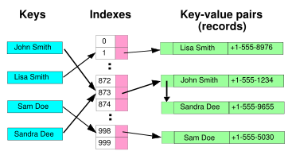
Hash collision resolved by chaining.
In the simplest chained hash table technique, each slot in the array references a linked list of inserted records that collide to the same slot. Insertion requires finding the correct slot, and appending to either end of the list in that slot; deletion requires searching the list and removal.
Chained hash tables have advantages over open addressed hash tables in that the removal operation is simple and resizing the table can be postponed for a much longer time because performance degrades more gracefully even when every slot is used. Indeed, many chaining hash tables may not require resizing at all since performance degradation is linear as the table fills. For example, a chaining hash table containing twice its recommended capacity of data would only be about twice as slow on average as the same table at its recommended capacity.
Chained hash tables inherit the disadvantages of linked lists. When storing small records, the overhead of the linked list can be significant. An additional disadvantage is that traversing a linked list has poor cache performance.

2)open addressing
Probing: If the table position given by the hashed key is already occupied, increase the position by some amount, until an empty position is found
- Linear probing: increase by 1 each time [mod table size!]
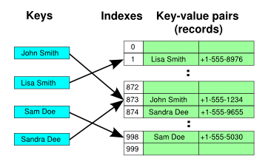
- Quadratic probing: to the original position, add 1, 4, 9, 16,…
Use the collision resolution strategy when inserting and when finding (ensure that the search key and the found keys match)
May also double hash: result of linear probing × result of another hash function
With open addressing, the table size should be double the expected no. of elements
- If the table is fairly empty with many collisions, linear probing may cluster (group) keys/entries
This increases the time to insert and to find

0 | 1 | 2 | 3 | 4 | 5 | 6 | 7 | 8

- For a table of size n, then if the table is empty, the probability of the next entry going to any particular place is 1/n
- In the diagram, the probability of position 2 getting filled next is 2/n (either a hash to 1 or to 2 fills it)
- Once 2 is full, the probability of 4 being filled next is 4/n and then of 7 is 7/n (i.e. the probability of getting long strings steadily increases)

- An empty key/entry marks the end of a cluster, and so can be used to terminate a find operation
- So, if we remove an entry within a cluster, we should not empty it!
- To allow probing to continue, the removed entry must be marked as ‘removed but cluster continues’

Quadratic probing is a solution to the clustering problem
  - Linear probing adds 1, 2, 3, etc. to the original hashed key
  - Quadratic probing adds 12, 22, 32 etc. to the original hashed key
- However, whereas linear probing guarantees that all empty positions will be examined if necessary, quadratic probing does not
  - e.g. Table size 16 and original hashed key 3 gives the sequence: 3, 4, 7, 12, 3, 12, 7, 4…
- More generally, with quadratic probing, insertion may be impossible if the table is more than half-full!
  - Need to rehash
Rehashing: enlarging the table
- To rehash:
  - Create a new table of double the size (adjusting until it is again prime)
  - Transfer the entries in the old table to the new table, by recomputing their positions (using the hash function)
- When should we rehash?
  - When the table is completely full
  - With quadratic probing, when the table is half-full or insertion fails
- Why double the size?
  - If n is the number of elements in the table, there must have been n/2 insertions before the previous rehash (if rehashing done when table full)
  - So by making the table size 2n, a constant cost is added to each insertion

Summary
Applications of Hashing
- Compilers use hash tables to keep track of declared variables
- A hash table can be used for on-line spelling checkers — if misspelling detection (rather than correction) is important, an entire dictionary can be hashed and words checked in constant time
- Game playing programs use hash tables to store seen positions, thereby saving computation time if the position is encountered again
- Hash functions can be used to quickly check for inequality — if two elements hash to different values they must be different
- Storing sparse data
Disadvantages
- Hash tables are very good if there is a need for many searches in a reasonably stable table
- Hash tables are not so good if there are many insertions and deletions, or if table traversals are needed — in this case, AVL trees are better
- If there are more data than available memory then use a B-tree
- Also, hashing is very slow for any operations which require the entries to be sorted
  - e.g. Find the minimum key

Operations on files
Operations on files are divided in to
a) Retrieval operations
b) Update operations

1) Open
-prepares the file for reading or writing.
-Allocates appropriate buffers to hold file blocks from the disk
-Retrieves file header
-Sets the file pointer to the beginning of the file.

2) Reset-sets the file pointer of an open file to the beginning of the file.

3) Find-Searches for the first record that satisfies a search condition and transfers the block containing that record in to main memory buffer.

4) Read-Copies the current record from the buffer to a program variable in the user program.

5) Find next:-Searches for the next record in the file that satisfies the search condition.

6) Delete-Deletes the current record and updates the file on disk to reflect the deletion.

7) Modify-modifies some field value for the current record and updates the file on disk.

8) Insert-Inserts a new record in the file by locating the block where the record is to be inserted.

9) Close- Completes the file access by releasing the buffers.

10) Scan-Scan returns the first record; otherwise it returns the next record.

11) Find all- Locates all the records in the file that satisfy a search condition.

12) Find ordered-returns all the records in the file in some specified order.

13) Reorganize: some files organization require periodic reorganization.

Indexing on multiple keys
So far we have seen indexing on a single attribute. Now we will see indexing on multiple keys.
Consider an employee file containing attributes DNO,AGE, STREET ,CITY,ZIPCODE,SALARY,SSN etc.
Consider the query “list the employees in the department no 4 with age =59”.
Here both DNO and AGE are non key attributes Now indexing can be done on both the keys.<DNO,AGE>
The search key is a pair of values <4,59> in the above example.
Thus <3,n> precedes <4,m> for all values of m and n.

Grid files

We can organize the employee file as a grid file. If we want to access a file on 2 keys, DNO and AGE , we can construct a grid array with one linear scale for each of the search attributes.
5
0 | 1,2
1 | 3,4
2 | 5
3 | 6,7
4 | 8
5 | 9,10
0 | 1 | 2 | 3 | 4 | 5
<20 | 21-25 | 26-30 | 31-40 | 41-50 | >50

4
3

2

1
0

0 1 2 3 4 5

Thus the request for DNO = 4 and AGE = 59 maps in to the cell (1,5) corresponding to the grid array.

Interpolation search

Interpolation search parallels how humans search through a telephone book. Instead of comparing against every item like the linear search, it attempts to find the item by approximating how far the item is likely to be from the current position. This differs from the binary search, in that the binary search always divides the search space in half. On average the interpolation search makes about log(log(N)) comparisons (if the elements are uniformly distributed), where N is the number of elements to be searched. In a worst case scenario, where the items increase exponentially it can make up to O (n) comparisons.
In reality, interpolation search is often no faster than binary search due to the complexity of the arithmetic calculations of approximating the indices.
