Experiment No: 1
Date: 20-Feb-2006

FAMILIARIZATION OF LOGIC GATES

INTRODUCTION:

A logic gate is an elementary building block of a digital circuit. Most logic gates have two inputs and one output. At any given moment, every terminal is in one of the two binary conditions low (0) or high (1), represented by different voltage levels. The logic state of a terminal can, and generally does, change often, as the circuit processes data. In most logic gates, the low state is approximately zero volts (0 V), while the high state is approximately five volts positive (+5 V).
Logic gates are available on special ICs (chips) which usually contain several gates of the same type, for example the 4001 IC contains four 2-input NOR gates. There are several families of logic ICs and they can be split into two groups:
4000 Series, 74 Series

PROBLEM DEFINITION:

1. To familiarize with logic gates and IC packages.
2. To verify the truth table of the logic gates.

COMPONENTS REQUIRED:

Components |  | Specification | Quantity
1 | And gate | IC 7408 | 1
2 | OR gate | IC 7432 | 1
3 | NOT gate | IC 7404 | 1
4 | NAND gate | IC 7400 | 1
5 | X-OR gate | IC 7486 | 1
6 | DC power supply | 0-30v
7 | LED |  | 1
8 | Resistor | 330Ω | 1
9 | Bread Board |  | 1

THEORETICAL BACKGROUND:

Logic gates process signals which represent true or false. Normally the positive supply voltage +Vs represent true and 0V represents false. Other terms which are used for the true and false states are shown in the table on the right. It is best to be familiar with them all. Gates are identified by their function: NOT, AND, NAND, OR, NOR, EX-OR and EX-NOR. Capital letters are normally used to make it clear that the term refers to a logic gate. Note that logic gates are not always required because simple logic functions can be performed with switches or diodes:

Inputs and outputs

Gates have two or more inputs, except a NOT gate which has only one input. All gates have only one output. Usually the letters A, B, C and so on are used to label inputs, and Q is used to label the output.

Truth tables

A truth table is a good way to show the function of a logic gate. It shows the output states for every possible combination of input states. The symbols 0 (false) and 1 (true) are usually used in truth tables. The example truth table on the right shows the inputs and output of an AND gate

AND gate

The output Q is true if input A AND input B are both true: Q = A AND B
An AND gate can have two or more inputs, its output is true if all inputs are true.

The traditional symbol is given below:

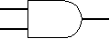

The AND gate is so named because, if 0 is called "false" and 1 is called "true," the gate acts in the same way as the logical "and" operator. The output is "true" when both inputs are "true." Otherwise, the output is "false."

OR gate

The output Q is true if input A OR input B is true (or both of them are true): Q = A OR B
An OR gate can have two or more inputs, its output is true if at least one input is true.

The traditional symbol is given below:
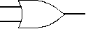

The OR gate gets its name from the fact that it behaves after the fashion of the logical inclusive "or." The output is "true" if either or both of the inputs are "true." If both inputs are "false," then the output is "false."

NOT gate (inverter)

The output Q is true when the input A is NOT true, the output is the inverse of the input: Q = NOT A
A NOT gate can only have one input. A NOT gate is also called an inverter.

The traditional symbol is given below:

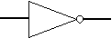

A logical inverter, sometimes called a NOT gate to differentiate it from other types of electronic inverter devices, has only one input. It reverses the logic state.

NAND gate (NAND = Not AND)

This is an AND gate with the output inverted, as shown by the 'o' on the output.
The output is true if input A AND input B are NOT both true: Q = NOT (A AND B)
A NAND gate can have two or more inputs, its output is true if NOT all inputs are true.

The traditional symbol is given below:

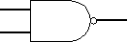

The NAND gate operates as an AND gate followed by a NOT gate. It acts in the manner of the logical operation "and" followed by negation. The output is "false" if both inputs are "true." Otherwise, the output is "true."

NOR gate (NOR = Not OR)

This is an OR gate with the output inverted, as shown by the 'o' on the output.
The output Q is true if NOT inputs A OR B are true: Q = NOT (A OR B)
A NOR gate can have two or more inputs, its output is true if no inputs are true.

The traditional symbol is given below:

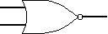

The NOR gate is a combination OR gate followed by an inverter. Its output is "true" if both inputs are "false." Otherwise, the output is "false."

EX-OR (Exclusive-OR) gate

The output Q is true if either input A is true OR input B is true, but not when both of them are true: Q = (A AND NOT B) OR (B AND NOT A). This is like an OR gate but excluding both inputs being true. The output is true if inputs A and B are different.
EX-OR gates can only have 2 inputs.

The traditional symbol is given below:

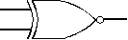

An X-OR gate produces an output 1 only when the inputs are not equal, it is called an anti-coincidence gate or inequality detector. The output of an X-OR gate is the modulo sum of its two inputs. The name Exclusive-OR is derived from the fact that its output is a1, only when exclusively one of its inputs is a 1 (it excludes the condition when bott| inputs are 1).

PROCEDURE:

1. Set the IC on the bread board after checking for continuity.
2. Supply voltage is given to pin no. 14 and pin no. 7 is grounded.
3. Appropriate connections are made to the gates and output is connected through a resistor to a LED.
4. Glowing of LED indicates high output and low otherwise.
5. Each input combination is carried out as in the truth table and output is observed

CIRCUIT DIAGRAM:

The 74 series of AND gate IC is shown below:

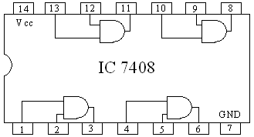

The 74 series of OR gate IC is shown below:

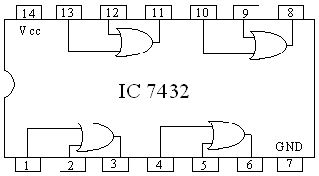

The 74 series of NOT gate IC is shown below:

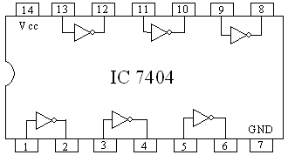

The 74 series of NAND gate IC is shown below:

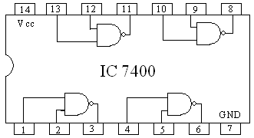

The 74 series of NOT gate IC is shown below:

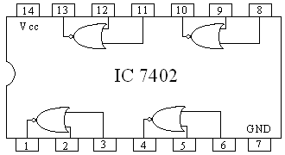

The 74 series of NOT gate IC is shown below:

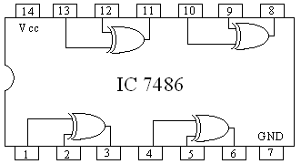

OBSERVATION:

For AND gate

A | B | OUTPUT
0 | 0 | 0
0 | 1 | 0
1 | 0 | 0
1 | 1 | 1

For OR gate

A | B | OUTPUT
0 | 0 | 0
0 | 1 | 1
1 | 0 | 1
1 | 1 | 1

For NOT gate:

A | OUTPUT
1 | 0
0 | 1

For NAND gate:

A | B | OUTPUT
0 | 0 | 1
0 | 1 | 1
1 | 0 | 1
1 | 1 | 0

For NOR gate:

A | B | OUTPUT
0 | 0 | 1
0 | 1 | 0
1 | 0 | 0
1 | 1 | 0

For EX-OR gate:

A | B | OUTPUT
0 | 0 | 0
0 | 1 | 1
1 | 0 | 1
1 | 1 | 0

RESULT:

The various IC were set up and output was obtained for different inputs. The truth table was verified in each case.

CONCLUTION:

1. The AND gate is same as logical multiplication. The OR gate is same as logical
addition.

2. The NOT gate is same as inversion or complementation

3. The NAND and NOR gates are universal gates, as all the three basic functions that is
AND, OR,NOT can be realized using either NAND gates or using NOR gates.

APPLICATION:

The logical gates(IC’s) are mainly used in most of the electronic equipments. Since the size is small it save more space. It is used in computer and all other electronic equipments.

Experiment No: 2
Date: 20-Feb-2006

REALIZATION OF LOGIC GATES USING UNIVERSAL GATES

INTRODUCTION:

The NAND and NOR gates are the two universal gates. They are called so because the NAND gate can be used to generate the NOT function, the AND function, the OR function and the NOR function. Similarly the NOR gate can be used to generate the AND, OR, NOT and the NAND function. i.e.; all the basic gates can be constructed by them. To simplify the Boolean expression with POS or SOP the De’Morgans law can be used.

PROBLEM DEFINITION:

Realization of logical gates using universal gates.

COMPONENTS REQUIRED:

Components |  | Specification | Quantity
1 | 2 input NAND gate | IC 7408 | 1
2 | 2 input NOR gate | IC 7432 | 1
3 | Resistor | 330Ω | 1
4 | LED |  | 1
5 | DC power supply | 0-30v | 1
6 | Bread Board |  | 1

THEORETICAL BACKGROUND:

An inverter can be made from a NAND gate by connecting all of the inputs together and creating, in effect, a single common input. An AND function and or function can be generated using only NAND gates as shown in the figures. A NAND gate is used to invert a NAND output to form the AND function as indicated in the following equation:
X=((A.B)')'=>A.B

To obtain an OR circuit the first two gates are used to invert the two input variables before they are applied to the third NAND gate. The final OR output is derived as indicated in the following equation by application of De Morgan’s theorem:
X=(A'.B')' =>A+B

A NOT circuit or an inverter can be obtained from a NOR gate by connecting all of its inputs to effectively create a single input, as given in the diagram. Also OR gate can be produced from NOR gates by inverting the output of the first NOR gate using another NOR gate.
X=((A+B)')'=>A+B

An AND gate can be constructed using NOR gates, as given in the diagram. In this case the
first two NOR gates are used as inverters, and the final output is derived using
De Morgan’s theorem:
X=(A'+B')'=>A.B

PROCEDURE:

- Check the components using multimeter
- Set up the circuit and feed the input combinations.
- Observe the output corresponding to input combination and enter into the truth table.

CIRCUIT DIAGRAM:

NOT gate Using NOR
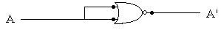

AND gate Using NOR
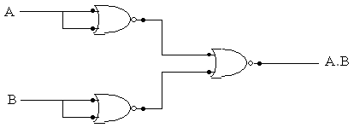

OR gate Using NOR
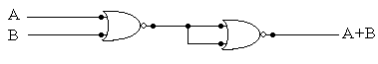
NOT gate Using NAND
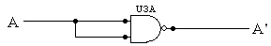

AND gate Using NAND
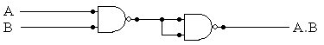

OR gate Using NAND
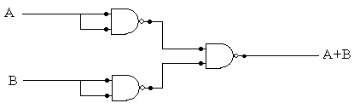

OBSERVATION :

For AND gate

A | B | OUTPUT
0 | 0 | 0
0 | 1 | 0
1 | 0 | 0
1 | 1 | 1

For OR gate

A | B | OUTPUT
0 | 0 | 0
0 | 1 | 1
1 | 0 | 1
1 | 1 | 1

For NOT gate:

A | OUTPUT
1 | 0
0 | 1

RESULT:

The AND, NOT, OR gates are implemented using universal gates and the output was obtained. The truth table was verified in each case.

CONCLUTION:

Since the gates can be combined and can form any other logic gates, they help in reducing the components required. As these gates (NAND & NOR) can be helpful in realizing many other gates. They can also implement many other gates.

APPLICATION:

- NAND gates are used in flip-flops and shift registers.
- It is also used in counters.
- NAND gates are used BCD to 7-segment display decoders.

EXP No: 3
Date: 21-Feb-06

HALF-ADDER/FULL-ADDER USING GATES

INTRODUCTION:

The logic gates are the fundamental building blocks of the combinational logic circuit. In computing, the adder is part of the ALU (Arithmetic and logic Unit) and some ALU contain multiple adders. The most basic arithmetic operation is the addition of two binary digits. This simple addition consists of four possible elementary operations. In combinational logic, the output level is at all time dependent on the combinational logic. The half adder and full adder are such combinational circuits which implement binary addition.

PROBLEM DEFINITION:

To implement the half and full adders using the basic logic gates.

COMPONENTS REQUIRED:

Components |  | Specification | Quantity
1 | And gate | IC 7408 | 1
2 | OR gate | IC 7432 | 1
3 | NOT gate | IC 7404 | 1
4 | NAND gate | IC 7400 | 1
5 | X-OR gate | IC 7486 | 1
6 | DC power supply | 0-30v | 1
7 | Resistor | 1K | 2
8 | LED | 30mA | 2

THEORETICAL BACKGROUND:

Adders are the basic building blocks of all the arithmetic circuits, adders add two binary numbers and give out sum and carry as output. Basically we have two types of adders.

Half Adder
2. Full adder.

A combinational circuit that performs the addition of two bits is called a half adder. One that performs the addition of three bits (two significant bits and a previous carry) is a full adder.

HALF ADDER
A half adder is a logical circuit that performs an addition operation on two binary digits. The half adder produces a sum and a carry value which are both binary digits. Half adders have two inputs, and two outputs, the sum and carry output. Essentially the output of a half adder is the two-bit arithmetic sum of two one-bit numbers, with carry output being the more significant of these two outputs.

The sum output is generated with an exclusive OR gate and the carry output is produced with an AND gate with A and B as the inputs and S and C as the outputs which symbolize the sum and carry respectively.

Sum=A’B+AB’=A⊕B
Carry=A.B

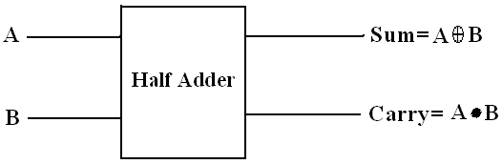

FULL ADDER
The other type of single bit adder is the full adder which is like a half adder, but takes an additional input carry C_{i}. A full adder can be constructed from two half adders by connecting A and B to the input of one half adder, connecting the sum from that to an input to the second adder, connecting C_{i} to the other input and or the two carry outputs. Equivalently, S could be made the three-bit xor of A, B, and C_{i} and C_{o} could be made the three-bit majority function of A, B, and C_{i}. The output of the full adder is the two-bit arithmetic sum of three one-bit numbers.
The purpose of the carry input on the full-adder is to allow multiple full-adders to be chained together with the carry output of one adder connected to the carry input of the next most significant adder. The carry is said to ripple down the carry lines of this sort of adder, giving it the name ripple carry adder.
Sum=A⊕B⊕Ci
Carry=A⊕B.C+A.B

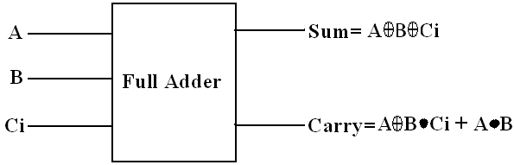

PROCEDURE:

- Check the components using multimeter
- Set up the circuit as per the circuit diagram.
3. Take the input states and corresponding output states and draw the truth table.

CIRCUIT DIAGRAM:

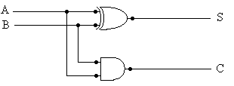
HALF-ADDER USING XOR & AND GATES

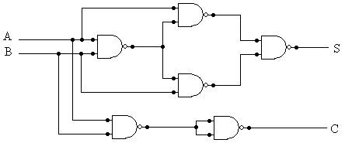
HALF-ADDER USING NAND GATE ONLY

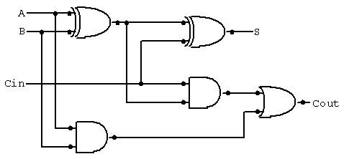
FULL-ADDER USING XOR & AND GATES

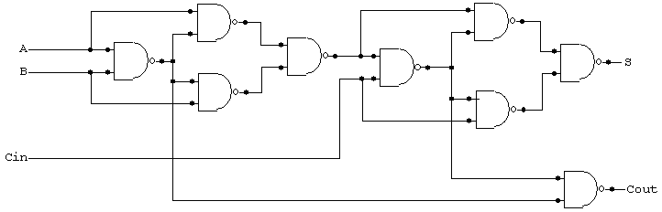

FULL-ADDER USING NAND GATE ONLY

OBSERVATION:

HALF ADDER:

INPUT |  | OUTPUT
X | Y | SUM | CARRY
0 | 0 | 0 | 0
0 | 1 | 1 | 0
1 | 0 | 1 | 0
1 | 1 | 0 | 1

FULL ADDER:

INPUTS |  |  | OUTPUTS
X | Y | C0 | SUM | C
0 | 0 | 0 | 0 | 0
0 | 0 | 1 | 1 | 0
0 | 1 | 0 | 1 | 0
0 | 1 | 1 | 0 | 1
1 | 0 | 0 | 1 | 0
1 | 0 | 1 | 0 | 1
1 | 1 | 0 | 0 | 1
1 | 1 | 1 | 1 | 1

RESULT:

The half adder and full adder circuits were connected as per the circuit diagram and the output obtained. The output was varified.

CONCLUTION:

The half and full adders can be implemented using the common and universal logic gates and their different output states were studied.

APPLICATION:

Adders are the building blocks of a microprocessor. The main application of an adder is in computer processors. All the other operation like multiplication, subtraction, division can be implemented using adders. So most of the operation in an ALU takes place using adders.

EXP No: 4
Date: 28-Feb-06

HALF-SUBTRACTOR/FULL-SUBTRACTOR GATES

INTRODUCTION:

The subtraction of two binary numbers may be accomplished by taking the complement of the subtrahend and adding it to the minuend. By this method, the subtraction operation becomes an addition operation requiring full adders for its machine implementation. It is possible to implement subtraction with logic circuits in a direct manner. By this method, each subtrahend bit of the number is subtracted from its corresponding significant minuend bit to form a difference bit. If the minuend bit is smaller than the subtrahend bit, a 1 is borrowed from the next significant position. The fact that a 1 has been borrowed must be conveyed to the next higher pair of bits by means of a binary signal coming out (output) of a given stage and going into (input) the next higher stage.

PROBLEM DEFINITION:

To implement half and full subtractors using the common logic gates.

COMPONENTS REQUIRED:

Components |  | Specification | Quantity
1 | And gate | IC 7408 | 1
2 | OR gate | IC 7432 | 1
3 | NOT gate | IC 7404 | 1
4 | NAND gate | IC 7400 | 1
5 | X-OR gate | IC 7486 | 1
6 | DC power supply | 0-30v | 1
7 | Resistor | 1K | 2
8 | LED | 30mA | 2

THEORETICAL BACKGROUND:

Subtractor circuits take two binary numbers as input and subtract one binary number input with other binary number input. Similar to adders it gives out two output, difference and borrow (Carry in the case of Adder). There are two types of subtractors.

- Half Subtractor.
- Full Subtractor.

HALF SUBTRACTOR
A half-subtractor is a circuit that computes a difference by subtracting one bit from another. Like the half-adder, it has an extra output, in this case specifying whether a 1 has been
borrowed. The half-subtractor is a combinational circuit, which is used to perform subtraction of two bits. It has two inputs, A (minuend) and B (subtrahend) and two outputs Diff (difference) and Bo (borrow).
The half subtractor needs two outputs. One output generates the difference and will be designated by the symbol Diff. The second output, designated Bo for borrow, generates the binary signal that informs the next stage that a 1 has been borrowed. The output borrow Bo is a 0 as long as x > y. It is a 1 for x = 0 and y = 1. The Diff output is the result of the arithmetic operation 2Bo + x − y.

Difference = Diff = A'B+ AB' = A⊕B
Borrow = Bo = A'B

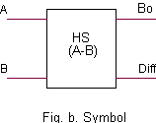

FULL SUBTRACTOR

A full subtractor is a combinational circuit that performs a subtraction between two bits, taking into account that a 1 may have been borrowed by a lower significant stage. This circuit has three inputs and two outputs. The three inputs A, B, and C, denote the minuend, subtrahend, and previous borrow, respectively. The two outputs, Diff and Bo, represent the difference and output borrows, respectively.

Difference = D = A'B'B_{n-1} + A'BB_{n-1}' + AB'B_{n-1}' + ABB_{n-1}
= (A'B' + AB) B_{n-1} + (A'B + AB’) B_{n-1}'
= (A⊕B)' B_{n-1} + (A⊕B) B_{n-1}’
= A⊕B⊕B_{n-1}
B_{n} = A'.B + A'.B_{n-1} + B.B_{n-1}
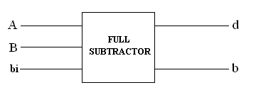

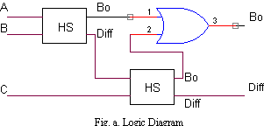

PROCEDURE:

- Check the components using multimeter
- Set up the circuit as per the circuit diagram.
3. Take the input states and corresponding output states and draw the truth table.

CIRCUIT DIAGRAM:

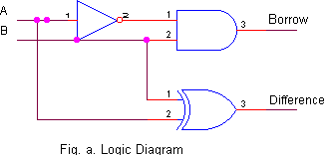

Half subtractor

Full Subtractor

OBSERVATION:

HALF Subtractor:

INPUT |  | OUTPUT
A | B | DIFFERENCE | borrow
0 | 0 | 0 | 0
0 | 1 | 1 | 1
1 | 0 | 1 | 0
1 | 1 | 0 | 0

FULL Subtractor:

INPUTS |  |  | OUTPUTS
A | B | C0 | DIFFERENCE | BORROW
0 | 0 | 0 | 0 | 0
0 | 0 | 1 | 1 | 1
0 | 1 | 0 | 1 | 1
0 | 1 | 1 | 0 | 1
1 | 0 | 0 | 1 | 0
1 | 0 | 1 | 0 | 0
1 | 1 | 0 | 0 | 0
1 | 1 | 1 | 1 | 1

RESULT:

The half subtractor and full subtractor circuits were connected as per the circuit diagram and the output obtained. The output was verified.

CONCLUTION:

The half and full subtractors can be implemented using the common and universal logic gates and their different output states were studied and found as same.

APPLICATION:

In an ALU along with adders, subtractors can also be used.

Experiment No: 5
Date: 07-Mar-2006

ADDER AND SUBTRACTOR USING IC 7483

INTRODUCTION:

The needness of the complement numbers stems from the fact that subtraction of a number from another can be accomplished by adding the complement of the subtrahend to the minuend.The basic operation that can be performed by a computer is only addition. IC 7483 is an integrated circuit which is used to add two 4 bit binary numbers. It is used to implement a 4 bit full adder.

PROBLEM DEFINITION:

To design and set up a 4 bit adder and subtractor circuit using IC 7483.

COMPONENTS REQUIRED:

Components |  | Specification | Quantity
1 | Adder/Subtractor | IC 7483 | 1
2 | X-OR gate | IC 7486 | 4
3 | LED | 30mA | 4
4 | Resistor | 1K | 4
5 | DC power supply | 0-30v | 1
6 | Bread Board | - | 1

THEORETICAL BACKGROUND:

We can convert a 4-bit adder circuit to an adder or subtractor as needed. By leaving the inputs unchanged, we get the result of A + B. But if we invert B and add 1 with the low-order C_{in}, we get the result of A - B.
The 7483 is a full 4 bit adder. The IC features 2 four bit inputs labeled A1-A4 & B1-B4 and a carry-in input C0. The output is the sum of the 2 four bit numbers and the carry-in. The outputs can be sampled at Sum1 - Sum4 with an overflow bit available at C4.

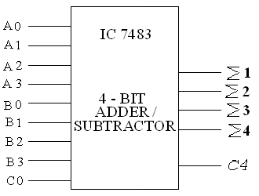

An exclusive-OR gate is used to control whether we will add or subtract on any given occasion. With a control input of 0, the XOR gates will leave the B input number unchanged, and will also apply a logic 0 as the initial input carry. This is exactly what we want in order to add the two numbers. But if we apply a logic 1 to the control input, the XOR gates will invert the B input number to form its one's complement, and will also add 1 through the initial input carry. This changes B to its two's complement. Thus, the output result will actually be A - B. In two's complement addition, the output carry is ignored. It can be taken as an inverted borrow bit rather than as a carry, so that a carry of 1 corresponds to a borrow of 0. That logic also holds for the input carry, which also represents an input borrow bit of 0.
When we add or subtract signed numbers, we need to introduce a new concept known as overflow. Overflow occurs when the result has the wrong sign bit for the operation that was performed. For example, if we add two positive numbers 7 and 6, we should get a positive result 13. But using 4-bit binary numbers, we would add 0111 to 0110 and get 1101 as the result. In signed notation, this is a result of -3, not +13. Therefore, an overflow has occurred, where the result would have to have more bits than the original two numbers

PROCEDURE:

- Check whether all the wires and components are in good condition using multi-meter and digital IC tester.
- Set up the circuit as per the circuit diagram.
- Vcc and ground connections in each IC are made. If the output is 1 then the LED will glow otherwise the LED will not glow.
- Addition can be performed by grounding 13th pin and subtraction can be performed by giving Vcc to the 13th pin.

CIRCUIT DIAGRAM:

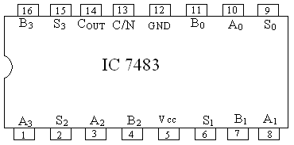

PIN DIAGRAM OF IC 7483

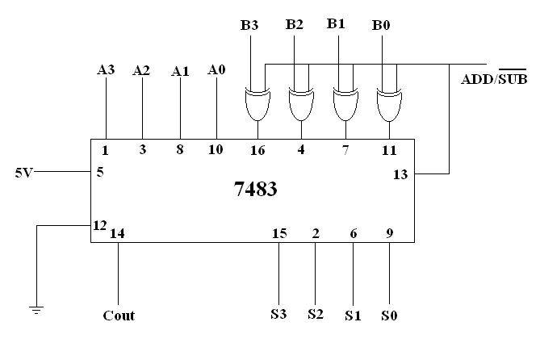

OBSERVATION:

IC 7483 AS ADDER:

A0 | A1 | A2 | A3 | B0 | B1 | B2 | B3
1 | 1 | 0 | 1 | 0 | 0 | 1 | 0
1 | 0 | 1 | 1 | 0 | 0 | 1 | 1
1 | 1 | 1 | 0 | 1 | 0 | 0 | 1
0 | 0 | 0 | 1 | 0 | 1 | 1 | 0

C | S0 | S1 | S2 | S3
0 | 1 | 1 | 1 | 1
1 | 1 | 1 | 0 | 0
1 | 0 | 0 | 0 | 0
0 | 0 | 1 | 1 | 1

IC 7483 AS SUBTRACTOR:

A0 | A1 | A2 | A3 | B0 | B1 | B2 | B3
1 | 1 | 0 | 1 | 0 | 0 | 1 | 0
1 | 0 | 0 | 1 | 0 | 0 | 1 | 1
1 | 1 | 1 | 0 | 1 | 0 | 0 | 1
0 | 0 | 0 | 1 | 0 | 1 | 1 | 0

C | S0 | S1 | S2 | S3
0 | 1 | 1 | 1 | 0
1 | 1 | 1 | 0 | 0
1 | 0 | 1 | 0 | 0
0 | 0 | 1 | 0 | 0

RESULT:

The 4-bit adder and subtractor were implemented using IC 7483 and the output obtained. The output was verified.

CONCLUTION:

Using IC 7483 both an adder and subtractor can be implemented in one circuit. The S input can be used to perform addition or subtraction as needed.

APPLICATION:

Adder and subtractor circuits using IC 7483 are generally used in computers since it provides a relatively simple means for adding and subtracting. These circuits are also used for the implementation of multiplication and division.

Experiment No: 6
Date: 14-Mar-2006

ASYNCHRONOUS COUNTER USING FLIP FLOPS

INTRODUCTION:

A counter is a very simple device. It usually counts from 0 to N (treating them as UB). Some counters allow you to hold the value or to increment one at a time. In other way counter is a sequential circuit which consists of a set of flip flops connected in a suitable manner to count the sequence of input pulses. A counter is one of the most important subsystems in a digital system. A counter circuit activated by a clock can be used to count the number of clock cycles. There are two types of counters:

- Asynchronous counters, and
- Synchronous counters

In asynchronous counter all the flip flops are not hooked to the same clock. But in synchronous counter all flip flop are worked at the same time

PROBLEM DEFINITION:

To design a four bit asynchronous counter using J-K flip flops and study its working.

COMPONENTS REQUIRED:

Components |  | Specification | Quantity
1 | J-K Flip Flop | IC 7476 | 2
2 | LED | 30mA | 4
3 | Resistor | 1K | 4
4 | DC power supply | 0-30v | 1
5 | Bread Board | - | 1
6 | Wires | - | Lump sum

THEORETICAL BACKGROUND:

The external clock is connected to the clock input of the first flip flop only. So, the first flip flop changes state at the falling edge of each clock pulse, but the second flip flop changes only when triggered by the falling edge of the Q output of the first flip flop. Because of the inherent propagation delay through a flip flop, the transition of the input clock pulse and a transition of the Q output of the first flip flop can never occur exactly at the same time. Therefore, the flip flops cannot be triggered simultaneously, producing an asynchronous

operation. The clock pulse fed into the first flip flop is rippled through the other counters after propagation delays, like a ripple on water, hence the name ripple counter.

A counter with n flip flops can have 2 to the power n states. The number of states in a counter is known as its mod (modulo) number. Thus a 2-bit counter is a mod-4 counter. A mod-n counter may also be described as a divide by n counter. This is because the most significant flip flop (the furthest flip flop from the original clock pulse) produces one pulse for every n pulses at the clock input of the least significant flip flop(the one triggered by the clock pulse).

For each flip flop, the J and K inputs are connected to +5V. This means that each flip flop will toggle when its clock input receives a negative going pulse. The MSB of the counter is Q3 and the LSB is Q0. Initially the CLR’ inputs are tied to the ground and hence all the Q outputs will be 0. When the flip flops are counting, the CLR’ input is tied to +5V, its inactive state. At each negative going clock edge, the count increases by 1.

Initially the count is 0000. For the first negative going edge of the clock input, the LSB flip flop sets, increasing the count to 0001. The Q0 output is connected to the clock input of the next most significant flip flop. This high clock pulse does not cause the Q1 output to change. However, the second negative going clock edge applied to the LSB flip flop causes the Q0 output to toggle from 1 to 0. This negative going clock edge causes the Q1 output to go from 0 to 1, changing the count to 0010. The count continues until 1111 is reached. Then on the next negative going pulse, all flip flop outputs toggle back to 0 for a count of 0000.

Each flip flop divides the incoming clock pulse frequency by a factor of 2. The frequency of the Q0 output is one-half that of the clock input. Similarly, Q1 output is one-fourth the frequency of the clock input, Q2 output is one-eight the frequency of the clock input and the Q3 output is one-sixteenth the frequency of the clock input.

PROCEDURE:

- Firstly all the components are tested using a digital IC tester.
- All the required ICs are connected on the breadboard as shown in the circuit.
- All the ground and Vcc connections for each IC are made. If the output is 1 then the LED will glow otherwise the LED will not glow.
- The order in which the LED’s are glowing is checked with the order in the state table of the decade counter.

CIRCUIT DIAGRAM:

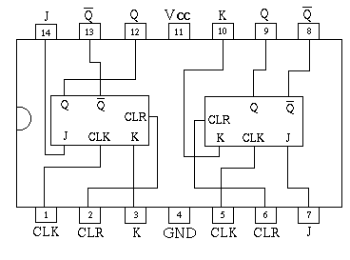
PIN DIAGRAM OF IC 7476

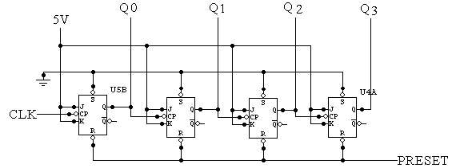

OBSERVATION:

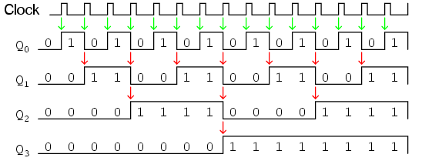

CLOCK | Q4 | Q2 | Q1 | Q0
0 | 0 | 0 | 0 | 0
1 | 0 | 0 | 0 | 1
2 | 0 | 0 | 1 | 0
3 | 0 | 0 | 1 | 1
4 | 0 | 1 | 0 | 0
5 | 0 | 1 | 0 | 1
6 | 0 | 1 | 1 | 0
7 | 0 | 1 | 1 | 1
8 | 1 | 0 | 0 | 0
9 | 1 | 0 | 0 | 1
10 | 1 | 0 | 1 | 0
11 | 1 | 0 | 1 | 1
12 | 1 | 1 | 0 | 0
13 | 1 | 1 | 0 | 1
14 | 1 | 1 | 1 | 0
15 | 1 | 1 | 1 | 1

RESULT:

An asynchronous decade counter was implemented successfully and the output was verified with that in the state table.

CONCLUTION:

The different states were noted and the change from one state to another was studied, the initial state being 0000 and the final state being 1111.

APPLICATION:

1.Counters are also used primarily to keep track of events. They are extensively used in microprocessor circuits.
2. They can be easily found in digital clocks and parallel to serial data conversion (multiplexing).
3. The counters can also be used for frequency division as frequency dividers.

Experiment No: 7
Date: 21-Mar-2006

SYNCHRONOUS COUNTER USING FLIP FLOPS

INTRODUCTION:

A counter is a very simple device. It usually counts from 0 to N (treating them as UB). Some counters allow you to hold the value or to increment one at a time. In other way counter is a sequential circuit which consists of a set of flip flops connected in a suitable manner to count the sequence of input pulses. A counter is one of the most important subsystems in a digital system. A counter circuit activated by a clock can be used to count the number of clock cycles. There are two types of counters:

- Asynchronous counters, and
- Synchronous counters

In asynchronous counter all the flip flops are not hooked to the same clock. But in synchronous counter all flip flop are worked at the same time

PROBLEM DEFINITION:

To design a four bit synchronous counter using J-K flip-flops and study its working.

COMPONENTS REQUIRED:

Components |  | Specification | Quantity
1 | J-K Flip Flop | IC 7476 | 2
2 | AND Gate | IC7408 | 1
3 | LED | 30mA | 4
4 | Resistor | 1K | 4
5 | DC power supply | 0-30v | 1
6 | Bread Board | - | 1

THEORETICAL BACKGROUND:

Synchronous digital counters have a common clock which results in all the flip-flops being triggered simultaneously. Consequently, there are no cumulative delays that result because the clock signal must ripple through the stages as in the asynchronous counters. Synchronous counters can be designed to count up and down in numerical order. In addition, they may be used to produce count sequences of non-consecutive numbers. The count sequence produced by synchronous counters is not dependent on the trigger characteristics of the flip-flops that comprise the count stages. The count sequence is achieved by applying the required logic function into the flip-flops.

A synchronous 4-bit up/down counter is built from JK flip flops. Depending on the logic value on the Up/Down input, the counter will increment or decrement its value on the falling edge of the clock signal. The additional enable input enables (1) or disables (0) counting.
During up-counting, the stage-n flip flop should toggle when all lower flip flops are 1. Therefore, in each stage, one AND gate is used to calculate this carry signal for the next stage flip flop. Similarly, during down-counting, the stage-n flip flop should toggle when all lower flip flops are 0. This is calculated using AND gates connected to the NQ outputs of the flip flops. Each AND gate has one additional input that takes the corresponding up or down enable signal. The outputs of both AND gates are then ORed together to enable the J=K=1 inputs to toggle the JK flip flops.

PROCEDURE:

- Firstly all the components are tested using a digital IC tester.
- All the required ICs are connected on the breadboard as shown in the circuit.
- All the ground and Vcc connections for each IC are made. If the output is 1 then the LED will glow otherwise the LED will not glow.
- The order in which the LED’s are glowing is checked with the order in the state table of the up counter.

CIRCUIT DIAGRAM:

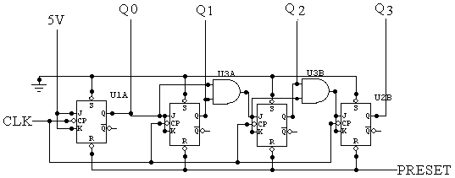

OBSERVATION:

CLOCK | Q4 | Q2 | Q1 | Q0
0 | 0 | 0 | 0 | 0
1 | 0 | 0 | 0 | 1
2 | 0 | 0 | 1 | 0
3 | 0 | 0 | 1 | 1
4 | 0 | 1 | 0 | 0
5 | 0 | 1 | 0 | 1
6 | 0 | 1 | 1 | 0
7 | 0 | 1 | 1 | 1
8 | 1 | 0 | 0 | 0
9 | 1 | 0 | 0 | 1
10 | 1 | 0 | 1 | 0
11 | 1 | 0 | 1 | 1
12 | 1 | 1 | 0 | 0
13 | 1 | 1 | 0 | 1
14 | 1 | 1 | 1 | 0
15 | 1 | 1 | 1 | 1

RESULT:

The 4-bit synchronous up counter was successfully set up and all the counting states from 0 to 15 were observed.

CONCLUTION:

The different states were noted and the change from one state to another was studied, the initial state being 0000 and the final state being 1111.

APPLICATION:

Digital counters are very useful in many applications. They can be easily found in digital clocks and parallel to serial data conversion (multiplexing). Parallel to serial conversion is normally accomplished by the use of a counter to provide a binary sequence for the data select inputs of a multiplexer. Counters are also used primarily to keep track of events. They are extensively used in microprocessor circuits.

Experiment No: 8
Date: 28-Mar-2006

RING COUNTER

INTRODUCTION:

Two of the most common types of shift register counters are introduced here: the Ring counter and the Johnson counter. They are basically shift registers with the serial outputs connected back to the serial inputs in order to produce particular sequences. These registers are classified as counters because they exhibit a specified sequence of states.

PROBLEM DEFINITION:

To design a ring counter using D flip-flops and study its working.

COMPONENTS REQUIRED:

Components |  | Specification | Quantity
1 | D Flip Flop | IC 7474 | 2
2 | LED | 30mA | 4
3 | Resistor | 1K | 4
4 | DC power supply | 0-30v | 1
5 | Bread Board | - | 1
6 | Wires | - | Lump Sum

THEORETICAL BACKGROUND:

A 4-bit ring counter is constructed using 4 D flip-flops. It is referred as a mod4 ring counter. The output of each stage is shifted into the next stage on the positive edge of a clock pulse. If the CLEAR signal is high, all the flip-flops except the first one are reset to 0. Instead the first flip flop is PRESET to 1.
A ring counter is defined as a loop of bistable devices (flip-flops) interconnected in such a manner that only one of the devices may be in a specified state at one time. It is actually a synchronous counter as clock inputs for all the flip flops are given in common.

The decoding circuit required to construct a ring counter is less than that required to construct a Johnson counter. Of all the shift register counters available ring counter requires the most number of flip flops for a given mod. For constructing a mod-n ring counter n flip flops are needed.
For the ring counter to operate properly, it must start with only one flip-flop in the 1 state and all the others at 0. Since it is not possible to expect the counter to come up to this state when power is first applied to the circuit, it is necessary to preset the counter to the required starting state before the clock pulses are applied. One way to do this is to apply a pulse to the PRESET input of one of the flip-flops and the CLEAR inputs of all the others. This will place a single 1 in the ring counter.

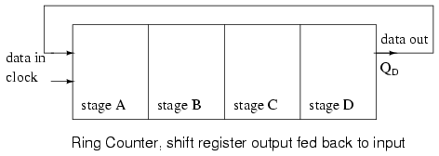

PROCEDURE:

1. Check whether all the wires and components are in good condition.
2. Connect the components as per the circuit diagram and provide it with the input
combinations.
3. Enter the obtainned outputs for the corresponding input combinations in the truth table.

CIRCUIT DIAGRAM:

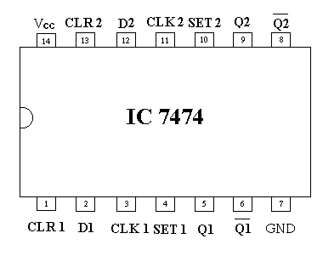
PIN DIAGRAM OF D FLIP FLOP

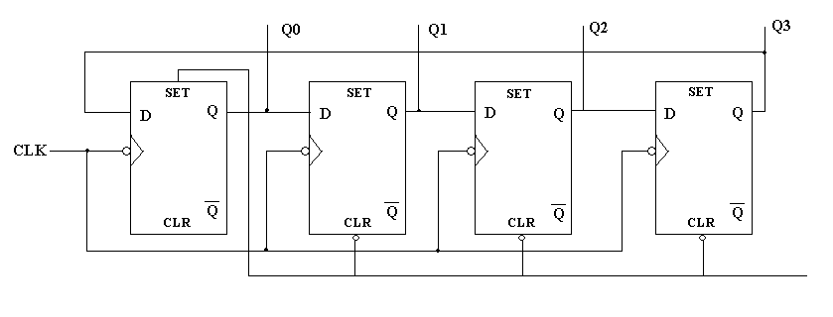

OBSERVATION:

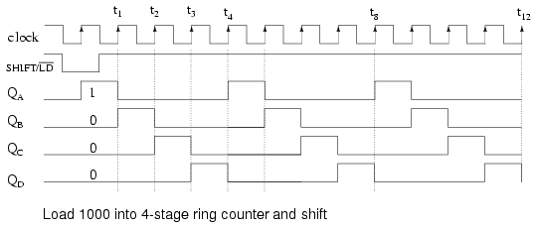

CLK | Q0 | Q1 | Q2 | Q3
0 | 0 | 0 | 0 | 0
1 | 1 | 0 | 0 | 0
2 | 1 | 1 | 0 | 0
3 | 1 | 1 | 1 | 0

RESULT:

The ring counter was successfully implemented using IC 7474 and the counting states were observed. And the output was verified.

CONCLUTION:

In terms of state usage ring counters are very inefficient because only four of the maximum 16 states are used. The main advantage of a ring counter over a binary counter is that it is self-decoding. Only four D flip flops are needed for their implementation and no extra decoding circuits are needed.

APPLICATION:

- To produce time delay.
- To simplify the combinational logic.
- To convert serial data to parallel data.

Experiment No: 9
Date: 04-Apr-2006

JOHNSON COUNTER

INTRODUCTION:

Two of the most common types of shift register counters are introduced here: the Ring counter and the Johnson counter. They are basically shift registers with the serial outputs connected back to the serial inputs in order to produce particular sequences. These registers are classified as counters because they exhibit a specified sequence of states.

PROBLEM DEFINITION:

To design a Johnson counter using D flip-flops and study its working.

COMPONENTS REQUIRED:

Components |  | Specification | Quantity
1 | D Flip Flop | IC 7474 | 2
2 | LED | 30mA | 4
3 | Resistor | 1K | 4
4 | DC power supply | 0-30v | 1
5 | Bread Board | - | 1
6 | Wires | - | Lump Sum

THEORETICAL BACKGROUND:

A Johnson counter is a special case of shift register, where the output from the last stage is inverted and fed back as input to the first stage. A pattern of bits equal in length to the shift register thus circulates indefinitely. These counters are sometimes called “walking ring” counters, and find specialist applications, including those similar to the decade counter, digital to analogue conversion, etc.

Johnson counters are a variation of standard ring counters, with the inverted output of the last stage fed back to the input of the first stage. They are also known as twisted ring counters. An n-stage Johnson counter yields a count sequence of length 2n, so it may be considered to be a mod-2n counter. Again, the apparent disadvantage of this counter is that the maximum available states are not fully utilized. Only eight of the sixteen states are being used. The Johnson counter must initially be forced into a valid state in the count sequence because they operate on a subset of the available number of states. Otherwise, the ideal sequence will not be followed.

It is a k-bit switch tail ring counter with 2k decoding gates to provide outputs for 2k timing signals. The number of states can be doubled if the shift register is connected as a switch tail ring counter. A switch tail ring counter is a circular shift register with the complement output of the last flip flop connected to the input of the first flip flop. The circular connection is made from the complement output of the rightmost flip flop to the input of the leftmost flip flop. The register shifts its contents once to the right with every clock pulse, and at the same time, the complement value of the last flip flop is transferred to the first flip flop. Starting from a cleared state, the switch tail ring counter goes through a sequence of eight states. Starting from all 0’s, each shift operation inserts 1’s from the left until the register is again filled with all 0’s.

One disadvantage of this counter is that, if it finds itself in an unused state, it will persist in moving from one invalid state to another and never find its way to a valid state. Johnson counters can be constructed for any number of timing sequences. The number of flip flops needed is one-half the number of timing signals. The number of decoding gates is equal to the number of timing signals and only 2-input gates are employed.

PROCEDURE:

- Firstly all the components are tested using a digital IC tester.
- All the required ICs are connected on the breadboard as shown in the circuit.
- All the ground and Vcc connections for each IC are made. If the output is 1 then the LED will glow otherwise the LED will not glow.
- The order in which the LED’s are glowing is checked with the order in the state table of the Johnson counter.

CIRCUIT DIAGRAM:

PIN DIAGRAM OF D FLIP FLOP

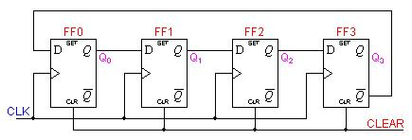

OBSERVATION:

CLK | Q3 | Q2 | Q1 | Q0
0 | 0 | 0 | 0 | 0
1 | 0 | 0 | 0 | 1
2 | 0 | 0 | 1 | 1
3 | 0 | 1 | 1 | 1
4 | 1 | 1 | 1 | 1
5 | 1 | 1 | 1 | 0
6 | 1 | 1 | 0 | 0
7 | 1 | 0 | 0 | 0

RESULT:

Mod-8 Johnson counter was implemented successfully and the output was verified with that in the state table.

CONCLUTION:

A single IC 7474 contains 2 D flip flops and 2 such IC’s makeup the ring counter. The Johnson counter consists of sixteen counting sequences out of which only 8 states are utilized and these were observed using the four LED’s.

APPLICATION:

- To produce time delay.
- To simplify the combinational logic.
- To convert serial data to parallel data.

Experiment No: 10
Date: 11-Apr-2006

CHARACTERISTICS OF TTL & CMOS GATES

INTRODUCTION:

TTL that is Transistor-Transistor Logic isa class of digital circuits built from bipolar junction transistors and resistors. TTL became important because it was the first time that low-cost integrated circuits made digital techniques economically practical for tasks previously done by analog methods. Each integrated circuit performs separate building-block functions such aslogic gates such as AND, OR, NAND, NOR, XOR, inversion ,flip-flops, latch elements , Ripple, synchronous, decade, and hexadecimal counters ,adders . CMOS logic is based on the use of complementary MOS transistors to perform logic functions with almost no current required. This makes these gates very useful in battery-powered applications. They can work with supply voltages as low as 3 volts and as high as 15 volts. The central characteristic of CMOS technology is that it only uses significant power when its transistors are switching between on and off states.

PROBLEM DEFINITION:

To plot the transfer characteristics of a TTL and CMOS gates.

COMPONENTS REQUIRED:

Components |  | Specification | Quantity
1 | NOR gate | IC 7404 | 1
2 | NAND gate | IC 7400 | 1
3 | Ammeter | 0 – 1 mA | 1
4 | Voltmeter | 0 – 5 V | 1
5 | Rheostat | 750Ω | 1
6 | DC power supply | 0-30v | 1
6 | Bread Board | - | 1

THEORETICAL BACKGROUND:

The fundamental switching action of a TTL gate is based on a multiple-emitter input transistor. This replaces the multiple input diodes of the earlier DTL logic, with improved speed and a reduction in chip area. The active operation of this input transistor removes stored charge from the output stage transistors more rapidly than a comparable DTL gate, making TTL much faster in switching. A small amount of current must be drawn from a TTL input to ensure proper logic levels. The total current draw must be within the capacities of the preceding stage, which limits the number of nodes that can be connected (the fanout).

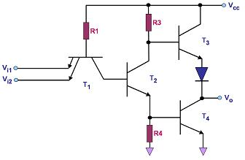
Simplified schematic of two input TTL NAND gate.

All standardized TTL circuits operate with a +5 volt power supply. A TTL signal is defined "low" when the signal is between 0V and 0.8V with respect to the ground terminal, and "high" when the signal is between 2V and 5V.Most TTL circiuts are standaridsed for inter-operability.

TTL devices are packaged in through-hole, dual in-line packages with between 14 and 24 lead wires, which are made usually of epoxy plastic but also commonly ceramic. Other packages included the flat-packwhich are used for military and aerospace applications and beam-lead chips without packages used for assembly into larger arrays. Most popular TTL devices are also available in surface-mounted packages.

CMOS which stands for complementary metal-oxide semiconductor, is a major class of integrated circuits. CMOS chips include microprocessor, microcontroller, static RAM, and other digital logic circuits.
CMOS devices use little power and do not produce as much heat as other forms of logic. CMOS also allows a high density of logic functions on a chip.

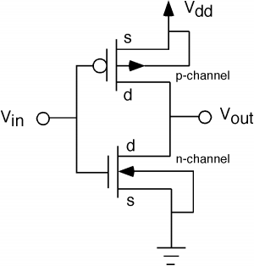

Internal Diagram Of A CMOS Inverter

CMOS logic uses a combination of p-type and n-type metal-oxide-semiconductor field effect transistors (MOSFETs) to implement logic gates. Although CMOS logic can be implemented with discrete devices (for instance, in an introductory circuits class), typical commercial CMOS products are integrated circuits composed of millions (or hundreds of millions) of transistors of both types on a rectangular piece of silicon of between 0.1 and 4 square centimeters. These bits of silicon are called chips.

In this experiment we use a CMOS inverter. When the input is High the output will be low and when the output is low the output will be high. This inverter can be operated with a Vcc varying from 3V to 15V.

PROCEDURE:

For TTL characteristics

- Test all the components and IC packages using multimeter or digital IC tester.
- Set up the circuit to plot the transfer characteristics of TTL NAND gate.
- Vary the input the input voltage from 0 to 5V.
- Note the output voltage from the CRO.
- Plot the characteristics with input voltage V_{i} on the X-axis and output voltage V_{o} on the Y-axis.

For CMOS characteristics

- Test all the components and IC packages using multimeter or digital IC tester.
- Set up the circuit to plot the transfer characteristics of CMOS gate.
- Vary the input the input voltage from 0 to 5V.
- Note the output voltage from the CRO.
- Plot the characteristics with input voltage V_{i} on the X-axis and output voltage V_{o} on the Y-axis.

CIRCUIT DIAGRAM:

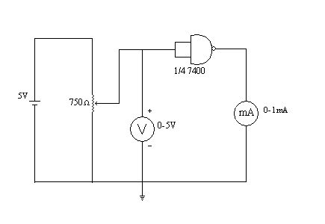
Circuit of TTL characteristics

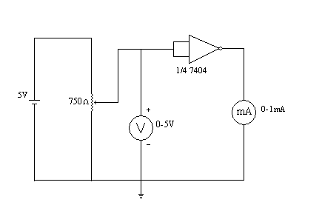
Circuit of TTL characteristics

OBSERVATION:

For TTL

V_{i} | V_{o}
0 | 4.4
1 | 4.4
2 | 4.4
3 | 0
4 | 0
4.4 | 0

For CMOS

V_{i} | V_{o}
0 | 4.2
1 | 4.2
2 | 0
3 | 0
4 | 0
4.4 | 0

GRAPHS:

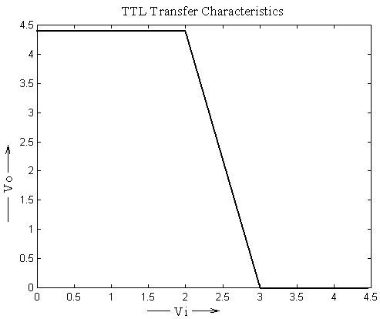

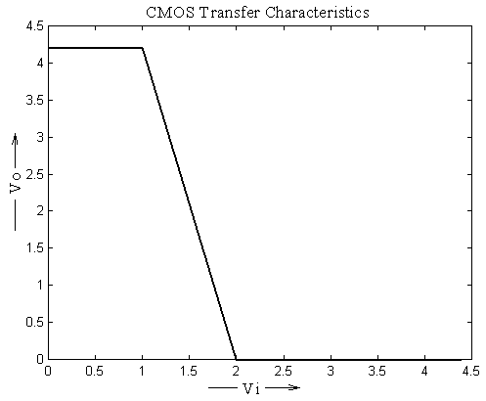

RESULT:

The circuit of TTL and CMOS gates was setup independently on the bread board and output voltage corresponding to different voltages were noted. The transfer curves were plotted based on those values.

CONCLUTION:

This experiment helped in familiarizing the characteristics of TTL and CMOS circuits

APPLICATION:

As microprocessors became more functional, TTL devices became important for "glue logic" applications, such as fast bus drivers on a motherboard, which tie together the function blocks realized in VLSI elements.
A chip with a large number of CMOS transistors packed tightly together is sometimes known as CHMOS (for "Complementary High-density metal-oxide-semiconductor").

The combination of MEMS sensors with digital signal processing on one single CMOS chip is sometimes known an CMOSens.

Careful study of CMOS characteristics show that CMOS devices used in a system design can be used for linear building blocks as well as digital blocks. Utilization of these new devices will decrease package count and reduce supply requirements.

Experiment No: 11
Date: 11-Apr-2006

REALISATION OF FLIP-FLOPS USING GATES

INTRODUCTION:

The flip-flop is a pulsed digital circuit capable of serving as a one-bit memory. A flip-flop typically includes zero, one, or two input signals; a clock signal; and an output signal, though many commercial flip-flops additionally provide the complement of the output signal. Some flip-flops include a clear input signal, which resets the current output. Because flip-flops are implemented as integrated circuit chips, they also require power and ground connections.
Flip flops are the basic building block of any memory system since its output will remain in its state until it is forced to change it by some means. The most important memory element is the flip-flop, which is made of an assembly of logic gates.

PROBLEM DEFINITION:

To realize
- JK flip flop.
- Master Slave JK flip flop
- D flip flop
- T flip flop
using NAND gate

COMPONENTS REQUIRED:

Components |  | Specification | Quantity
1 | 3 input NAND gate | IC 7410 | 2
2 | 2 input NAND gate | IC 7400 | 2
3 | Resistor | 1K | 1
4 | LED | - | 1
5 | Bread Board | - | 1

THEORETICAL BACKGROUND:

Flip flop is the basic building block in any memory system since its outputs will remain in its state until it is forced to change it by some means.

J-K flip-flop

The J-K flip-flop is the most versatile of the basic flip-flops. It has two inputs, traditionally labeled J and K. If J and K are different then the output Q takes the value of J at the next clock edge.

The logical symbol is shown below:

Truth Table of J-K Flip Flop:

J | K | Q1 | Q1' | operation
0 | 0 | Q0 | Q0' | No Change
0 | 1 | 0 | 1 | Reset
1 | 0 | 1 | 0 | Set
1 | 1 | Q0' | Q0 | Toggle

Master Slave J-K flip-flop

This will avoid the raze around condition, that occur with oscillation that occurs with a JK Flip-when J=K=1.
The master-slave flip-flop is essentially two back-to-back JKFFs, that feedback from this device is fed back both to the master FF and the slave FF.

The logical diagram is shown below:
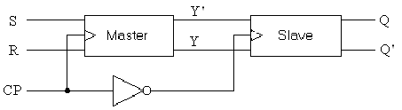

D flip-flop

The D flip-flop has only one input, the D input in addition to the clock. If there is a HIGH on the D input when a clock pulse is applied, the flip-flop will set, and the HIGH on the D input is stored by the flip-flop on the positive going edge of the clock pulse. If there is a LOW on the D input when the clock pulse is applied, the flip-flop will reset, and the LOW on the D input is stored by the flip-flop on the leading edge of the clock pulse. In the SET state the flip-flop is storing a 1, and in the RESET state it is storing a 0.

The logical symbol is shown below:
Truth Table of D Flip Flop:

D | Q1 | Q1' | operation
0 | 0 | 1 | Reset
1 | 1 | 0 | set

T Flip Flop

The toggle, or T, flip-flop is a bistable device that changes state on command from a common input terminal.

The logical diagram is shown below:

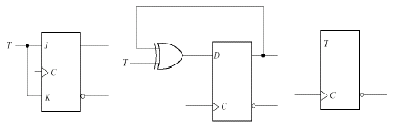

Truth Table of D Flip Flop:

T | Q1 | Q1' | operation
0 | Q0 | Q0' | No Change
1 | Q0' | Q0 | Toggle

PROCEDURE:

- Test all components and ICs using multimeter.
- Set up the flip flop circuits using the NAND gates and note down the outputs in the truth tables.
- Verify these truth tables with that of 7473,7474,7476 ICs.

CIRCUIT DIAGRAM:

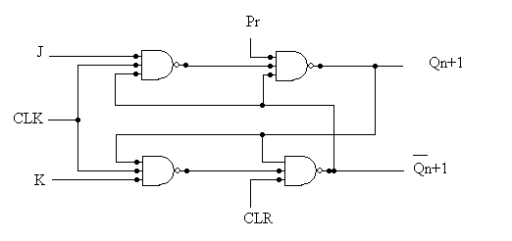
J k Flip-Flop

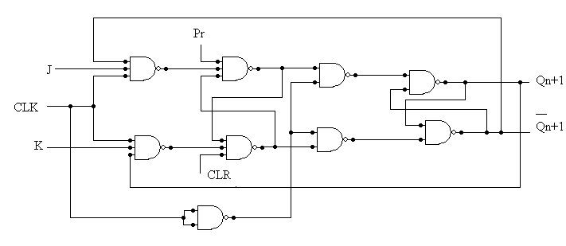
Master Slave J k Flip-Flop

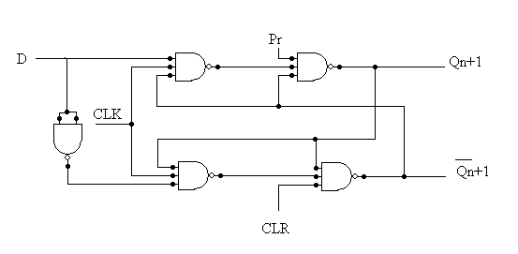
D Flip-Flop
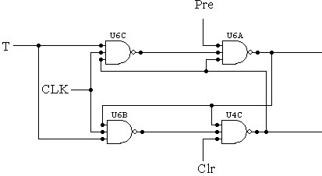
T Flip-Flop

OBSERVATION:

JK flip flop

INPUT |  | OUTPUT
J | K | Q_{n+1}
0 | 0 | Q_{n}
0 | 1 | 0
1 | 0 | 1
1 | 1 | Q_{n}'

Master Slave JK flip flop

INPUT |  | OUTPUT
J | K | Q_{n+1}
0 | 0 | Q_{n}
0 | 1 | 0
1 | 0 | 1
1 | 1 | Q_{n}'

D flip flop

INPUT | OUTPUT
D | Q
0 | 0
1 | 1

T flip flop

INPUT | OUTPUT
T | Q_{n+1}
0 | Q_{n}
1 | Q_{n}'

RESULT:

The various flip flops that is J-K, D, T and Master slave J-K was set up and realized using the IC’s and the results were verified from the truth table by giving different input combinations.

CONCLUTION:

A single flip-flop can be used to store one bit, or binary digit, of data. The data contained in several such flip-flops may represent the state of a sequencer, the value of a counter, an ASCII character in a computer's memory or any other piece of information.
One use is to build finite state machines from electronic logic. The flip-flops remember the machine's previous state, and digital logic uses that state to calculate the next state.

APPLICATION:

Flip-Flops are the most essential components of modern computing. They are used in even the most fundamental logic circuit and memory device.

Experiment No: 12
Date: 18-Apr-2006

OP-AMP CHARACTERISTICS

INTRODUCTION:

An Operational Amplifier or Op Amp, is a dual-input, single-output linear amplifier that exhibits a high open-loop gain, high input resistances, and a low output resistance. One of the inputs of an operational amplifier amp is non-inverting while the other is inverting.

PROBLEM DEFINITION:

To obtain the ac and dc parameters of an op-amp namely :
- Offset voltage
- Input offset current
- Common Mode Rejection Ratio(CMRR)

COMPONENTS REQUIRED:

Components |  | Specification | Quantity
1 | Op-amp | IC 741 | 1
2 | CRO | 1MHz | 1
3 | DC power supply | 0-5V | 1
4 | Bread Board | - | 1

THEORETICAL BACKGROUND:

Input offset current: The algebraic difference between the currents into the inverting
and non-inverting terminals is referred to as input offset current IIO.
In the form of an equation
I_{IO}= | I_{B1} - I_{B2} |

Where IB1 is the current into the non-inverting input and IB2 is the current into the
inverting input.
We know that the input stage of an op-amp is supposed to be a balanced input balanced
output differential amplifier. So we expect the currents entering into the two input points
to be equal, when the output is zero. But this is not so in practice because of the
dissimilarities between two transistor parameters. Thus, to fix two transistors at the same
operating point, we have to apply dissimilar base currents at the base junctions of the
transistors. That difference between the base currents entering the two input terminals
with the output at zero volts is termed as input offset current. This also varies with
temperature.

Input offset voltage: Ideally, with no input an op-amp should give no output. This is
never the practical case. There is always a non-zero output. We can make it zero by
giving an input of proper sign and magnitude. It could be positive or negative. The
d.c.voltage applied between the input terminals to force the quiescent d.c.output to zero,
is called the input offset voltage. It is represented as VIO. VIO could change with
temperature.

V_{o}/V_{in} = 1+ (R_{f} / R₁)
The common mode rejection ratio (CMRR) is a measure of the 'quality' of the op-amp to reject common mode signals (the higher the better) and is defined as:
CMRR = A_{d} / A_{cm}
CMRR is often expressed in dB:
CMRR = 20 log₁₀(A_{d} / A_{cm}) dB

A high CMRR is important in applications where the signal of interest is represented by a small voltage fluctuation superimposed on a (possibly large) voltage offset, or when relevant information is contained in the voltage difference between two signals. (An example is audio transmission over balanced lines.)

PROCEDURE:

Set up the circuit as in the circuit diagram and measure the output voltage. Input offset
voltage can be calculated by using the expression. Set up the circuit for measuring the input
bias current and the input offset current. Measure the output voltage asing the expression
Vo=IBlR and Vo=IB2R. Find IBl and IB2 and substitute in the expression. Set up the circuit to determine the CMMR. First apply same input voltage through the two terminals and then
apply different voltages through the inverting and non inverting terminals.

CIRCUIT DIAGRAM:

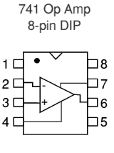

Input Offset voltage:
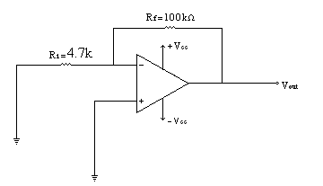

Input offset current:
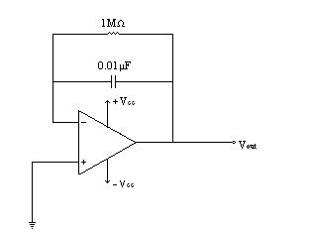

Common Mode Rejection Ratio:

OBSERVATION:

Input Offset Voltage

Vo = Vio(1+Rf /R₁).
Vio = Vo / (1+Rf /R₁)
0.6/ (1+100000 /100)
0.6mV

Input Bias Current

Vo = 0.04V
I_{BI} = .04/ 10^6
= 40nA
Vo = 0.12V

I_{B2} = 0.12 1 10^6
= 120nA
I_{B} = (I_{Bl}+I_{B2})/2
= (40nA + 120nA)/2
= 60nA

Input Offset Current

I_{IO} = | I_{BI}-I_{B2}|
= |40-120 |
= 80nA

Common Mode Rejection Ratio

CMRR = Vin(1+Rf/R₁)Vo
=5*(1+100*1000/100)12
=418

RESULT:

The op-amp parameters were successfully calculated using the corresponding formulas and the values were manually verified. The values are as given below:

Input Offset voltage = 0.6mV
Input Bias current = 60nA
Input Offset current = 80nA
Common mode rejection ratio = 418

CONCLUTION:

For ideal op-amp cases, the input offset voltage is zero and CMRRis infinite, but this is
not the situation for practical cases.

APPLICATION:

The op-amp can be used in almost any d.c. to 1MHz amplifier and signal processing
applications. IC op-amps are inexpensive, versatile and easy to use. For this reason, they are used not only for negative-feedback amplifiers but also for wave shaping, filtering and mathematical operations. Some of the common applications are in comparators, current sources, summing amplifiers and active filters.

Experiment No: 13
Date: 18-Apr-2006

INVERTING AND NON-INVERTING AMPLIFIERS

INTRODUCTION:

The op-amp can be effectively utilized in linear applications by providing feedback from the output to the input either directly or via another network. If the signal feedback is out of phase by 1800 with respect to the input, then the feedback is referred to as negative feedback or degenerative feedback. Conversely, if the signal feedback is in phase with that at the input, then the feed back is referred to as positive feedback or regenerative feedback.

An op-amp that uses feedback is called as closed-loop amplifier. The most commonly used closed-loop configurations are (i) Inverting amplifier (voltage shunt feedback) and (ii) Non- inverting amplifier (voltage series feedback).

PROBLEM DEFINITION:

To implement a Inverting and Non-Inverting operational amplifier.

COMPONENTS REQUIRED:

Components |  | Specification | Quantity
1 | Op-amp | IC 741 | 1
2 | Resistor | 1K, 10K | 1 each
3 | CRO | 1MHz | 1
4 | DC power supply | 0-5V | 1
4 | Bread Board | - | 1

THEORETICAL BACKGROUND:

Inverting Amplifier:

The op-amp is connected using two resistors RA and RB such that the input signal is applied in series with RA and the output is connected back to the inverting input through RB. The noninverting input is connected to the ground reference or the center tap of the dual polarity power supply. In operation, as the input signal moves positive, the output will move negative and visa versa. The amount of voltage change at the output relative to the input depends on the ratio of the two resistors RA and RB. As the input moves in one direction, the output will move in the opposite direction, so that the voltage at the inverting input remains constant or zero volts in this case. If RA is 1K and RB is 10K and the input is +1 volt then there will be 1 mA of current flowing through RA and the output will have to move to -10 volts to supply the same current through RB and keep the voltage at the inverting input at zero. The voltage

gain in this case would be RB/RA or 10K/1K = 10. Note that since the voltage at the inverting input is always zero, the input signal will see a input impedance equal to RA, or 1K in this case. For higher input impedances, both resistor values can be increased.

Non-Inverting Amplifier:

The noninverting amplifier is connected so that the input signal goes directly to the noninverting input (+) and the input resistor RA is grounded. In this configuration, the input impedance as seen by the signal is much greater since the input will be following the applied signal and not held constant by the feedback current. As the signal moves in either direction, the output will follow in phase to maintain the inverting input at the same voltage as the input (+). The voltage gain is always more than 1 and can be worked out from Vgain = (1+ RB/RA).

Voltage Follower:

The voltage follower, also called a buffer, provides a high input impedance, a low output impedance, and unity gain. As the input voltage changes, the output and inverting input will change by an equal amount.

PROCEDURE:

Set up the inverting amplifier on the bread board. Feed a 2 Vpp sine wave and observe the input and output simultaneously on the CRO. Verify whether the output is a 10 vpp sine wave with a 180 degree phase shift for the inverting amplifier and a 0 or 360 degree phase shift for the Non-Inverting amplifier. Vary the input voltage levels and observe the difference.

DESIGN:

Inverting Amplifier:

A= -RF/Ri
Gain= -10
Rf/Ri= 10
Let Ri= 1K
Hence Rf= 10K

Non-Inverting Amplifier

A= (1+RF)/Ri
Gain= -11
Rf/Ri= 10
Let Ri= 1K
Hence Rf= 10K

CIRCUIT DIAGRAM:

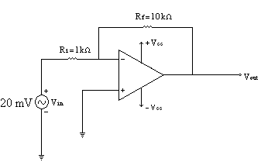
Inverting Amplifier

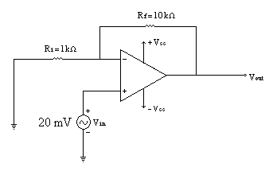
Non-Inverting Amplifier

OBSERVATION:

GRAPHS:
frequency |  | Inverting |  | Non-Inverting
Freq(Hz) | Log f (Hz) | Av(Vo/Vi) | 20 log Av |  | Av(Vo/Vi) | 20 log Av
100 | 2 | 11 | 20.82 |  | 11.1 | 20.9
500 | 2.7 | 11 | 20.82 |  | 11.1 | 20.9
2k | 3.3 | 11 | 20.82 |  | 11.1 | 20.9
7k | 3.85 | 10.5 | 20.42 |  | 11.1 | 20.9
10k | 4.0 | 9 | 19.08 |  | 11.1 | 20.9
15k | 4.17 | 7.1 | 16.9 |  | 9 | 19.08
20k | 4.30 | 6 | 15.6 |  | 6 | 15.56
22k | 4.34 | 5.5 | 14.80 |  | 5.6 | 14.96
24k | 4.38 | 5 | 13.97 |  | 5 | 13.97

Inverting Amplifier
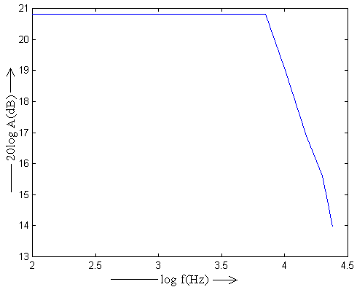

Non-Inverting Amplifier

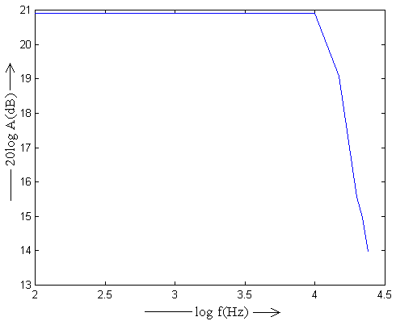
RESULT:

The inverting and non-inverting amplifiers were successfully designed and their output
voltage readings were noted and the graph plotted.

CONCLUTION:

The inverting and non-inverting configurations of op-amp are classified based on the
number of inputs used and the terminal to which the input is applied. The op-amp is a
versatile device and it amplifies both a.c. and d.c. input signals. Thus, the input signals can be either a.c. or d.c. voltages.

APPLICATION:

The op-amp can be used in almost any d.c. to IMHz amplifier and signal processing
applications. IC op-amps are inexpensive, versatile and easy to use. For this reason, they are used not only for negative-feedback amplifiers but also for wave shaping, filtering and mathematical operations. Some of the common applications are in comparators, current sources, summing amplifiers and active filters.

