The 8255A is a programmable peripheral interface (PPI) device designed for use in Intel microcomputer systems. Its function is that of a general purposes I/O component to Interface peripheral equipment to the microcomputer system.
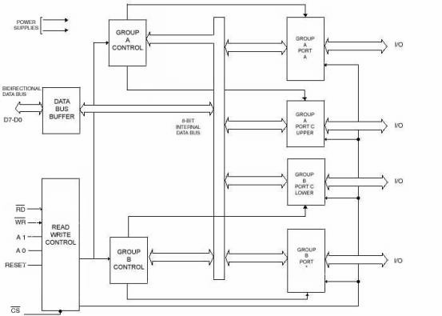

The device has got 24 I/O lines.

It has 3 ports
PORT A and PORT B: used as an 8 bit input port or 8 bit output port.
PORT C: can be used as an a) 8 bit input port or
b) 8 bit output port. or
c) two 4 bit ports or
d) to produce handshake signals for ports A and B.
From the diagram it can be seen that the eight data lines allows to
- write data bytes to a port
- write control word to a control register.
- to read bytes from a port
- to read bytes from a status register.

under the control of Read and Write lines.
The address inputs A0 and A1 allows one to selectively access one of the 3 ports or control register. The internal addresses for the device are
Port A -00 , Port B-01 ,Port C-11, Control Register-11.

8255 Modes and Initialization

Mode 0

When one want to use a port for simple input or output without handshaking , one initialize the port in MODE 0.
If both port A and port B are initialized in MODE 0 , then the two halves of the port C can be used together as an additional 8 bit port. or they can be used individually as two 4 bit ports.

When used as the output, port C can be individually set or reset by sending a special control word to the control register address.

Mode 1
When one want to use port A or port B for a handshake input or output operation , initialize that port in Mode 1.
Pins PC0, PC1 and PC2 function as handshake signals for port B if it is initialized in Mode 1.
Pins PC3, PC4 and PC5 function as handshake signals for port A if it is initialized as a handshake input port and Pins PC6 and PC7 are available for used as input lines or output lines.
Pins PC3, PC6 and PC7 function as handshake signals for port A if it is initialized as a handshake output port and Pins PC4 and PC5 are available for used as input lines or output lines.
Mode 2
Only port A can be initialized in mode 2.
Port A can be used for bidirectional data transfer. This means that the data can be output or input on same eight lines.
The 8255 might be used in this mode to to extend the system bus to a slave microprocessor or to transfer data bytes to and from a floppy disk controller board.
If port A is initialized in mode 2, then pins PC3-PC7 are used as the handshake signals for port A.The other 3 pins of port C can be used for I/O if port B is in mode 0. The 3 pins will be used for port B handshake lines if port B is initilalized in mode 1.

Constructing and sending the 8255A control words.

The two figures below show the formats for two 8255A control words. The MSB of the control word tells the 8255A which control word one is sending. One uses the mode definition control word in first figure to tell the device what mode one wants the port to operate in. For mode definition format one puts a one in the MSB.
One uses the bit set /reset control word format , when one want to set or reset the output on a pin of port C or when one want to enable the interrupt output signals for handshake data transfers. The MSB is zero for this control word. Both control words are sent to control register address for 8255A.

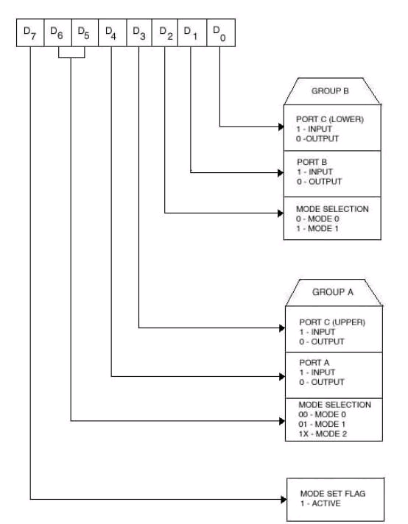

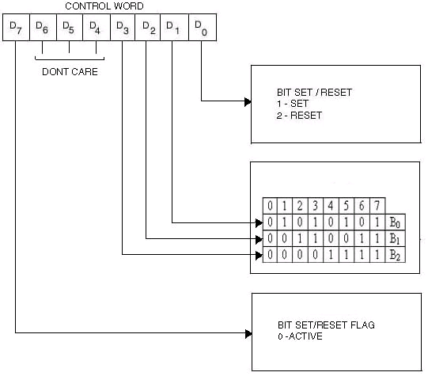

Making up a control word consist of figuring out what to put in the eight little boxes one bit at a time.

Suppoese you want to set up 8255 in mode 0.
Suppose one want to use port A port B and port C as output ports.
The mode definition control word is 10000000B.
Suppose the control register address is X.
To send a control word, then one load the control word in AL with a MOV AL,10000000B instruction, point DX at the port address with the MOV DX,X H instruction and send the control word to the 8255 with the OUT DX,AL instruction.

As an example of how to use the bit set/reset control word. Suppose that one wants to output a 1 to bit 3 of port C, which was initialized as an output with the mode definition word above. To set or reset a port C output pin, one uses the bit set/reset control word. Make bit D7 a 0 to identify that it is bit/reset control word and put a 1 int bit D0 to specify that one want o set a bit of port C. Bits D3, D2 and D1 are used to tell the 8255 which bit one wants to act on. In this example ,it is to set bit 3,so put 011 in this 3 bits. For simplicity, make the other 3 bits of the control word 0.

To send this control word to 8255, simply load it into AL with the MOV AL,00000111B instruction, point DX at the control register address with the MOV DX,X instruction, and send the control word with the OUT DX,AL instruction.

8251 USART(Universal Synchronous Asynchronous Transmitter Chip)
The Intel 8251 USART consists of three interacting modules:
the transmitter, the receiver, and the CPU interface.The CPU interface accepts words written by the processor into the peripheral and sets up the mode of operation and
the state values to perform operations as required by the command words. It also accepts data values to transmit and returns received data values to the processor on a data read
operation. The status word is returned to the processor on a
status read.

The _ transmitter section can be enabled in either a synchronous or asynchronous transmit mode. In the synchronous mode, the transmitter transmits either one or two
SYNC characters if it is enabled until data is written into its buffer. The data is then transmitted one bit per clock followed by the programmed parity bit. In the asynchronous
mode, the transmitter transmits a mark (logic high) signal till the transmit data buffer is full. Then the start (logic low) signal is transmitted followed by the data. Finally the parity bit and a programmed number of stop bits are transmitted. The receiver section can also operate in both synchronous or asynchronous reception modes. In the synchronous
mode, the receiver waits for a programmed number of SYNC characters in the hunt mode. Once synchronization has been achieved, the receiver samples the receive line at the middle of the bit (as determined by the programmed baud) and shifts in the received characters and the parity bit. In the asynchronous receive mode, the receiver waits for the start bit. Once this bit is detected and verified as valid, it assembles the received data and the parity bit. The stop bits are sampled to validate the number received. Once data has been received, the RxRDY flag is set to let the processor know that data has been received. The parity bit received is compared against a fresh computation of parity and an error is flagged if the parity is in error. If the number of stop bits detected is incorrect, a frame error is flagged. If the processor did not read in the previously received character, the fresh data would overwrite the previous data and an overrun error is flagged.

The signal labeled T X D on the upper right corner of the block diagram is the actual serial-data output. The pin labeled R X D is the serial data input. The shift registers in the USART requires the clocks to shift the serial data in and out. TXC is the transmit shift register cloack input and RXC is the receive shift register clock input.

The 8251 is double buffered.This means that one character can be loaded into a holding buffer while another character is being shifted out of the actual transmit shift register.

The TXRDY input from the 8251 will go high when the holding buffer is empty and another character can be sent from the CPU. The TXEMPTY pin on the 8251 will go high when both the holding buffer and transmit shift register are empty.

The RxRDY pin of the 8251 will go high when a character has been shifted into the receive buffer and is ready to be read out by the CPU.

The sync-detect/break-detect(SYNDET/BD) pin has two uses. When the device is operating in asynchronous mode, this pin will go high if the serial data input line, RXD stays low for more than 2 character times. This signal then shows an intentional break in data transmission or a break in signal lines. When programmed for synchronous data transmission, this pin will go high when 8251 finds a specified sync character(s) in the
incoming string of data bits.

The three registers used are Status Register, Mode Register and Control Word Register.

Status Register
- Contains information available for executing program
- It contain 3 kinds of error information
- Framing Error
This flag is set when a valid stop bit is not detected at the end of every character
- Overrun Error
This flag is set if CPU deosn’t read a character before the next is available
- Parity Error
This flag is set when a parity error is detected
Control Register
- Controls the operation of the interface
For eg: enabling the transmitter, enabling the receiver etc
Mode Register
- Reflects the mode of operation
- Synchronous or asynchronous
- No of stop bits to be sent ( asynchronous only)
- No of synch characters to be sent( synchronous only)

Block diagram in Douglas V hall or Glenn A Gibson

Programmable Interval Timer: 8254
Three independent 16-bit programmable counters (timers).
Each capable in of counting in binary or BCD with a maximum frequency of 10MHz.

Used for controlling real-time events such as real-time clock, events counter, and motor speed and direction control.

Usually decoded at port address 40H-43H and has following functions:
Generates a basic timer interrupt that occurs at approximately 18.2Hz.
Interrupts the micro at interrupt vector 8 for a clock tick.
Causes DRAM memory system to be refreshed.
Programmed with 15us on the PC/XT.
Provides a timing source to the internal speaker and other devices.
8254 Functional Description

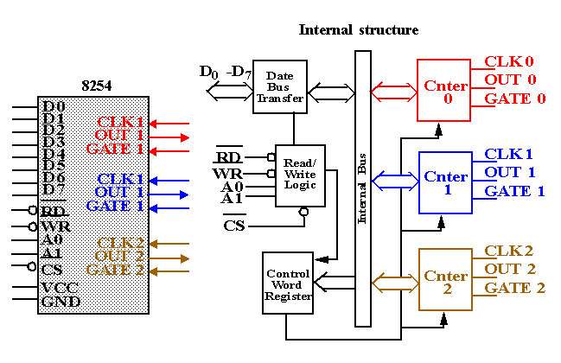

8254 Pin Definitions
A1, A0:The address inputs select one of the four internal registers with the 8254 as follows:

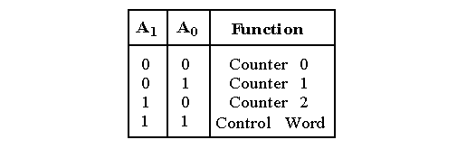
CLK: The clock input is the timing source for each of the internal counters.
It is often connected to the PCLK signal from the bus controller.
CS: Chip Select enables the 8254 for programming, and reading and writing.
G: The gate input controls the operation of the counter in some modes.
OUT: A counter output is where the wave-form generated by the timer is available.
RD/WR: Read/Write causes data to be read/written from the 8254 and often connects to the IORC/IOWC.
8254 Programming
Each counter is individually programmed by writing a control word, followed by the initial count.

The control word allows the programmer to select the counter, model of operation, binary or BCD count and type of operation (read/write).
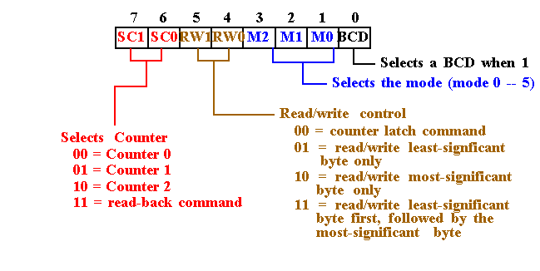
8254 Programming
Each counter may be programmed with a count of 1 to FFFFH.
Minimum count is 1 all modes except 2 and 3 with minimum count of 2.

Each counter has a program control word used to select the way the counter operates.
If two bytes are programmed, then the first byte (LSB) stops the count, and the second byte (MSB) starts the counter with the new count.

There are 6 modes of operation for each counter:
Mode 0: An events counter enabled with G.
The output becomes a logic 0 when the control word is written and remains there until N plus the number of programmed counts.
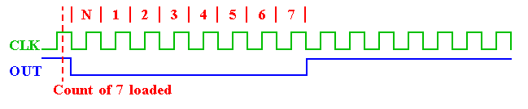

8254 Modes
Mode 1: One-shot mode.
The G input triggers the counter to output a 0 pulse for `count' clocks.
Counter reloaded if G is pulsed again.

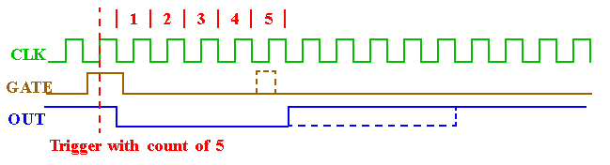
Mode 2: Counter generates a series of pulses 1 clock pulse wide.
The seperation between pulses is determined by the count.
The cycle is repeated until reprogrammed or G pin set to 0.

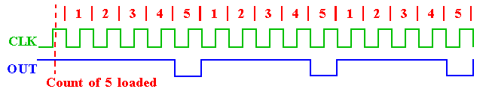

8254 Modes
Mode 3: Generates a continuous square-wave with G set to 1.
If count is even, 50% duty cycle otherwise OUT is high 1 cycle longer.
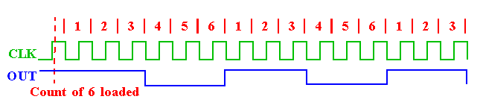

Mode 4: Software triggered one-shot (G must be 1).
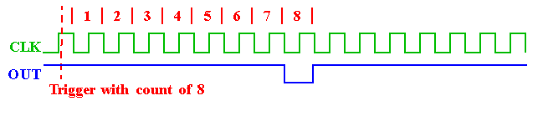
Mode 5: Hardware triggered one-shot. G controls similar to Mode 1.

