1. Explain FSK
Ans:
Frequency-shift keying is a method of transmitting digital signals through communication channels. The two binary states, logic 0 (low) and 1 (high), are each represented by an analog waveform. Logic 0 is represented by a wave at a specific frequency, and logic 1 is represented by a wave at a different frequency.
A modem converts the binary data from a computer to FSK for transmission over telephone lines, cables, optical fiber, or wireless media. The modem also converts incoming FSK signals to digital low and high states, which the computer can "understand
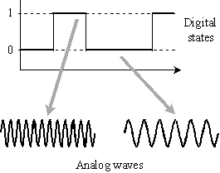

ADVANTAGES. FSK rejects unwanted signals that are weaker than the desired signal. Because the receiving device is looking for specific frequency changes over a given number of period it can ignore the voltage spikes. Automatic volume control methods may be used to minimize the effects of signal fading since a signal is always present in the FSK receiver. The limiting factors of FSK is the physical capabilities of the carrier.
2. Explain Wave length Division Multiplexing

Ans:

WDM is a technique of coupling light with two or more discrete wave length into and out of an optic fiber. Each wave length is capable of carrying large amount of information in either analogue or digital form. WAM is also referred as wave – division Multiplexing

Waves going inside the fiber optic cable Waves coming out of the fiber optic cable

fiber cable fiber cladding

The basic principle of WDM is, different wave lengths in a light pulse travel through an optical fiber at different speed.

WDM is conceptually the same as FDM , except that the multiplexing and demultiplexing involve light signals transmitted through fiber optic channels.

Source A Transmitter A Receiver A Destination A

Source B Transmitter B Receiver B Destination B

Narrow bands of light from different source are combined to make a wider band of light. At the receiver end the signals are separated by demultiplexer. Combining and splitting of light sources can be handled by a prism.

Fiber optic cable

Multiplexer Demultiplexer

Prism bends a beam of light based on the angle of incidence and frequency.
Using this technique a multiplexer can be made to combine several i/p beams of light, each containing a narrow band of frequency into one out put beam of a wider band of frequency. A demultiplexer can also be made to reverse the process.

Multiplexer Demultiplexer

3. Describe and compare Analog Encoding Methods
Ans:
1. In Amplitude modulation the amplitude of the carrier wave modulated according to the amplitude of information signal. We may use the same technology for carrying computer data as well. For digital data, it's called Amplitude-Shift Keying (ASK). Here are a couple of examples:

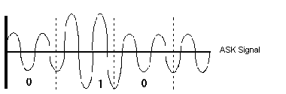

2. In Frequency modulation, carrier frequency is varied according to information signal amplitude. In the case of digital data the same technology can be applied using Frequency-Shift Keying (FSK).
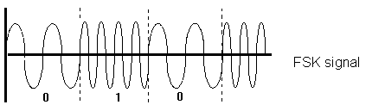
3. An analog signal may also carry data by having its phase modulated. In transmitting digital data, modulating the signal phase is called Phase Shift Keying (PSK).
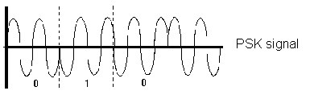

As we can see the difference is obvious between the different technologies but the result is the same. Data, whether audio, video or digital, can be encoded and transmitted via analog signals, However, some of these methods offer distinctive advantages over the others.
In analyzing methods for carrying digital data, Amplitude-Shift Keying is fairly easy to accomplish. On the other hand, any kind of amplitude modulated signal is very susceptible to outside interference. This is evident if you have ever tried listening to an AM station during an electrical storm. Each lightning occurrence fires random radio waves through the air resulting in signal interference. The same thing happens to ASK devices. Therefore, ASK is not really suitable for transmission over long distances.
Just as FM radio is not generally affected by weather, neither are FSK transmissions. In spite of this, Frequency-Shift Modulation is seldom used for transmission over high-speed lines as the technology does not allow as many bits per second throughput as PSK does.
Phase-Shift Keying technology is what is utilized by most high speed modern modems. PSK is very resistant to external interference as it enjoys most of the same characteristics that FM or FSK devices do. The signals encoded using PSK may be used for synchronization purposes as well for the sender and receiver.
4. What is meant by Digital Encoding ? Explain some digital encoding Methods
Ans:
There are numerous methods used to encode digital data directly in digital signals. First, it is important to distinguish digital signals from analog ones. An analog signal, is a continuously varying wave. Digital signals simply represent ones or zeros, so they are much less variable than analog. Since digital signals generally only represent one of two values, they are much easier to decode than multi-value analog waves. Plus the lack of multiple values makes digital signals easier to decode even after they have been affected by interference.
Digital signals are used internally in computer devices as well as externally in networks. A crucial element for digital signals is timing. Timing (or clocking) is used for synchronization so that the communications between two devices can be coordinated. The clocking may be controlled locally on each device after the devices synchronize with one another, or be assisted by "clocking bits", which are special bits used to help synchronize communications. The clocking bits are actually encoded in the information being sent from sender to receiver.
The various digital encoding methods vary from one another in the manner in which they carry binary data, susceptibility to interference and clocking information. Few examples of digital encoding methods with descriptions of each are given below.

Polar
Uses a positive and negative voltage to represent 1s and 0s. A separate clock signal is used to keep sender and receiver synchronized. Fairly resistant to interference because of the great voltage distance between 1 and 0 signals.
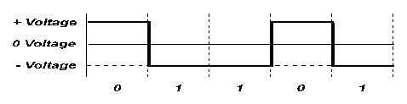
Unipolar
Uses positive voltage but no negative voltage to represent 1s and 0s. Because of low voltage variance, unipolar systems are more given to interference problems. Most use separate clocking signals as polar systems because long streams of 0s and 1s may be confusing if clocks are not exactly synchronized at sender and receiver.

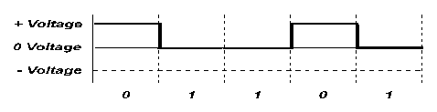
Bipolar
Similar to the other polar methods except that a positive, negative and zero voltage are utilized. Whenever a 1 is encountered, the voltage jumps alternately to the positive voltage or the negative voltage. 0 is always represented by zero voltage. This type of encoding is very resistant to interference.
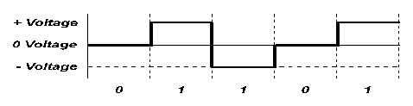

Manchester
This coding scheme involves voltage changes midway through the item of digital data being encoded. This serves the dual purpose of providing the type of bit being represented plus providing a synchronization cue for clocking purposes. In this encoding scheme a positive to negative mid-bit voltage transition denotes a 0 and a negative to positive transition denotes a 1. The Manchester coding scheme is known as "biphase".
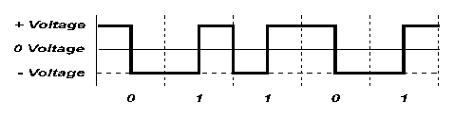
Differential
Similar to the Manchester scheme, this method is also a Manchester biphase encoding scheme. The mid-bit transition from a positive to negative voltage (or vice versa) takes place to offer synchronization (clocking). A 0 is represented by a voltage transition at the beginning of a bit and a 1 is represented by no change in the voltage at the beginning of a bit. This type of coding scheme is implemented in local area networking for token ring systems, while the standard Manchester method is utilized for another popular LAN type called Ethernet.
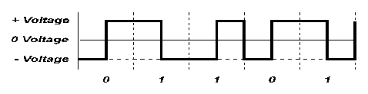

RZ
RZ (Return to Zero) encoding Is a variation on bipolar coding. As in bipolar methods, 1 is represented by a negative voltage while 0 is represented by a positive voltage. However, RZ involves switching mid-bit to zero. This provides clocking information for synchronization and better resistance to interference as it is easy to detect a voltage change mid-bit.
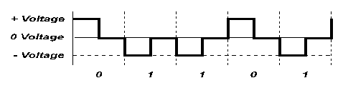

NRZ
NRZ (or Non-Return to Zero) encoding utilizes transitions between positive and negative voltages to denote 1s and 0s. Transitions are relied on rather than specific voltage levels. A 1 is represented by a transition where 0 is represented by no transition. This method is not self-clocking.
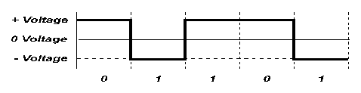
5. Explain FDM.
Ans:
Frequency Division Multiplexing (FDM) is an analog technique where each communications channel is assigned a carrier frequency. To separate the channels, a guard-band would be used. This is to ensure that the channels do not interfere with each other.
For example, if we had our 3 terminals, each requiring a bandwidth of 3 kHz and a 300 Hz guard-band, Terminal 1 would be assigned the lowest frequency channel 0 - 3 kHz, Terminal 2 would be assigned the next frequency channel 3.3 kHz - 6.3 kHz and Terminal 3 would be assigned the final frequency channel 6.6 kHz - 9.6 kHz.
The frequencies are stacked on top of each other and many frequencies can be sent at once. In this method the overall line bandwidth increases. Individual terminal requirement were 3 kHz bandwidth each, in this example the bandwidth to transmit all 3 terminals is now 9.6 kHz.
FDM does not require all channels to terminate at a single location. Channels can be extracted using a multi-drop technique, terminals can be stationed at different locations within a building or a city.
FDM is an analog multiplexing technique. It is has a disadvantage of noise problems, and this has been overtaken by Time Division Multiplexing (better suited for digital data).
6. Explain TDM - Time Division Multiplexing
Ans:
Time Division Multiplexing is a technique where a short time sample of each channel is inserted into the multiplexed data stream. Each channel is sampled in turn, and then the sequence is repeated. The sample period has to be fast enough to sample each channel according to the Nyquist Theory (2x highest frequency), and to be able to sample all the other channels within that same time period. It can be thought of as a very fast mechanical switch: selecting each channel for a very short time, then going on to the next channel.
Each channel has a time slice assigned to it (whether the terminal is being used or not). Again, to the send and receiving stations, it appears as if there is a single line connecting them. TDM is more efficient, easier to operate, less complex and less expensive than FDM.
7. What is multiplexing ?
Ans:
Multiplexing is the transmission of multiple data communication sessions over a common wire or medium. Multiplexing reduces the number of wires or cable required to connect multiple sessions. A session is considered to be data communication between two devices: computer to computer, terminal to computer, etc.
A multiplexer allows sharing of a common line to transmit the many terminal communications.
The operation of multiplexers is transparent to the sending and receiving computers. Transparent means everyone appear to be directly connected to the receiver with individual wires. The multiplexer does not interfere with the normal flow of data and it can allow a significant reduction in the overall cost of connecting to remote sites (through the reduced cost of cable and telephone line charges).
Multiplexers are used to connect terminals located throughout a building to a central mainframe. They are also used to connect terminals located at remote locations to a central mainframe through the phone lines.

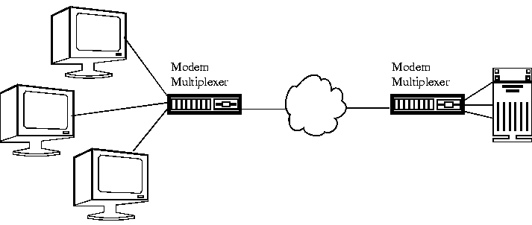
There are 3 basic techniques that are used for multiplexing:
- Frequency Division Multiplexing (FDM)
- Time Division Multiplexing (TDM)
- Statistical Time Division Multiplexing (STDM)

8. Explain statistical time-division multiplexing:

Time-division multiplexing in which connections to communication circuits are made on a statistical basis.
STDM is a system developed to overcome some inefficiencies of standard time division multiplexing, where time slices are still allocated to channels, even if they have no information to transmit.
STDM uses a variable time slot length and by allowing channels to vie for any free slot space. It employs a buffer memory which temporarily stores the data during periods of peak traffic. This scheme allows STDM to waste no high-speed line time with inactive channels. STDM requires each transmission to carry identification information (i.e. a channel identifier). To reduce the cost of this overhead, a number of characters for each channel are grouped together for transmission.
- State the difference and similarities of FDM and TDM.

Both FDM and TDM are used for multiplexing
In FDM systems, each transmitter is allocated a portion of the frequency spectrum (that is a frequency band
Each signal is modulated to a different carrier frequency
Carrier frequencies are separated so that signals do not overlap (guard bands)
Channel is also allocated even there is no data to be transmitted
In TDM system, each station is allocated the entire frequency bandwidth of the transmission media
Only for a limited portion of time called a time slot

Two basic techniques:
Synchronous TDM
Asynchronous TDM

10. State and explain Shannons’s theorem.

Ans:

Shannon's Theorem defines the theoretical maximum rate at which error-free digits can be transmitted over a bandwidth-limited channel in the presence of noise.
Shannon's Theorem gives an upper bound to the capacity of a link, in bits per second (bps), as a function of the available bandwidth and the signal-to-noise ratio of the link.
The Theorem can be stated as:

C = B * log2(1+ S/N)
where C is the achievable channel capacity, B is the bandwidth of the line, S is the average signal power and N is the average noise power.
The signal-to-noise ratio (S/N) is usually expressed in decibels (dB) given by the formula:
10 * log10(S/N)

11. How does a TDM system manage to convey all the necessary information even though the user signal is only sampled?
Ans:

Time-division multiplexing (TDM) is a method of putting multiple data streams in a single signal by separating the signal into many segments, each having a very short duration. Each individual data stream is reassembled at the receiving end based on the timing. The circuit that combines signals at the source (transmitting) end of a communications link is known as a multiplexer. It accepts the input from each individual end user, breaks each signal into segments, and assigns the segments to the composite signal in a rotating, repeating sequence. The composite signal thus contains data from multiple senders. At the other end of the long-distance cable, the individual signals are separated out by means of a circuit called a demultiplexer, and routed to the proper end users.

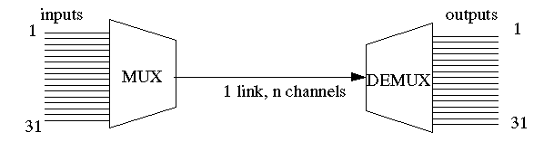

Time Division Multiplexing operates by dividing the network bandwidth into fixed bandwidth segments. Each segment or channel is assigned to a user and is given its own time slot for using the network. First, information from channel 1 is transmitted, then information from channel 2, and so on in a regular sequence, cycling back to channel 1 and continuing. Bandwidth allocation is static, that is, each channel has a fixed predetermined bandwidth.
But we cannot increase the number of channels beyond a limit. It should satisfy the sampling theorem. The theorem states that, when converting from an analog signal to digital (or otherwise sampling a signal at discrete intervals), the sampling frequency must be greater than twice the highest frequency of the input signal in order to be able to reconstruct the original perfectly from the sampled version.
f_{sample} >=2 f_{max}
Sampling at this rate will not result in any loss of information, but if you sample at less than this then you will not be able to reconstruct the signal as it first appeared.
12. What is Keying, and which are the three main Keying techniques.
Ans:
Keying is the process of generating signals by the interruption or modulation of a steady signal or carrier.
Basically there are three ways of keying. They are implemented by altering of the amplitude, frequency and phase of the carrier sine wave. These techniques give rise to amplitude-shift-keying (ASK), frequency-shift-keying (FSK) and phase-shift-keying (PSK), respectively.

13. Explain ASK
ASK describes the technique the carrier wave is multiplied by the digital signal
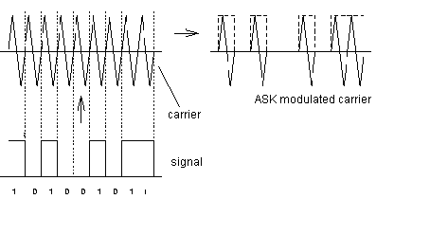
Amplitude shift keying
The bandwidth of the signal remains unchanged. The fact that AM simply shifts the signal spectrum is often used to convert the carrier frequency to a more suitable value without altering the modulation.
14. Explain PSK
PSK describes the modulation technique that alters the phase of the carrier. Its bandwidth requirement is the same as that of ASK. Phase-shift-keying offers a simple way of increasing the number of levels in the transmission without increasing the bandwidth by introducing smaller phase shifts. For a given bit-rate, QPSK requires half the bandwidth of PSK and is widely used for this reason.
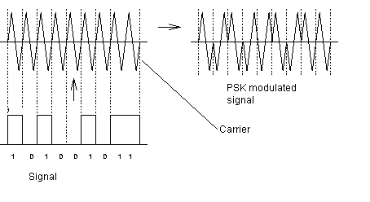
phase shift keying

